Lab: Linear-Data-Structures
This document defines the lab for "Data Structures – Fundamentals (C#)" course @ Software University.
Please submit your solutions (source code) of all below described problems in Judge.

List
Your task is to implement the ADS IAbstractList<T> inside the List<T> class provided.
You have to implement all the methods in order to solve the problem, however you are free to add more methods with any access modifier you want.

void Add(T item)

Adds an element at the end of the sequence.

This method should in addition increase the size of the structure and ensure that there is enough space for the addition to work.

If needed you will have to resize the array.

int Count

Returns the number of elements.

void Insert(int index, T item)

Inserts the passed element at the specified index in the sequence (if possible).

If the index is outside of the sequence bounds, throw an IndexOutOfRangeException.

Get (indexer)

Returns the element at the given index and does not remove it from the collection.

If the index is invalid throw IndexOutOfRangeException with a proper message of your chose (the message itself in not subjected to testing).

Set (indexer)

Sets the element at given index. Again you should validate the index and throw IndexOutOfRangeException if the validation fails.

void RemoveAt(int index)

Removes the element at specified index.

If the index is outside of the sequence bounds, throw an IndexOutOfRangeException.
- bool Contains (T item)
  - Returns true or false if the element is present inside the structure.

int IndexOf(T item)

Returns the index of an element if the element is not present in the structure then return -1 as invalid array index.
- bool Remove (T item)
  - Removes the first occurrence of the passed item and returns true.
  - If it is not present in the list, return false.

Solution:

public List(int capacity)

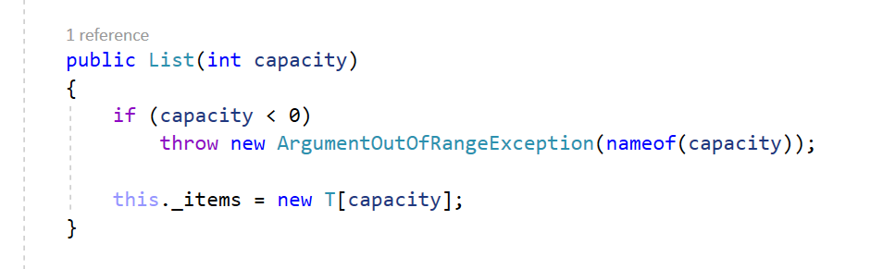

void Add(T item)
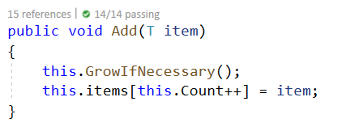

Grow() helper methods
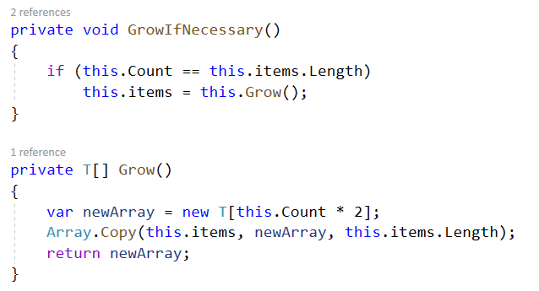

void Insert(int index, T item)
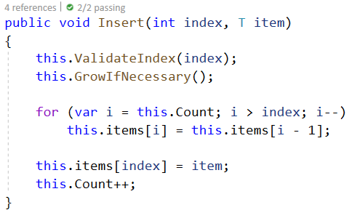

Get and set through indexer
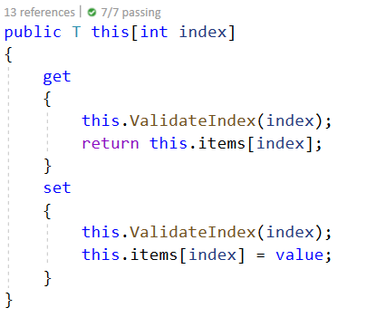

void RemoveAt(int index)
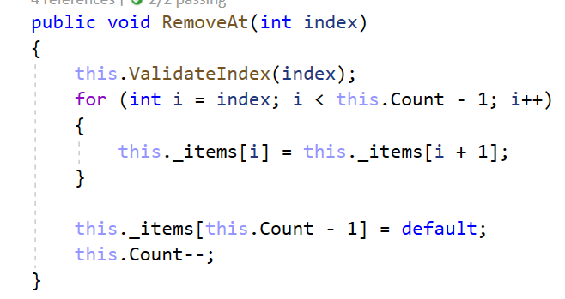

Take a look at those additional helper methods, you can reuse them whenever needed:

The ValidateIndex() method, feel free to add a message.
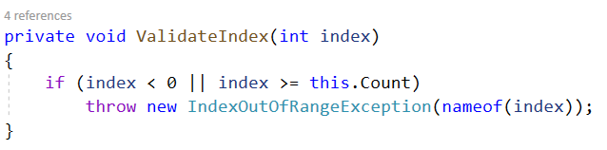

GetEnumerator()
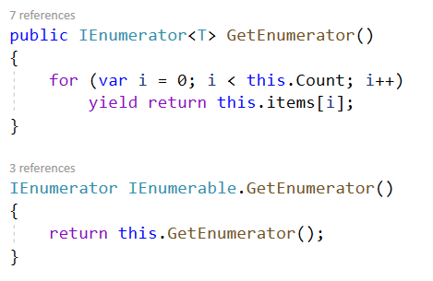

All of the other methods are really easy and straightforward to be implemented so you won't need any help. If it doesn't work the first time simply try different approach.

Stack

Your task is to implement the ADS IAbstractStack<Т> inside the Stack<Т> class provided.

You have to implement all the methods in order to solve the problem, however you are free to add more methods with any access modifier you want.

void Push(T item)

Adds an element at the top of the stack and increases the size.

T Pop()

Removes an element at the current top of the stack and returns it.

If the stack is empty throw InvalidOperationException with appropriate message.

T Peek()

Returns the element at the current top of the stack without removing it.

If the stack is empty throw InvalidOperationException with appropriate message.

int Count

Returns the number of elements inside the stack.

Solution:

void Push (T item)
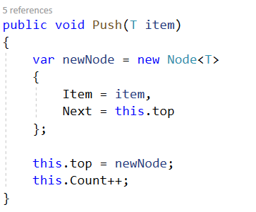

T Pop ()
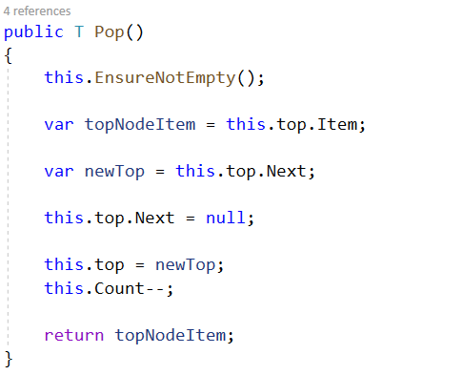

T Peek ()
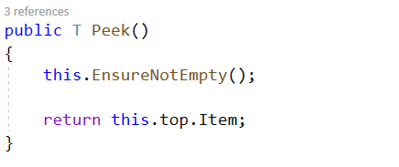

GetEnumerator()
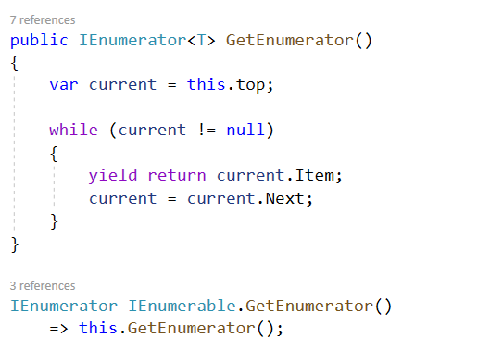
All of the other methods are really easy and straightforward to be implemented. If it doesn't work the first time simply try different approach.

Queue
Your task is to implement the ADS IAbstractQueue<T> inside the Queue<T> class provided.
You have to implement all the methods in order to solve the problem, however you are free to add more methods with any access modifier you want.

void Enqueue(T item)
  - Adds an element at the end of the queue and increases the size.

T Dequeue()

Removes and returns the first element at the queue also decreases the size and performs a check if this method is called upon empty collection.

If so throw InvalidOperationException with message of your choice.

T Peek()

Returns the element at the current front of the queue. If the collection is empty throw InvalidOperationException with appropriate message.

int Count

Returns the number of elements inside the stack.

Solution:
As you can see a lot of the operations described above are a lot like those we did on the Stack problem so think how you can reuse and modify those.
Now you can see slightly different way of adding the elements - in the stack implementation we had pointer to the top element here we have to the first pointer so you need to find the last element so you can enqueue the new node.

SinglyLinkedList
Your task is to implement the ADS IAbstractLinkedList<T> inside the SinglyLinkedList<T> class provided.
You have to implement all the methods in order to solve the problem, however you are free to add more methods with any access modifier you want.

void AddFirst(T item)

Adds an element in front of the collection and increases the size.

void AddLast(T item)

Adds an element after the last element of the collection and increases the size.

T RemoveFirst()

Removes and returns the first element of the collection if there is such if no then throw InvalidOperationException with appropriate message.

T RemoveLast()

Removes and returns the last element of the collection if there is such if no then throw InvalidOperationException with appropriate message.

T GetFirst()

Returns but does not remove the first element of the collection if there is such if no then throw InvalidOperationException with appropriate message.

T GetLast()

Returns but does not remove the last element of the collection if there is such if no then throw InvalidOperationException with appropriate message.

int Count

Returns the number of elements inside the collection.

Solution:
Here comes the tricky part, all of the operations above are really alike the previous ones you have implemented combined and modified of course. But in really small and simple matters so try to solve those on your own.
Good Luck! And remember if something gets too complicated or unclear and does not work you can always start again by choosing a different approach.

