C# Web Basics Exam – 25 October 2020

_{Git}

Exam problems for the C# Web Basics course @ SoftUni. Submit your solutions in the SoftUni judge system (delete all "bin"/"obj" folders).
Git is a free and open source distributed version control system designed to handle everything from small to very large projects with speed and efficiency.

Technological Requirements
- Use the SUS
- Use Entity Framework Core – 3.1
The Technological Requirements are ABSOLUTE. If you do not follow them, you will NOT be scored for other Requirements.
Now that you know the Technological Requirements, let us see what the Functional Requirements are.

Database Requirements
The Database of Git needs to support 3 entities:

User
- Has an Id – a string, Primary Key
- Has a Username – a string with min length 5 and max length 20 (required)
- Has an Email - a string (required)
- Has a Password – a string with min length 6 and max length 20 - hashed in the database (required)
- Has Repositories collection – a Repository type
- Has Commits collection – a Commit type

Repository
- Has an Id – a string, Primary Key
- Has a Name – a string with min length 3 and max length 10 (required)
- Has a CreatedOn – a datetime (required)
- Has a IsPublic – bool (required)
- Has a OwnerId – a string
- Has a Owner – a User object
- Has Commits collection – a Commit type

Commit
- Has an Id – a string, Primary Key
- Has a Description – a string with min length 5 (required)
- Has a CreatedOn – a datetime (required)
- Has a CreatorId – a string
- Has Creator – a User object
- Has RepositoryId – a string
- Has Repository– a Repository object

Implement the entities with the correct datatypes and their relations.

Page Requirements

Index Page (logged-out user)
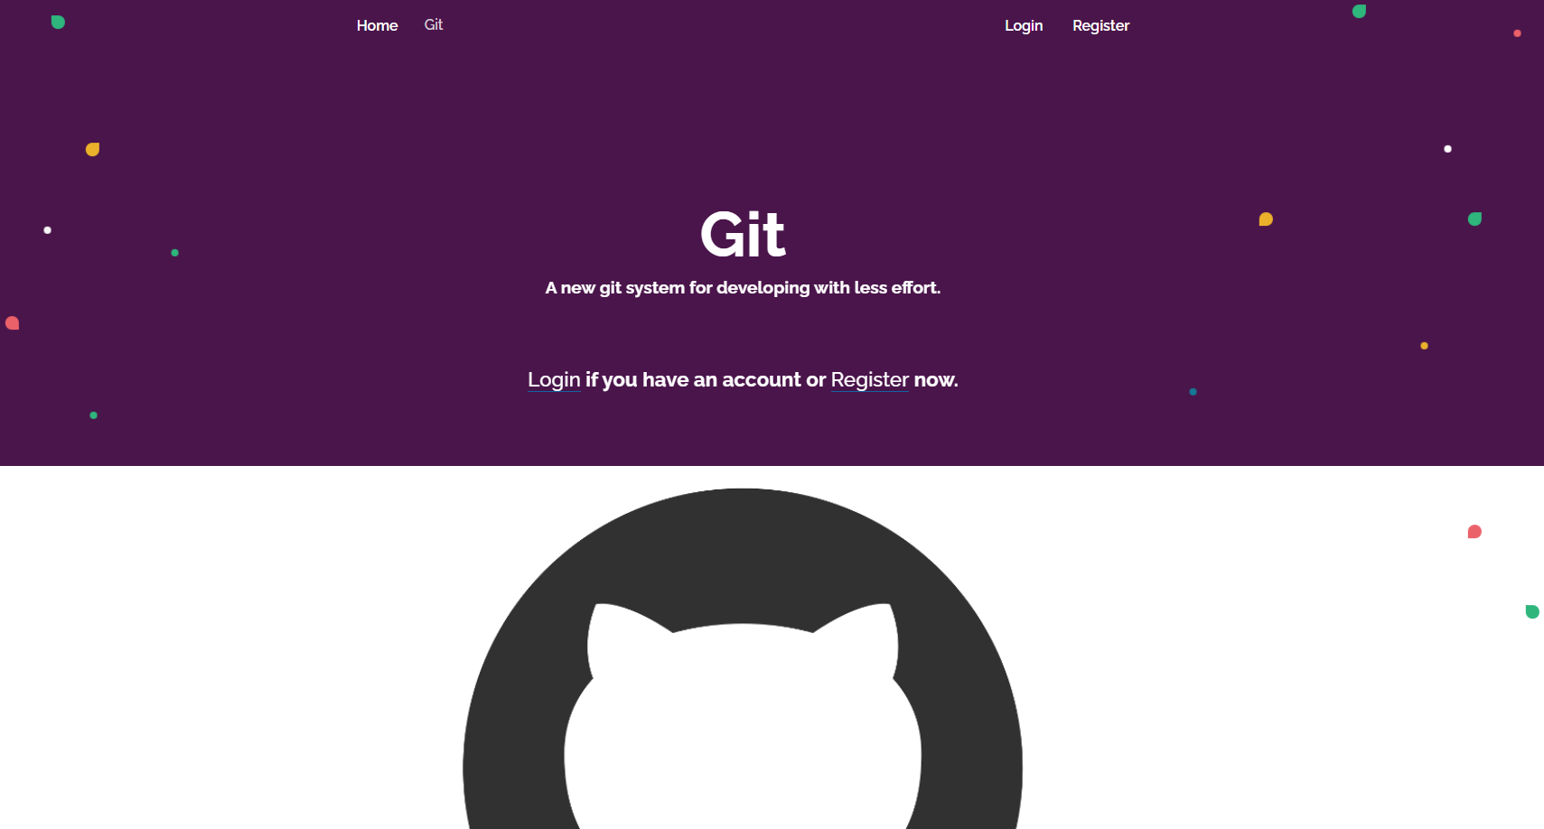

Login Page (logged-out user)
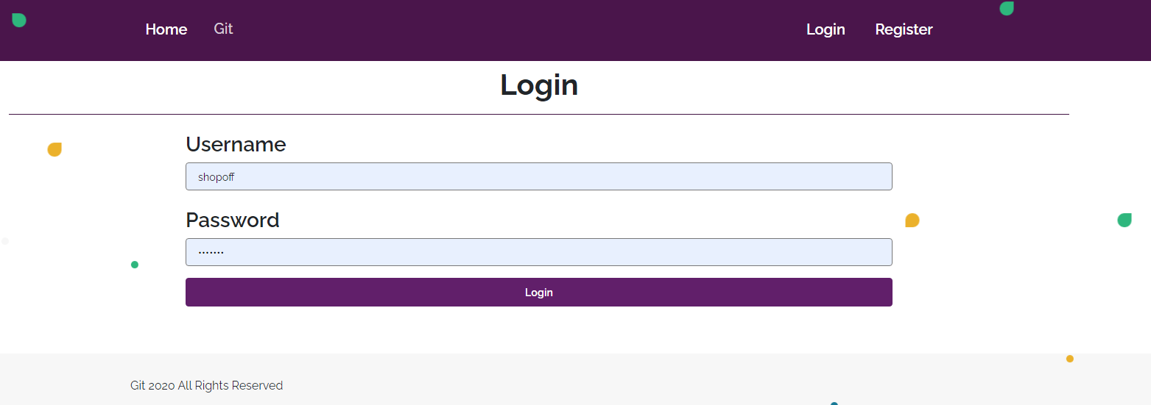

Register Page (logged-out user)
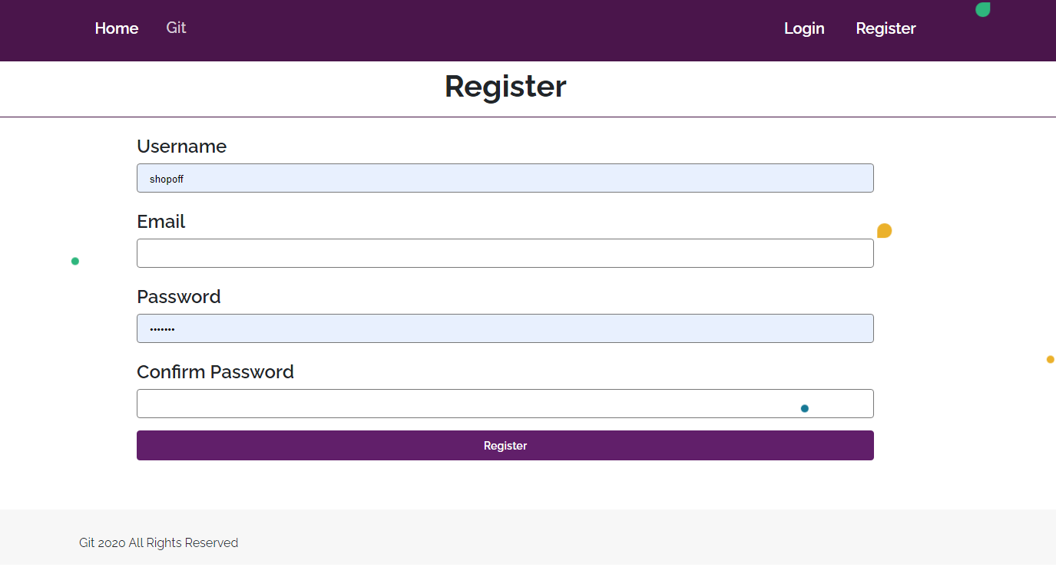

/Repositories/All (logged-in user)
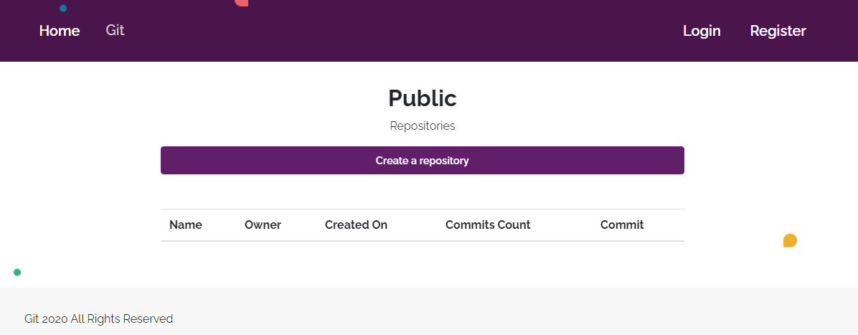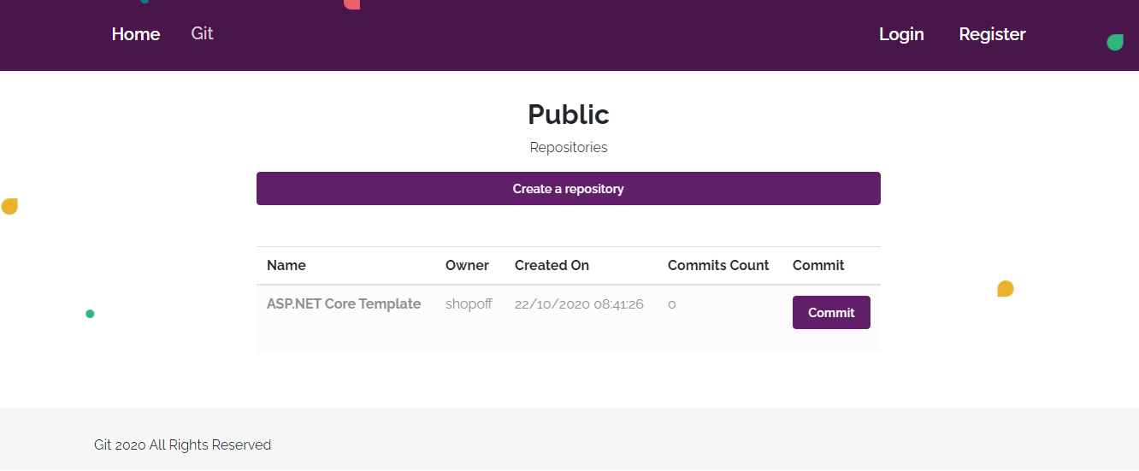

NOTE:
If the user is logged in and he tries to go the home page, the application must redirect him to the /Repositories/All
DateTime format does not matter

/Repositories/Create (logged-in user)
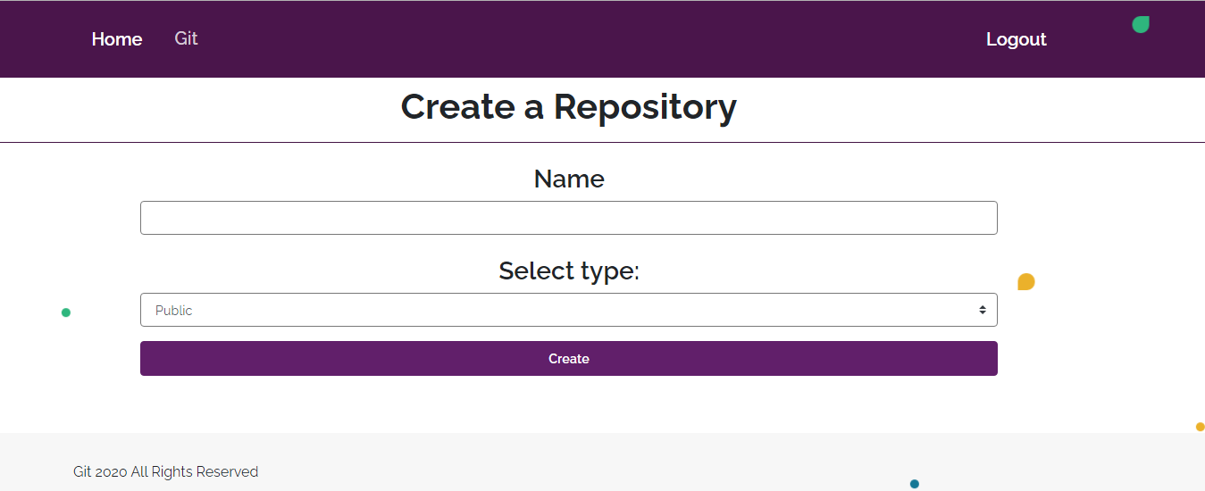

/Commits/Create?id={id} (logged-in user)
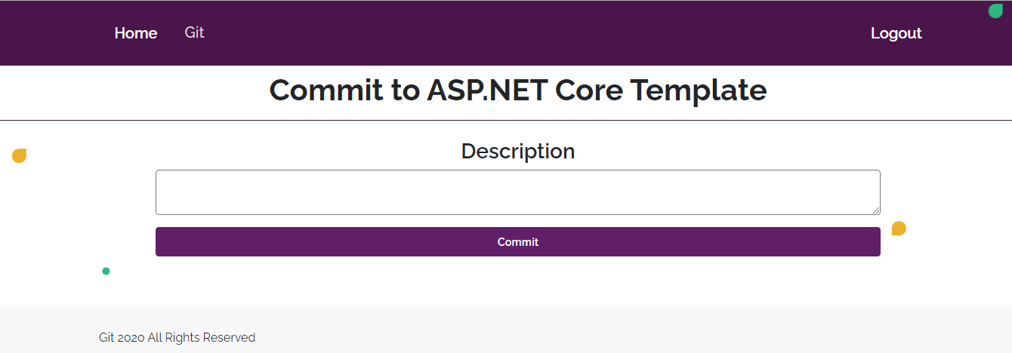

/Commits/All (logged-in user)
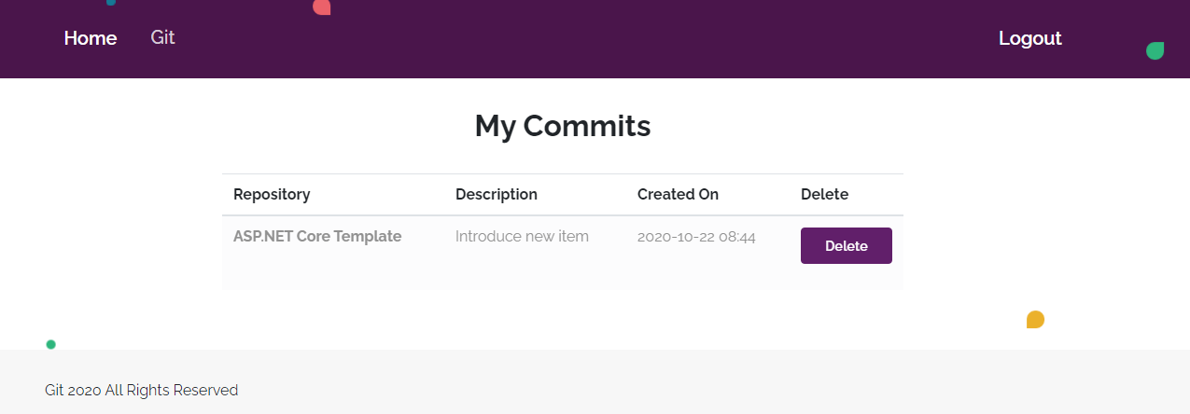
DateTime format does not matter

/Commits/Delete?id ={id} (logged-in user)
Deletes the given commit. Only the owner can delete his commit. If everything is successful, the user must be redirect to the all repositories.
NOTE: The templates should look EXACTLY as shown above.
NOTE: The templates do NOT require additional CSS for you to write. Only bootstrap and the given css are enough.

Functionality
The functionality of Git platform is very simple.

Users
Guests can see Register, Login, Index and All Repositories views.
Users can create repositories, which can be private or public. User can see all public repositories on the repositories page. From the repository page they can also commit to a repository. They are able to delete their commits.

Repositories
Users can add repositories. All public repositories are visualized on the all repositories page, each one in its own separate rectangular element.
Repositories are visualized on the all repositories page as a table with Name, Owner, Created On, Commits Count (total commits) and Commit action.
Repositories are visualized on the all repositories page with button – [Commit].
- The [Commit] button leads to the create commit page and creates commit for the particular repository.

Commits
Users can make commits on all repositories. All commits are visualized on the all commits page, each one in its own separate rectangular element. Only user's own commits must be listed.
Commits are visualized on the all commits page with button – [Delete].
- The [Delete] button deletes the particular commits only if the owner tries to delete it.

Redirections
- Upon successful Registration of a User, you should be redirected to the Login Page.
- Upon successful Login of a User, you should be redirected to the /Repositories/All.
- Upon successful creation of a repository, you should be redirected to the /Repositories/All.
- Upon successful creating commit to a repository, should be redirected to the /Repositories/All.
- Upon successful deletion of a commit, should be redirected to the /Commits/All.
- If any of the validations in the POST forms do not pass, redirect to the same page (reload/refresh it) or return an error.

Security
The Security section mainly describes access requirements. Configurations about which users can access specific functionalities and pages:
- Guest (not logged in) users can access Index page.
- Guest (not logged in) users can access Login page.
- Guest (not logged in) users can access Register page.
- Guest (not logged in) users can access Repositores/All page.
- Users (logged in) cannot access Guest pages.
- Users (logged in) can access Repositories/All page and functionality.
- Users (logged in) can access Repositories/Create page.
- Users (logged in) can access Commits/Delete page and functionality.
- Users (logged in) can access Commits/Create page and functionality.
- Users (logged in) can access Commits/All page and functionality.
- Users (logged in) can access Logout functionality.

Code Quality
Make sure you provide the best architecture possible. Structure your code into different classes, follow the principles of high-quality code (SOLID). You will be scored for the Code Quality and Architecture of your project.

Scoring

Database Requirements – 10 points.

Template Requirements – 10 points.

Functionality – 50 points.

Security – 10 points.

Code Quality – 15 points.

Data Validation – 5 points.

