Lab: Mass Effect
This document defines a lab assignment from the "OOP" Course @ Software University.
Mass Effect is a video game where starships can travel from one star system to another and attack other ships. You are given a skeleton (partially written code) for the game as well as a problem description. Your task is to finish the game by applying the best practices of OOP. You can test your solution in the automated Judge system here.

Step 1 - Read the Problem Description
Read the given problem description to better understand the problem.

Step 2 - Study the Code
Being able to find your way around someone else's code is a very important skill. Let's study the provided classes in the skeleton one by one:
- Engine
  - GameEngine - implements the IGameEngine interface. The Run() method starts a while loop until its IsRunning property yields false. It reads a string command from the console and passes it to the ProcessCommand() method of its CommandManager. A try-catch block ensures that any ShipException that might occurr in ProcessCommand() will be properly handled.
  - CommandManager - keeps all commands in a dictionary where the key is the command as a string (e.g. "attack") and the value is the instance of the corresponding command (e.g. new AttackCommand());
ProcessCommand() retrieves a command from the dictionary and calls its Execute() method:
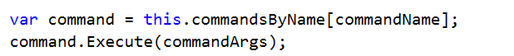
  - Commands - none of the commands are implemented
    - Command - base class for any command; holds a reference to an IGameEngine and an empty Execute() method.
    - AttackCommand - encapsulates logic for executing an attack
    - CreateCommand - encapsulates logic for creating a ship
    - OverCommand - encapsulates logic for stopping the game engine
    - PlotJumpCommand - encapsulates logic for changing the location of a ship
    - StatusReportCommand - encapsulates logic for displaying info about a ship
  - Factories
    - ShipFactory - holds method CreateShip() that creates a ship, given a type, name and location
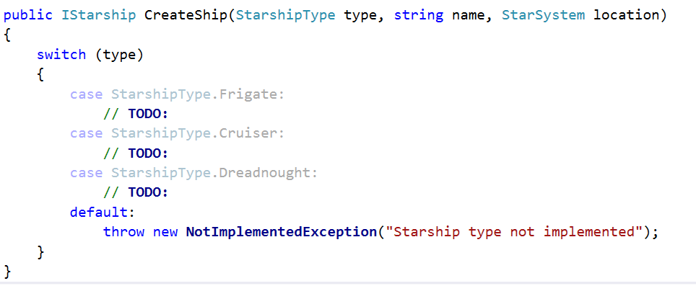
    - EnhancementFactory - holds method Create() that creates an enhancement, given a type
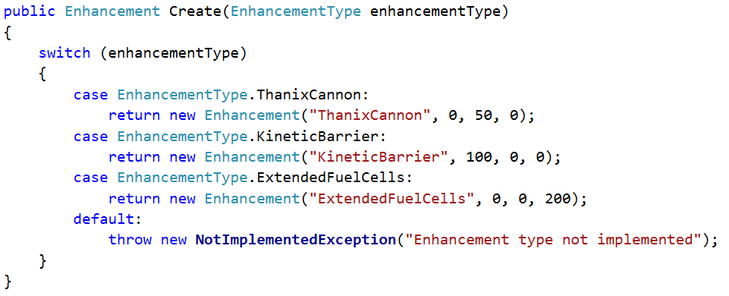
  - Messages - a static class that holds messages as public constants, available for use in the entire application
- Exceptions - the namespace holds custom exception classes
  - ShipException
  - InsufficientFuelException
  - LocationOutOfRangeException
- GameObjects
  - Enhancements
    - Enhancement - holds ShieldBonus, DamageBounus and FuelBonus
    - EnhancementType - enumeration that holds the 3 possible enhancements - ThanixCannon, KineticBarrier, ExtendedFuelCells
  - Locations
    - StarSystem - holds name and a dictionary with all neighboring star systems, where the key is a reference to another star system and value is the fuel required to travel there (e.g. ArtemisTau -> 120).
  - Ships
    - StarshipType - enumeration that holds the 3 possible starship types - Frigate, Cruiser and Dreadnought
  - Projectiles - empty namespace left for future projectile implementations
  - Galaxy - class that holds a set of all star systems and 2 methods: GetStarSystemByName() and TravelTo()
- Interfaces
  - ICommandManager - defines what a CommandManager should have - hold a reference to a GameEngine, ProcessCommand() method for processing individual commands and SeedCommands() method for initializing the dictionary with commands.
  - IEnhanceable - defines something that can be enhanced (meaning upgraded) - holds IEnumerable<Enhancements> (a read-only collection of enhancements) and AddEnhancement() method
  - IGameEngine - defines a GameEngine (see the interface for more info)
  - IProjectile - defines a Projectile - holds Damage and Hit() method
  - IStarship - defines a Starship (see the interface for more info). Extends IEnhanceable.
Take your time and study the provided code well before proceeding with the next tasks.

Step 3 - Implement Ships
The whole game depends on the 3 ship types. Let's implement classes for them! Create 3 classes in the Ships namespace - Frigate, Cruiser and Dreadnought. All three ships have Name, Health, Shields, Damage, Fuel, Location, enhancements and methods: ProduceAttack(), RespondToAttack(), AddEnhancement().
In other words, we have common properties and methods. Let's extract those common members in a base class - Starship. It should implement the IStarship interface (since it defines the behavior of a starship, and our class is one).
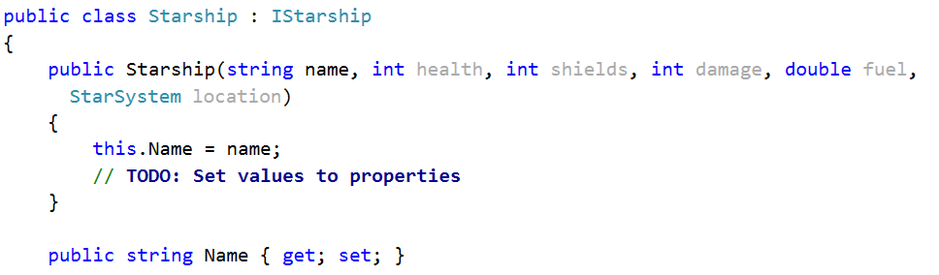
Implement the missing members of that interface (properties, methods). Think about if the class should be allowed to be instantiated (tip: abstraction). In that sense, should the constructor of Starship be public?
Implement concrete classes - Frigate, Cruiser and Dreadnought.
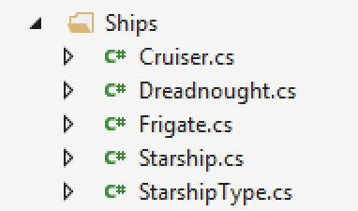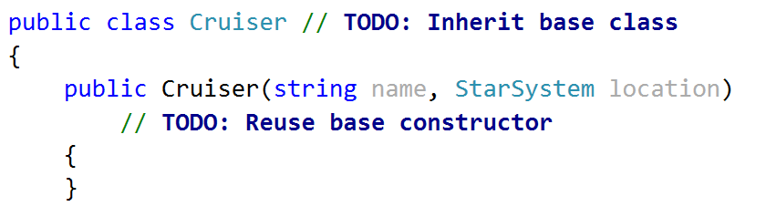
Notice the problem description states that the Frigate should also keep count of all projectiles fired (we'll talk more about later). For now, just create a field projectilesFired in the frigate class for keeping track of all fired porjectiles.
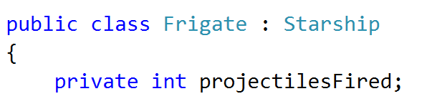

Step 4 - Implement TODOs in ShipFactory
Now that we have classes for each ship in our game, let's implement the missing parts of the ShipFactory.
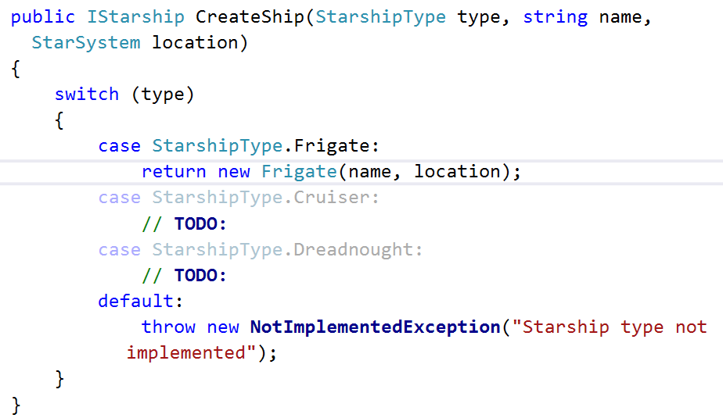

Step 5 - Create Command
It's time we implemented our first command - create. The Commands namespace contains several commands, all of which inherit the base Command class. However, there are 3 things wrong with it.
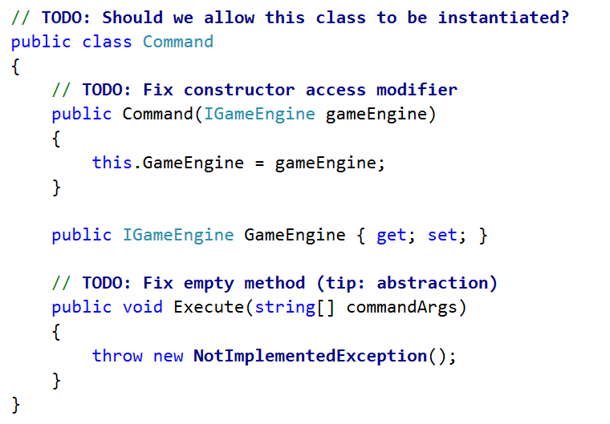
Now that we've fixed the base Command class, it's time we started implementing our concrete commands.
As we already saw, each command's Execute() method is called whenever a command string is entered by the user. Obviously, each command class will implement that method differently.
In order for a descendant class to change a method, it needs to override it.
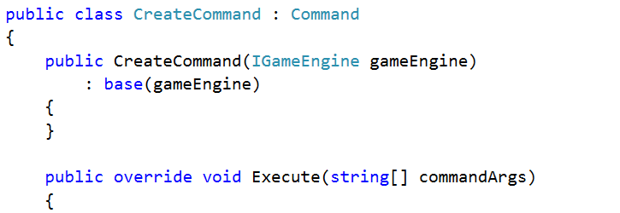
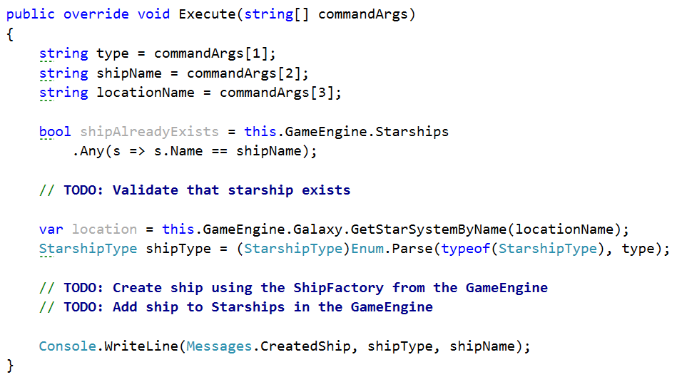
If everything is correct, the Create command should successfully create a ship and add it to the Starships collection in the engine.

Step 6 - Implement AddEnhancement()
The starships we made (Frigate, Cruiser and Dreadnought) inherit Starship. Starship implements the IStarship interface. IStarship extends the IEnhanceable (which defines behavior for holding enhancements and adding new ones). Therefore, all ships are enhanceable.
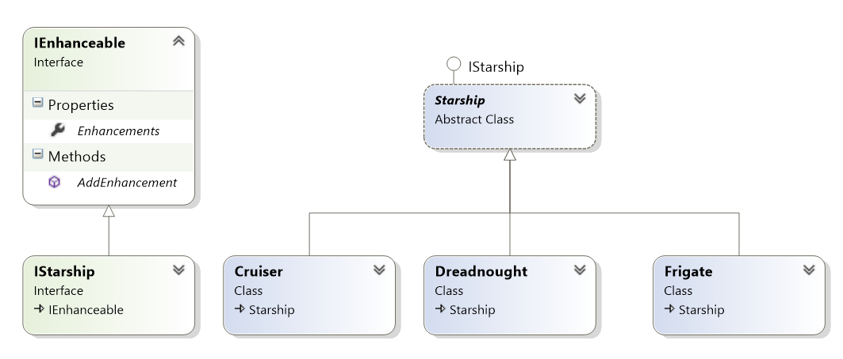
Since all ships are IEnhanceable, they have AddEnhancement() method.
Judging from the Create command, all arguments after the 4th will be enhancements
(e.g. create {shipType} {shipName} {starSystem} {enhancement1 enhancements2 ...}).
Let's go back to the CreateCommand class and add enhancements after we've created a ship.
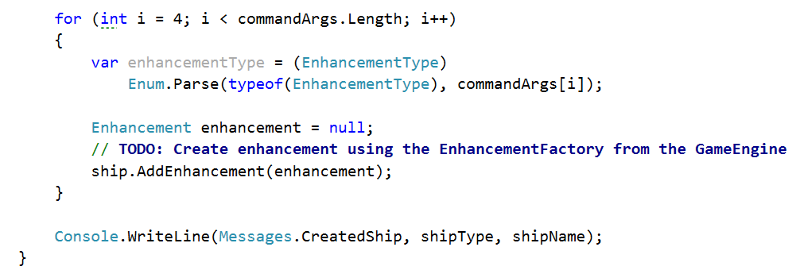
So far so good, but we need to implement the AddEnhancement() method. The question is - where? In Frigate? In Dreadnought? No, in Spaceship - it is the base class for all ships so each ship will reuse it.
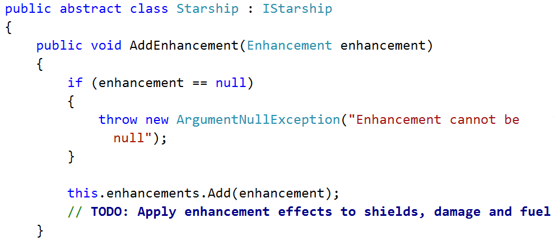
But, enhancements is IEnumerable<Enhancement>. How do we add an element to an IEnumerable collection? We don't.
Internally we keep the enhancements as private IList<Enhancement> (a collection that allows adding elements) and add to that collection. But we reveal it as IEnumerable<Enhancement> (a collection that can only be iterated).
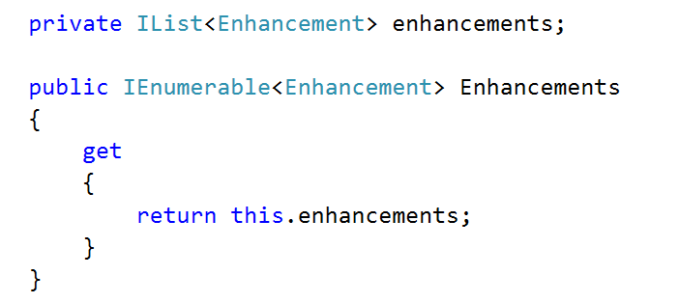
Why is this allowed? Because IList<T> extends IEnumerable<T> and thanks to polymorphism we can reveal a more concrete object as a more abstract one.
Note: That way nobody from outside the class can add/remove enhancements, because the collection is revealed as IEnumerable. Inside the class, however, we can work with IList and we can add/remove elements.

Step 7 - Status Report Command
Just like CreateCommand, StatusReportCommand should inherit the base Command class and override its Execute() method.
It should print information about a given ship in the following format:
If health > 0 | If health <= 0
--{shipName} - {shipType}  -Location: {locationName}  -Health: {health}  -Shields: {shields}  -Damage: {damage}  -Fuel: {fuel}  -Enhancements: {enh1, enh2, ...} | --{shipName} - {shipType}  (Destroyed)
The format varies depending on the ship's health. Let's implement the command:
- Inherit the Command class
- Reuse the base constructor to avoid code repetition
- Override the abstract Execute() method:
  - Get the ship from the engine by name
  - Print the ship to the console by calling its ToString() method
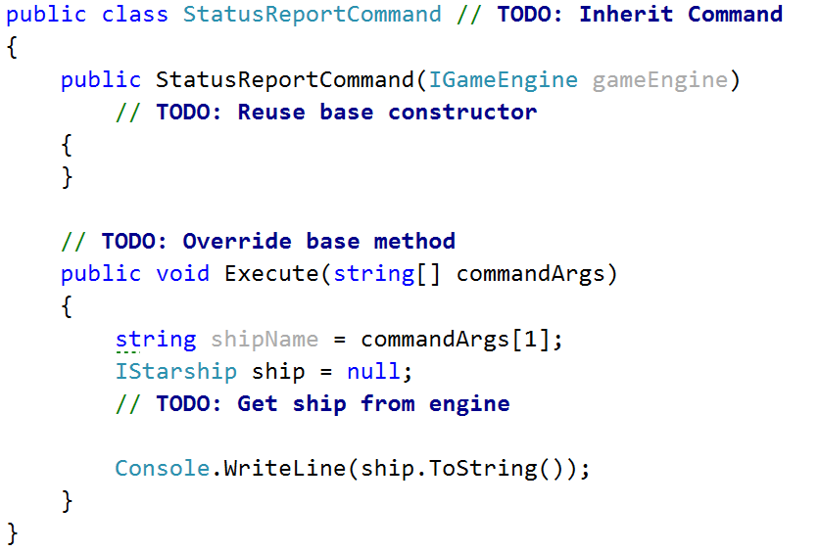
Obviously the ship's ToString() method must return information about the ship.
However, by default ToString() returns the class' type. We want it to return ship info. Fortunately for us, ToString() is a virtual method - therefore we can override it and change its behavior for our needs.
Let's go to the base Starship class and override its ToString() method. By overriding a method in a parent class, all child classes also inherit the overriden method.
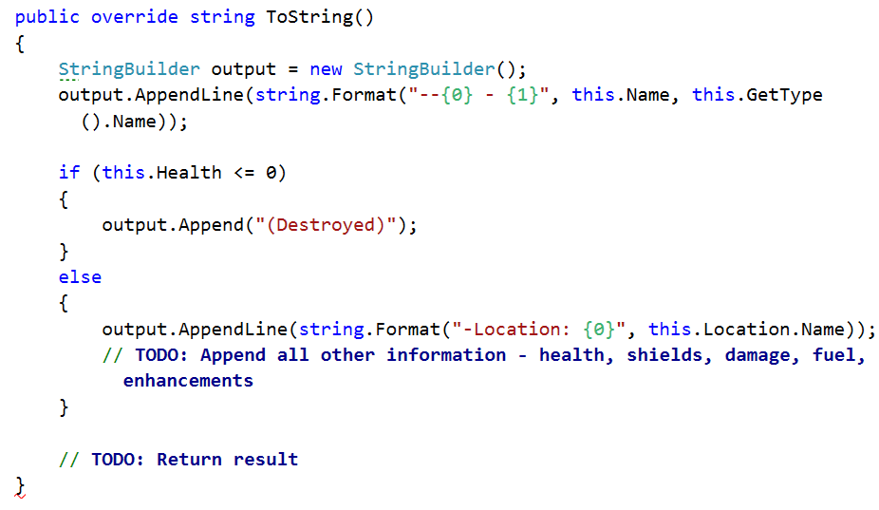
Thanks to inheritance the Frigate, Cruiser and Dreadnought classes inherit the above method implementation and we avoid code repetition!
However, there is one more thing: If the ship is a frigate (and not destroyed), it should also display the number of projectiles fired so far in the format:
-Projectiles fired: {count}
We need to override the Frigate's ToString() method too and add that additional line. Make sure you do not repeat any code by reusing the base (Starship) implementation!
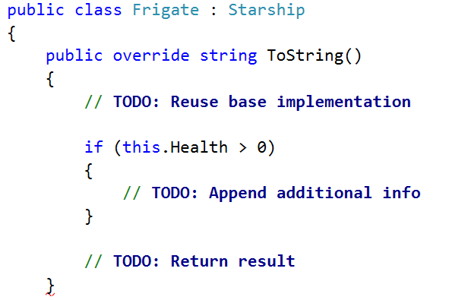

Step 8 - Attack Command
Time to implement the attack command. Let's go to the AttackCommand class and override the Execute() method.
- We get the attacker ship name and target ship name from the command arguments
- Then we get the ships with those names from the engine
- Finally, we pass the 2 ships to our ProcessStarshipBattle() method (notice how it's private because there is no need for the method to be visible to the outside world)
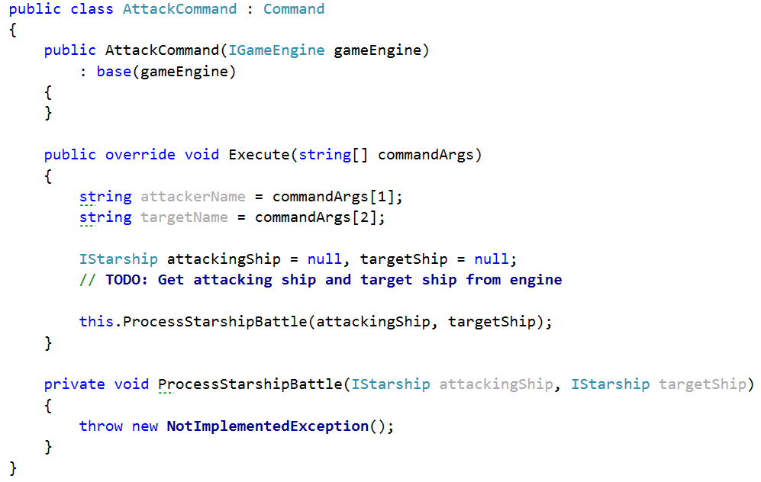
The ProcessStarshipBattle() method should do the following things:
- Validate that the 2 ships have not been destroyed (are still alive)
- Validate the two ships are in the same star system (by rules, a ship cannot ships in other star systems)
- The attacking ship's ProduceAttack() method should produce a projectile
- The target ship should take the projectile using its RespondToAttack() method
- Finally, check if the target ship's health or shields has fallen below 0 and raise them back to 0
First, let's create method that validates whether a ship is alive (not destroyed).
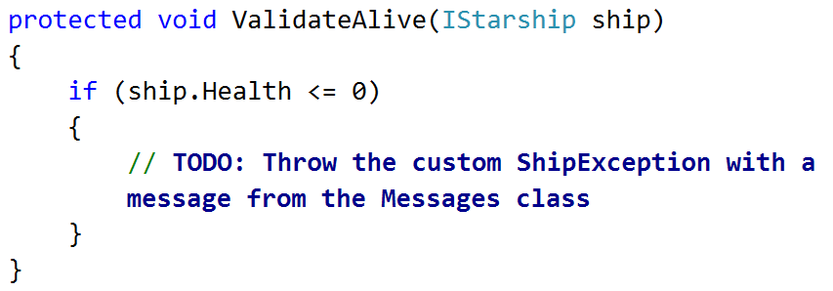
Think about where you should place this method - it will be used by several commands later (not only the AttackCommand class).
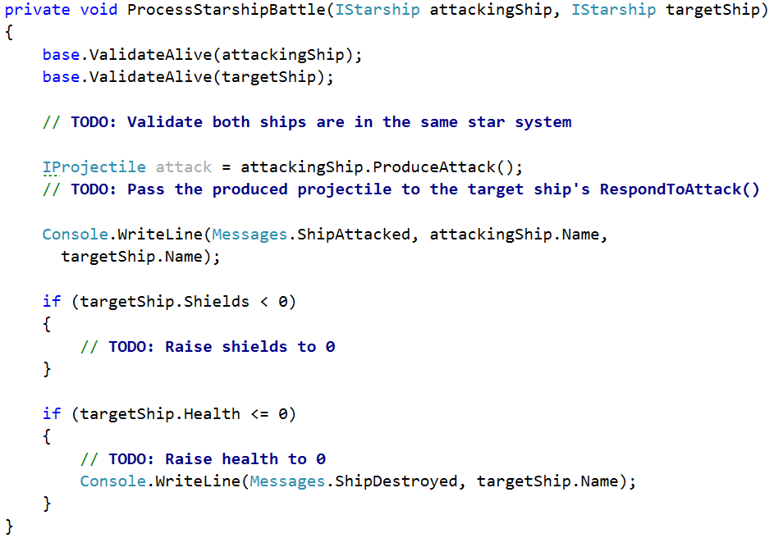
If all is right, the attack command should be ready. But it cannot work correctly until we implement each ship's (Frigate, Cruiser and Dreadnought) ProduceAttack() and RespondToAttack() methods.

Step 9 - Implement ProduceAttack()
Every ship has a ProduceAttack() method (as defined by the IStarship interface). The method's return type is IProjectile - this suggests it must return the projectile of the attacking ship. The problem description states that every ship fires a different projectile - Penetration Shell, Shield Reaver or Laser. Let's implement the projectiles.
Create a base class Projectile and a class for each of the actual projectiles - Laser, PenetrationShell and ShieldReaver.
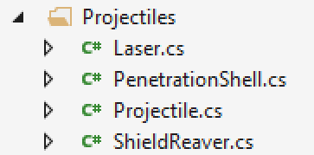
Projectile should serve as a base class for all projectiles and should not allow to be instantiated. It should also implement the IProjectile interface.
The interface defines that all projectile should have damage (passed by the firing ship) and Hit() method.
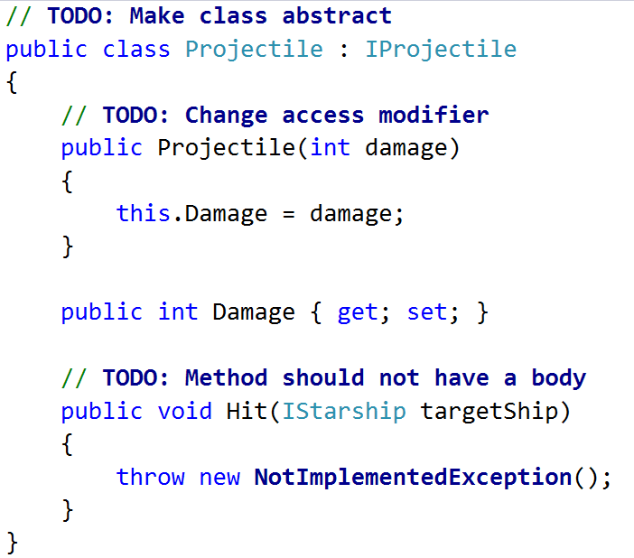
Let's take a look at what each projectile's Hit() method should do:
- PenetrationShell - removes health from the ship equal to the projectile's damage.
- ShieldReaver - removes health from the ship equal to the projectile's damage. It also removes shields from the ship equal to 2x the projectile's damage.
- Laser - removes shields from the ship equal to the projectile's damage. If the damage is more than the ship's shields, it also takes health equal to the damage left. (e.g. 50 shields and 100 health - a laser of 80 damage would remove 50 shields and 30 health, resulting in 0 shields and 70 health for the ship).
Let's start with the PenetrationShell:
- Create a PenetrationShell class and inherit the base Projectile class
- Reuse the base constructor
- Override the abstract Hit() method. It should subtract health from the hit ship equal to the projectile's own damage
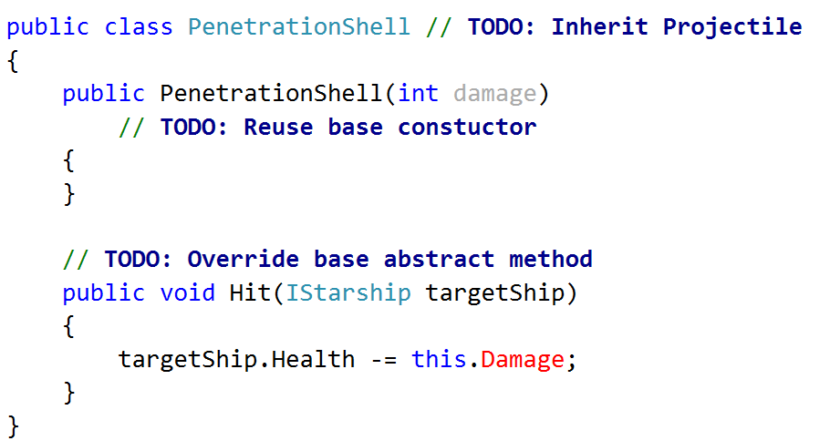
Do the same for each of the other Projectile classes - ShieldReaver and Laser.
Now that we have the projectile's available, it's time we implemented the ProduceAttack() method for each of our ships.
Ship | Projectile | Description
Frigate | PenetrationShell | Shoots a ShieldReaver with damage equal to its own damage.
Cruiser | ShieldReaver | Shoots a PenetrationShell with damage equal to its own damage.
Dreadnought | Laser | Shoots a Laser with damage equal to half its shields + own damage.

For example, a Cruiser should produce a PenetrationShell with damage equal to its own damage.
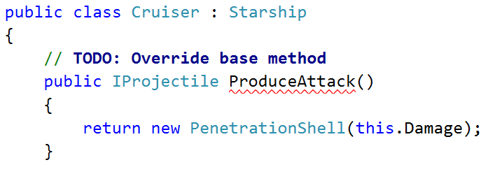
Follow the table above and do the same for other ships as well.
Hint: Increase the projectilesFired field of Frigates before producing a projectile.

Step 10 - Implement RespondToAttack()
Let's take a look at how different ships respond to attacks.
Ship | Response
Frigate | None (i.e. they just get hit)
Cruiser | None (i.e. they just get hit)
Dreadnought | Raises its shields by 50 before getting hit (and removes them after that)

In other words, the RespondToAttack() method of Frigates and Cruisers should only call the Hit() method of the projectile.
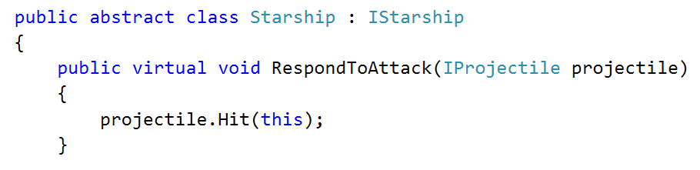
Since this behavior is common for the majority of ships, it's safe to extract it to the base Starship class. We declare it virtual, so any descendants who wish to change the method should be free to do so.
The only descendant class which responds differently to attacks is the Dreadnought.
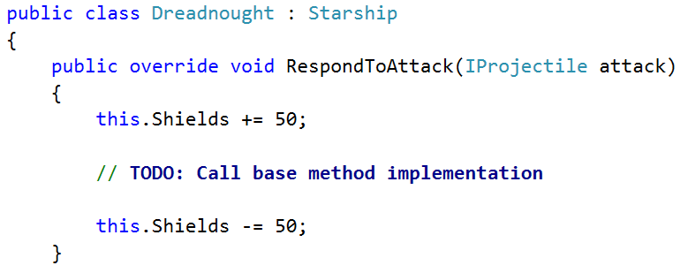

Step 11 - Plot Jump Command
The command should change the location of the given starship to another star system. The following steps should be taken:
- Get the ship from the engine by name
- Validate it is not destroyed
- Get the destination star system from the Galaxy
- Validate that the ship is not already in the given destination
- Call the appropriate method from the galaxy class to perform the travel for you
Hint: Look through the Galaxy class
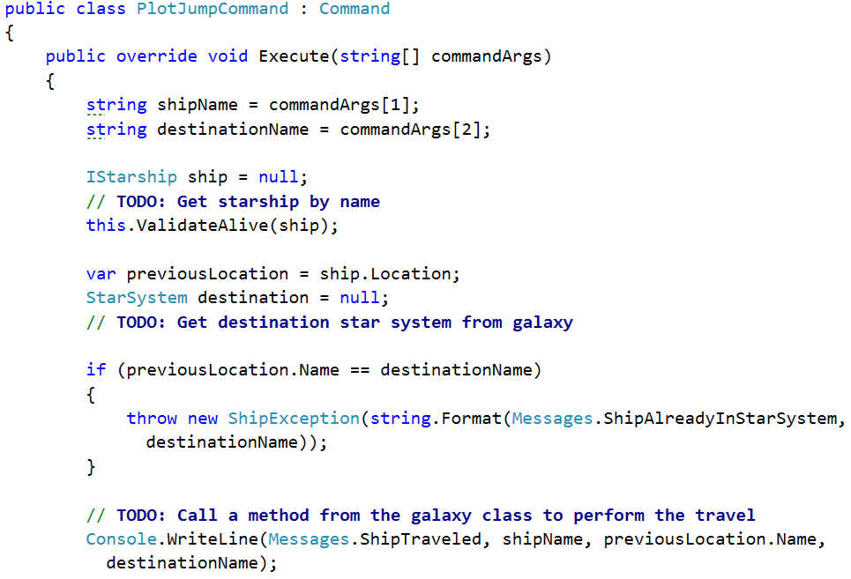

Step 12 - Over Command
Implementing the over command is done like just any other command - we override the Execute() method in the OverCommand class. This one is up to you - look up the GameEngine class and see if there's any property you can change to stop the engine.

Step 13 - System Report Command
The system-report command should print all ships in the given star system. Let's create a new SystemReportCommand class (following the naming convention of the other command classes - "CommandName + Command"). It should inherit the base Command class and reuse its constructor.
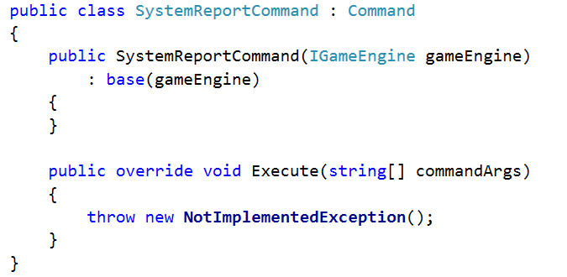
Its Execute() method should print information about all ships in the given star system as defined in the description.
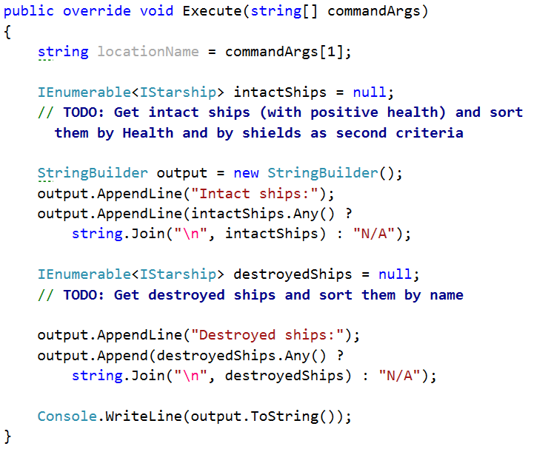

Step 14 - Extend the Engine
We have our new command class. However, the problem description explicitly tells us we have to extend the game engine without editing its source code (following the so-called Open/Closed Principle - open for extension, closed for modification).
This is often the case with external libraries - we wish to extend a library's functionality by adding our own code, but the library is already compiled (thus we do not have access to the source code).
One possible way to extend a class' functionality is to inherit the class and override the methods we wish to change. Let's take a look at the GameEngine class.
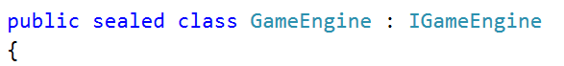
It is declared sealed - therefore it cannot be inherited. But we need to add a new command to the engine - commands are stored in the CommandManager class.
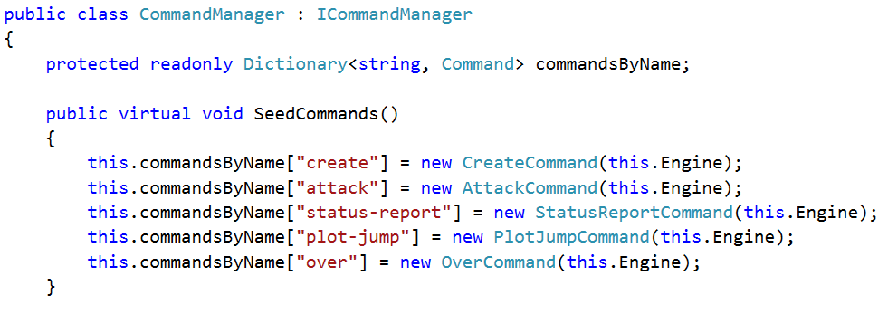
Again, we are not allowed to edit this class (if we were, we would simply add the system-report command and be done with it). But if we look closely:
- SeedCommands() is left virtual (i.e. can be overridden by descending classes)
- commandsByName has access modifier protected (i.e. can be accessed by descending classes)
Let's create a ExtendedCommandManager class that inherits the existing CommandManager. The new class should override the SeedCommands() method and add the newly created command to the dictionary.
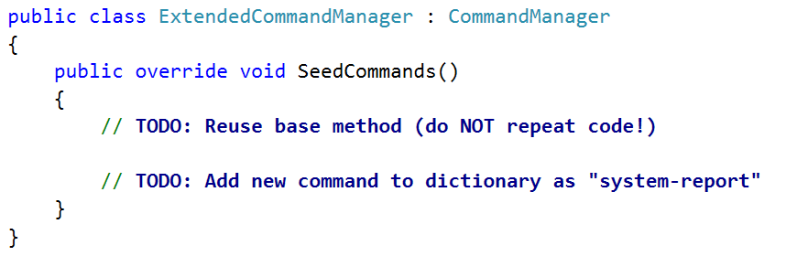
Note: Reuse the base method implementation (just like you reuse a base constructor) - do NOT repeat code.
If all is well, the ExtendedCommandManager should support all old commands, as well as the newly created SystemReportCommand.
One last thing - we need to change the commandManager instance we pass to the GameEngine in the Main() method.


