Path Finder
Write a program to check if a given path is existing in a graph.

Input
- You will receive an integer – n – number of nodes in a graph.
  - The graph nodes are numbered from 0 to n - 1.
- On the next n lines, you will receive a list of children for the nodes 0 … n - 1 (separated by a space).
- On the next line you will receive an integer – p – number of paths to check.
- On the next p lines, you will receive a path of nodes (separated by a space).

Output
- For each path print either "yes" – if the path exists, or "no" if the path does not exist.

Constraints
- Path will always contain at least 2 nodes.
- Nodes in the path will always be in the range [0… n – 1].

Examples
Input | Output | Comments
7  3 6  4 5  1  1 2  3  0 3 1 5  0 3 1 5 6  0 6 2 | yes  no  yes | 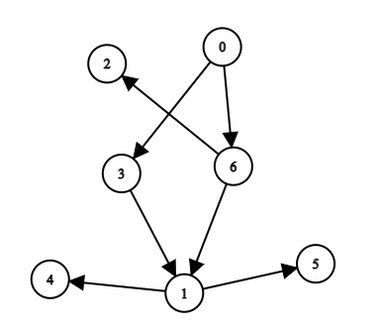
5  3 4  2  1  1  3  0 3 2 1  0 4 1 2  0 4 1 3 | no  yes  no | 

