Paths
Given a directed acyclic graph (DAG) of n nodes (from 0 to n – 1), find all possible paths from each node to the last (n – 1) node.

Input
- On the first line you will receive an integer – n – number of nodes.
- On the next n lines, you will receive a list of children for the nodes 0 … n - 1 (separated by a space).

Output
- Print each path on a new line.
- Nodes in the path should be joined by a space.

Constraints
- Nodes in the path will always be in the range [0… n – 1].

Examples
Input | Output | Comments
5  1  2 3  3  4 | 0 1 2 3 4  0 1 3 4  1 2 3 4  1 3 4  2 3 4  3 4 | 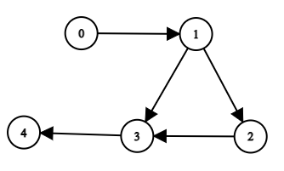
5  1 3  2 3  3 4  4 | 0 1 2 3 4  0 1 2 4  0 1 3 4  0 3 4  1 2 3 4  1 2 4  1 3 4  2 3 4  2 4  3 4 | 

