JS Advanced - Exam: 08.04.2020

Problem 1. Task Manager
Use the index.html and app.js files to solve this problem. You have NO permission to directly change the given HTML code (index.html file).
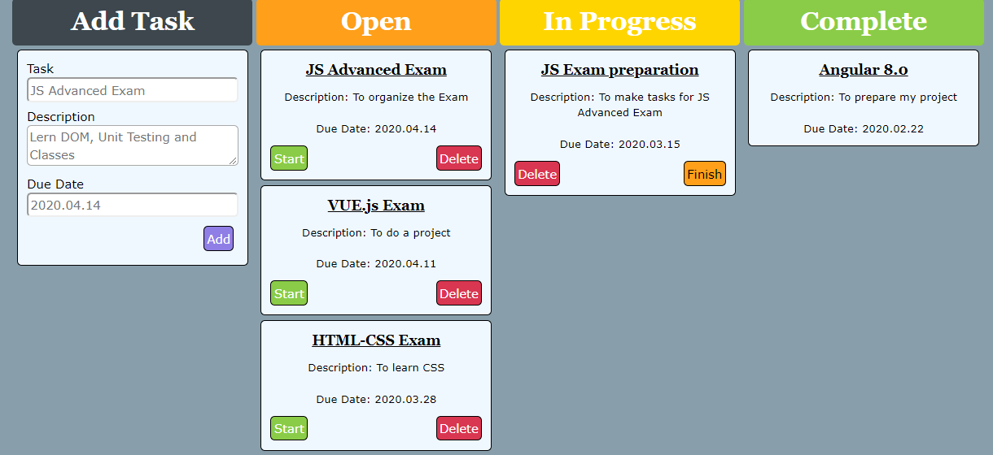

Your task
Write the missing JavaScript code to make the Task Manager Functionality work as follows:
When clicking the Add button, you first need to validate the inputs. If any of the input fields are empty, the function doesn’t do anything.
After validating the input fields, you need to add the new task (article) in “Open” section.
The HTML structure looks like this:
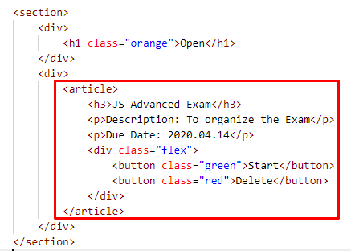
The article should have two buttons “Start” and “Delete”. Be careful to set the classes for the buttons and the parent-div.

When the “Start” button is clicked, you need to move the Task to the section “In Progress”. Be careful with the buttons! The HTML structure looks like this:
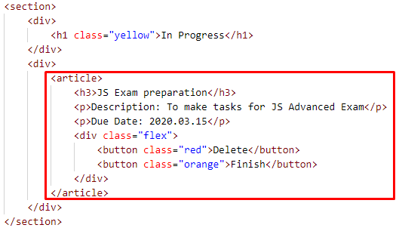

When the “Delete” button is clicked, the Task (whole article) should be removed from the HTML.

After clicking the “Finish” button, the Task will be completed, and you should move the article in the section “Complete”. The buttons with their parent div-element should be removed.
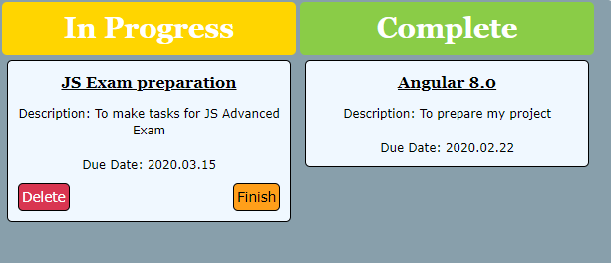
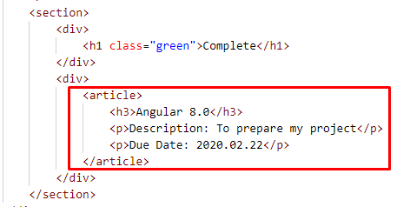

Submission
Submit your solution into a function.


