Robbery
You are robber who just stole a TV. Now you must escape the cops without being caught.
You are given a map of the city streets. There are few rules:
- Going from one point to other costs you some energy (displayed as a value on each arrow) and takes one turn.
- Each point is being watched by a video camera. A point can be black (a camera is not watching it) or white (a camera is watching it).
- You can only travel to points where the camera is off.
Find the path that requires the least energy to go to the final point. Print the required energy.

Input
- On the first line you will receive a number - n specifying the number of points.
- On the second line you will receive a number - c specifying the number of point connections.
- On the next c lines you will receive the connections in the format "<firstPoint> <secondPoint> <distance>"
- On the next line you will receive all points in the format "<point1><color1> <point2><color2> …<pointK><colorK>".
- On the next line, you will receive the starting point.
- On the next line, you will receive the ending point.

Output
- Print the energy of the path that requires the least energy to go to the final point.

Constraints
- The number of points in the city will be between [2…20000].
- The distance of a connection will be a valid integer between [0…10000].
- The points will always be numbers starting from [0… number of points – 1].
- The color will be either "b" or "w" – b means the camera is currently not watching, w means the camera is currently watching.
- There will always be a valid path from start to end.

Examples
Input | Output | Comments
5  7  0 1 30  0 2 2  1 3 12  1 4 15  2 1 3  2 3 15  3 4 18  0b 1b 2w 3b 4b  0  4 | 45 | 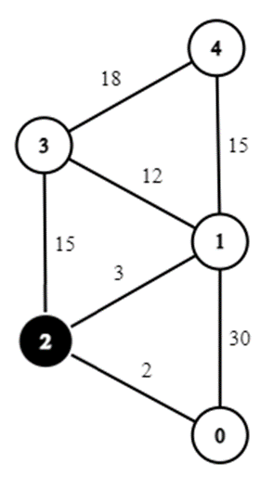  - Start – 0.  - Destination – 4.  - The path that requires the least energy to go to the final point is 0->2->1->4 (20 energy).  - However, camera 2 is watching, so we can’t go through this point.  - Therefore, the solution is 0->1->4 (45 energy).

