Water Supply System Disaster
You are given a system of pipes and N connecting parts. The pipes are bidirectional, so the water can flow both ways.
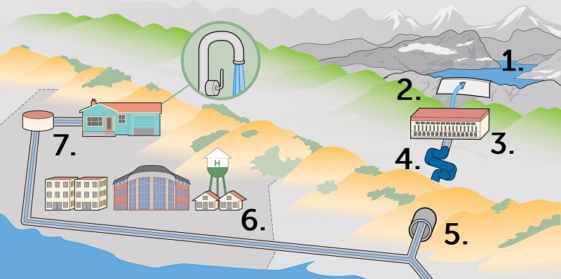
Your task is to find the connecting part, which if blown with an explosive, will leave exactly M separated parts of the system.

Input
- On the first line there will be N – the total number of connecting parts in the system.
  - The parts are numbered from 1 to N.
- On the second line there will be M – the separated parts of the system after the explosion.
- On the next N lines there will be the connections between the connecting parts.
  - List of connections (separated by a space) for the connecting parts from 1 to N.
    - On the first of the lines there will be connections for the first connecting part.
    - On the second – the connections of the second connecting part and so on.

Output
- If the system is connected initially but we cannot separate it to exactly M parts with one explosive – print the number 0.
- If the system is connected initially and we can separate it to exactly M parts – print the part, we want to explode.

Constraints
- N will be an integer in the range [2…1000].
- M will be an integer in the range [2…10].
- There will be only one possible solution in all tests.

Examples
Input | Output | Comments
5  2  4 5  3 5  2 5  1 5  1 2 3 4 | 5 | 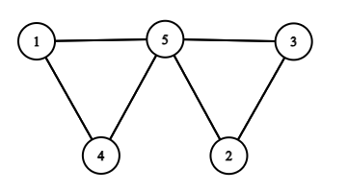  If we put an explosive on 5, the system will be separated in exactly M (2) parts.
5  2  5  3 5  2 5  5  1 2 3 4 | 0 | 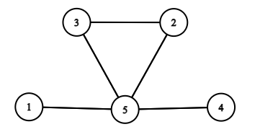  If we put an explosive on 5, the system will be separated in 3 parts and M is 2, so we cannot separate it to exactly M parts with one explosive

