Exercises: Entity Relations
This document defines the exercise assignments for the Databases Advanced - Entity Framework course @ SoftUni

Student System
Your task is to create a database for the StudentSystem, using the EF Core Code First approach. It should look like this:
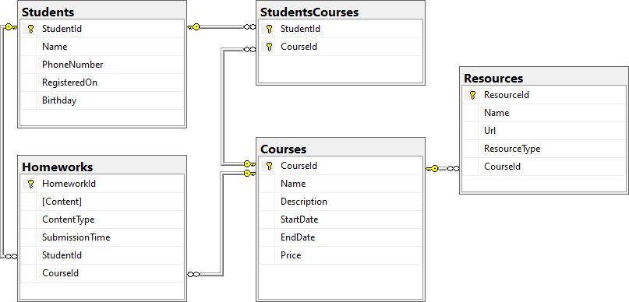

Constraints
Your namespaces should be:
- P01_StudentSystem – for your Startup class, if you have one
- P01_StudentSystem.Data – for your DbContext
- P01_StudentSystem.Data.Models – for your models
Your models should be:
- StudentSystemContext – your DbContext
- Student
  - StudentId
  - Name – up to 100 characters, unicode
  - PhoneNumber – exactly 10 characters, not unicode, not required
  - RegisteredOn
  - Birthday – not required
- Course
  - CourseId
  - Name – up to 80 characters, unicode
  - Description – unicode, not required
  - StartDate
  - EndDate
  - Price
- Resource
  - ResourceId
  - Name – up to 50 characters, unicode
  - Url – not unicode
  - ResourceType – enum, can be Video, Presentation, Document or Other
  - CourseId
- Homework
  - HomeworkId
  - Content – string, linking to a file, not unicode
  - ContentType - enum, can be Application, Pdf or Zip
  - SubmissionTime
  - StudentId
  - CourseId
- StudentCourse – mapping between Students and Courses
Table relations:
- One student can have many CourseEnrollments
- One student can have many HomeworkSubmissions
- One course can have many StudentsEnrolled
- One course can have many Resources
- One course can have many HomeworkSubmissions
You will need a constructor, accepting DbContextOptions to test your solution in Judge!

Football Betting
Your task is to create a database for a FootballBookmakerSystem, using the Code First approach. It should look like this:
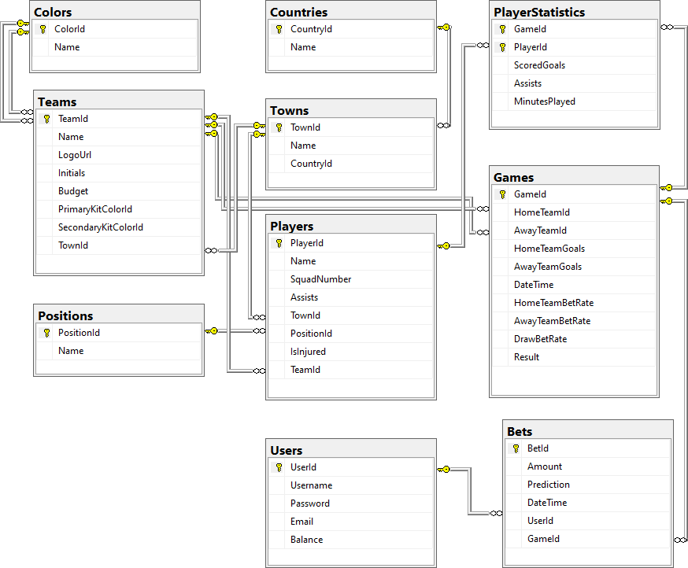

Constraints
Your namespaces should be:
- P03_FootballBetting – for your Startup class, if you have one
- P03_FootballBetting.Data – for your DbContext
- P03_FootballBetting.Data.Models – for your models
Your models should be:
- FootballBettingContext – your DbContext
- Team – TeamId, Name, LogoUrl, Initials (JUV, LIV, ARS…), Budget, PrimaryKitColorId, SecondaryKitColorId, TownId
- Color – ColorId, Name
- Town – TownId, Name, CountryId
- Country – CountryId, Name
- Player – PlayerId, Name, SquadNumber, TeamId, PositionId, IsInjured
- Position – PositionId, Name
- PlayerStatistic – GameId, PlayerId, ScoredGoals, Assists, MinutesPlayed
- Game – GameId, HomeTeamId, AwayTeamId, HomeTeamGoals, AwayTeamGoals, DateTime, HomeTeamBetRate, AwayTeamBetRate, DrawBetRate, Result
- Bet – BetId, Amount, Prediction, DateTime, UserId, GameId
- User – UserId, Username, Password, Email, Name, Balance
Table relationships:
- A Team has one PrimaryKitColor and one SecondaryKitColor
- A Color has many PrimaryKitTeams and many SecondaryKitTeams
- A Team residents in one Town
- A Town can host several Teams
- A Game has one HomeTeam and one AwayTeam and a Team can have many HomeGames and many AwayGames
- A Town can be placed in one Country and a Country can have many Towns
- A Player can play for one Team and one Team can have many Players
- A Player can play at one Position and one Position can be played by many Players
- One Player can play in many Games and in each Game, many Players take part (both collections must be named PlayerStatistics)
- Many Bets can be placed on one Game, but a Bet can be only on one Game
- Each bet for given game must have Prediction result
- A Bet can be placed by only one User and one User can place many Bets
Separate the models, data and client into different layers (projects).

