Lab: SQL Language
Problems for exercises and homework for the "Software Technologies Back End" course from the official "Applied Programmer" curriculum.
You can check your solutions here: https://judge.softuni.bg/Contests/2799/SQL-Language-Lab

Import the Database
Unzip the 02. Samples-Databases.zip file, containing the databases. Start your SQL Server Manager Studio.
Import the “SoftUni” database. Follow the steps from “02. Import-the-DB-Guide.docx”.

Create E/R Diagram
In order to create an E/R diagram of the SoftUni database, go to Object Explorer -> Databases -> SoftUni and right-click on Database Diagrams. Choose [New Database Diagram].
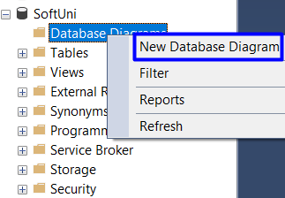
Then, select all tables and press [Add].
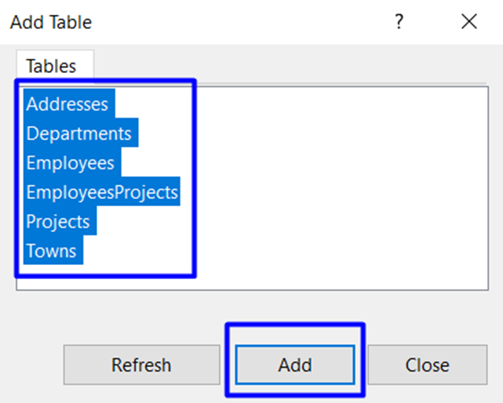
When tables are loaded, press [Close] and your diagram is already created. You can always re-arrange table blocks. The diagram should be something like this:
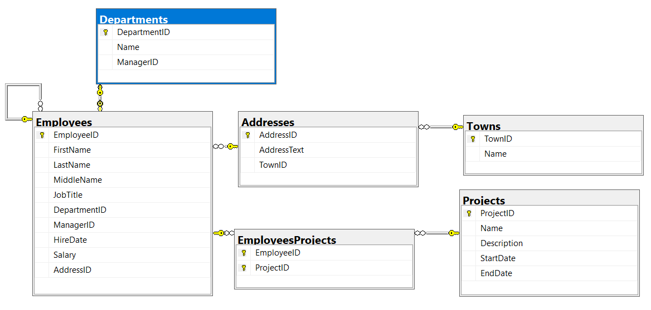

Explore the Database
Get familiar with the SoftUni database schema from the E/R diagram we already created and the tables. You will use them in the current and following exercises to write queries. The tables are the following:
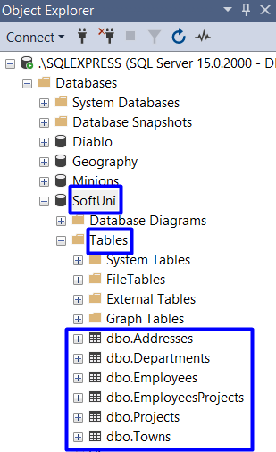

Use the Database
First, select the “SoftUni” as active database in SQL Server Management Studio:
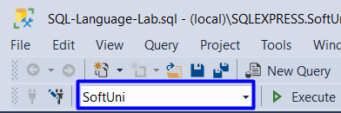
View the rows in the tables “Departments”:
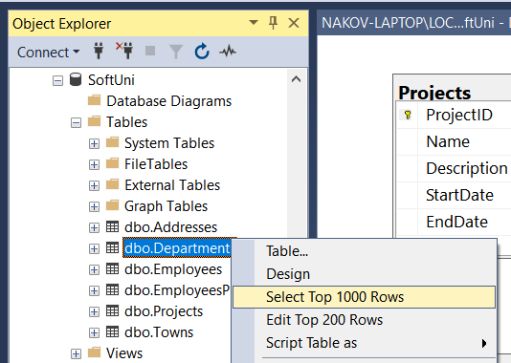
You will see the following output:
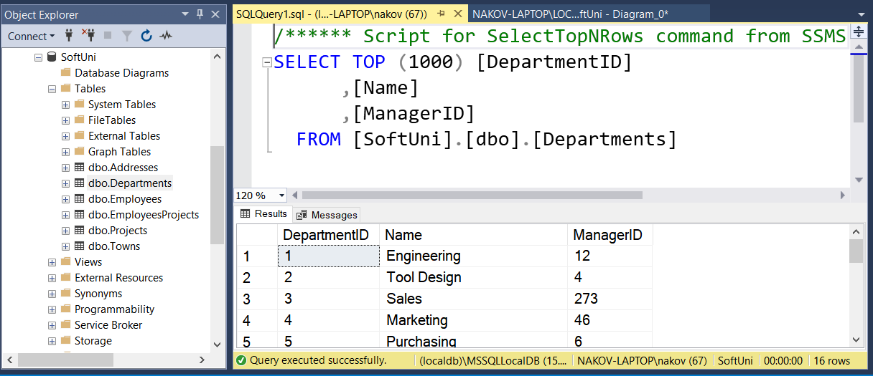

Display All Information About the Departments
Write a SQL query to find all available information about the Departments.

Example
DepartmentID | Name | ManagerID
1 | Engineering | 12
2 | Tool Design | 4
3 | Sales | 273
… | … | …

Hints
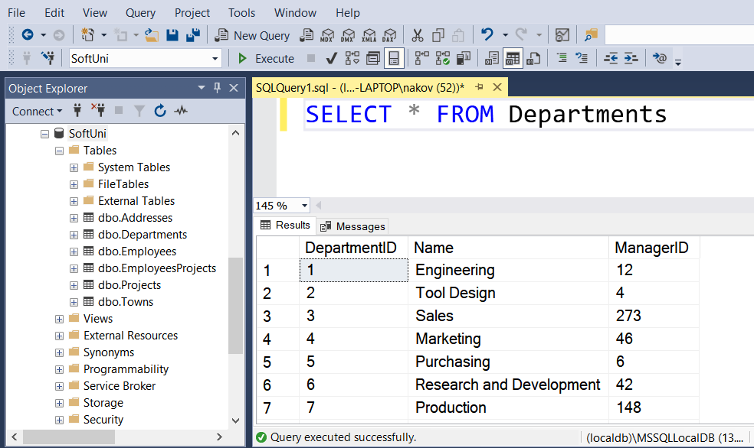

Submit Your Solution in Judge
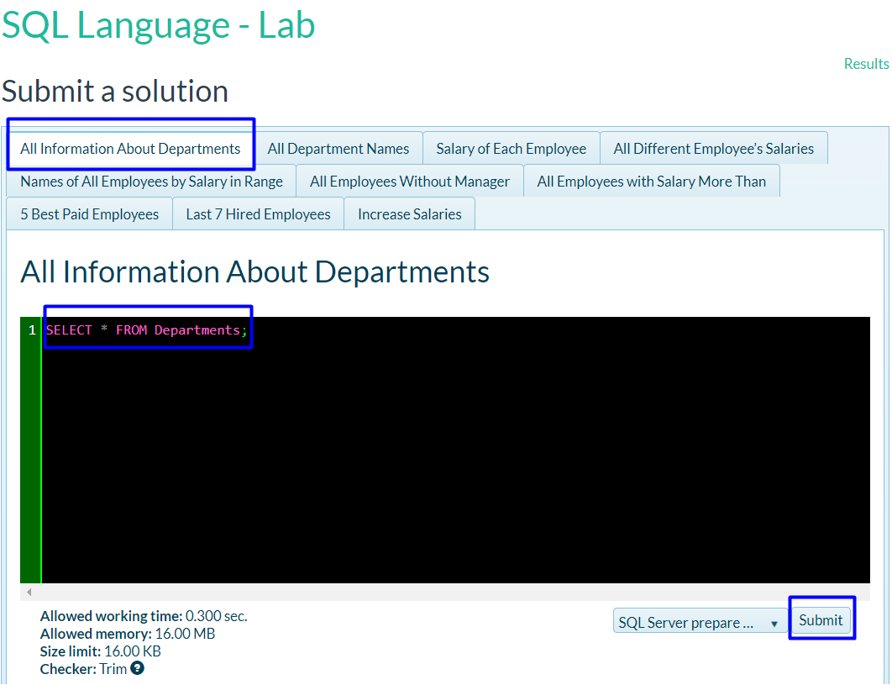
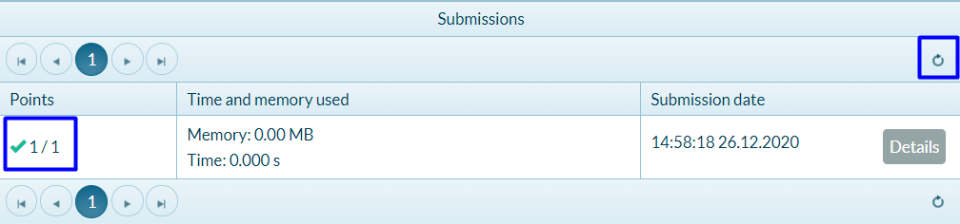

Display All Department Names
Write SQL query to find all Department names.

Example
Name
Engineering
Tool Design
Sales
…

Hints
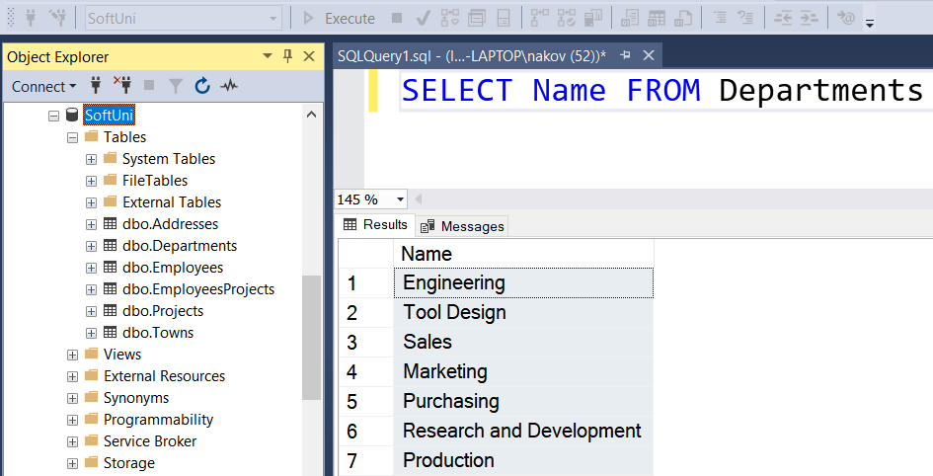

Salary of Each Employee
Write SQL query to find the first name, last name and salary of each employee.

Example
FirstName | LastName | Salary
Guy | Gilbert | 12500.00
Kevin | Brown | 13500.00
Roberto | Tamburello | 43300.00
… | … | …

All Different Employee’s Salaries
Write a SQL query to find all different employee’s salaries. Show only the salaries.

Example
Salary
9000.00
9300.00
9500.00
…

Names of All Employees by Salary in Range
Write a SQL query to find the first name, last name and job title of all employees whose salary is in the range [20000, 30000].

Example
FirstName | LastName | JobTitle
Rob | Walters | Senior Tool Designer
Thierry | D'Hers | Tool Designer
JoLynn | Dobney | Production Supervisor
… | … | …

All Employees Without Manager
Write a SQL query to find first and last names about those employees that does not have a manager.

Example
FirstName | LastName
Ken | Sanchez
Svetlin | Nakov
… | …

All Employees with Salary More Than 50000
Write a SQL query to find first name, last name and salary of those employees who has salary more than 50000. Order them in decreasing order by salary.

Example
FirstName | LastName | Salary
Ken | Sanchez | 125500.00
James | Hamilton | 84100.00
… | … | …

5 Best Paid Employees.
Write SQL query to find first and last names about 5 best paid Employees ordered descending by their salary.

Example
FirstName | LastName
Ken | Sanchez
James | Hamilton
… | …

Last 7 Hired Employees
Write a SQL query to find last 7 hired employees. Select their first, last name and their hire date.

Example
FirstName | LastName | HireDate
Rachel | Valdez | 2005-07-01 00:00:00
Lynn | Tsoflias | 2005-07-01 00:00:00
Syed | Abbas | 2005-04-15 00:00:00
… | … | …

Increase Salaries
Write a SQL query to increase salaries of all employees that are in the Engineering, Tool Design, Marketing or Information Services department by 12%. Then select Salaries column from the Employees table.

Example
Salary
12500.00
15120.00
48496.00
33376.00
…

Employee Address
Write a query that selects:
- EmployeeId
- JobTitle
- AddressId
- AddressText
Return the first 5 rows sorted by AddressId in ascending order.

Example:
EmployeeId | JobTitle | AddressId | AddressText
142 | Production Technician | 1 | 108 Lakeside Court
30 | Human Resources Manager | 2 | 1341 Prospect St
… | … | … | …

Addresses with Towns
Write a query that selects:
- FirstName
- LastName
- Town
- AddressText
Sorted by FirstName in ascending order then by LastName. Select first 50 employees.

Example:
FirstName | LastName | Town | AddressText
A.Scott | Wright | Newport Hills | 1400 Gate Drive
Alan | Brewer | Kenmore | 8192 Seagull Court
… | … | … | …

Sales Employee
Write a query that selects:
- EmployeeID
- FirstName
- LastName
- DepartmentName
Sorted by EmployeeID in ascending order. Select only employees from “Sales” department.

Example:
EmployeeID | FirstName | LastName | DepartmentName
268 | Stephen | Jiang | Sales
273 | Brian | Welcker | Sales
… | … | … | …

Employee Departments
Write a query that selects:
- EmployeeID
- FirstName
- Salary
- DepartmentName
Filter only employees with salary higher than 15000. Return the first 5 rows sorted by DepartmentID in ascending order.

Example:
EmployeeID | FirstName | Salary | DepartmentName
3 | Roberto | 43300.00 | Engineering
9 | Gail | 32700.00 | Engineering
… | … | … | …

Employees Without Project
Write a query that selects:
- EmployeeID
- FirstName
Filter only employees without a project. Return the first 3 rows sorted by EmployeeID in ascending order.

Example:
EmployeeID | FirstName
2 | Kevin
6 | David
… | …

Employees Hired After
Write a query that selects:
- FirstName
- LastName
- HireDate
- DeptName
Filter only employees hired after 1.1.1999 and are from either "Sales" or "Finance" departments, sorted by HireDate (ascending).

Example:
FirstName | LastName | HireDate | DeptName
Debora | Poe | 2001-01-19 00:00:00 | Finance
Wendy | Kahn | 2001-01-26 00:00:00 | Finance
… | … | … | …

Backup the DB as SQL Script
In order to generate a SQL script of your DB, first close all windows in SSMS. Then, go to Object Explorer -> Databases and right-click on the SoftUni database. From the menu choose Tasks -> Generate Scripts… as shown below:
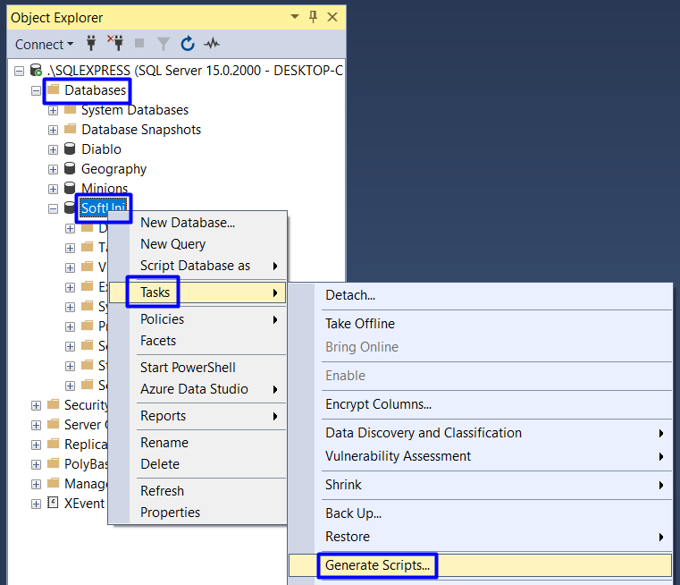
Press [Next] twice until the Set Scripting Options menu is displayed. Then select [Save as script file] and change the File Name.
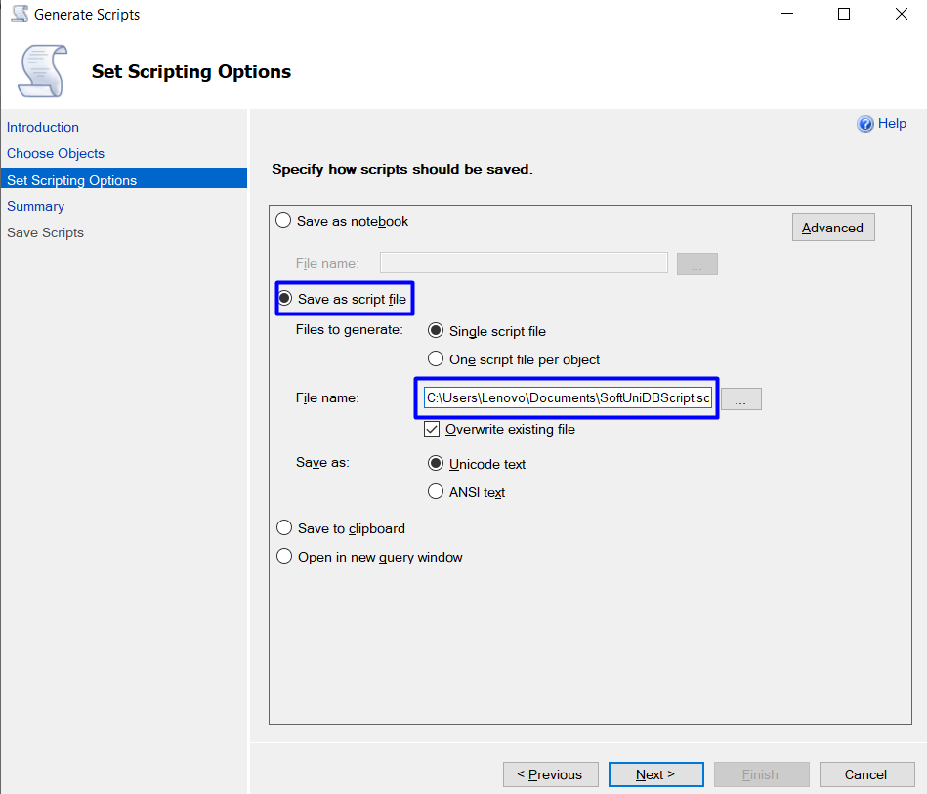
Then, press [Advanced] and scroll down to General -> Types of data to script and choose the option [Schema and data] from the dropdown menu. After that, press [OK].
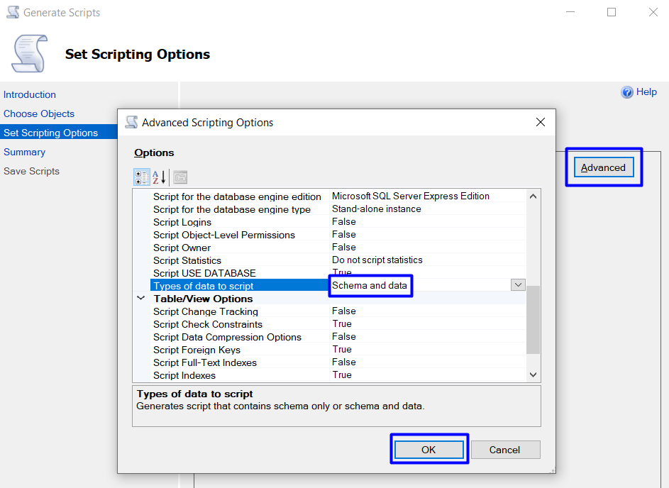
Then, press [Next] twice and when the scripts are ready, press [Finish].
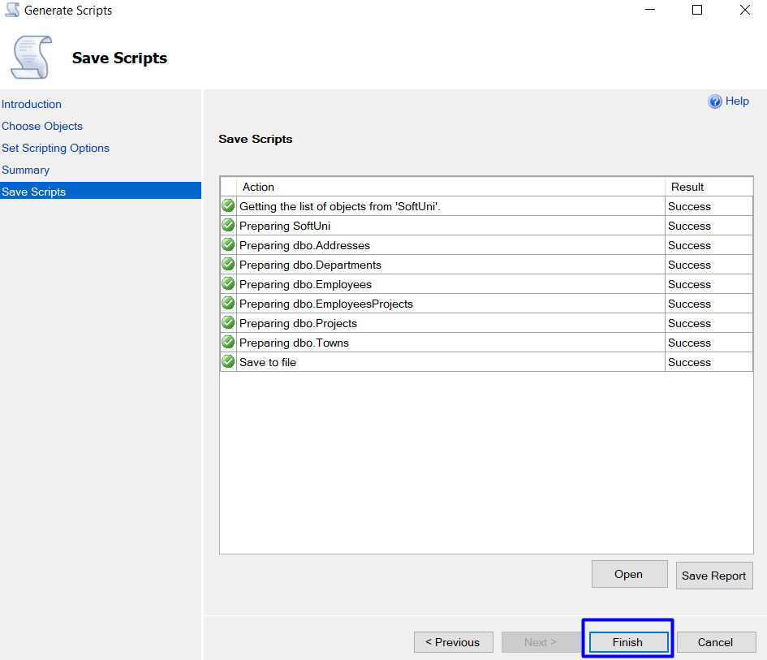
Check if the script file (.sql) appeared on the specified place in your file system. It should look like this:
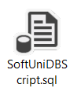

Restore DB from Existing SQL Script
Try restoring your SoftUni DB by following the same steps as when importing a database from “02. Work-with-DB-Guide.docx”.
- You should delete the SoftUni DB from SSMS first.
- Alternatively, edit the SQL script to restore the DB as different database name (e.g. “SoftUniNew”).


