Guide: Importing and Using “SoftUni” DB
Problems for exercises and homework for the "Software Technologies Back End" course from the official "Applied Programmer" curriculum. This guide explains how to import and use the “SoftUni” database from its SQL script.

Import the “SoftUni” Database
Unzip the 02. Samples-Databases.zip file, containing the databases. Start your SQL Server Manager Studio.
Let’s import the “SoftUni” database.
Note that if you have the database already created, you should first delete it and add it again, as shown below:
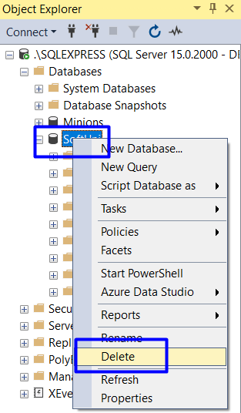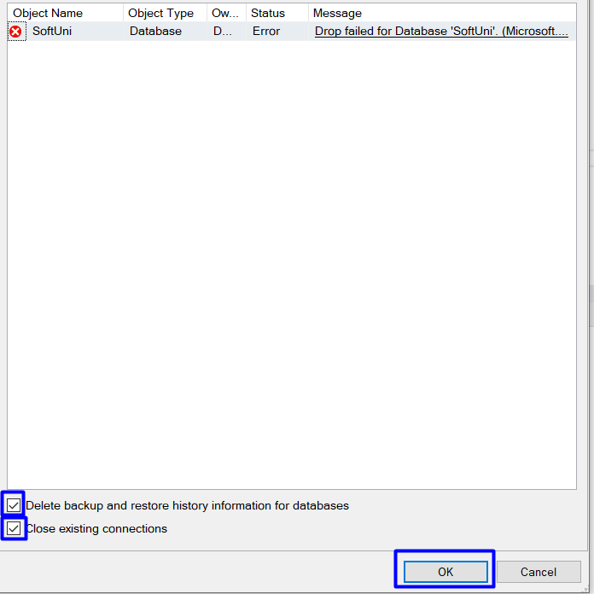
First, create a new query in SSMS by pressing the [New Query] button from the menu.
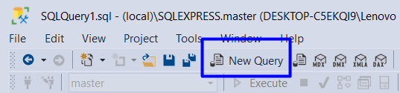
Next, find the database in your file directory and drag it to the query in SSMS the following way:
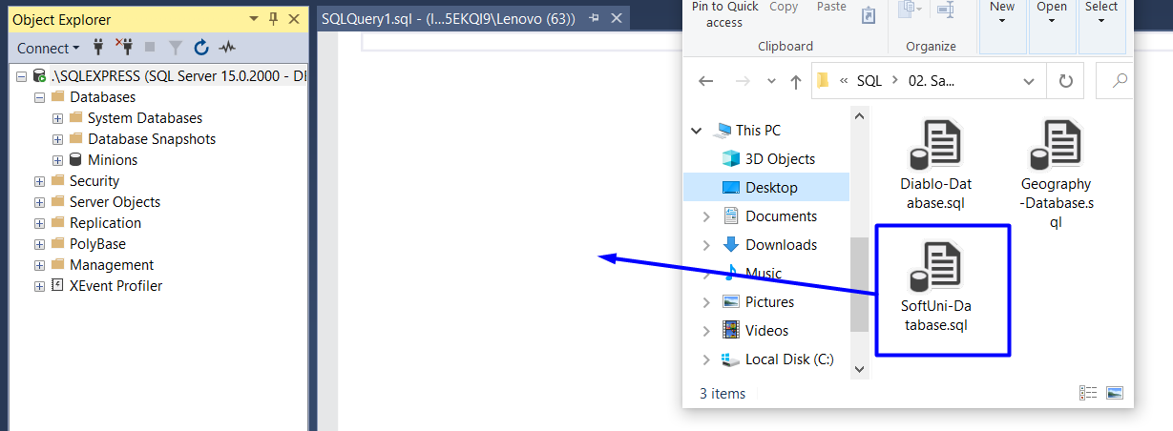
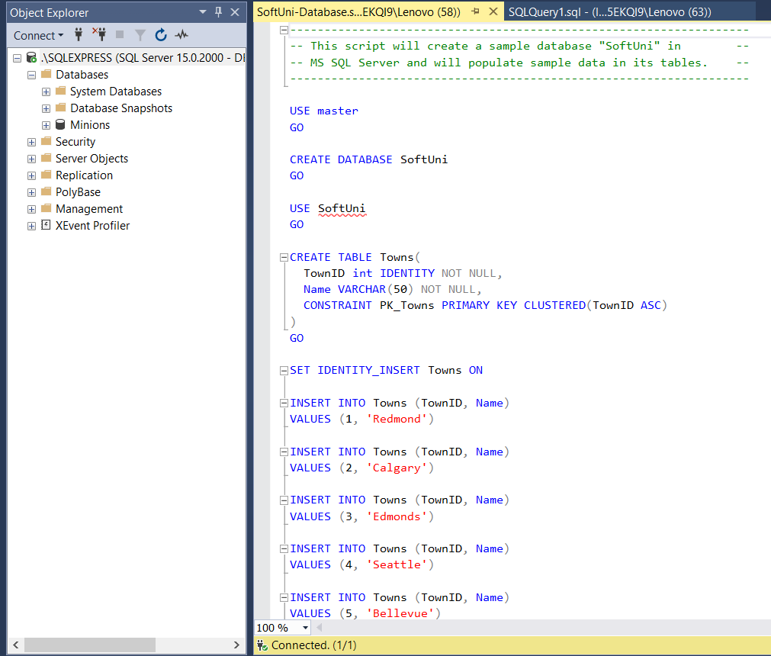
Then, press F5 or [Execute] to run the script and create the database.
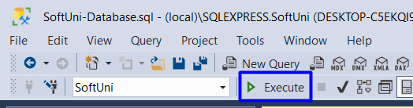
Then, refresh the Object Explorer and you should see the newly created SoftUni database.
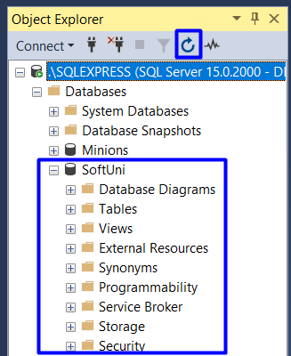

Explorer the Database
Get familiar with the SoftUni database schema and tables. You will use them in the current and following exercises to write queries. The database tables are the following:
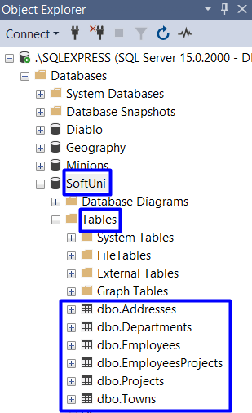
You can also generate a DB diagram for the SoftUni database:
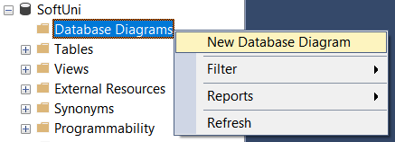
Select all tables and click [Add]:
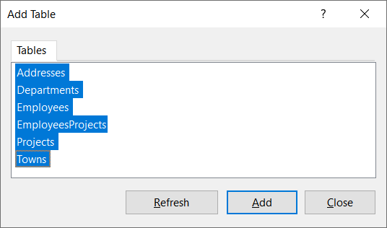
A database diagram will be generated and displayed. You can re-arrange the tables for better look and feel:
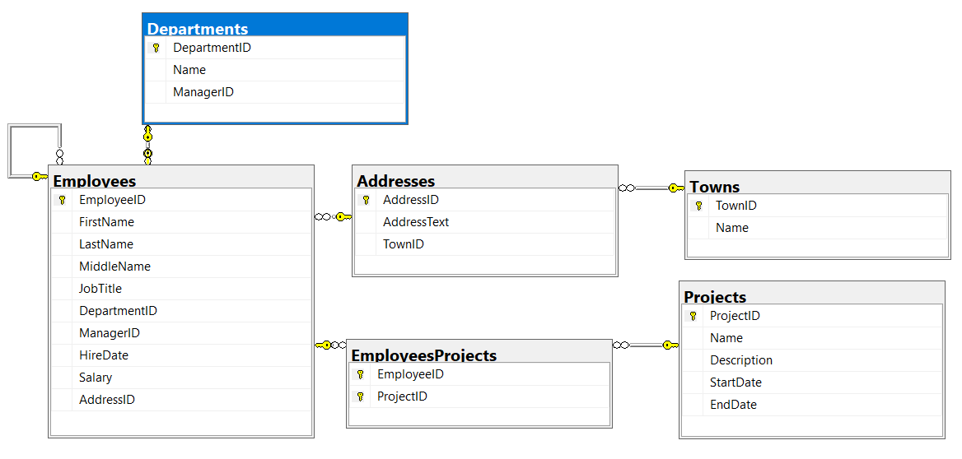

Use the Database
First, select the “SoftUni” as active database in SQL Server Management Studio:
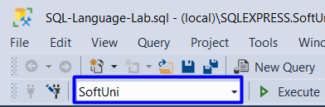
View the rows in the tables “Departments”:
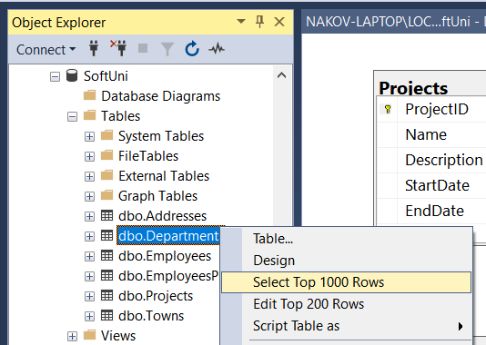
You will see the following output:


