Exercises: Defining Simple Classes
Problems for exercises and homework for the "Programming Advanced: OOP Basics" course from the official "Applied Programmer" curriculum.
You can check your solutions here: https://judge.softuni.bg/Contests/2931/Defining-Simple-Classes-Exercises.

Dates
Create a class DateCounter, which stores the difference of the days between two dates. It should have a method which takes two string parameters representing a date as strings and calculates the difference in the days between them. Prints the count of the days between two dates as absolute value.

Examples
Input | Output
1992/05/31  2016/06/17 | 8783
2016/05/31  2016/04/19 | 42

Hints
The solution should be similar to the photo.
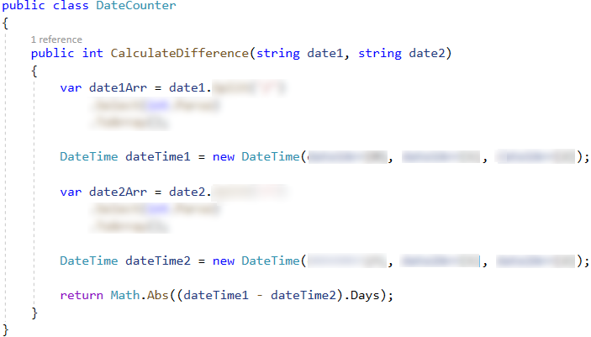

Calculation with Fractions
Write a program that sums and subtracts with a fractional data type. Use the Fractions library to do the calculations. You will be given on one line, separated by a single space: first fractional number, sign of sum or subtraction and second fractional number.
Print the result of the calculations in the following format:
"{fractional number} {sign} {fractional number} = {result}"

Examples
Input | Output
1/2 + 1/3 | 1/2 + 1/3 = 5/6
1/4 - 2/3 | 1/4 - 2/3 = -5/12

Hints

Install NuGet package Fractions library
Right click on the project and select [Manage NuGet Packages…]
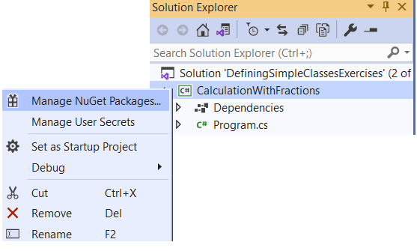
On the next screen, click on [Browse] write "Fractions" in the search field select "Fractions by Daniel Mueller" click on [Install] button.
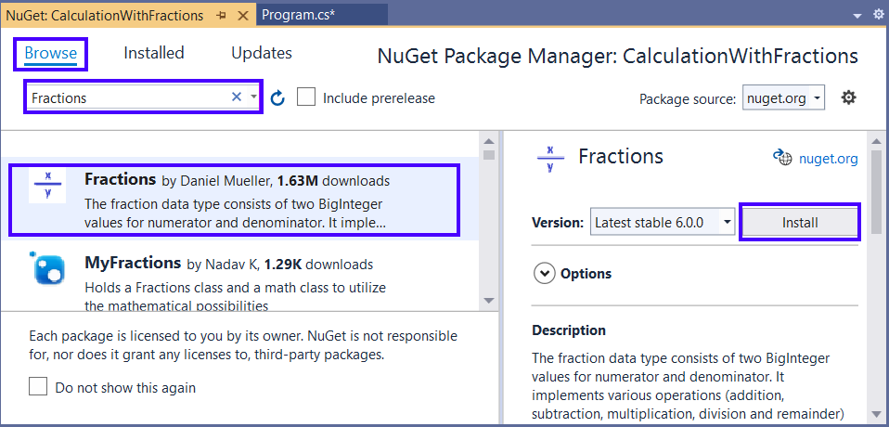
Implement using Fractions;
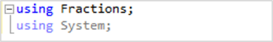
The solution should be similar to the photo.
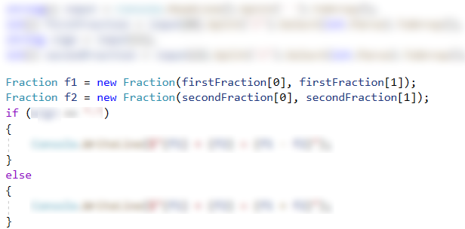

Class Card
Define a class Card, which hold a playing card, e. g. "A Spades". The class Card should have the following members:
- Property – Face (string), e. g. "5", "J" or "A"
- Property – Suite (string), e. g. "Spades", "Diamonds", "Clubs", "Hearts"
- A method – Print(), which prints a card.
Create in the Main method a list of cards List<Card> to hold the following cards:
- A Spades
- J Diamonds
- Q Clubs
- 10 Hearts
Print the cards on the console.

Examples
Input | Output
(no input) | A Spades  J Diamonds  Q Clubs  10 Hearts

Randomize Cards
You can use the solution from previous task. Generate list of all 52 cards (4 * 13 == 52) by using arrays of faces and suites. Shuffle the cards and print each card in a separate line.
- Array of faces: 2, 3, 4, 5, 6, 7, 8, 9, 10, A, J, Q, K.
- Array of suites: "Spades", "Diamonds", "Clubs", "Hearts".

Examples
Input | Output
(no input) | 10 Hearts  10 Clubs  7 Hearts  2 Hearts  K Spades  …

Hints
Swap each card in the deck starting with the first, use Random to generate a card index with which to swap the current card in the deck.
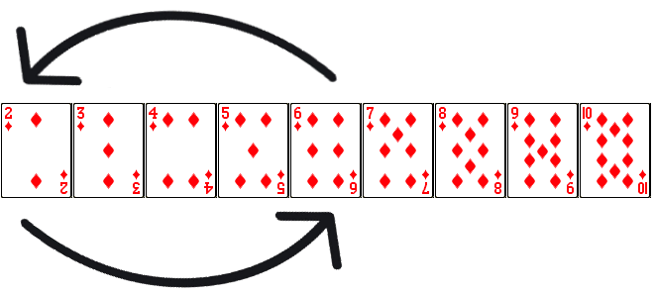

Class DeckOfCards
You can use the solution from previous task. You will be receiving operations (split by a single space) that you have to apply, until you receive the "End" command. The possible commands are: Add, Print, Get All Cards, Randomize, Clear.
Define class DeckOfCards, which should have:
- List<Card> (it is not property) holds a desk of cards
- Method Add(Card) adds a new card at the end of the deck
- Method Print() prints the face and suite of the last card in the deck
- Method GetAllCards() prints the cards in the deck
- Method Shuffle() Shuffle the cards and print each card
- Method Clear() removes all cards (makes the deck empty)

Examples
Input | Output
Clear  Add A Spades  Add J Diamonds  Add Q Hearts  Print  Randomize  Add 10 Spades  Add A Clubs  Get All Cards  Clear  End | Q Hearts  J Diamonds  A Spades  Q Hearts  A Spades  J Diamonds  Q Hearts  10 Spades  A Clubs

Hints
The class DeckOfCards should be similar to the photo.
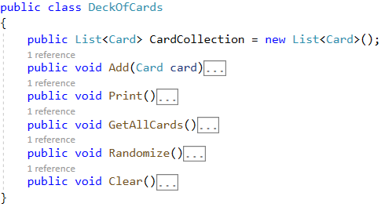

Advertisement Message
Write a program that generates random fake advertisement message to advertise a product. The messages must consist of 4 parts: phrase + event + author + city. Use the following predefined parts:
- Phrases – {"Excellent product.", "Such a great product.", "I always use that product.", "Best product of its category.", "Exceptional product.", "I can’t live without this product."}
- Events – {"Now I feel good.", "I have succeeded with this product.", "Makes miracles. I am happy of the results!", "I cannot believe but now I feel awesome.", "Try it yourself, I am very satisfied.", "I feel great!"}
- Authors – {"Diana", "Petya", "Stella", "Elena", "Katya", "Iva", "Annie", "Eva"}
- Cities – {"Burgas", "Sofia", "Plovdiv", "Varna", "Ruse"}
The format of the output message is the following: {phrase} {event} {author} – {city}.
You will receive the number of messages to be generated. Print each random message at a separate line.

Examples
Input | Output
3 | Such a great product. Now I feel good. Elena – Ruse  Excellent product. Makes miracles. I am happy of the results! Katya – Varna  Best product of its category. That makes miracles. Eva - Sofia

