Lab: Iterators and Comparators
Problems for exercises and homework for the "Programming Advanced- OOP Basics" course from the official "Applied Programmer" curriculum.
You can check your solutions here: https://judge.softuni.bg/Contests/2808/Iterators-and-Comparators-Lab

Library
NOTE: You need the namespace IteratorsAndComparators.
Create a class Book, which should have three public properties:
- string Title
- int Year
- List<string> Authors
Authors can be anonymous, one or many. A Book should have only one constructor.
Create a class Library, which should store a collection of books.
- List<Book> books
A Library could be intilized without books or with any number of books and should have only one constructor.

Examples
StartUp.cs
public static void Main()
{
Book bookOne = new Book("Animal Farm", 2003, "George Orwell");
Book bookTwo = new Book("The Documents in the Case", 2002,
"Dorothy Sayers", "Robert Eustace");
Book bookThree = new Book("The Documents in the Case", 1930);

Library libraryOne = new Library();
Library libraryTwo = new Library(bookOne, bookTwo, bookThree);
}

Solution
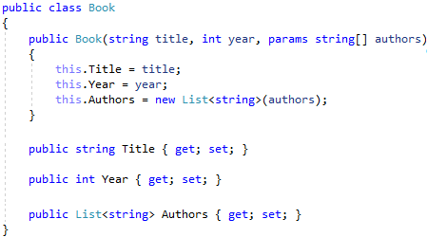
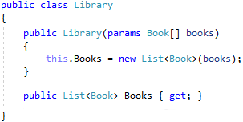

Library Iterator
NOTE: You need the namespace IteratorsAndComparators.
Extend your solution from the prevoius task. The Library class should implement the IEnumerable<Book> interface. Use a yield return statement to return each element one at a time. You will need one more member: List<Book> books.
Now you should be able to iterate through a Library in the Main() method.

Examples
Startup.cs | Output
public static void Main()  {  Book bookOne = new Book("Animal Farm", 2003, "George Orwell");  Book bookTwo = new Book("The Documents in the Case", 2002,  "Dorothy Sayers", "Robert Eustace");  Book bookThree = new Book("The Documents in the Case", 1930);  Library libraryOne = new Library();  Library libraryTwo = new Library(bookOne, bookTwo, bookThree);  foreach (var book in libraryTwo)  {  Console.WriteLine(book.Title);  }  } | Animal Farm  The Documents in the Case  The Documents in the Case

Solution
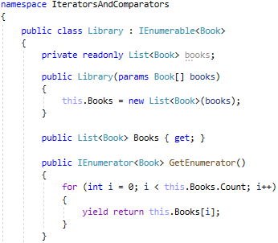
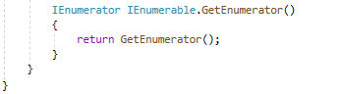

Comparable Book
NOTE: You need the namespace IteratorsAndComparators.
Extend your solution from the prevoius task. Implement the IComparable<Book> interface in the existing class Book. The comparison between two books should happen in the following order:
- First sort them in ascending chronological order (by year)
- If two books are published in the same year, sort them alphabetically
Override the ToString() method in your Book class, so it returns a string in the format:
- "{title} - {year}"
Modify your Library class, so that it stores the books in the correct order (sorted).
- You may use SortedSet<Book> to hold the books.
- Or you may explicitly sor the array of books: this.books.Sort().

Examples
Startup.cs | Output
public static void Main()  {  Book bookOne = new Book("Animal Farm", 2003, "George Orwell");  Book bookTwo = new Book("The Documents in the Case", 2002,  "Dorothy Sayers", "Robert Eustace");  Book bookThree = new Book("The Documents in the Case", 1930);  Library libraryOne = new Library();  Library libraryTwo = new Library(bookTwo, bookOne, bookThree);  foreach (var book in libraryTwo)  {  Console.WriteLine(book);  }  } | The Documents in the Case - 1930  The Documents in the Case - 2002  Animal Farm – 2003

Solution
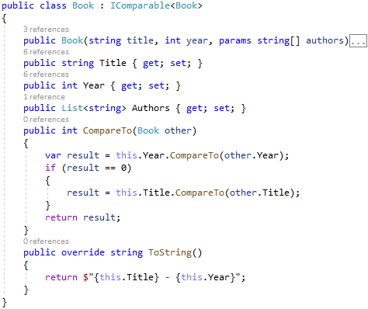

Book Comparator
NOTE: You need the namespace IteratorsAndComparators.
Extend your solution from the prevoius task. Create a class BookComparator, which should implement the IComparer<Book> interface and thus include the following method:
- int Compare(Book, Book)
BookComparator must compare two books by:
- Book title - alphabetical order
- Year of publishing a book - from the newest to the oldest
Modify your Library class once again to implement the new sorting.
- You may sort the books, e. g. like this: this.books.Sort(new BookComparator()).

Examples
Startup.cs | Output
public static void Main()  {  Book bookOne = new Book("Animal Farm", 2003, "George Orwell");  Book bookTwo = new Book("The Documents in the Case", 2002,  "Dorothy Sayers", "Robert Eustace");  Book bookThree = new Book("The Documents in the Case", 1930);  Library library = new Library(bookTwo, bookOne, bookThree);  } | Animal Farm - 2003  The Documents in the Case - 2002  The Documents in the Case - 1930

Solution


