- SoftBlog
Environment Specifics
Please, be aware that every JS environment may behave differently when executing code. Certain things that work in the browser are not supported in Node.js, which is the environment used by Judge.
The following actions are NOT supported:
- .forEach() with NodeList (returned by querySelector() and querySelectorAll())
- .forEach() with HTMLCollection (returned by getElementsByClassName() and element.children)
- Using the spread-operator (...) to convert a NodeList into an array
- append() in Judge (use only appendChild())
If you want to perform these operations, you may use Array.from() to first convert the collection into an array.

Use the Given Skeleton to Solve This Problem.
Note: You Have NO Permission to Change Directly the Given HTML (Index.html File).
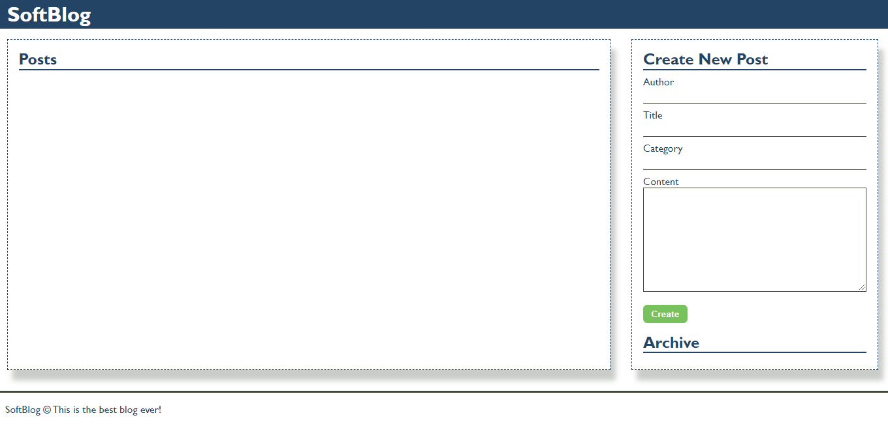

Your Task
Write the missing JavaScript code to make the Blog application work as expected.
You should be able to create new articles.
Each article has an author, title, category and content. When you click the [Create] button, a new article item should be added to the articles section.
The new item should have the following structure:
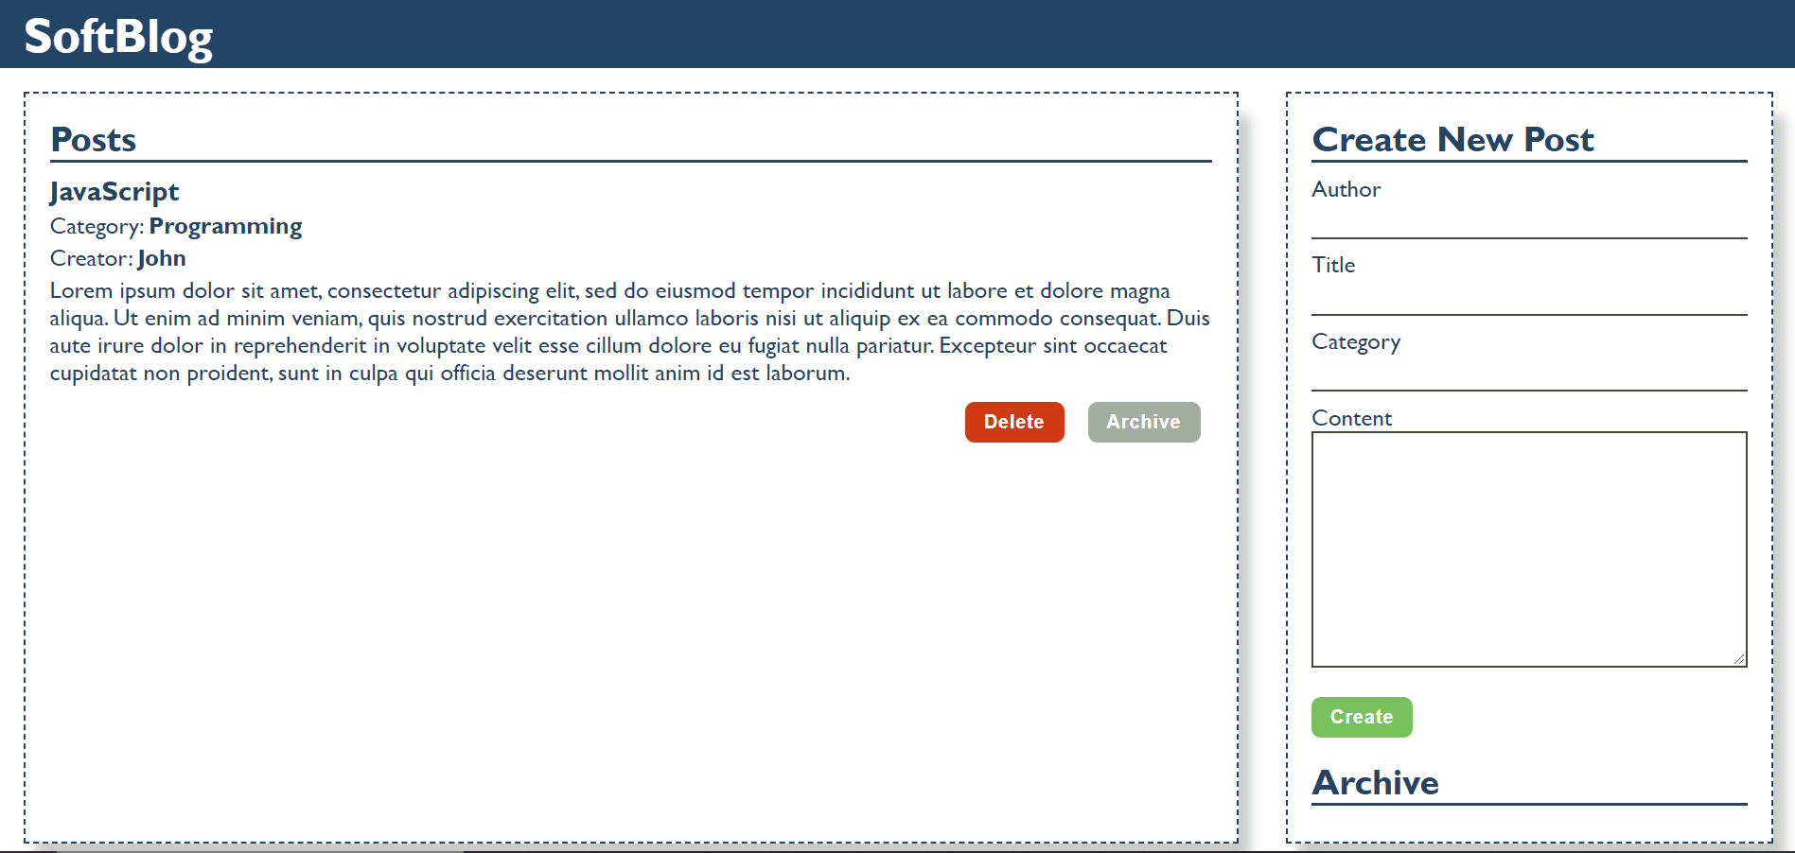
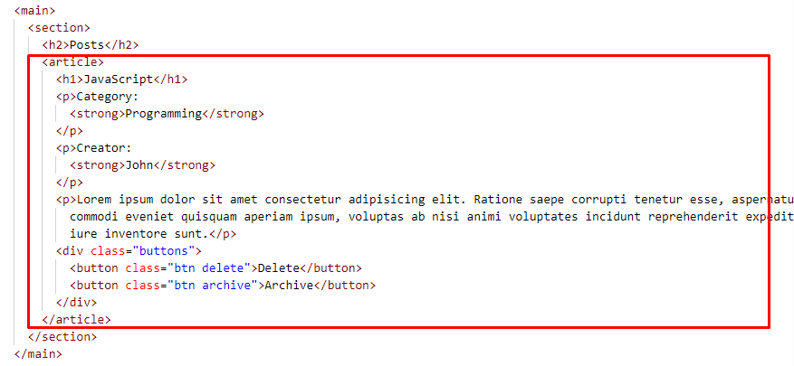

- Append two buttons, which are in a div element with class "buttons" to each article item
  - [Delete] button should have the following classes: "btn" and "delete"
  - [Archive] button should have the following classes: "btn" and "archive"
When you click the [Archive] button you should move the article to the ol in the archive section. The archive section should be sorted by title.
Important! Do not move the entire article, but only the title of the article.
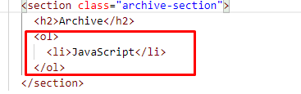
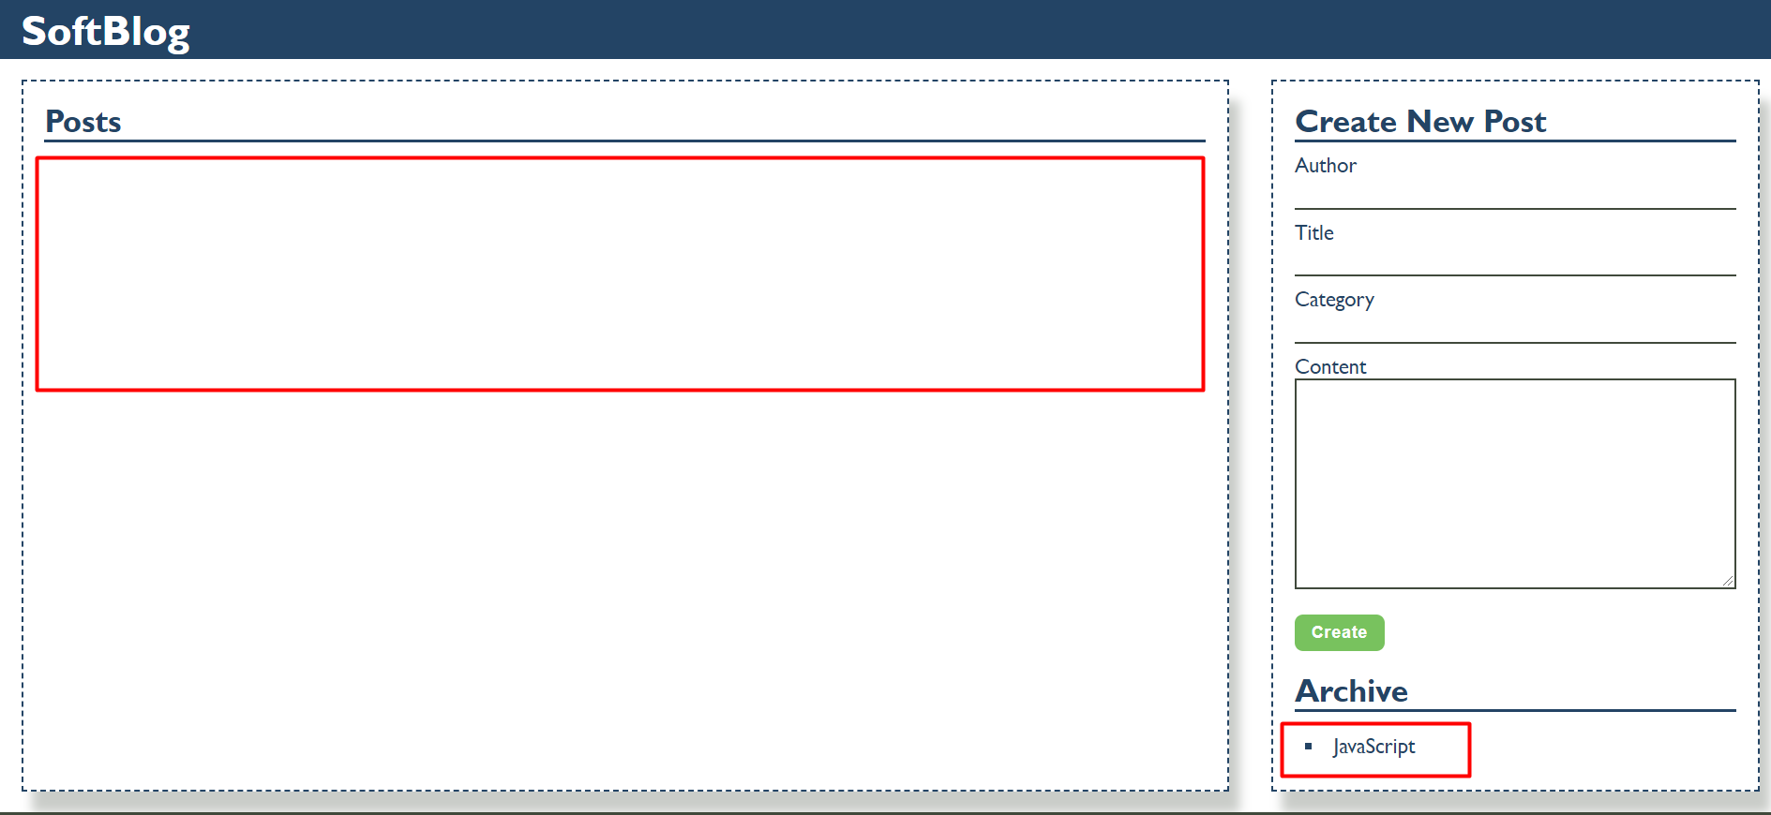

When you click the [Delete] button you should delete the entire article.



