Theater
Exercise Rules:
- When you are ready, delete the node_modules folder, make sure all dependencies are listed in the package.json file and submit your archived project at: SoftUni Judge
- You are provided with HTML & CSS resources
- You may add attributes (such as class and dataset), but it is forbidden to change existing attributes (such as class and id)
- You may change "href" attributes on links and add/change the method and action attributes of HTML Forms.
- Use bcrypt for hashing the password
- Use Express.js as a back-end framework
- Use MongoDB as a database with mongoose
- You can use whatever view engine you like (Handlebars, EJS, Pug etc.…)
- The application must start on port 3000
- It is forbidden to use React, Vue, Angular etc.

Application Overview
Get familiar with the provided HTML & CSS and create an application for theaters.

Functional Requirements
The Functionality Requirements describe the functionality that the Application must support.
Guest (Not Logged In)
The application should provide Guest (not logged in) users with the functionality to login, register and view the Guest Home page.
Users (Logged In)
The application should provide Users (logged in) with the functionality to view all the plays which are listed, play details page and they should be able to like a play. Plays can be public or not. Users can access only public plays.
Database Models (10 Pts)
The Database of the Tutorials application needs to support 2 entities

User
- Username - string (required), unique
- Password - string (required)
- Liked Plays - a collection of Plays

Play
- Title - string (required), unique
- Description - string (required), max length of 50 symbols,
- Image Url - string (required),
- Is Public - boolean, default - false,
- Created at – Date or String, required
- Users Liked - a collection of Users
Implement the entities with the correct datatypes.

Application Pages (70 Pts)
Guest Pages (15 Pts)
These are the pages and functionalities, accessible by Guests (logged out users).
Home Page (Logged Out User)
List the top three (3) public plays ordered by the count of likes in descending order.
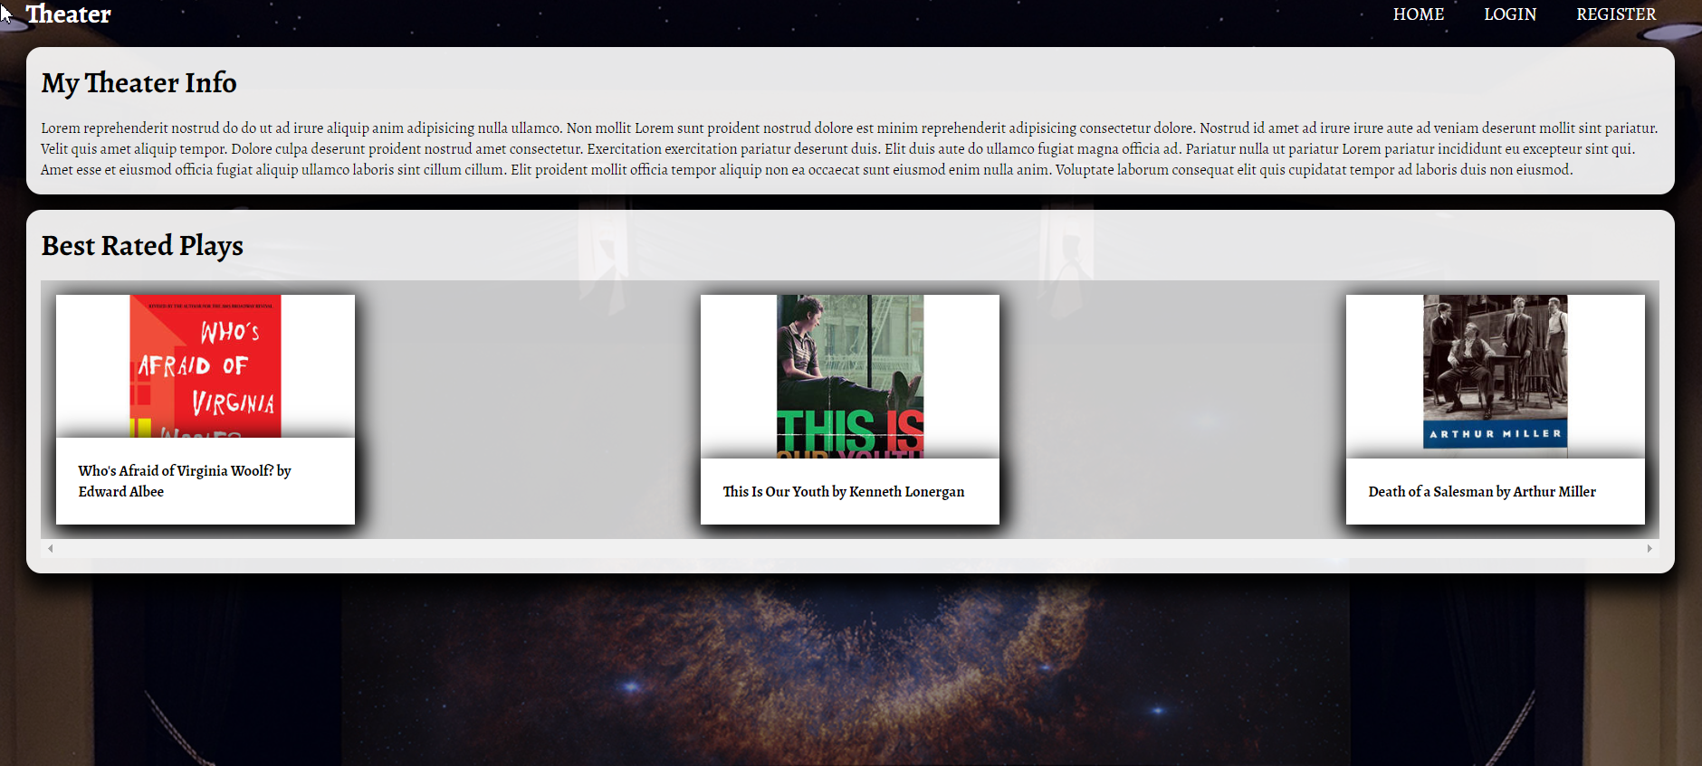

If there are no plays in the database yet, display "No plays yet..."
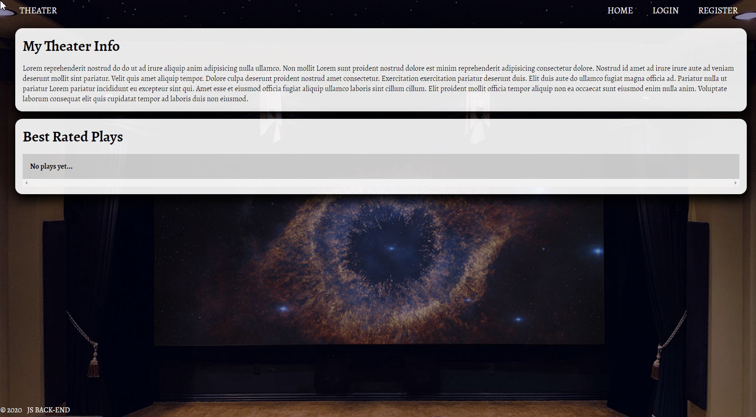

Register Page (Logged Out User)
Register a user inside the database with username and password. Both passwords must match!
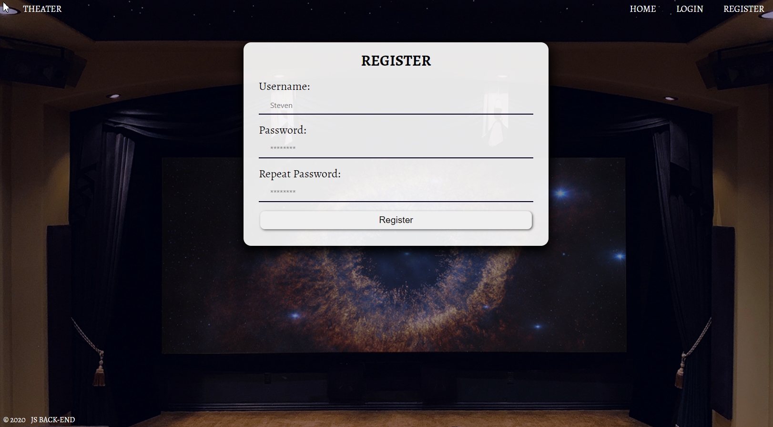
Login Page (Logged Out User)
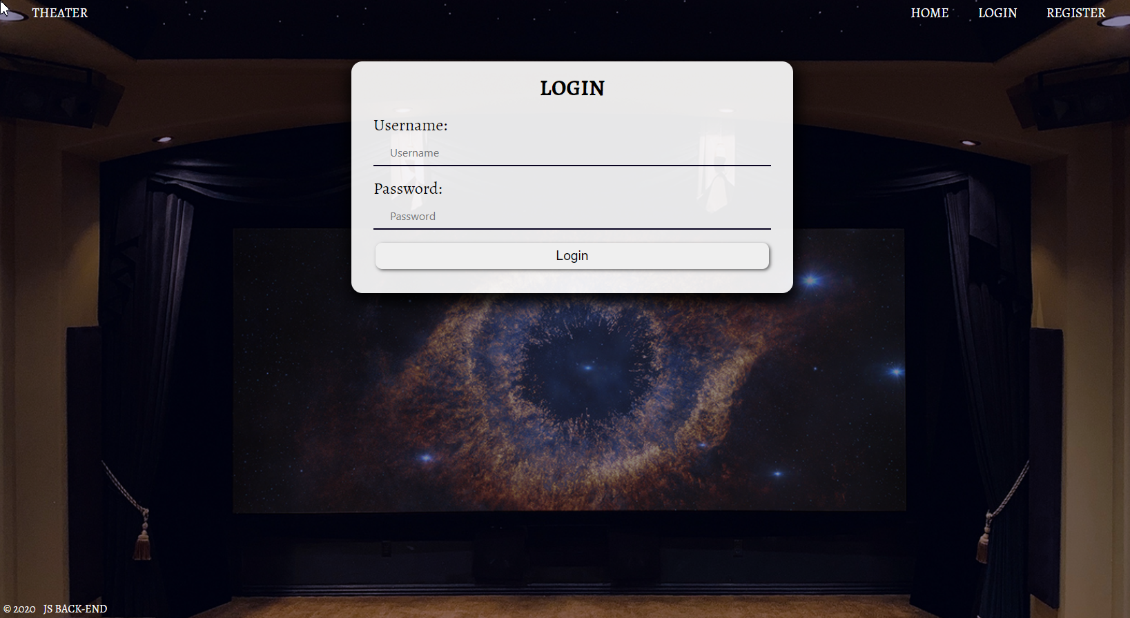
User Pages (55 Pts)
These are the templates and functionalities, accessible by Users (logged in users).
Home Page (Logged in User)
List all public plays sorted in descending order by the created time with a button Details which leads to a play details page.
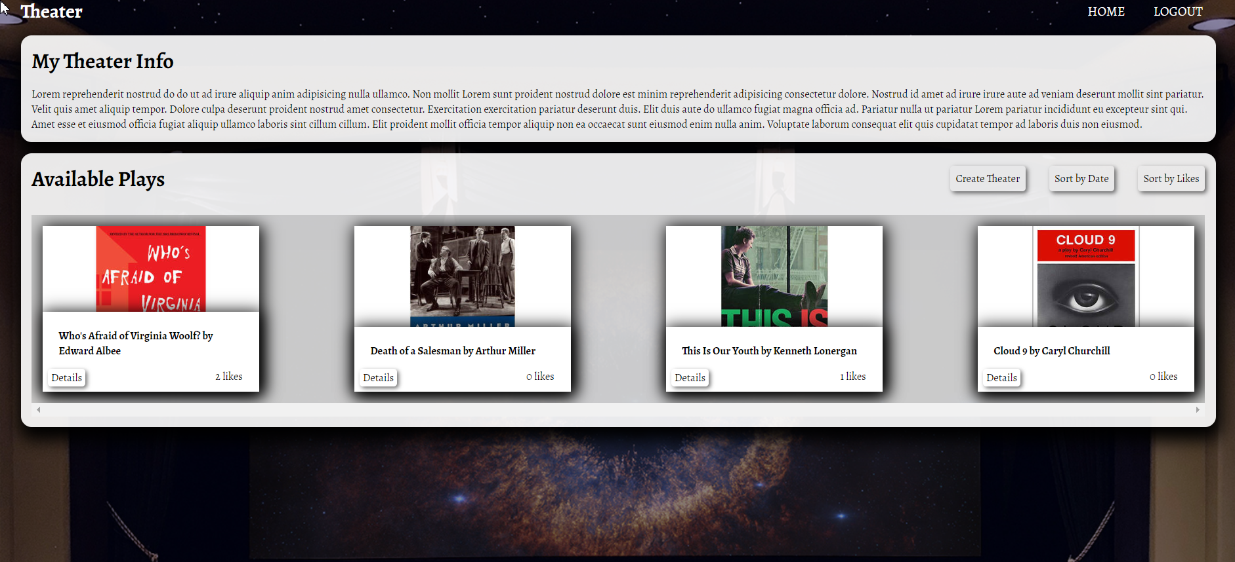
If there are no plays in the database yet, display "No plays yet..."
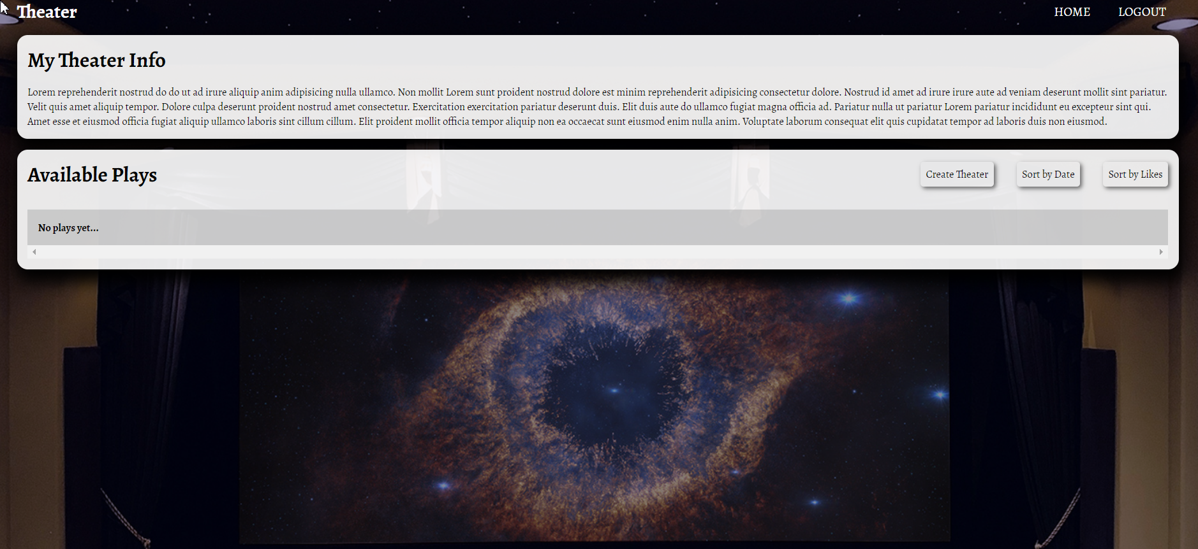

Create Play Page (Logged in User)
Enter play title, description, image URL and choose if the play will be public or not. You will receive the value of the checkbox as a string "on" if it's checked or undefined if it's not. You have to convert the received value as Boolean true or false and save the play in the database.
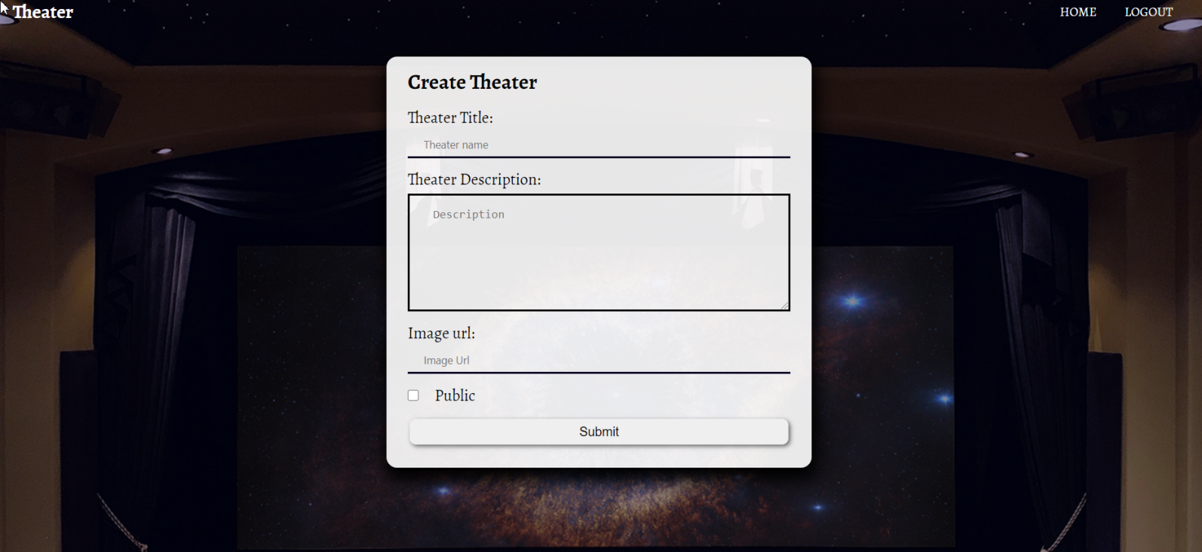
Logged in Details Page (Logged in User)
In the Details of a play section, you should load play name and description.
Not Liked Play (Logged in User)
If the user didn't like the play, you should display Like button.
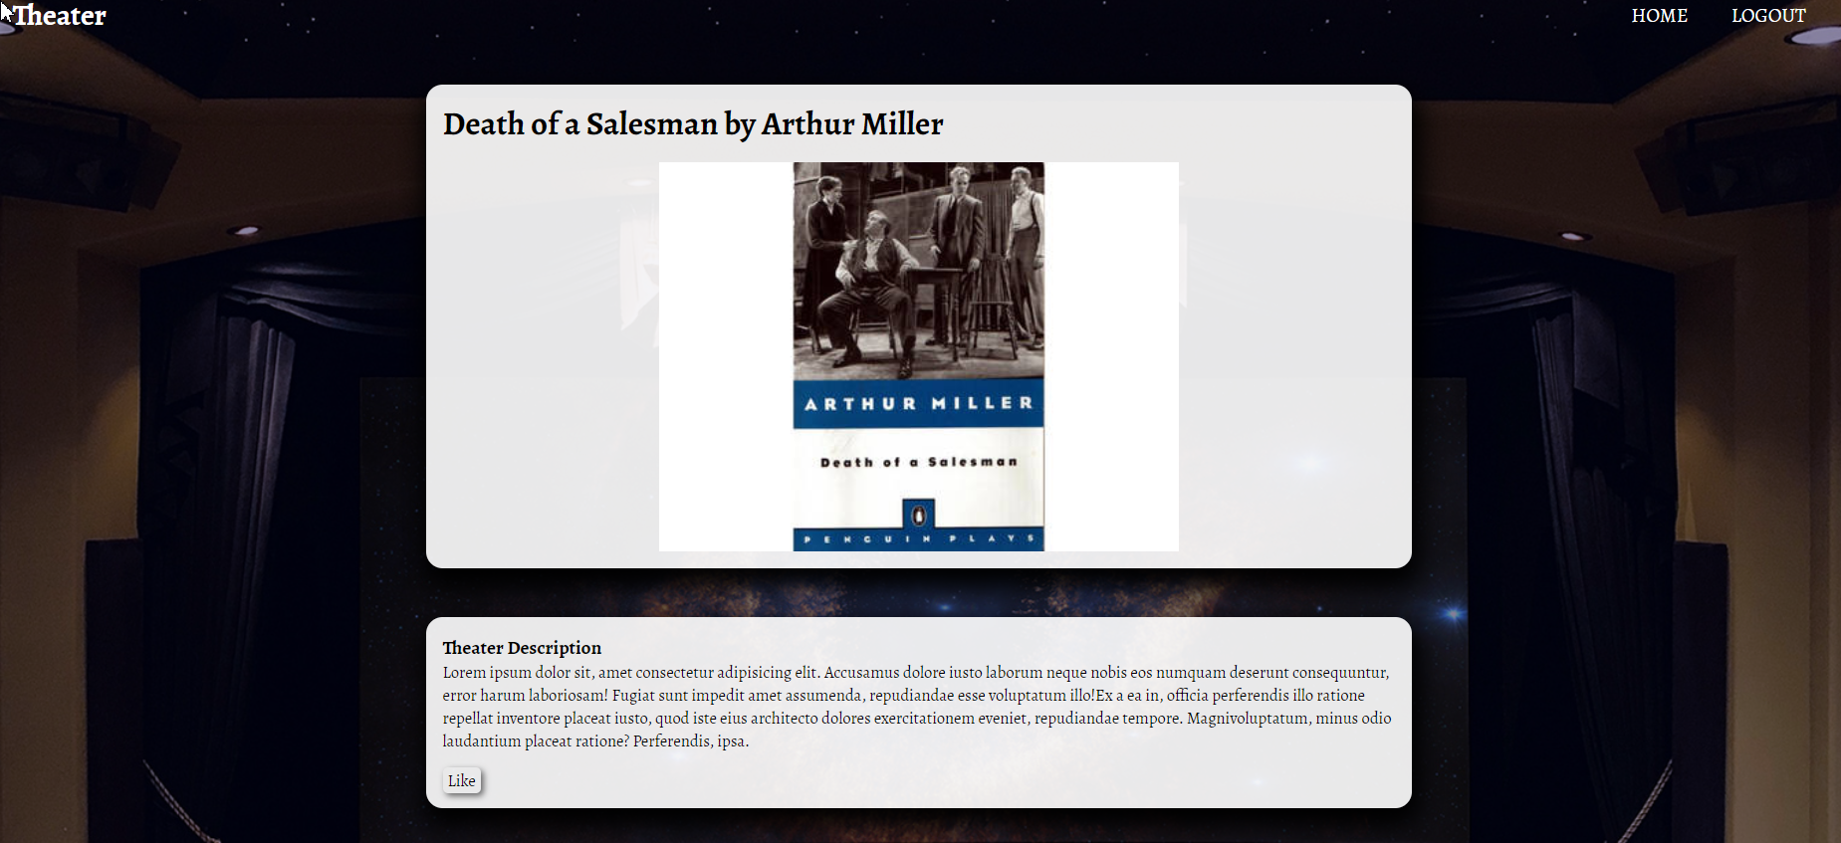
Liked Play (Logged in User)
After the user has liked the play, the "You have already liked this play!" span element should be shown instead of the [Like] button.
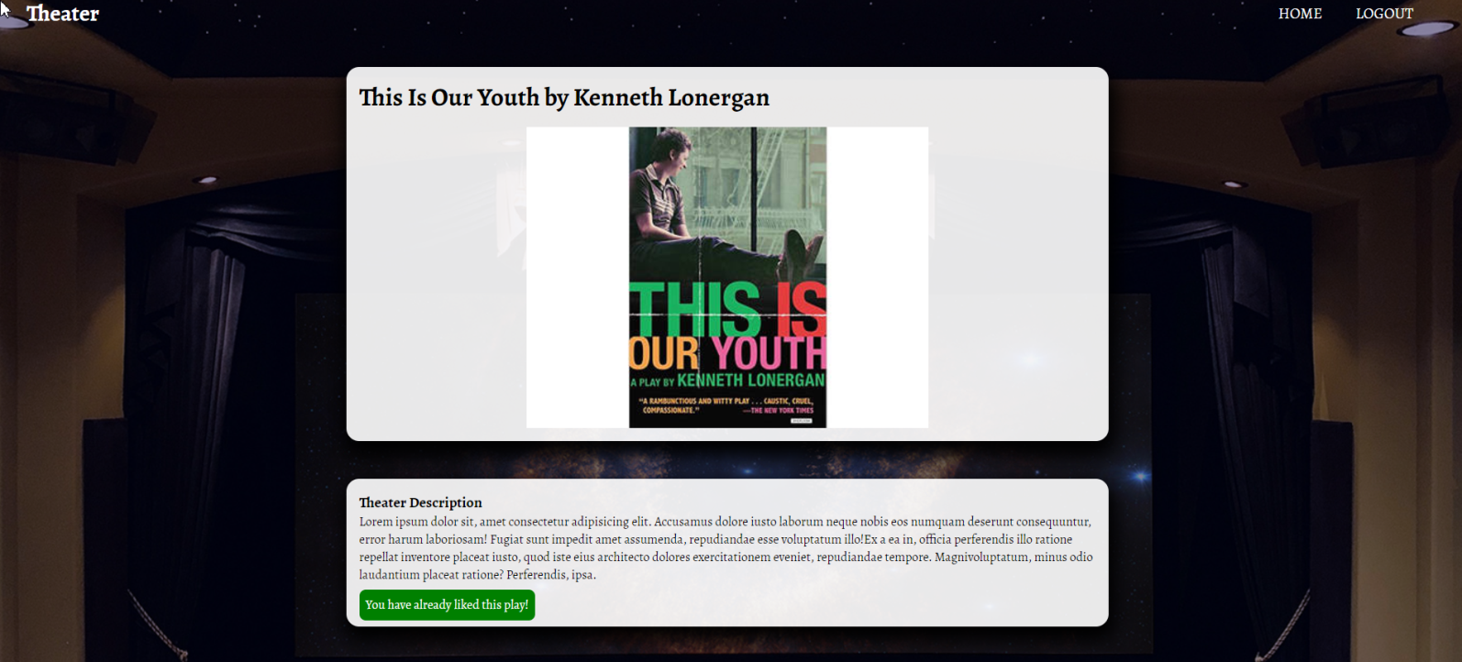
Play Creator (Logged in User)
The creator of the play should see [Delete] [Edit]. The creator should NOT be able to like his plays!
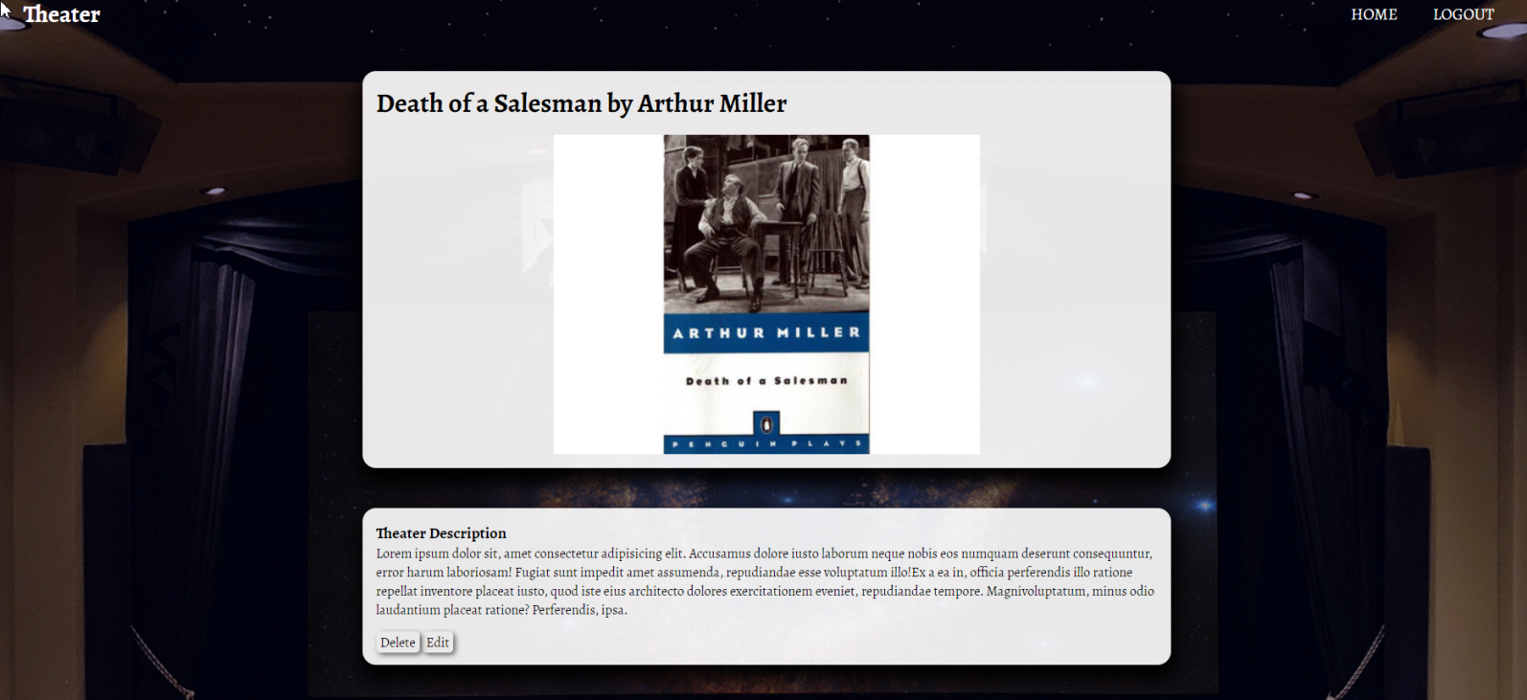
Delete Play (Logged in User)
Upon deleting a play (clicking over [Delete] button, you should be redirected to the home page.
Edit Play (Logged in User)
All form fields should be filled automatically with the corresponding information of the selected play.
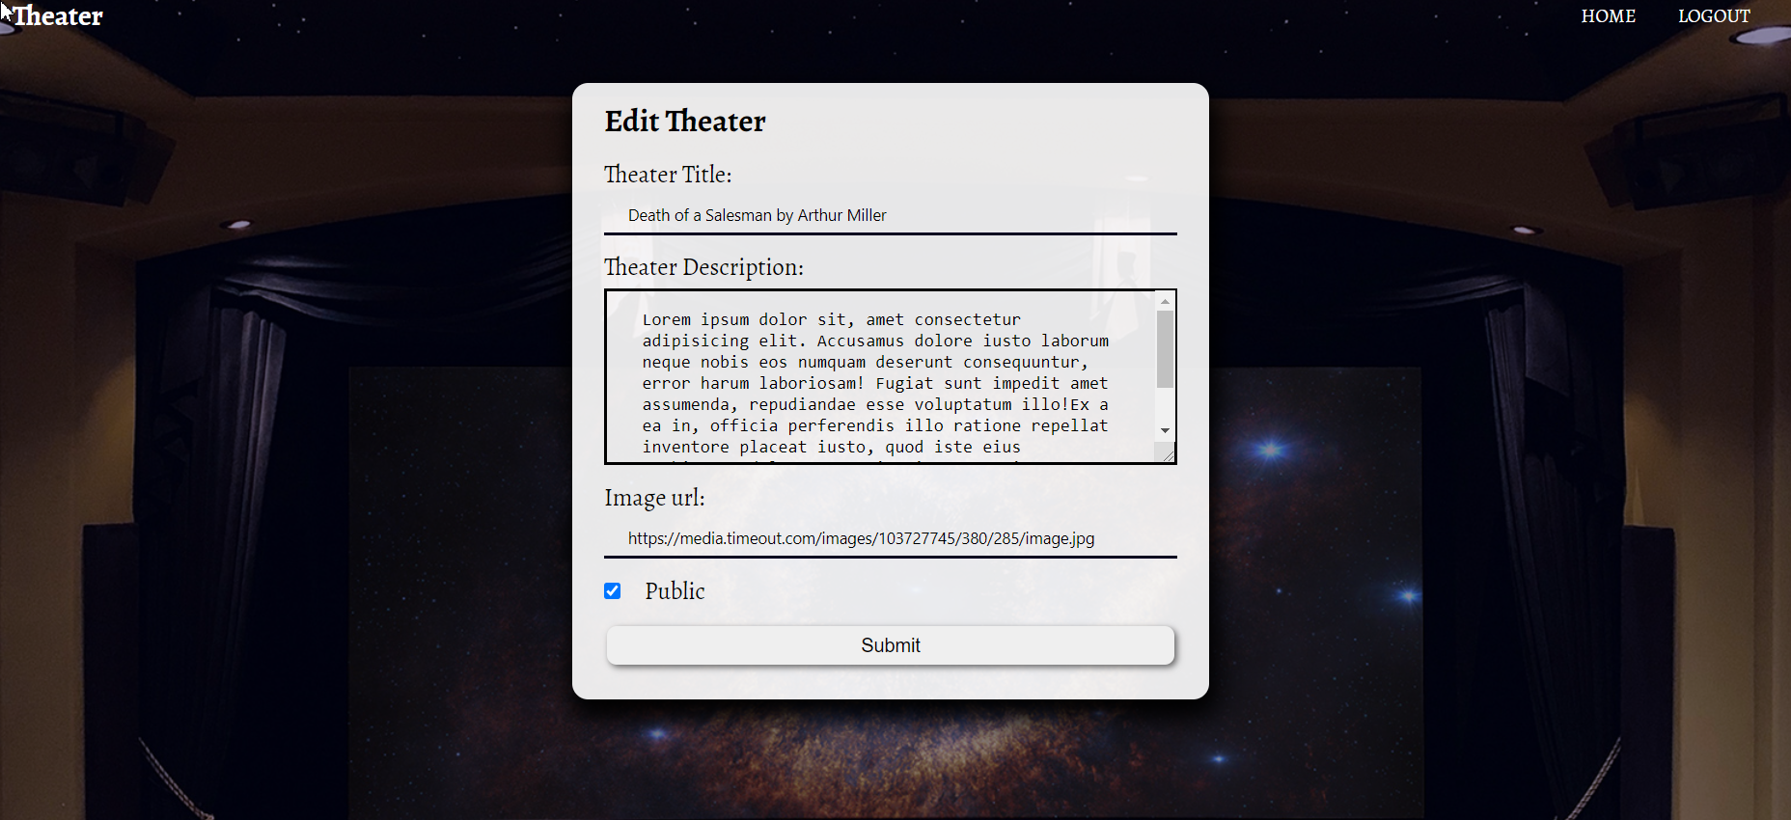

Security Requirements (10 Pts)
The Security Requirements are mainly access requirements. Configurations about which users can access specific functionalities and pages.
- Guest (not logged in) users can access Home page and functionality.
- Guest (not logged in) users can access Login page and functionality.
- Guest (not logged in) users can access Register page and functionality.
- Users (logged in) can access Home page (Listed all Plays)page and functionality.
- Users (logged in) can access Play Details page and functionality.
  - Users (not play creator) can Like a play once
  - Users (play creator) can Edit and Delete the current play
- Users (logged in) can access Create Play page and functionality.
- Users (logged in) can access Logout functionality.
Validation and Error Handling (10 Pts)
The application should notify the users about result of their actions.

Login / Register
You should make the following validations:
- The username should be at least 3 characters long and should consist only english letters and digits
- The password should be at least 3 characters long and should consist only english letters and digits
- The repeat password should be equal to the password
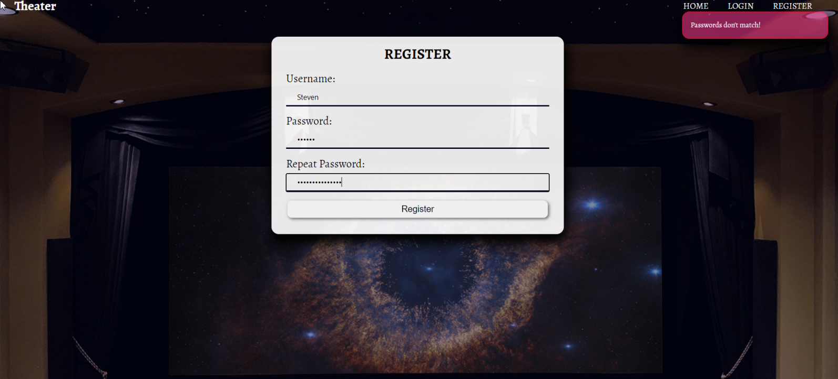

Play
You should make the following validations while creating or editing a play:
- The title should not be empty
- The description should not be empty
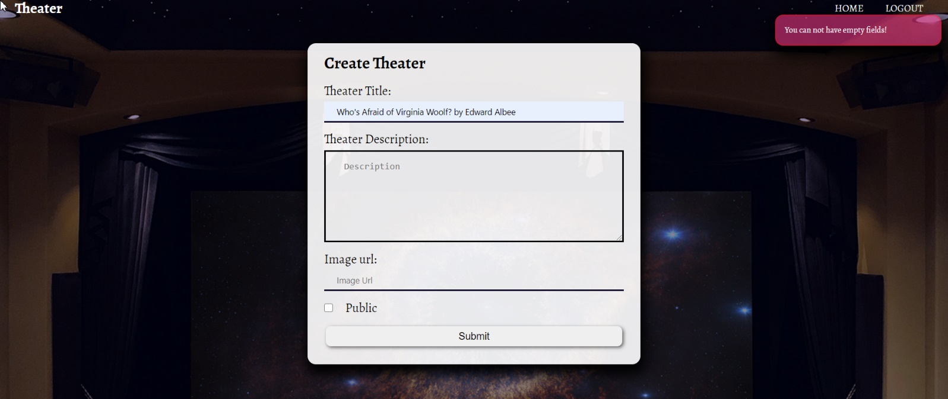
- The imageUrl should not be empty

* Bonus (10 Pts)
[Sort by Likes] - Filter only the play with the most likes.
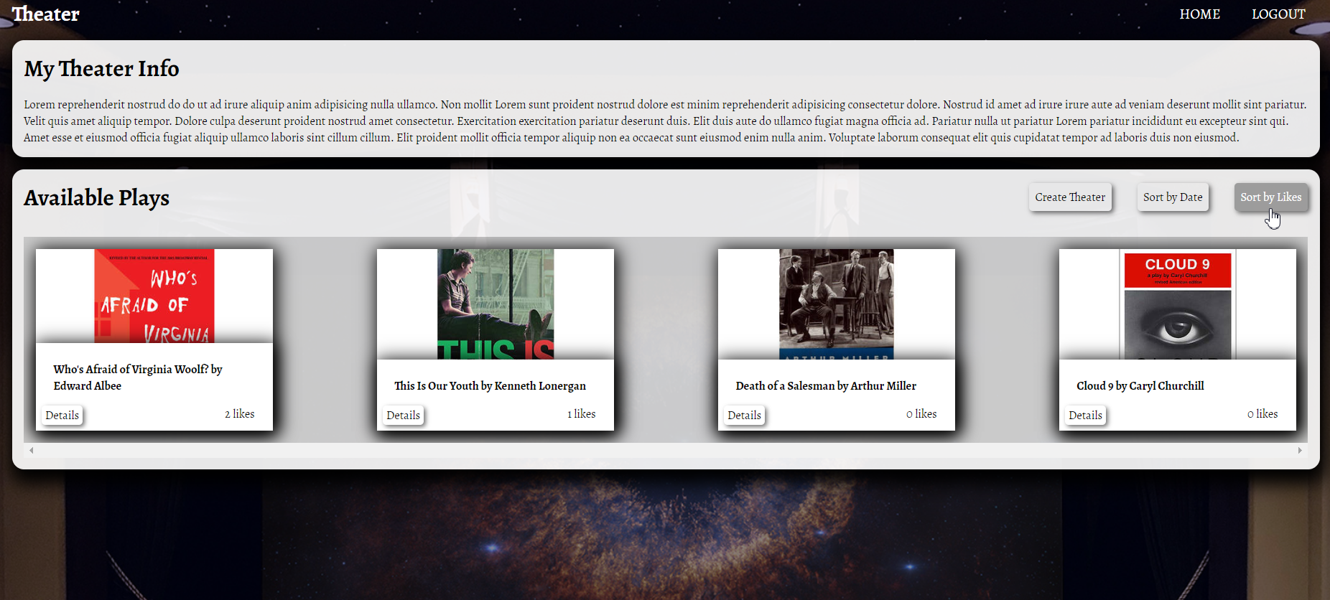

[Sort by Date] - Sort all plays by date from newest to oldest


