Gira
Submit your solutions on the here.

Database Requirements
The Database of the Gira application needs to support 3 entities:

User
- Has an Id – UUID-string or Long
- Has a Username (unique)
  - Username length must be between 3 and 20 characters (inclusive 3 and 20).
- Has a Password
  - Password length must be between 3 and 20 characters (inclusive 3 and 20).
- Has an Email (unique)
  - Must contains '@'.
  - Cannot be null.

Task
- Has an Id – UUID-string or Long
- Has a Name (unique)
  - Name length must be between 3 and 20 characters (inclusive 3 and 20).
- Has a Description
  - Description min length must be minimum 5(inclusive) characters
- Has a Progress (unique)
  - Option between (OPEN, IN_PROGRESS, COMPLETED, OTHER)
- Has a Due Date
  - A date, that cannot be in the past
- Has a Classification
  - Classification cannot be null.
- Has a User
  - Cannot be null.

Classification
- Has an Id – UUID-string or Long
- Has a ClassificaionName (unique)
  - option between (BUG, FEATURE, SUPPORT, OTHER)
- Has a Description

Implement the entities with the correct datatypes and implement repositories for them.

Initialize classifications
- Implement a method that checks (when the app is started) if the database does not have classifications and initialize them
  - You are free to do it in different ways.

Page Requirements

Index Page (logged out user)
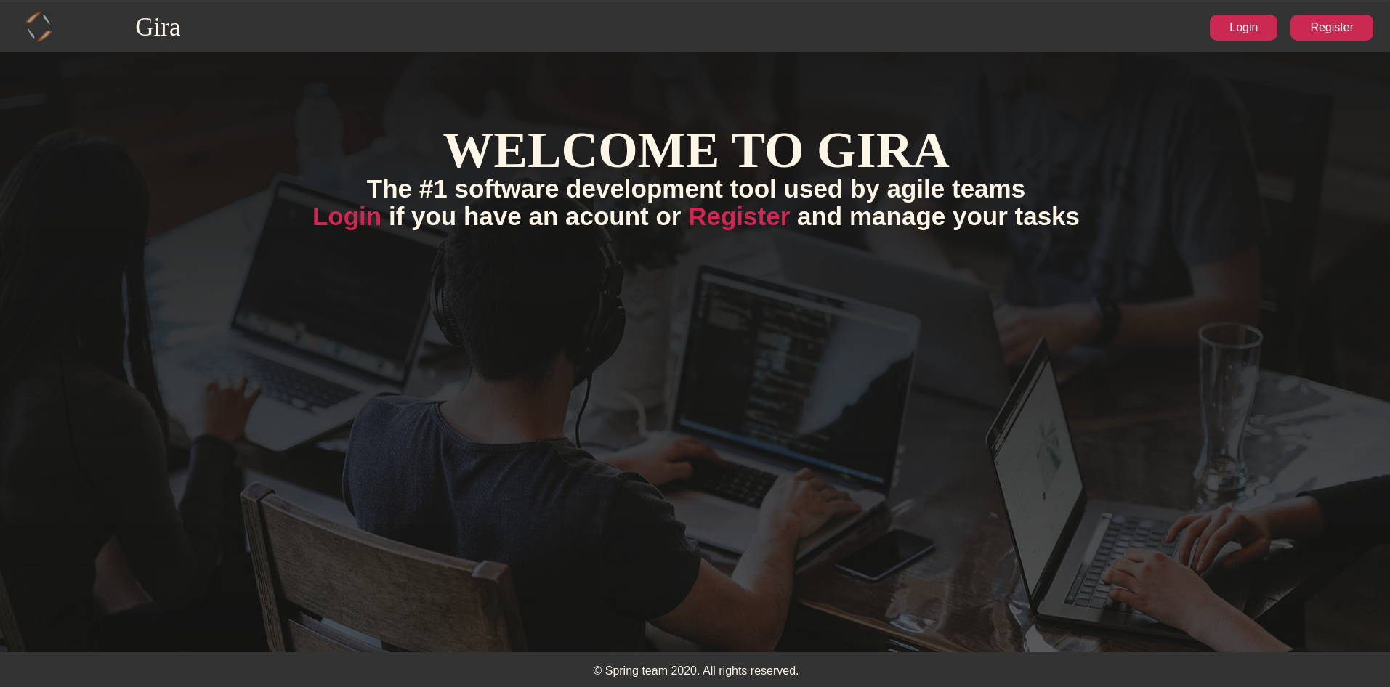

Login Page (logged out user)
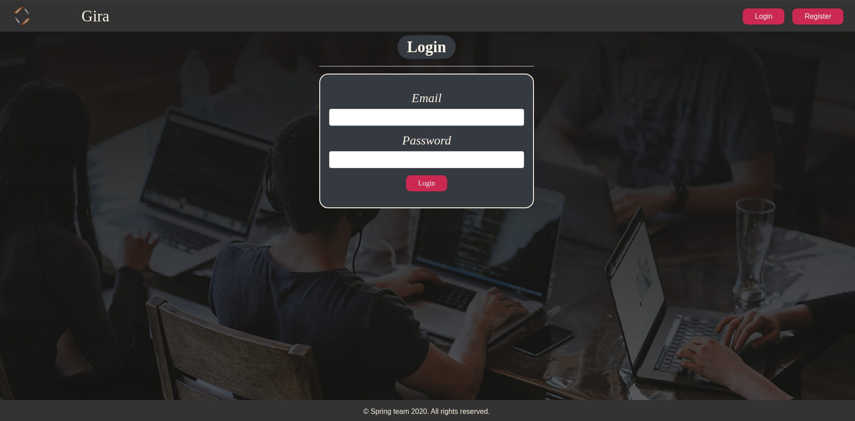

Login Page validations
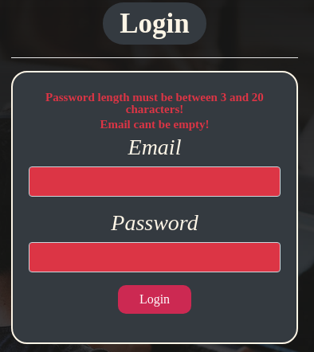
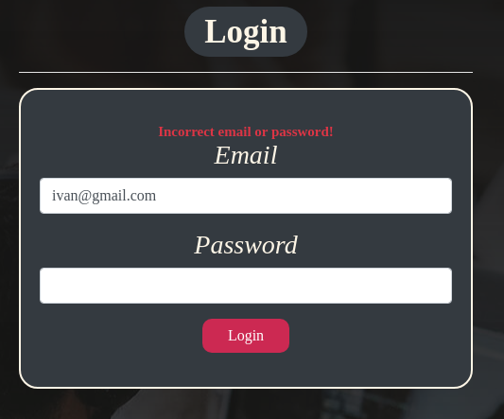

Register Page (logged out user)
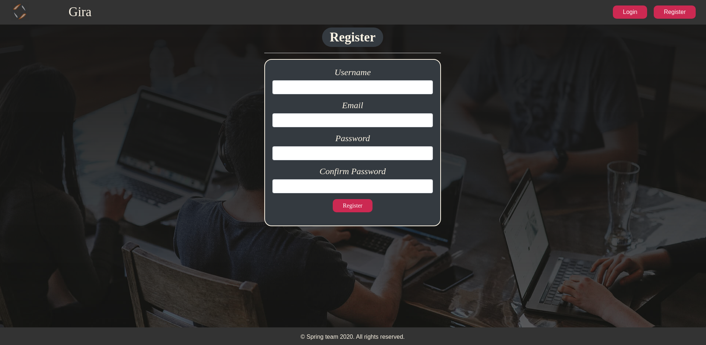

Register Page validations
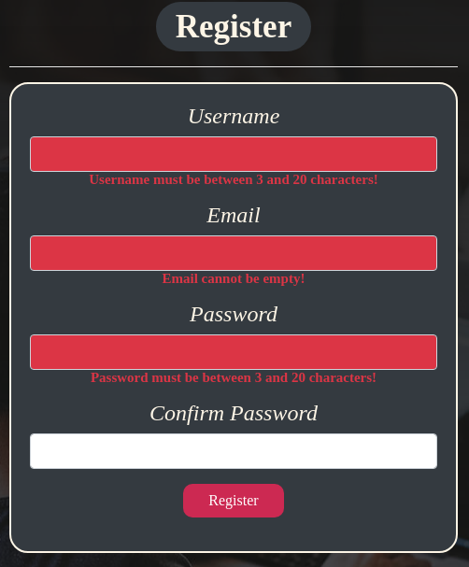

Home Page (without having any tasks)
- Note: The home page should visualize all of the tasks from the database
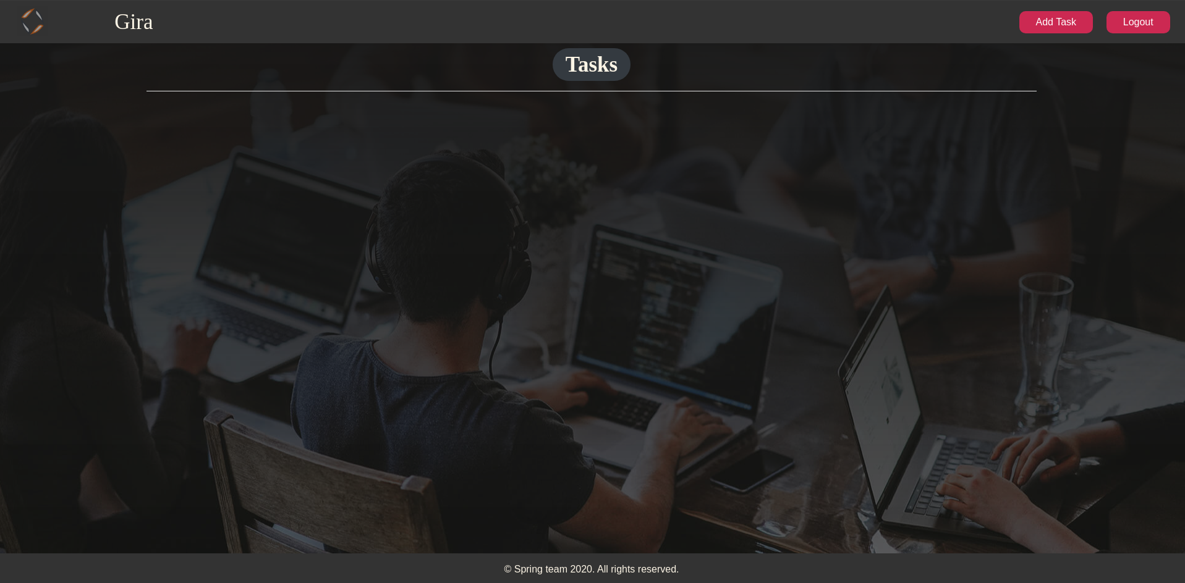

Add task
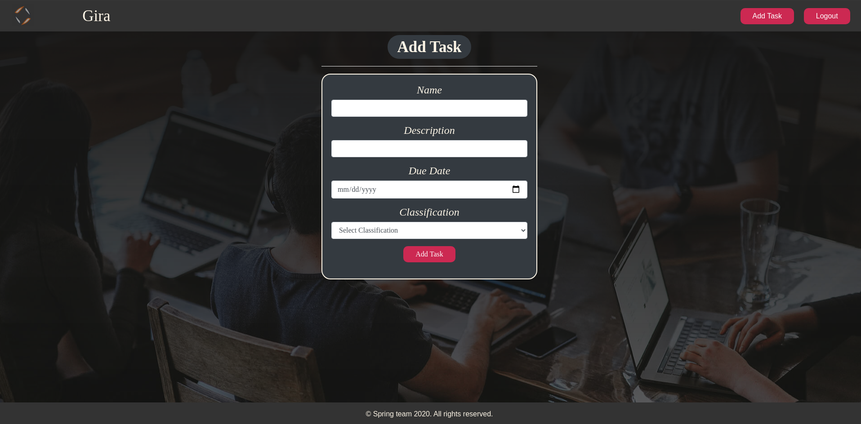

Add task validation
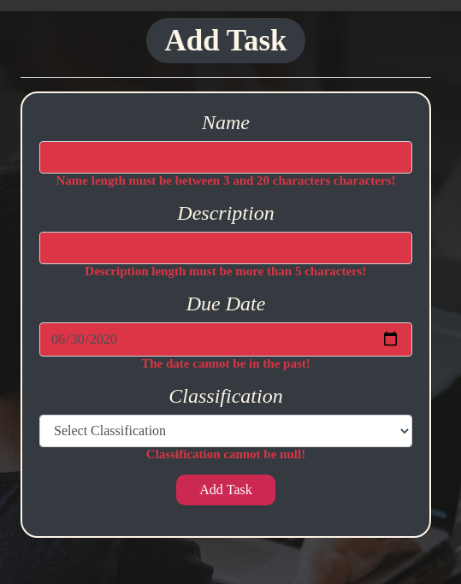

Home Page (with tasks)
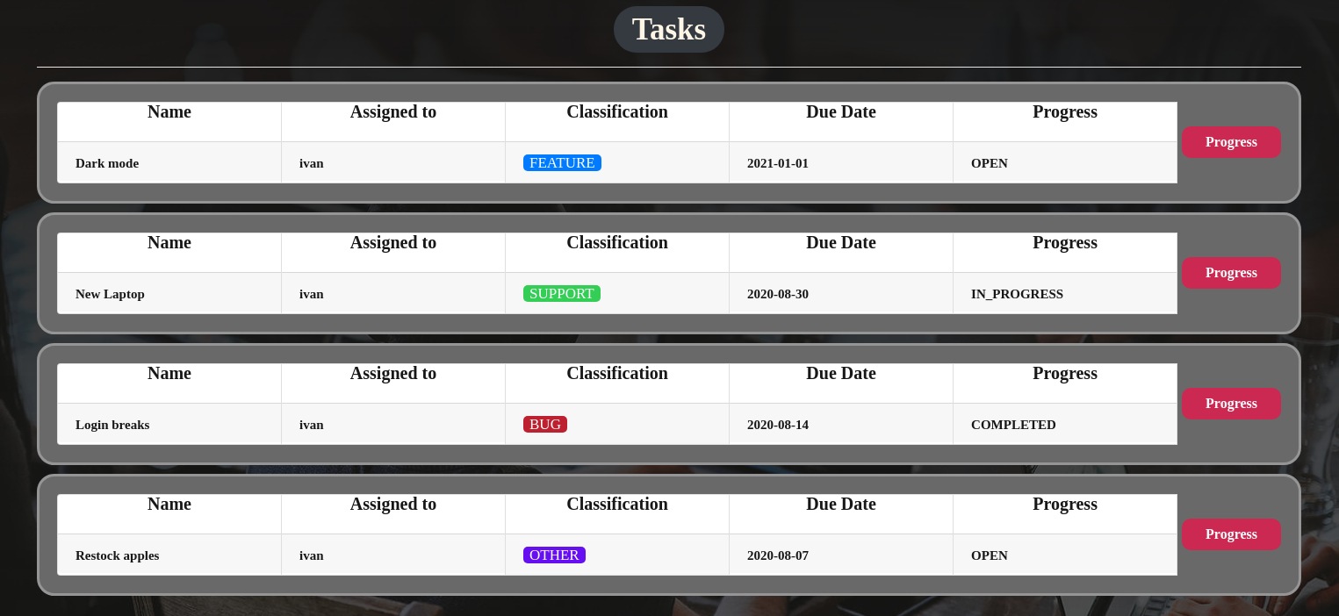

The templates have been given to you in the application skeleton, so make sure you implement the pages correctly.
NOTE: The templates should look EXACTLY as shown above.
NOTE: The templates do NOT require additional CSS for you to write. The bootstrap and the given css are enough.

Functional Requirements
The Functionality Requirements describe the functionality that the Application must support.
The application should provide Guest (not logged in) users with the functionality to login, register and view the Index page.
The application should provide Users (logged in) with the functionality to logout, add a Task, view all Tasks (Home page). When creating a task, the "Assigned to" field should have the person's name who created the task and the initial progress should be "OPEN".
The progress button changes the progress column of the task:
- If the progress is "OPEN", the progress becomes "IN_PROGRESS".
- If the progress is "IN_PROGRESS", the progress becomes "COMPLETED".
- If the progress is "COMPLETED", delete the task from the database.
Gira in navbar should redirect to appropriate URL depending on that if the user is logged in.
The application should provide functionality for adding tasks with classification (BUG, FEATURE, SUPPORT, OTHER).
The task's classification should have different colours. (The colours and the classes are in the end of the style.css file)
The appropriate task's classification should have the appropriate style class. The names are the same for the css classes and the classification names. For example:
The application should store its data into a MySQL database.

Security Requirements
The Security Requirements are mainly access requirements. Configurations about which users can access specific functionalities and pages.
- Guest (not logged in) users can access Index page.
- Guest (not logged in) users can access Login page.
- Guest (not logged in) users can access Register page.
- Users (logged in) can access Home page.
- Users (logged in) can access Add Task page.
- Users (logged in) can access Logout functionality.

