Lab: ORM and Entity Framework Overview
Problems for exercises and homework for the "Databases Programming and ORM" course from the official "Applied Programmer" curriculum.
You can check your solutions here: https://judge.softuni.org/Contests/3149
(delete all "bin"/"obj" folders)
Use the provided skeleton from resources! Do not change its methods, classes and namespaces!

Import the SoftUni Database
Import the SoftUni DB into SQL Management Studio (if not yet imported) by executing the provided .sql script.
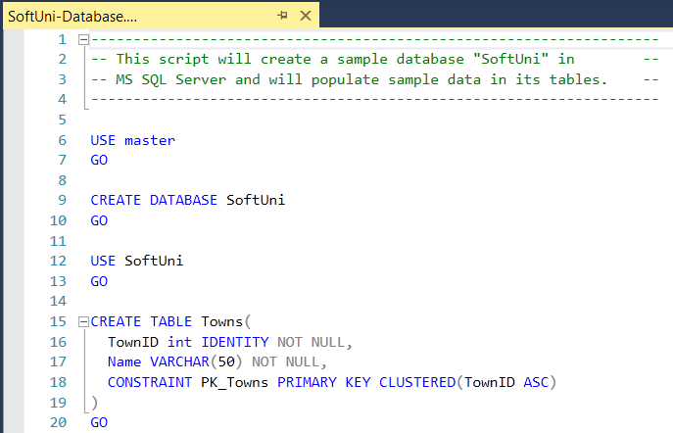

Generate Database First ORM Model
Model the existing database by using Database First in Entity Framework Core.
First create a new empty .Net Core Console Application and after it is created open the Package Manager Console:
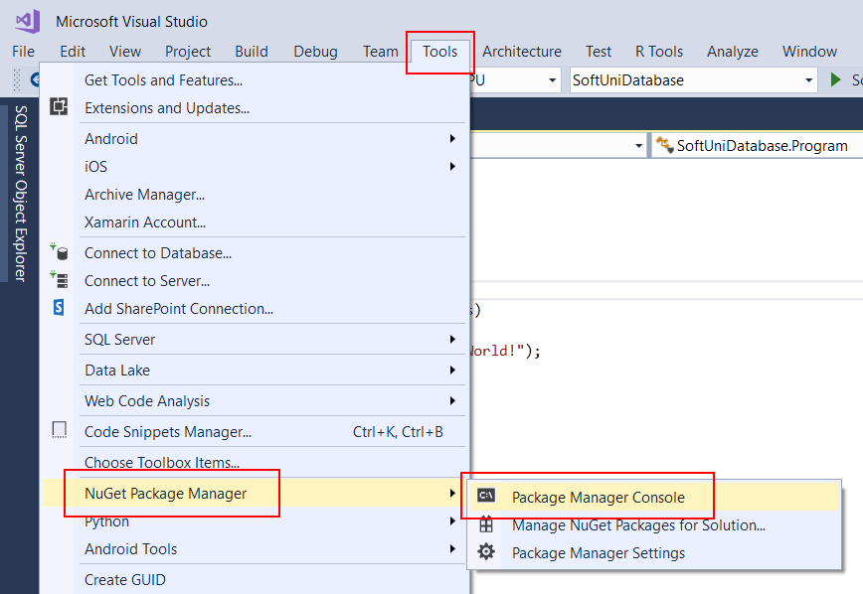
It will look something like this:
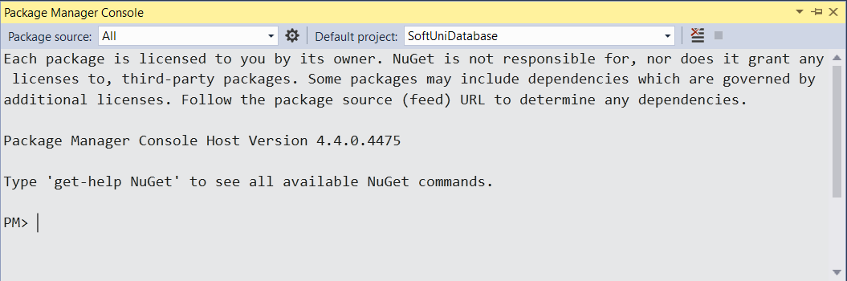
Use it to run the following commands one by one:
Install-Package Microsoft.EntityFrameworkCore.Tools –v 3.1.3
Install-Package Microsoft.EntityFrameworkCore.SqlServer –v 3.1.3
Install-Package Microsoft.EntityFrameworkCore.SqlServer.Design
NOTE: If Package Manager Console gives you error while trying to execute the above commands try using the following ones:
Install-Package Microsoft.EntityFrameworkCore.Tools –Version 3.1.3
Install-Package Microsoft.EntityFrameworkCore.SqlServer –Version 3.1.3
Install-Package Microsoft.EntityFrameworkCore.SqlServer.Design
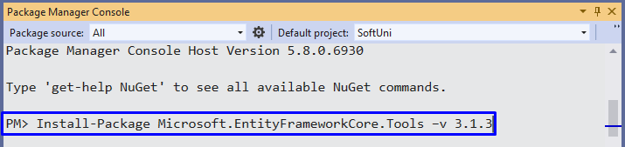
NOTE: If the installed versions are newer than these, your solution may be marked as incorrect when tested in judge.
These are the packages you will need, in order to scaffold our SoftUniContext from the SoftUni database.
Next, we must execute the command to scaffold our context class. It will consist of 4 things:
- First, the name of the command:
Scaffold-DbContext
- Second, the connection we will be using (our connection string):
-Connection "Server=<ServerName>;Database=<DatabaseName>;Integrated Security=True;"
For ServerName, use the name of your local MS SQL Server instance or ".".
For DatabaseName, use the name of the database you want to use, in this case – SoftUni.
- Third, we need to declare our service provider, we’ll be using Microsoft.EntityFrameworkCore.SqlServer:
-Provider Microsoft.EntityFrameworkCore.SqlServer
- And the fourth thing we’ll do, is to give it a directory where all of our models will go (e.g. Models):
-OutputDir Data/Models
Our final command will look like this:
Scaffold-DbContext -Connection "Server=(localdb)\MSSQLLocalDB;Database=SoftUni;Integrated Security=True;" -Provider Microsoft.EntityFrameworkCore.SqlServer -OutputDir Data/Models
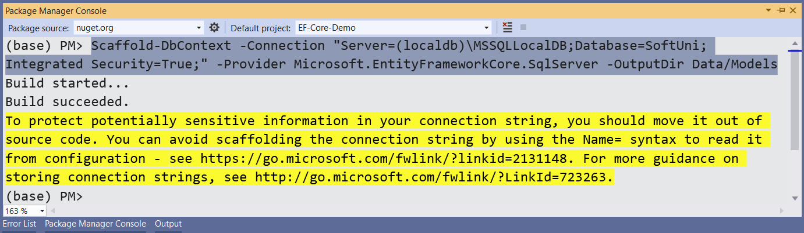
Execute the whole command on a single line.
Entity Framework Core has successfully mapped the database schema to C# classes. However, it isn't good enough with names – all classes have been pluralized.
- Use the Solution Explorer in Visual Studio to move the SoftUniContext class out of Models into the Data folder and rename all of our classes properly.
- Use right click → [Rename] or the [F2] shortcut and press [OK] on this pop up window after each class:
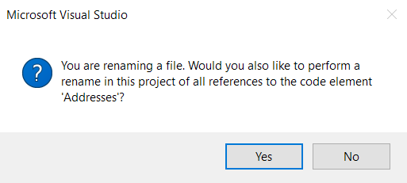
This way Visual Studio will also rename the classes everywhere they’re used.
The final result should look like this:
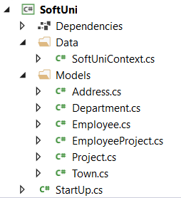
Don’t forget to fix the SoftUniContext’s namespace after moving it and add a reference to the Models namespace:
Make sure that your namespaces are exactly the same as these:
SoftUni
SoftUni.Data
SoftUni.Models
Finally, we can clean up the packages we won’t be using anymore from the package manager GUI or by running these commands:
Uninstall-Package Microsoft.EntityFrameworkCore.Tools -r
Uninstall-Package Microsoft.EntityFrameworkCore.SqlServer.Design -RemoveDependencies

Find Employees with Job Title
Create a method public static string FindEmployeesWithJobTitle(SoftUniContext context) to print the First Name of all employees with Job Title equal to “Design Engineer”.
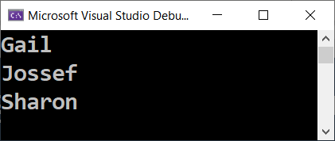

Hints
First, use the context in the method like this:
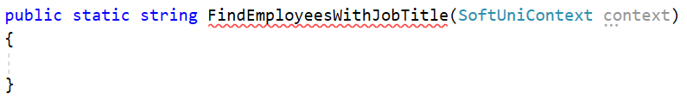
Get all employees and filter them using context.Employees. Then, select only the First Name of each employee and use String.Join() to return the array of names as a string to the method.
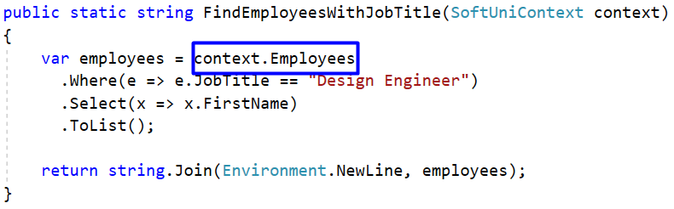

Run Your Code in the Console
Invoke the FindEmployeesWithJobTitle(SoftUniContext context) method from the application entry point Main():
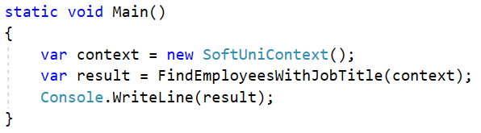
Press [Ctrl+F5] to run the application. Check if the result on the console is correct:

Submit Your Code to Judge
Save your files in Visual Studio. Delete the “bin” and “obj” folders from the SoftUni folder and create a ZIP archive of your solution:
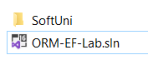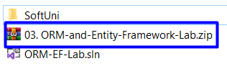
Submit the ZIP file in Judge:
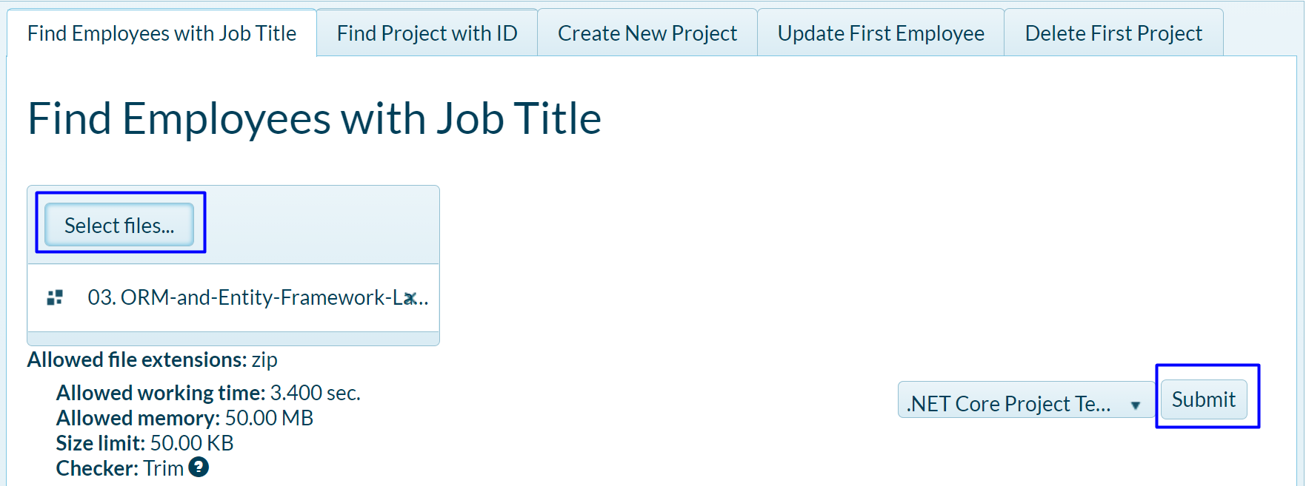
You should get 100 / 100 score:
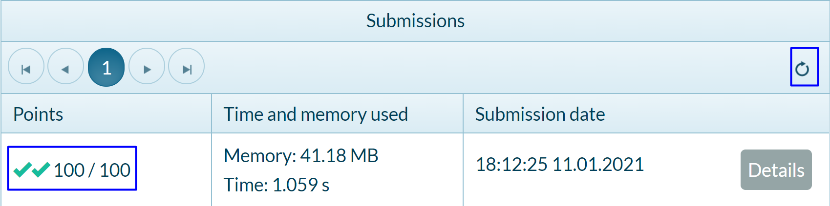

Find Project with ID
Again, use the context and get all Projects from it. Use .Find() method to find the project with ID 2 and return the Name of the project.


Hints
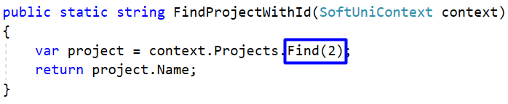

Create New Project
Your task is to create a new Project in the Projects table.

Hints
To create a new database row use the .Add() method of the corresponding DbSet. First, create a new Project object and give values to Name and StartDate properties.
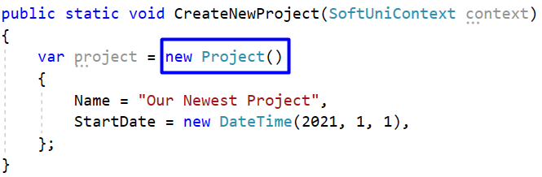
Then, add the object to the DbSet and do not forget to save changes the following way:
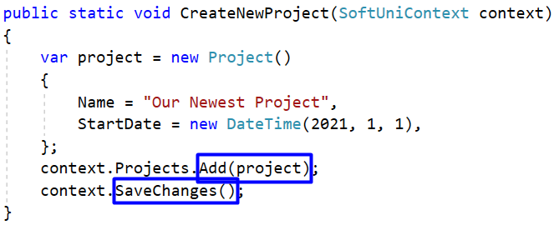
Run the app. There is no result displayed on the console.

Check the Result in the DB
In order to check the result, go to SQL Server Management Studio -> Object Explorer -> Databases -> SoftUni -> dbo.Projects. Right-click on it and choose Select Top 1000 Rows.
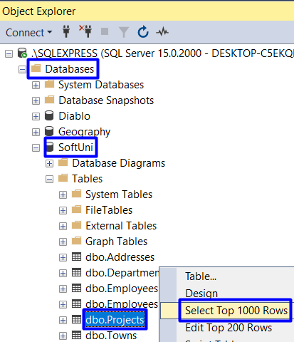
Scroll down to the last entity. It should be the one we added using a C# command in Visual Studio.

Update First Employee
Get the first employee using .FirstOrDefault() method and change their First Name to “Alex”. Do not forget to save changes! In case there are no employees, return empty string to the method, else return the changed employee’s first name.

Hints
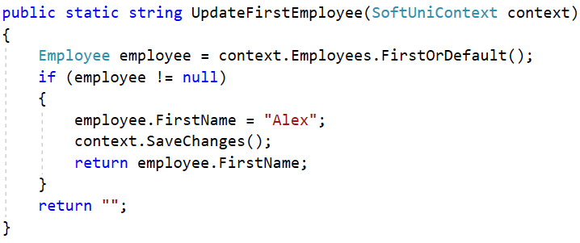

Check result in the DB
This is the database entity before the code execution:
After the code execution, the entity should be changed:

Delete First Project
Get the first project and delete it using the .Remove() method. Do not forget to save changes! The entity we should remove is the following:

Hints
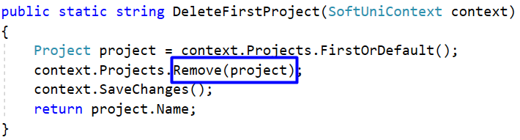
However, when the program is executed an error message appears.
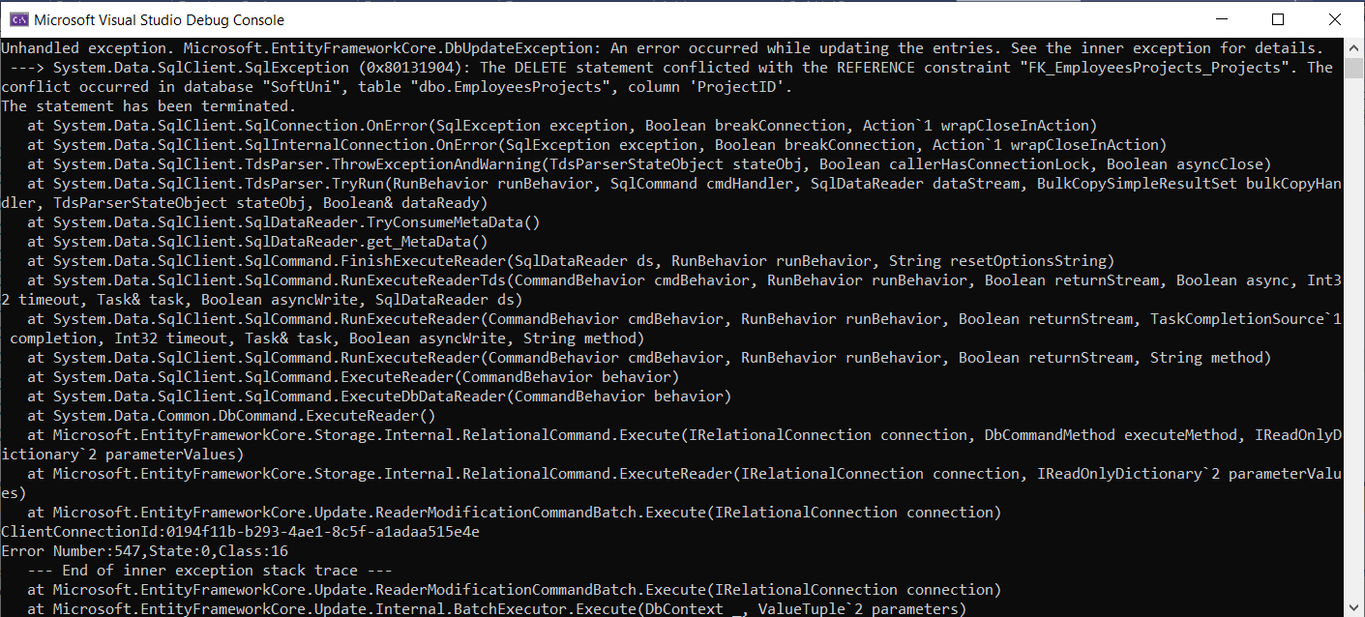
The reason for the error is that the EmployeesProjects table in the SoftUni DB contains a ProjectID column. So, entities from the Projects table cannot be deleted that way because some entities in the EmployeesProjects table contain the id of the project entity we want to delete. To solve that issue we may first delete all enities from the EmployeesProjects table, which contain our ProjectId (in our case with ProjectId=1). The command is the following:
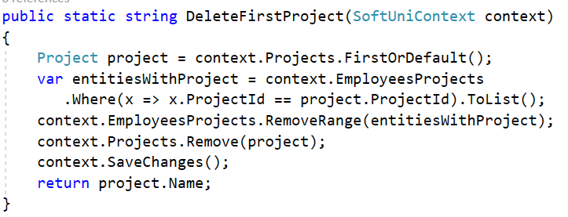

Check result in the DB
Execute the program and see the result in the Projects table in the SoftUni DB.
You can also check the EmployeesProjects table. Now it does not contain entities with ProjectId = 1.
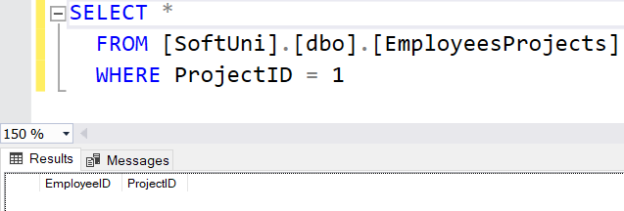

Update Addresses
Write a method to update TownId to 2 for all Addresses with AddressText, containing the word “Drive”.
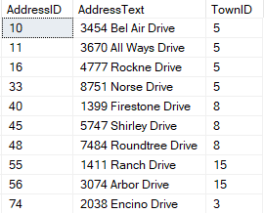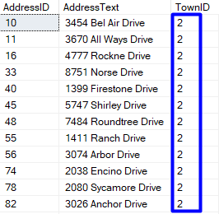
You can check the result in the SoftUni DB with this command:
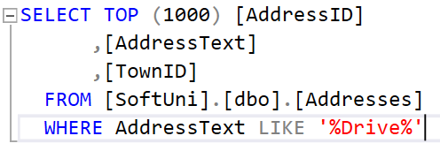
The method UpdateAddresses(SoftUniContext context) should return the count of changed addresses, converted to string.


