Exercise: Introduction to HTML and CSS
Problems for exercises and homework for the "HTML and CSS" course @ SoftUni. Submit your solutions in the SoftUni Judge system at https://judge.softuni.bg/Contests/1136/Introduction-to-HTML-and-CSS.

Simple HTML Page
Create a web page like the following:
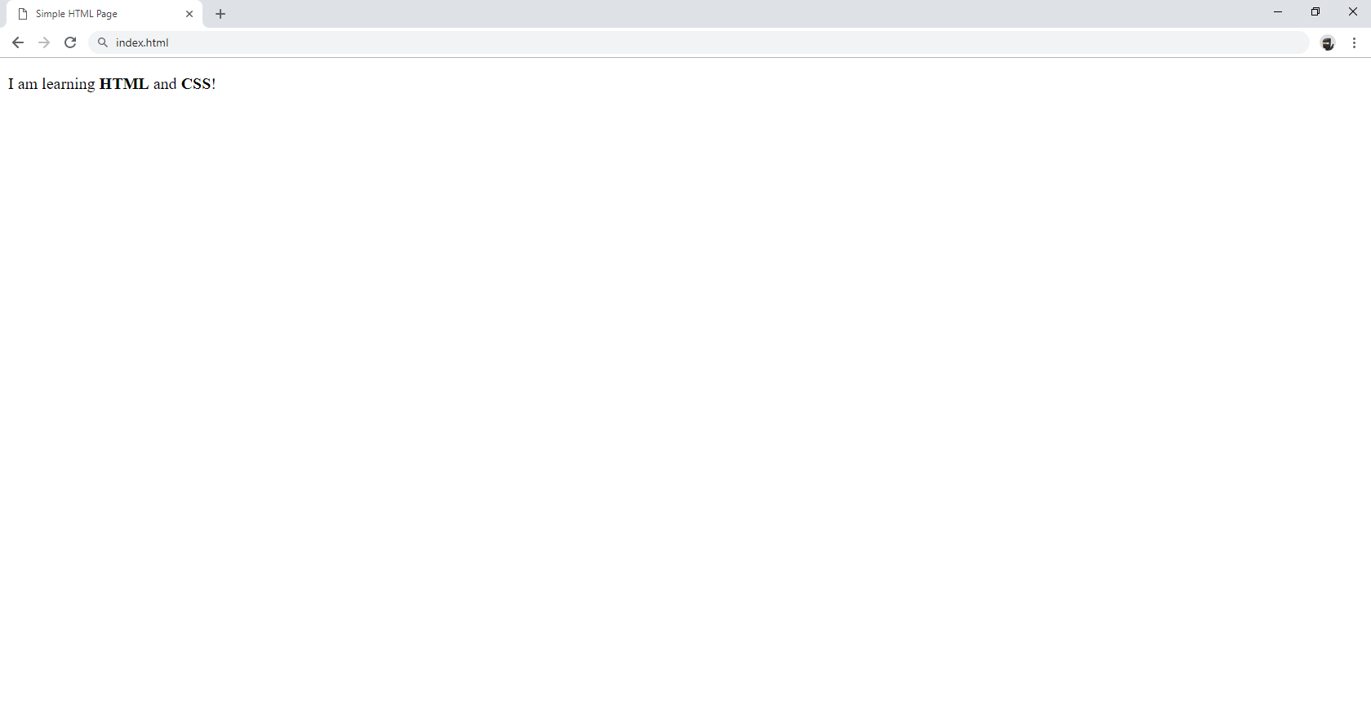

Constraints
- Change the document title to Simple HTML Page
- Use paragraph tag for plain text and strong tag for bold text

Tags Cardio - Paragraphs
Create a web page like the following:
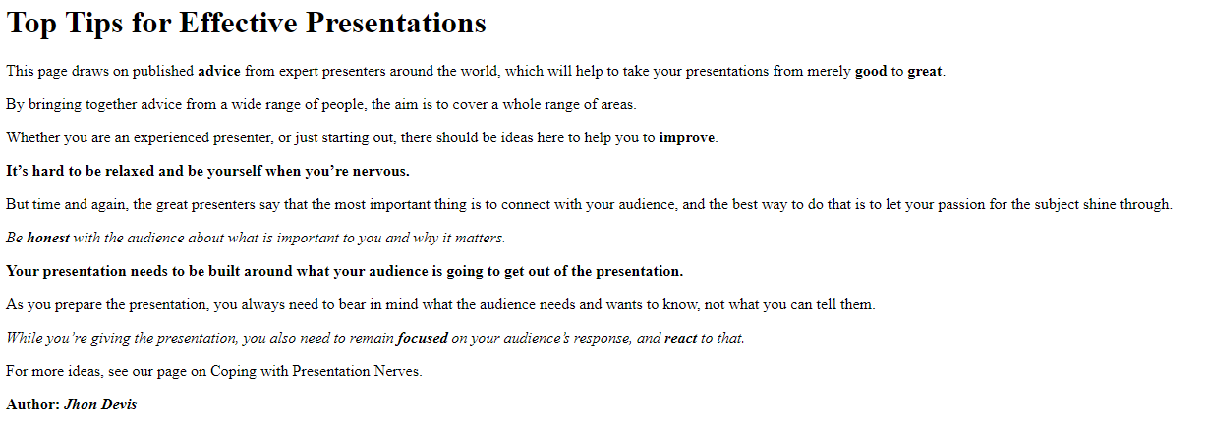

Constraints
- Change the document title to Paragraphs
- Use the h1 tag for heading
- Use p tags for each line of the text
- See the screenshot and use strong and em tags where needed

Single Article Page
Create a web page like the following:
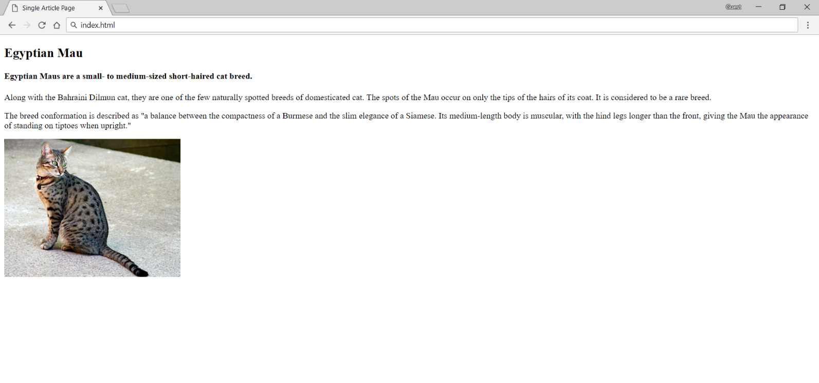

Constraints
- Change the document title to Single Article Page
- Create an article with several items inside
  - Use h2 and h4 tags for headings
  - Use p tags for the text
  - Use img tag for the photo

Tags Cardio - Lists
Create a web page like the following:
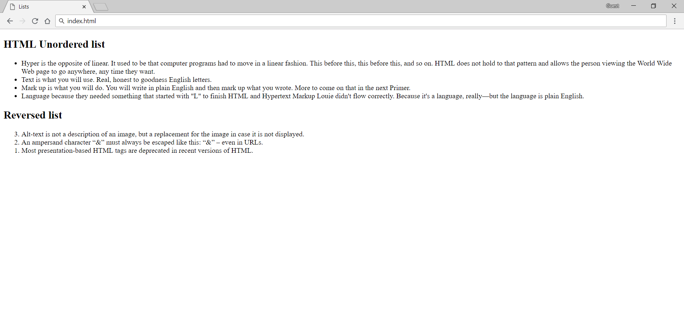

Constraints
- Change the document title to Lists
- Add section with two articles inside (for each list)
- Each article must have a h2 heading
  - Use ul for unordered list
- Add four list items
  - Use ol reversed for ordered reversed list
- Add list items

Tags Cardio - Nested Lists
Create a web page like the following:
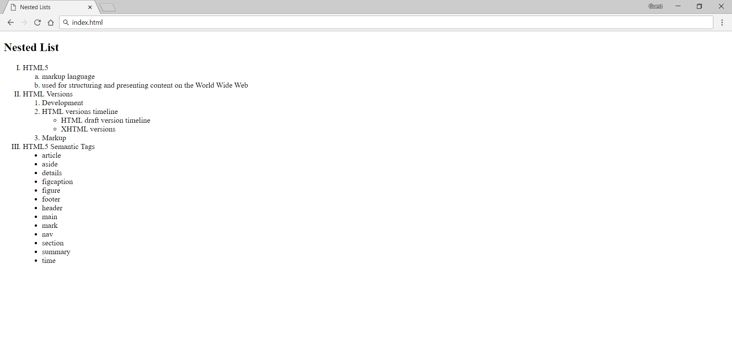

Constraints
- Change the document title to Nested List
- Use h2 tag for heading
- Use different types for ordered and unordered lists
- See the screenshot and use different type attribute as circle, disc etc.
  - Example: <ul type="disc"></ul>

Tags Cardio - Table
Create a web page like the following:
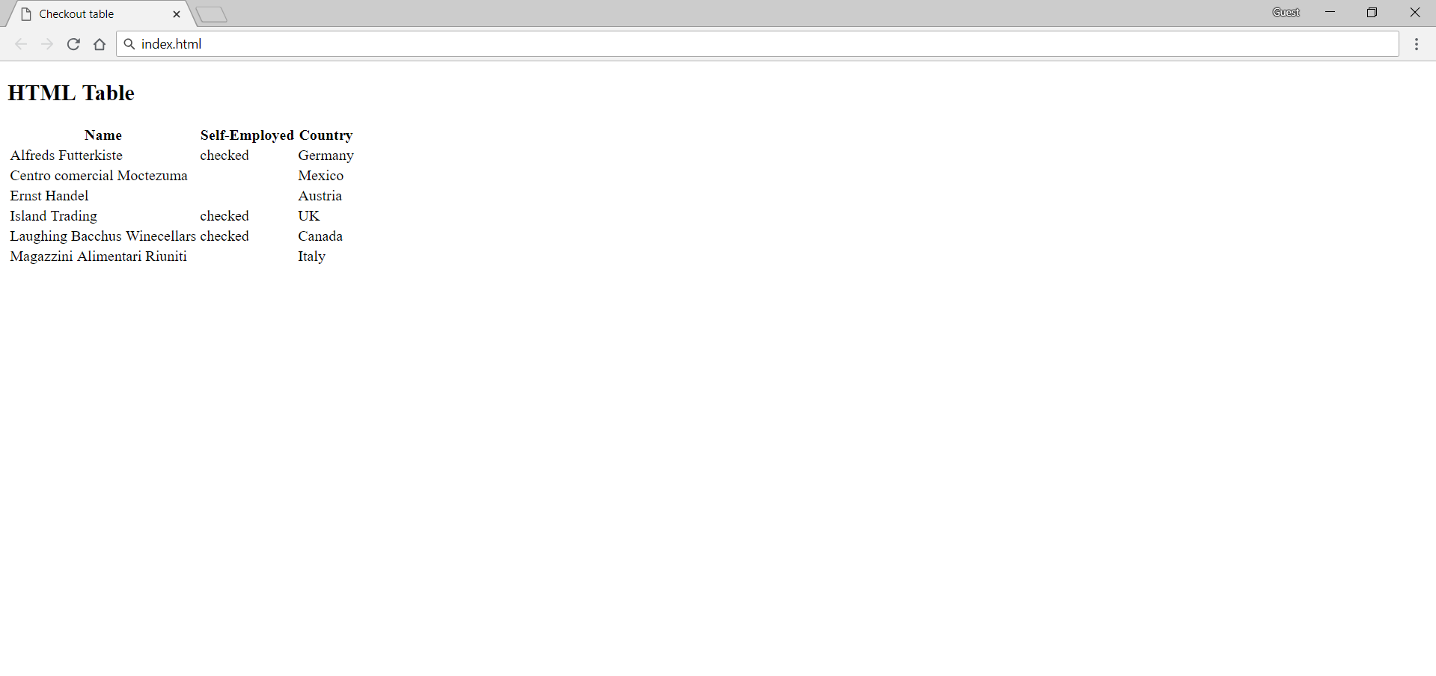

Constraints
- Change the document title to Checkout tablе
- Use h2 tag for heading
- Use table tag to create a table
- Use th and td tags for columns
- Use tr tag for rows
- Use span tag with value checked for checked items

