Exercise: CSS Box Model
Problems for exercises and homework for the "HTML and CSS" course @ SoftUni. Submit your solutions in the SoftUni Judge system at https://judge.softuni.bg/Contests/1235/CSS-Box-Model.

Box Model Container
Create a web page like the following:
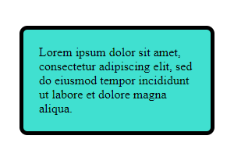

Constraints
- Change the document title to "Box Model Container"
- Use p tag to create a paragraph
- Set the paragraph width: 200px;
- Set padding and margin
- Set 5px solid border with border-radius
- Use rgb(64, 224, 208) color for the background
- Try to center the container with margin: auto

Box-sizing
Create a web page like the following:
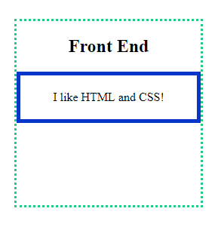

Constraints
- Change the document title to "Box Sizing"
- Use section tag to create a section. In the section you have:
  - h1 heading with content "Front End"
  - paragraph with content "I like HTML and CSS! "
- The section has width 250px, height 250px and border
- The paragraph has width 100%, border and padding 20px on all sides
- Set the "universal box-sizing" with inheritance
  - Hint: Check the presentation slide 40

Simple Article Page
Create a web page like the following:
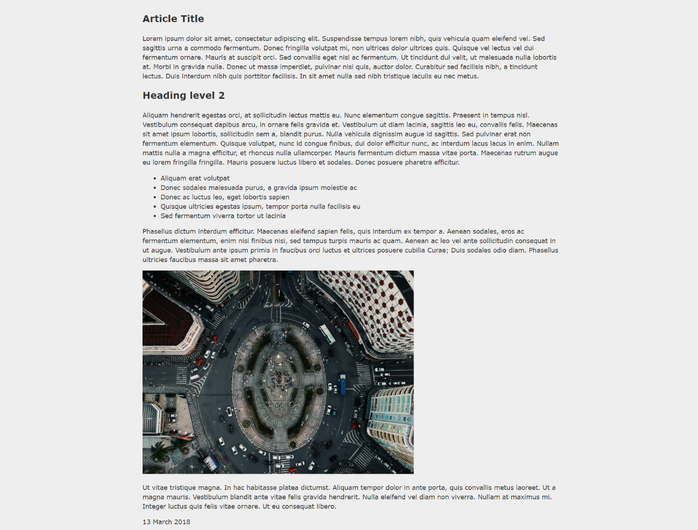

Constraints
- Change the document title to "Simple Article Page"
- Use article tag to create an article
  - Divide the article content into header, section and footer tags
- Add font to the document: Helvetica, sans-serif
- Use background with color - rgb(238, 238, 238)
- Use rgb(51, 51, 51) color for the text

Navigation Inline Block
Create a web page like the following:
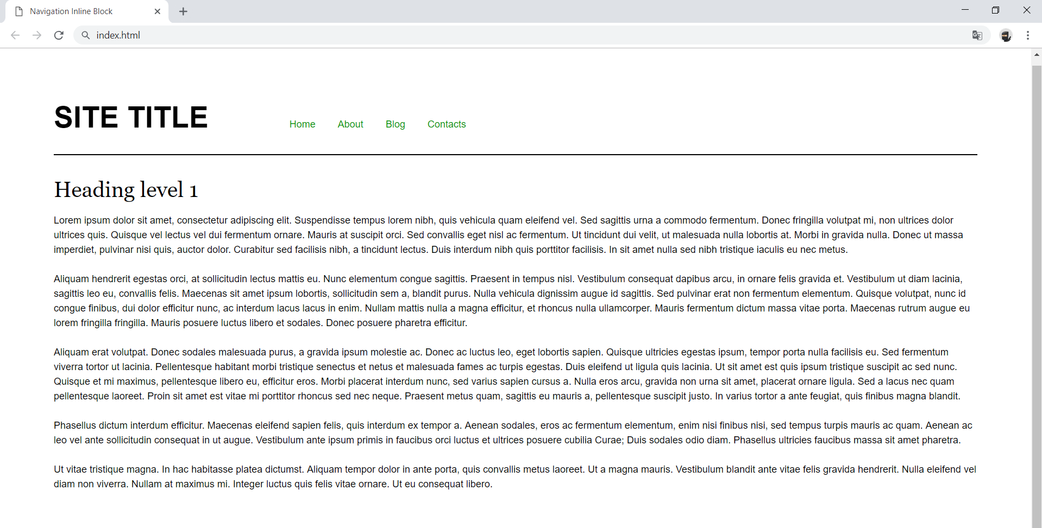

Constraints
- Change the document title to "Navigation Inline Block"
- Divide your content into header and main tags
- Add font to the document: Helvetica, sans-serif
- Create a navigation bar
  - Add four list items in nav tag with a tags inside
  - Add display: inline-block; style for each item in the nav

Photo Gallery Inline Block
Create a web page like the following:

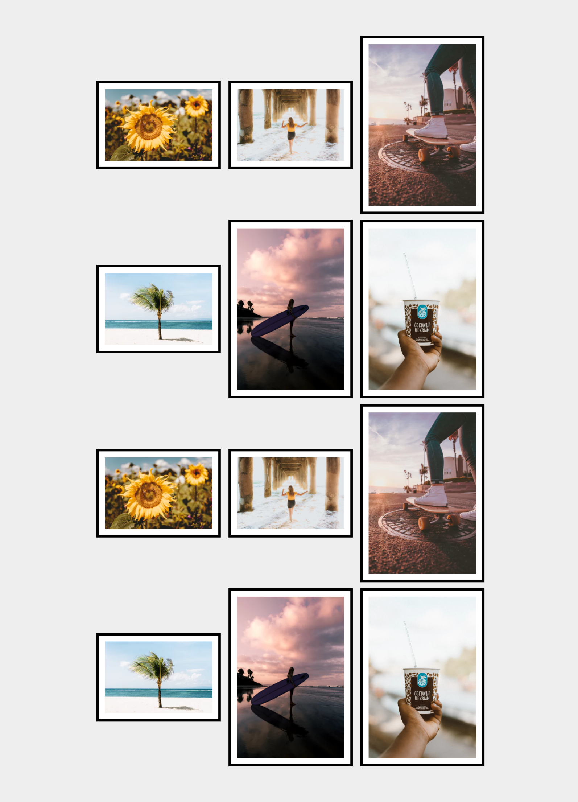

Constraints
- Change the document title to "Photo Gallery - Inline Block"
- Create unordered list with class gallery (ul.gallery)
- Add list items with images inside
- The list items must have
  - Border width - 0.4rem
  - Border color - black
  - Border style - solid

Blog Layout Inline Block
Create a web page like the following:
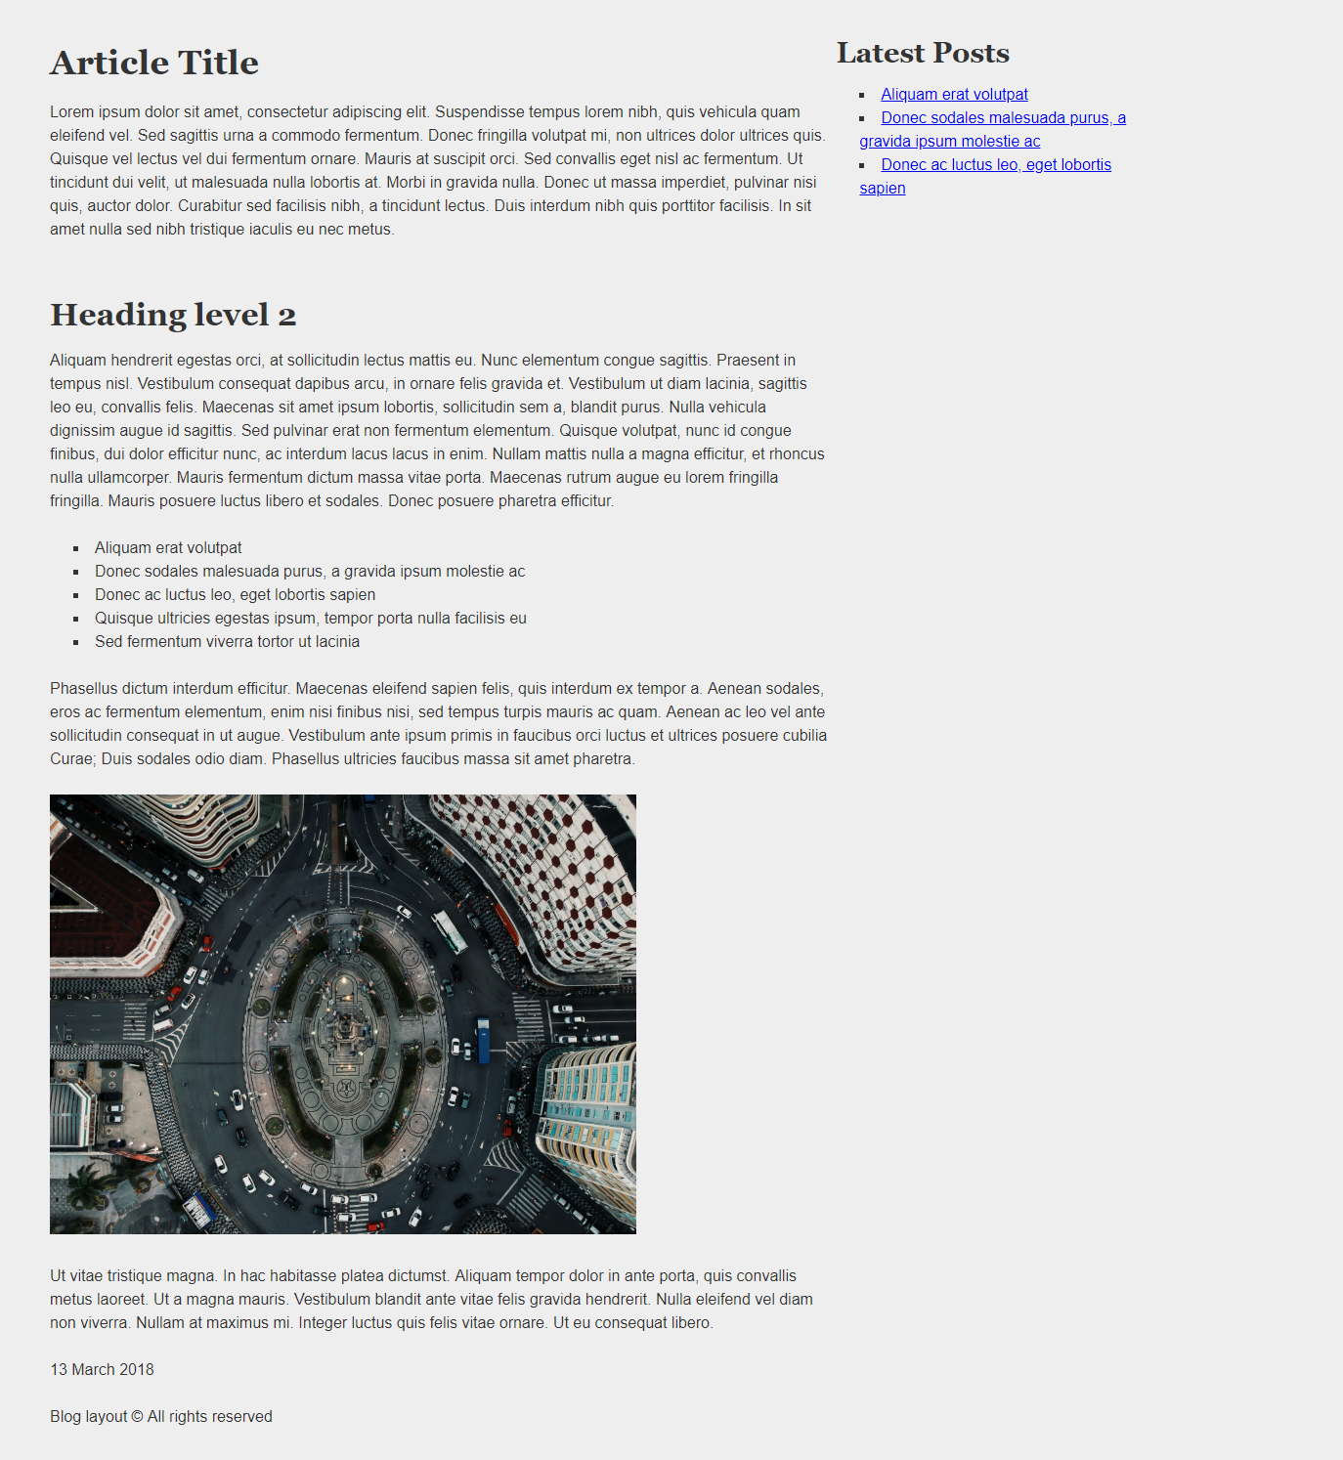

Constraints
- Change the document title to "Blog Layout Inline Block"
- Add font to the document: Helvetica, sans-serif
- Use article tag to create an article
  - Divide the article content into header, section and footer tags
- Use aside tag to create aside for the Latest Posts
- Use background with color - rgb(238, 238, 238)
- Use rgb(51, 51, 51) color for the text

