Database Basics MS SQL Exam – 13 February 2021
Submit your solutions in the SoftUni Judge system at Judge

Bitbucket

You've most likely heard of Github. Well … There is a side project called "Bitbucket" which is the back-up data of Github. You are one of the few selected to work in the multi-billion company, as one of the back-up database managers. You'll need to prove your skills by designing and manipulating data in the Instagraph prototype.

Section 1. DDL (30 pts)
You are given an E/R Diagram of the Trip Service:
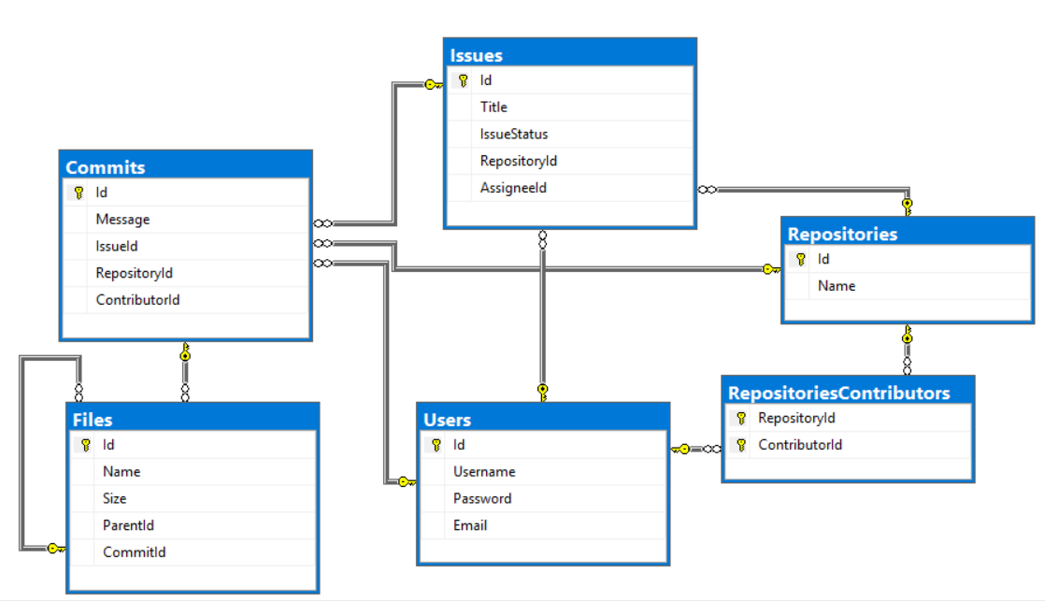
Crеate a database called Bitbucket. You need to create 6 tables:
- Users – contains information about the users
- Repositories – contains information about the repositories
- RepositoriesContributors – a many to many mapping table between the repositories and the users
- Issues – contains information about the issues
  - Each issue has a repository
  - Each issue has an assignee (user)
- Commits – contains information about the commits
  - Each commit MAY have an issue
  - Each commit has a repository
  - Each commit has a contributor (user)
- Files – contains information about the files.
  - Each file MAY have a parent (file)
  - Each file has a commit
NOTE: Keep in mind that Judge doesn't accept "ALTER" statement and square brackets naming (when the names are not keywords).
NOTE: Use VARCHAR for strings, not NVARCHAR.

You have been tasked to create the tables in the database by the following models:

Users
Column Name | Data Type | Constraints
Id | Integer from 0 to 2,147,483,647 | Unique table identificator, Identity
Username | String up to 30 symbols | NULL is not allowed
Password | String up to 30 symbols | NULL is not allowed
Email | String up to 50 symbols | NULL is not allowed

Repositories
Column Name | Data Type | Constraints
Id | Integer from 0 to 2,147,483,647 | Unique table identificator, Identity
Name | String up to 50 symbols | NULL is not allowed

RepositoriesContributors
Column Name | Data Type | Constraints
RepositoryId | Integer from 0 to 2,147,483,647 | NULL is not allowed, Relationship with table Repositories
ContributorId | Integer from 0 to 2,147,483,647 | NULL is not allowed, Relationship with table Users

Issues
Column Name | Data Type | Constraints
Id | Integer from 0 to 2,147,483,647 | Unique table identificator, Identity
Title | String up to 255 symbols | NULL is not allowed
IssueStatus | String with maximum 6 symbols | NULL is not allowed
RepositoryId | Integer from 0 to 2,147,483,647 | NULL is not allowed, Relationship with table Repositories
AssigneeId | Integer from 0 to 2,147,483,647 | NULL is not allowed, Relationship with table Users

Commits
Column Name | Data Type | Constraints
Id | Integer from 0 to 2,147,483,647 | Unique table identificator, Identity
Message | String up to 255 symbols | NULL is not allowed
IssueId | Integer from 0 to 2,147,483,647 | Relationship with table Issues
RepositoryId | Integer from 0 to 2,147,483,647 | NULL is not allowed, Relationship with table Repositories
ContributorId | Integer from 0 to 2,147,483,647 | NULL is not allowed, Relationship with table Users

Files
Column Name | Data Type | Constraints
Id | Integer from 0 to 2,147,483,647 | Unique table identificator, Identity
Name | String up to 100 symbols | NULL is not allowed
Size | Decimal number with two-digit precision | NULL is not allowed
ParentId | Integer from 0 to 2,147,483,647 | Relationship with table Files
CommitId | Integer from 0 to 2,147,483,647 | NULL is not allowed, Relationship with table Commits

Database Design
Submit all of yours CREATE statements to Judge (only creation of tables).

Section 2. DML (10 pts)
Before you start, you must import "DataSet-Bitbucket.sql". If you have created the structure correctly, the data should be successfully inserted without any errors.
In this section, you have to do some data manipulations:

Insert
Insert some sample data into the database. Write a query to add the following records into the corresponding tables. All Ids should be auto-generated.
Files
Name | Size | ParentId | CommitId
Trade.idk | 2598.0 | 1 | 1
menu.net | 9238.31 | 2 | 2
Administrate.soshy | 1246.93 | 3 | 3
Controller.php | 7353.15 | 4 | 4
Find.java | 9957.86 | 5 | 5
Controller.json | 14034.87 | 3 | 6
Operate.xix | 7662.92 | 7 | 7

Issues
Title | IssueStatus | RepositoryId | AssigneeId
Critical Problem with HomeController.cs file | open | 1 | 4
Typo fix in Judge.html | open | 4 | 3
Implement documentation for UsersService.cs | closed | 8 | 2
Unreachable code in Index.cs | open | 9 | 8

Update
Make issue status 'closed' where Assignee Id is 6.

Delete
Delete repository "Softuni-Teamwork" in repository contributors and issues.

Section 3. Querying (40 pts)
You need to start with a fresh dataset, so recreate your DB and import the sample data again ("DataSet-Bitbucket.sql").

Commits
Select all commits from the database. Order them by id (ascending), message (ascending), repository id (ascending) and contributor id (ascending).

Example
Id | Message | RepositoryId | ContributorId
1 | Deleted deprecated functionality from index.cpp | 17 | 8
2 | Created README.MD | 14 | 8
3 | Initial Commit | 24 | 1
4 | Implemented config.json functionality | 10 | 12
… | … | … | …

Front-end
Select all of the files, which have size, greater than 1000, and a name containing "html". Order them by size (descending), id (ascending) and by file name (ascending).

Example
Id | Name | Size
49 | compile.html | 27402.59
17 | Login.html | 2863.23
… | … | ..

Issue Assignment
Select all of the issues, and the users that are assigned to them, so that they end up in the following format: {username} : {issueTitle}. Order them by issue id (descending) and issue assignee (ascending).

Example
Id | IssueAssignee
75 | TheDivineBel : Critical bug in Controller.php ruins application when executed
74 | DarkImmagidsa : Compilation failed while trying to execute init.xml
73 | ScoreAntigarein : Loose Cohesion and Strong Coupling in Beat.html
… | …

Single Files
Select all of the files, which are NOT a parent to any other file. Select their size of the file and add "KB" to the end of it. Order them file id (ascending), file name (ascending) and file size (descending).

Example
Id | Name | Size
6 | Controller.json | 14034.87KB
12 | Model.MD | 4753.67KB
17 | Login.html | 2863.23KB
… | … | …

Commits in Repositories
Select the top 5 repositories in terms of count of commits. Order them by commits count (descending), repository id (ascending) then by repository name (ascending).

Example
Id | Name | Commits
1 | WorkWork | 20
7 | DundaApp | 16
10 | SortedTupleJS | 12
… | … | …

Average Size
Select all users which have commits. Select their username and average size of the file, which were uploaded by them. Order the results by average upload size (descending) and by username (ascending).

Example
Username | Size
RoundInspecindi | 19506.877500
BlaAntigadsa | 18397.434000
… | …

Section 4. Programmability (20 pts)

All User Commits
Create a user defined function, named udf_AllUserCommits(@username) that receives a username.
The function must return count of all commits for the user.

Example
Query
SELECT dbo.udf_AllUserCommits('UnderSinduxrein')
Output
6

Search for Files
Create a user defined stored procedure, named usp_SearchForFiles(@fileExtension), that receives files extensions.
The procedure must print the id, name and size of the file. Add "KB" in the end of the size. Order them by id (ascending), file name (ascending) and file size (descending).

Example
Query
EXEC usp_SearchForFiles 'txt'
Output
Id | Name | Size
28 | Jason.txt | 10317.54KB
31 | file.txt | 5514.02KB
43 | init.txt | 16089.79KB

