JS Back-End Exam – Tutorials

Exam Rules:
- You have 4 hours
- When you are ready, delete the node_modules folder, make sure all dependencies are listed in the package.json file and submit your archived project at: SoftUni Judge
- You are provided with HTML & CSS resources
- You may add attributes (such as class and dataset), but it is forbidden to change existing attributes (such as class and id)
- You may change "href" attributes on links and add/change the method and action attributes of HTML Forms.
- Use bcrypt for hashing the password
- Use Express.js as a back-end framework
- Use MongoDB as a database with mongoose
- You can use whatever view engine you like (Handlebars, EJS, Pug etc.…)
- The application must start on port 3000
- It is forbidden to use React, Vue, Angular etc.
- Only the last submission will be evaluated!

Application Overview
Get familiar with the provided HTML & CSS and create an application for tutorials, courses and course lectures.

Functional Requirements
The Functionality Requirements describe the functionality that the Application must support.
Guest (Not Logged In)
The application should provide Guest (not logged in) users with the functionality to login, register and view the Home page.
Users (Logged In)
The application should provide Users (logged in) with the functionality to view all the courses which are listed, course details page of all listed courses and they should be able to enroll in courses.
Database Models (10 Pts)
The Database of the Tutorials application needs to support:

User
- Username - string (required), unique
- Password - string (required)
- Enrolled Courses - a collection of Courses

Course
- Title - string (required), unique
- Description - string (required), max length of 50 symbols,
- Image Url - string (required),
- Duration – string (required),
- Created at – Date or String, (required),
- Users Enrolled - a collection of Users
Implement the entities with the correct datatypes.

Application Pages (70 Pts)
Guest Pages (15 Pts)
These are the pages and functionalities, accessible by Guests (logged out users).
Home Page (Logged Out User)
List the top three (3) public courses ordered by the count of enrolled in users in descending order.
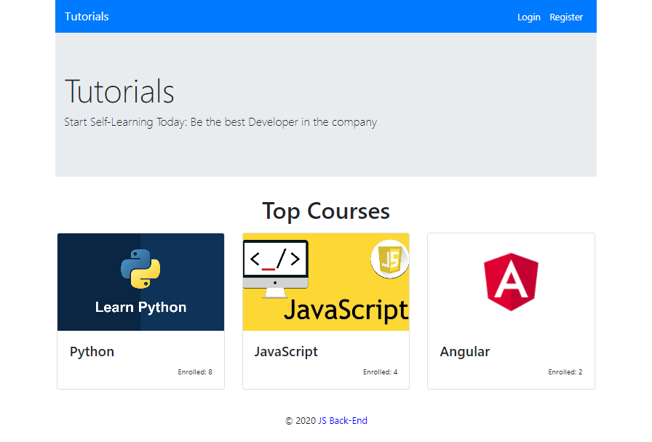
If there are no courses in the database yet, display "No courses..."
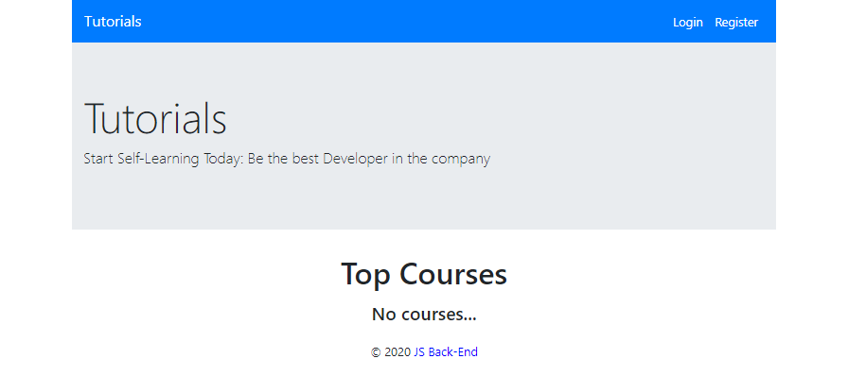
Register Page (Logged Out User)
Register a user inside the database with username and password. Both passwords must match! After successful registration, you should redirect to Home page and the user should be already logged in.
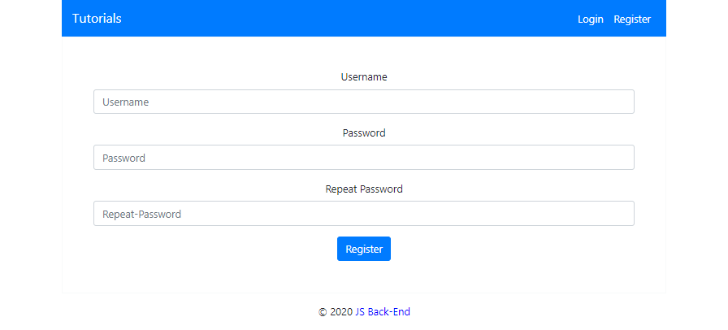
Login Page (Logged Out User)
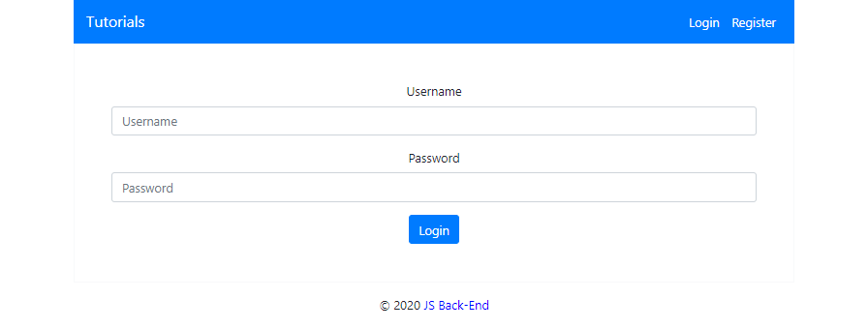
User Pages (55 Pts)
These are the templates and functionalities, accessible by Users (logged in users).
Home Page (Logged in User)
List all public courses sorted in ascending order by the created time with a button Details which leads to a course details page.
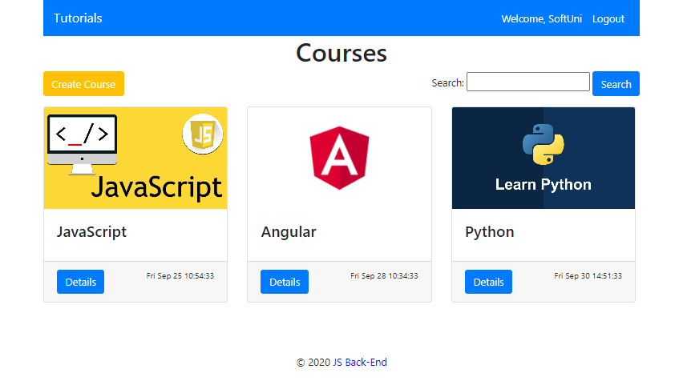
If there are no courses in the database yet, display "No courses..."
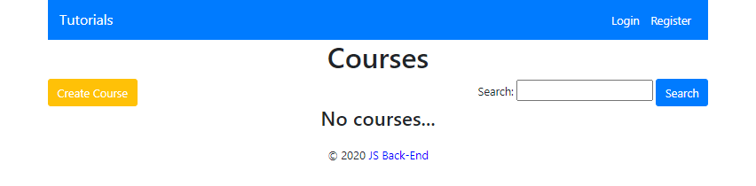
Create Course Page (Logged in User)
Enter course title, description, image URL and duration. After the course is created successfully, you should redirect to Home page.
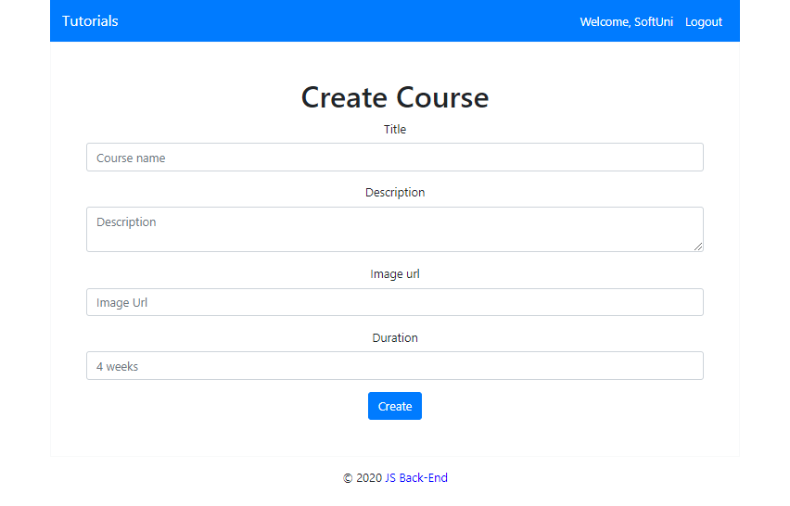
Logged in Details Page (Logged in User)
In the Details of a course section, you should load course name and description.
Not Enrolled in Course (Logged in User)
If the user is not enrolled in the course, you should display Enroll button.
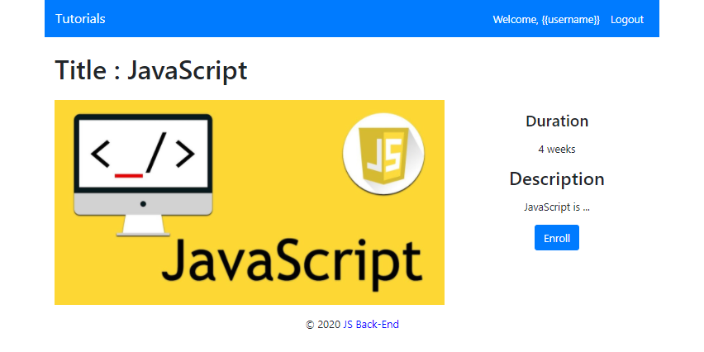

Enrolled in Course (Logged in User)
After the user has enrolled in the course, the "You are already enrolled" span element should be shown instead of the [Enroll] button.
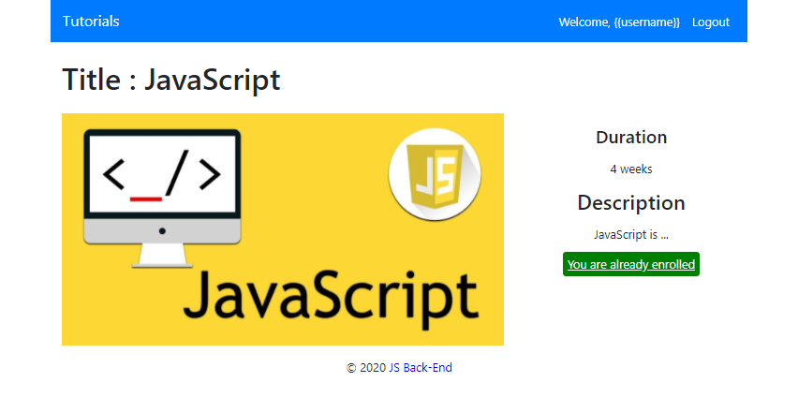
Course Creator (Logged in User)
The creator of the course should see [Delete] [Edit]
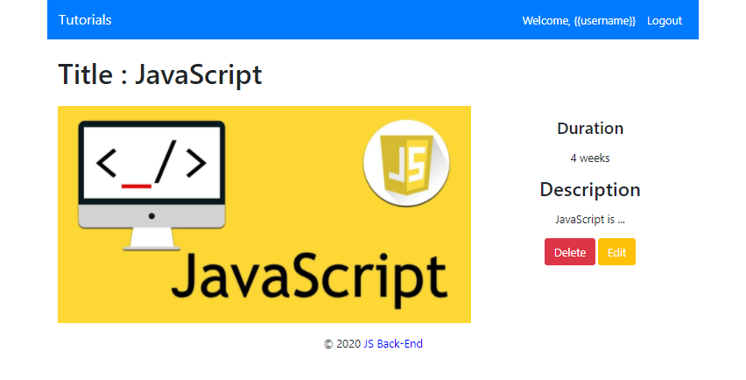
Delete Course (Logged in User)
Upon deleting a lecture (clicking over [Delete] button), you should be redirected to the home page.
Edit Course (Logged in User)
All form fields should be filled with the corresponding information of the selected course. When a put request is sent (clicking over [Edit] button), you should be redirected to the Details page.
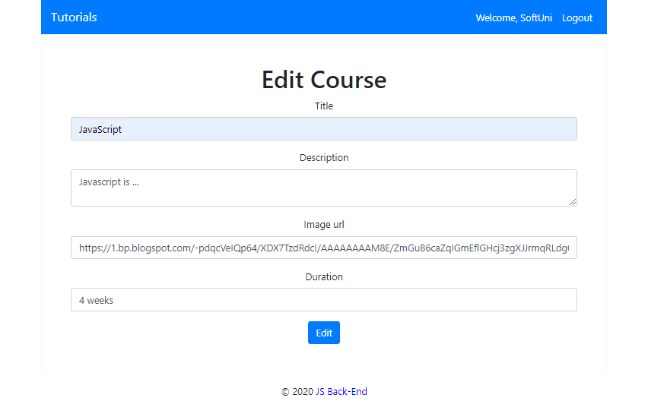
Security Requirements (10 Pts)
The Security Requirements are mainly access requirements. Configurations about which users can access specific functionalities and pages.
- Guest (not logged in) users can access Home page and functionality.
- Guest (not logged in) users can access Login page and functionality.
- Guest (not logged in) users can access Register page and functionality.
- Users (logged in) can access Home page (Listed all Courses)page and functionality.
- Users (logged in) can access Course Details page and functionality.
  - Users (not course creator) can Enroll once for the course
  - Users (course creator) can Edit and Delete the current course
- Users (logged in) can access Create Course page and functionality.
- Users (logged in) can access Logout functionality.
Validation and Error Handling (10 Pts)
The application should notify the users about result of their actions.

Login / Register
You should make the following validations:
- The username should be at least 5 characters long and should consist only english letters and digits
- The password should be at least 5 characters long and should consist only english letters and digits
- The repeat password should be equal to the password

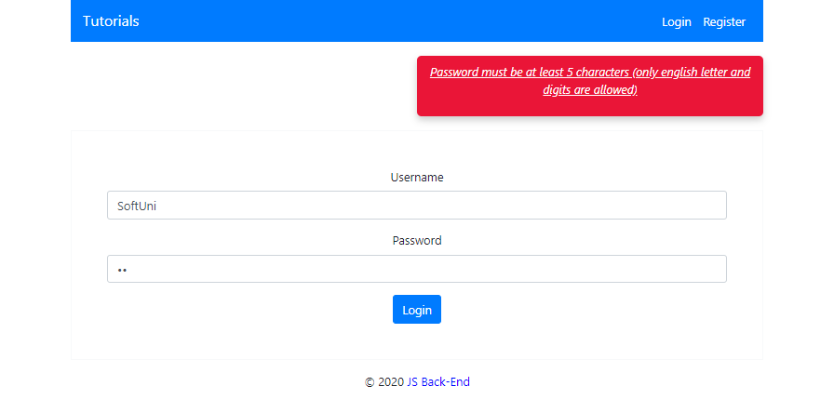

Course
You should make the following validations while creating or editing a course:
- The title should be at least 4 characters
- The description should be at least 20 characters long
- The imageUrl should starts with http or https
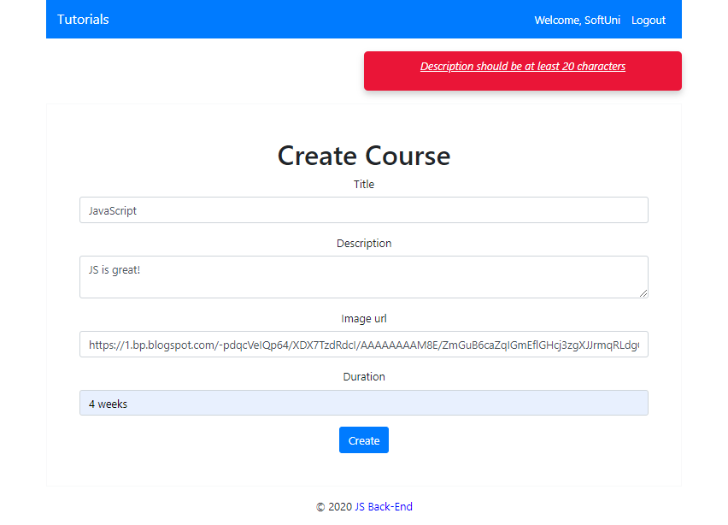

* Bonus (10 Pts)
Search in courses. Filter only the courses names that include the searched string (case-insensitive).


