JS Back-End Retake Exam – Art Gallery

Exam rules:
- You have 4 hours
- When you are ready, delete the node_modules folder, make sure all dependencies are listed in the package.json file and submit your archiving project.
- You are provided with HTML & CSS resources
- You may add attributes (such as class and dataset), but it is forbidden to change existing attributes (such as class and id)
- You may change "href" attributes on links and add/change the method and action attributes of HTML Forms.
- Use Express.js as a back-end framework
- Use MongoDB as a database with mongoose
- You can use whatever view engine you like (express-handlebars, EJS, Pug, etc.…)
- Use bcrypt for hashing the password
- The application must start from file "index.js" on port 3000
- It is forbidden to use React, Vue, Angular, etc.
- Only the last submission will be evaluated!

Application Overview
Get acquainted with the provided HTML and CSS and create an application for sharing masterpieces in an art gallery.
The visitors can view the home page - ArtGallery and Gallery with all art publications, they can also register with a username, password, and address, which will allow them to create their art publications, as well as share if interested (but only if the current user is not the author). Authors can edit or delete publications at any time.

Functional Requirements
The Functional Requirements describe the functionality that the application must support.

Guest (not logged in)
Guest navigation example:
The application should provide Guest (not logged in) users with the functionality to login, register, view the ArtGallery (home page), Gallery (all publications), and the Details page.

Users (logged in)
User navigation example:
The application should provide Users (logged in) with the functionality to:
- View ArtGallery (home page) and all other pages with logged-in navigation
- View Gallery
- Create new publication [Create Publication]
- Access publication details page [Details]
- Share publication (if the current user is not the author of the publication)
- Delete or Edit publication depending on user's authentication (only for the author of the current publication)

Database Models
The Database of the Art Gallery application needs to support 2 entities.
Note: You can add additional properties to the models if this will help you solve the task.

User
- Username - string (required),
- Password - string (required),
- Address - string (required),
- My Publications - a collection of Publication (a reference to the Publication Model)
Note: When a user creates a new publication, a reference to that publication is added to that collection (My Publications).

Publication
- Title - string (required),
- Painting technique - string (required),
- Art picture - string (required),
- Certificate of authenticity - string ("Yes", "No") required,
- Author - object Id (a reference to the User model),
- Users Shared - a collection of Users (a reference to the User model)
Note: When a user shares a given publication, their id is added to that collection (Users Shared).
Implement the entities with the correct data types.

Application Pages (80 pts)
Note: Don't forget to change the paths to the CSS files, and the images.

ArtGallery (for logged in users and logged-out users)
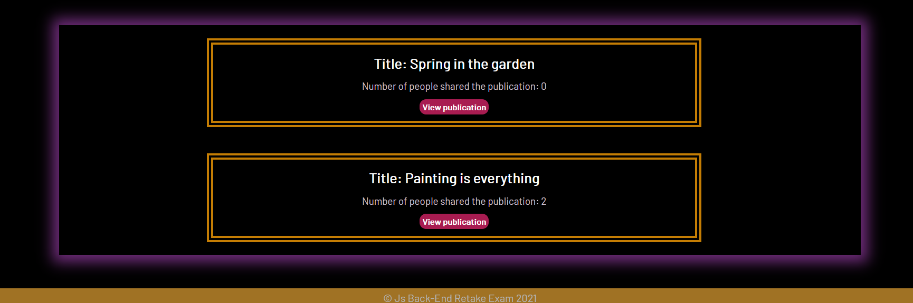
Preview all publications and user activity statistics. Each publication should display information about the title, and the number of people shared the publication, as well as the [View publication] button that leads to the details page for the specific publication.
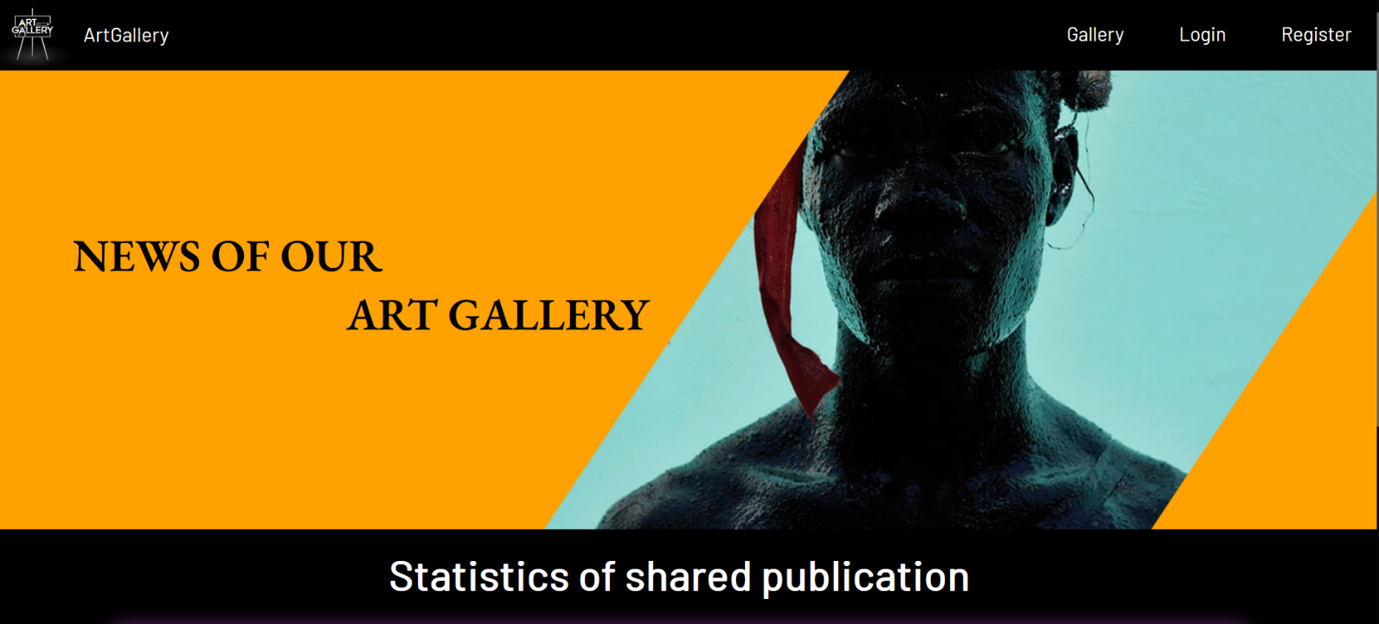
If there are NO publications yet, show the following view:
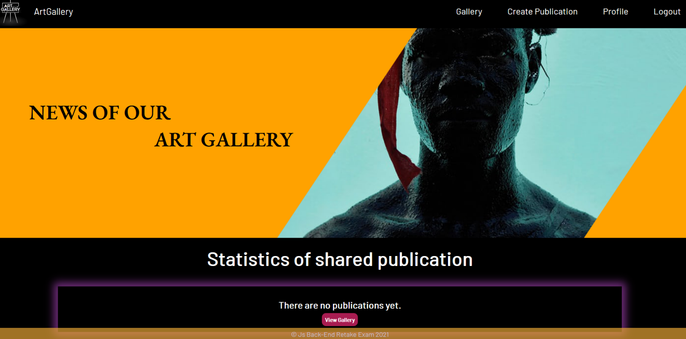

Register Page (logged out user)
Register a user inside the database with username, password, and address. Password inside the database must be hashed (use bcrypt) and both passwords must match! After successful registration redirects to the ArtGallery (home page), with an already logged-in user.
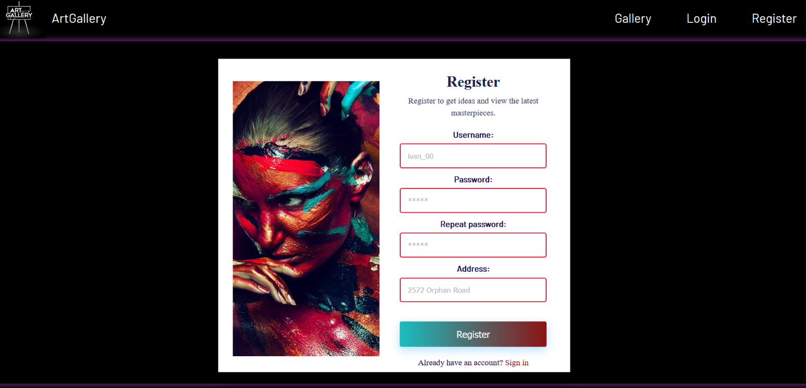

Login Page (logged out user)
Logging an already registered user with the correct username and password. After successful login redirects to the ArtGallery (home page), with an already logged-in user.
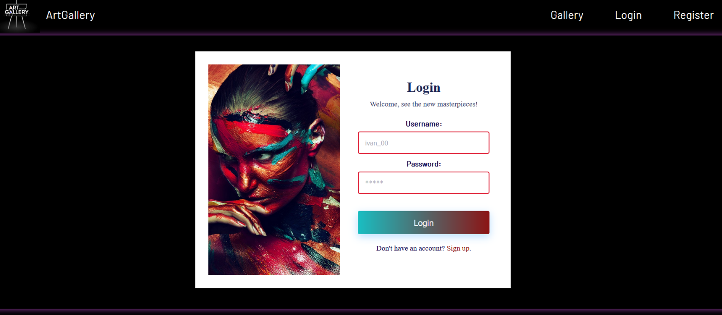

Logout (logged in user)
The logout action is available to logged-in users. Upon success, clear any session information and redirect the user to the ArtGallery (home page).

Gallery (for logged in users and logged out users)
List of all art publications. Each publication should display information about the art picture, the title, the certificate of authenticity, as well as the [Details] button that leads to the details page for the specific publication. Like in the picture below:
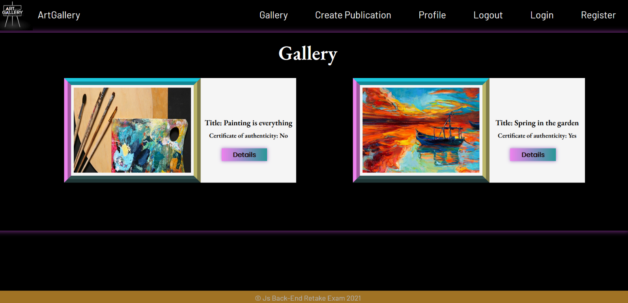
[Details] button should be a link to the details page for the current publication.
If there are no art publications in the database, display the following view:
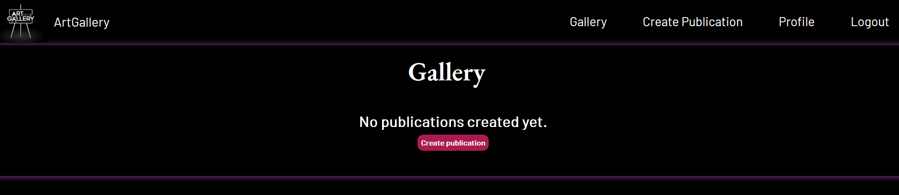
Details Page - (for logged in users and logged out users)
All users should be able to view details about the publication. Clicking the Details button in a publication card should display the Details page. If the currently logged-in user is the author of the publication, the Edit and Delete buttons should be displayed, otherwise they should not be available.
Information about the publication:
- Title
- Author
- Painting technique
- Certificate of authenticity
- Buttons (Depending on the status of the currently logged in user)

Details Page (logged out users)
If there are no logged-in users, no buttons should be displayed.
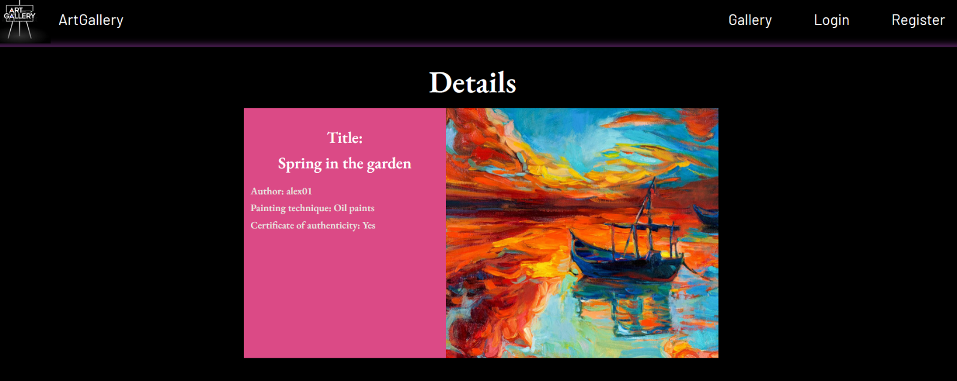

Details Page (logged in user and author of the current publication)
If the currently logged-in user is the author (the user who created the art publication), he should see the [Edit] and [Delete] buttons.
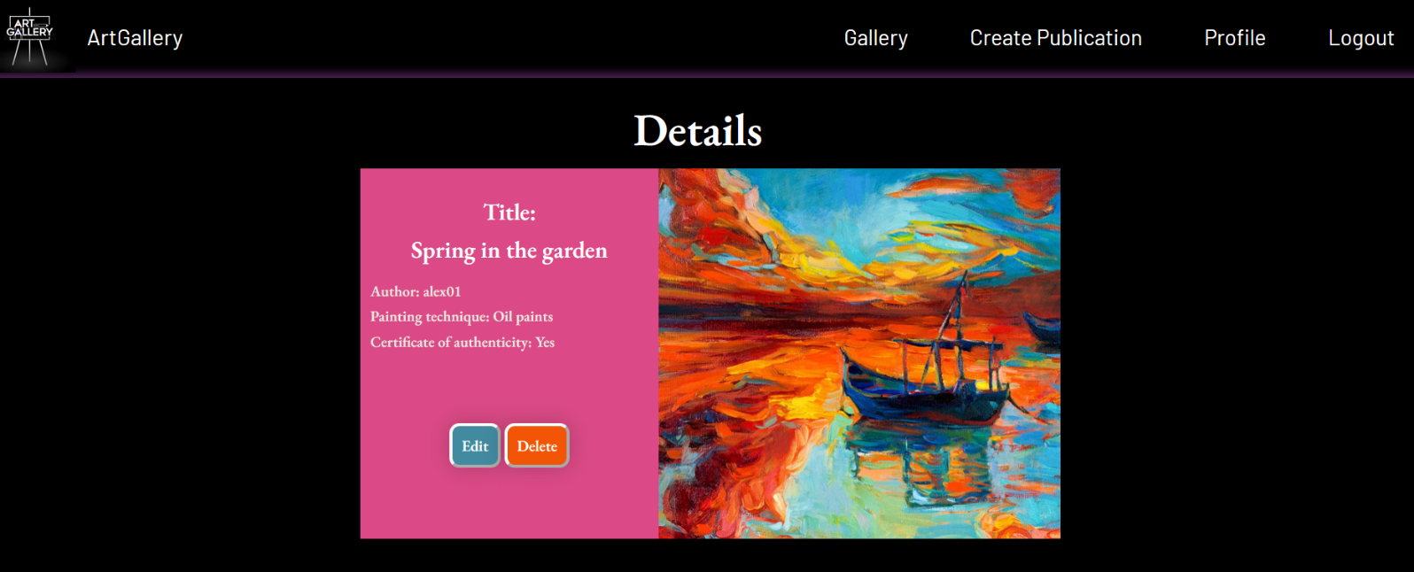

Details Page (logged in user who did not share publication)
If the currently logged-in user is not the author (the user that is not the creator for that publication) and has not shared this publication, he should see the [Share publication] button.
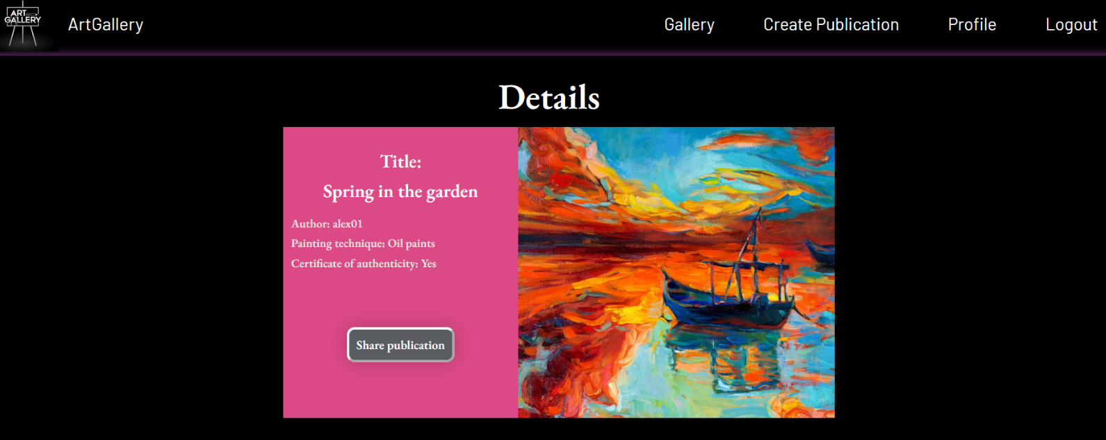
Note: In the photo shown, the [Share publication] button is not pressed, and the photo below (from the ArtGallery page) shows that there are no users who have shared the publication yet.
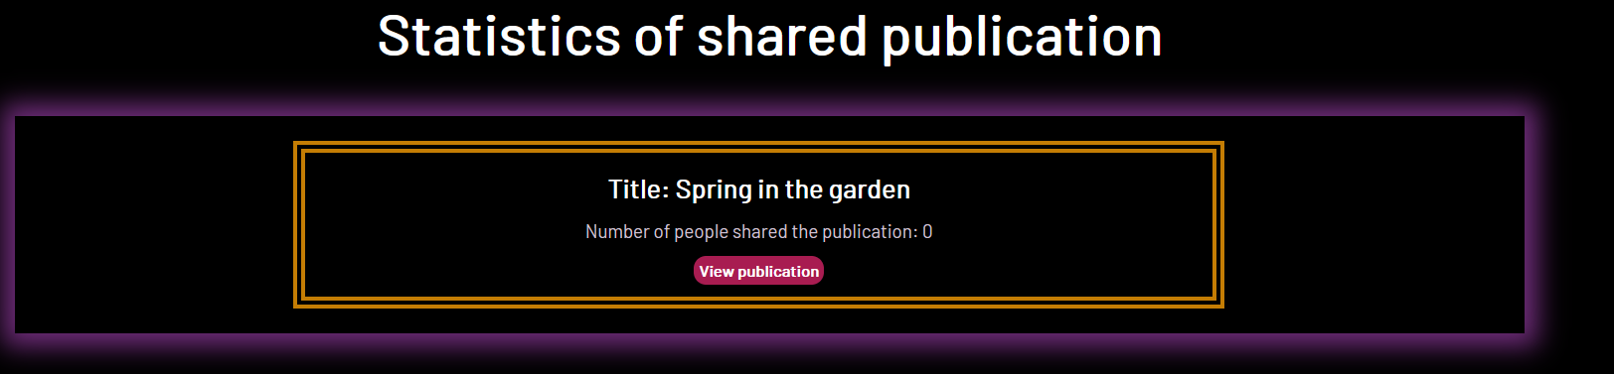

Details Page (logged in and has already shared a publication)
If the currently logged-in user is not the author and has already shared a current publication, he should see the paragraph [You already shared this publication].
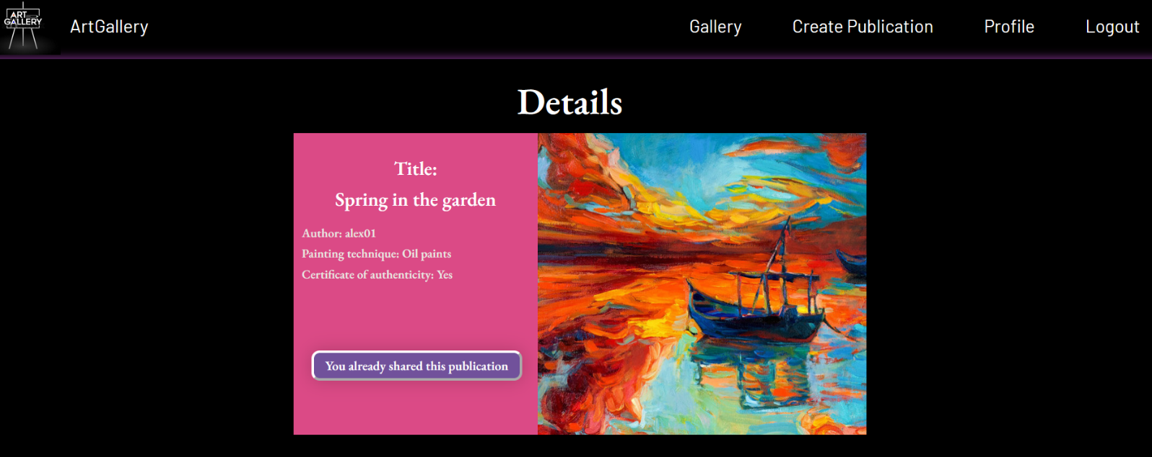
The photo below (from the ArtGallery page) should see the updated number as the user has already shared the publication.
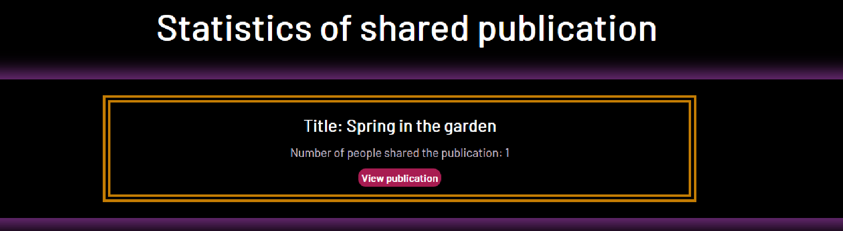

Share publication (logged in user who is not the author of the publication)
Any registered user who is not the author of the art publication must be able to share it (if he has not already shared it).
If it is successfully shared, the userId of the user must be added to the collection of Users Shared.
Then redirect the user to ArtGallery (home page), where they should see the updated value of a number of people shared the publication for the current publication, and it will be incremented by one. (See the reflected changes for the publication in the section "Shared Post Statistics").
If a user has shared a current publication, he should see the paragraph "You already shared this publication".

Create Publication Page (logged in user)
The Create page is available to logged-in users. It contains a form for adding new art publications. Upon success, redirect the user to the Gallery page (all art publications).
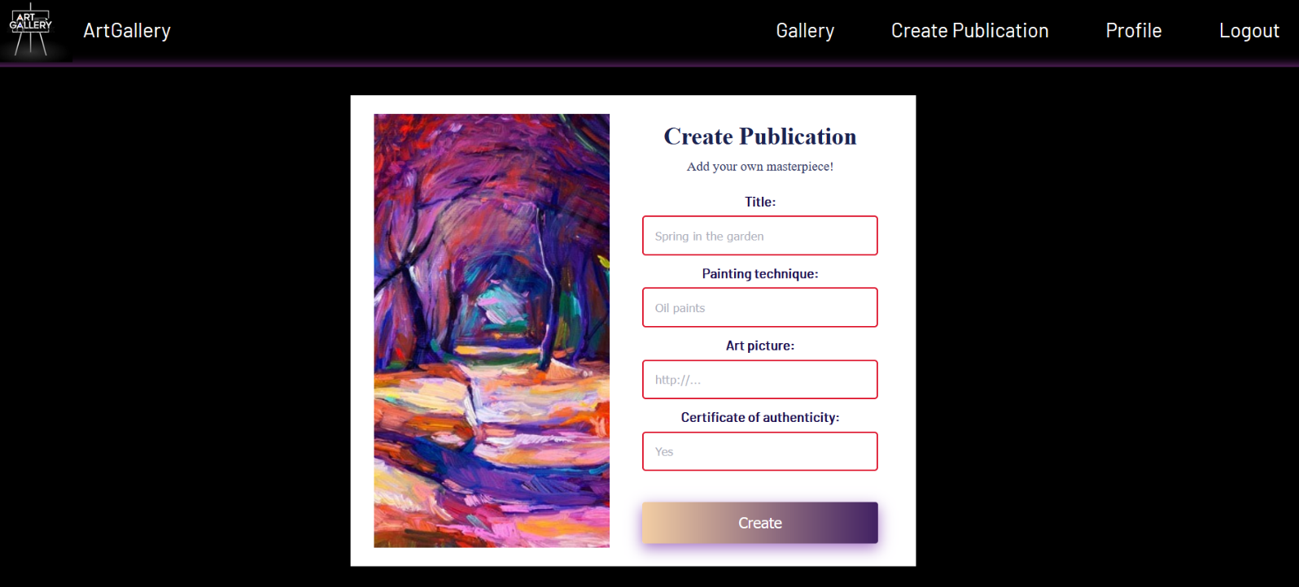

Delete Publication (logged in user and author of the current publication)
Every author should be able to click over the [Delete] button - deleting the current publication from the database and the user should be redirected to the Gallery page (all art publications).

Edit Publication (logged in user and author of the current publication)
The Edit page is available to logged-in users and it allows authors to edit their publications. Clicking the [Edit] button of a particular publication on the Details page should display the Edit page, with all fields filled with the data for the publication. It contains a form with input fields for all relevant properties. Upon success, redirect the user to the Details page for the current publication.
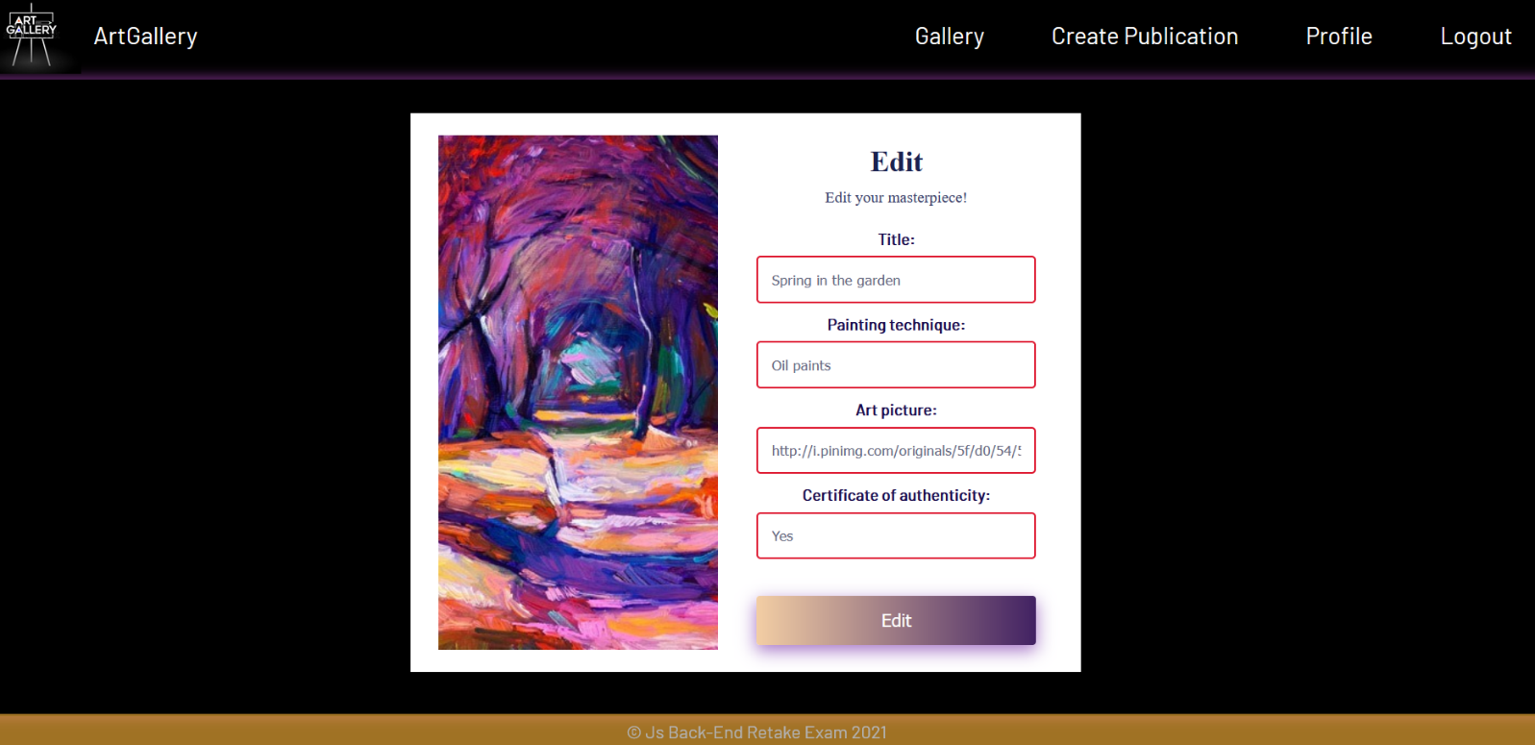

Security Requirements (Routes Guards) - (10 pts)
The Security Requirements are mainly access requirements. Configurations about which users can access specific functionalities and pages.
- Guest (not logged in) users can access the ArtGallery (home page).
- Guest (not logged in) users can access the Login page and functionality.
- Guest (not logged in) users can access the Register page and functionality.
- Guest (not logged in) and Users (logged in) can access Gallery (listed all publications).
- Guest (not logged in) can access the Details page without functionality.
- Users (logged in) can access ArtGallery (home page).
- Users (logged in) can access the Details page and functionality.
- Users (logged in) can access Create Publication page and functionality.
- Users (logged in) can access to Share Publication functionality.
- Users (logged in and author of the current publication can access the Delete and Edit publication functionality.
- Users (logged in) can access Logout functionality.
If Guests (not logged in) trying to access а page that it should not be able to, you must redirect them to the Login page.
If Users (logged in) trying to access а page that it should not be able to, you must redirect them to the ArtGallery.
Use the following view for invalid paths:
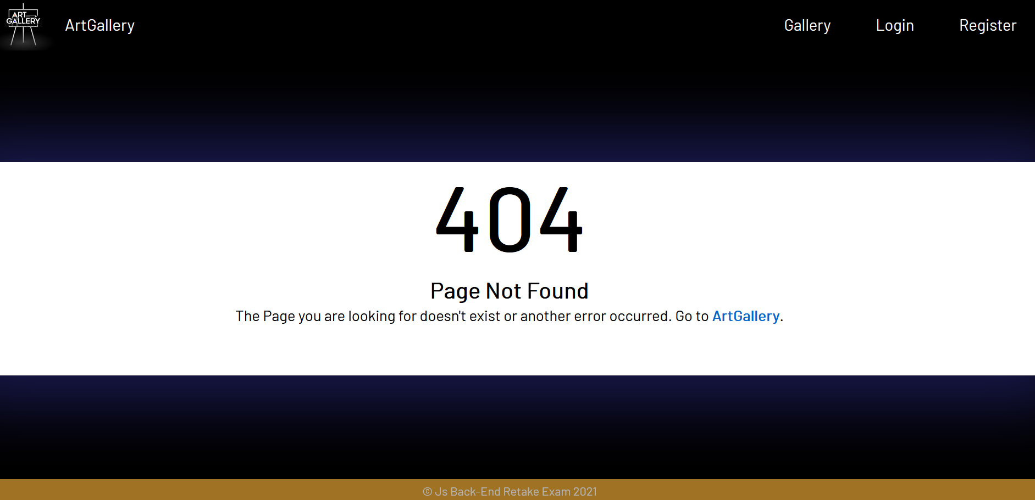

Validation and Error Handling (10 pts)
The application should notify the users about the result of their actions.
In case of error, you should display div with class "error-box".
You can choose to display the first error or all of them. You have complete freedom to choose the content of the error message you will display.

Login / Register
You should make the following validations:
- The username should be at least 4 characters long
- The password should be at least 3 characters long
- The repeat password should be equal to the password
- The address should be a maximum of 20 characters long
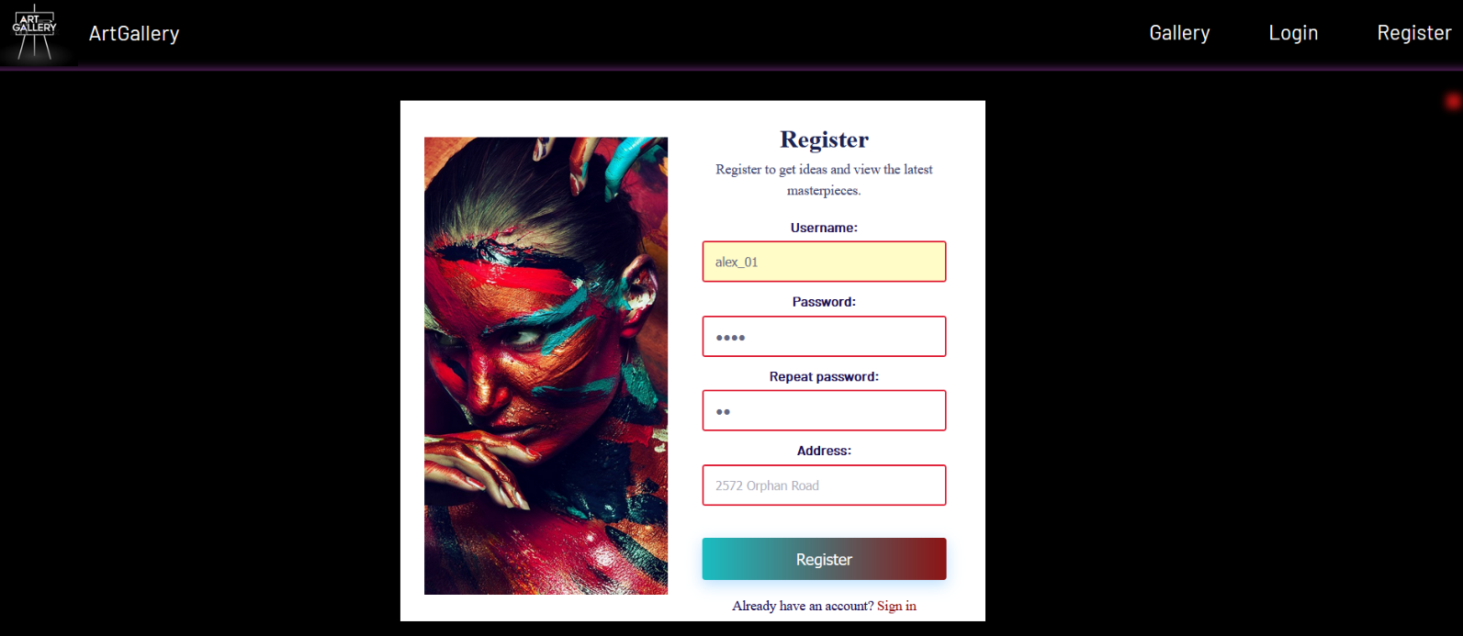

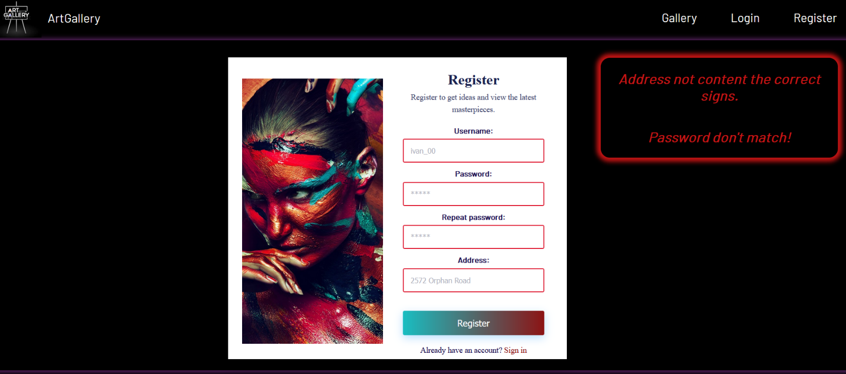
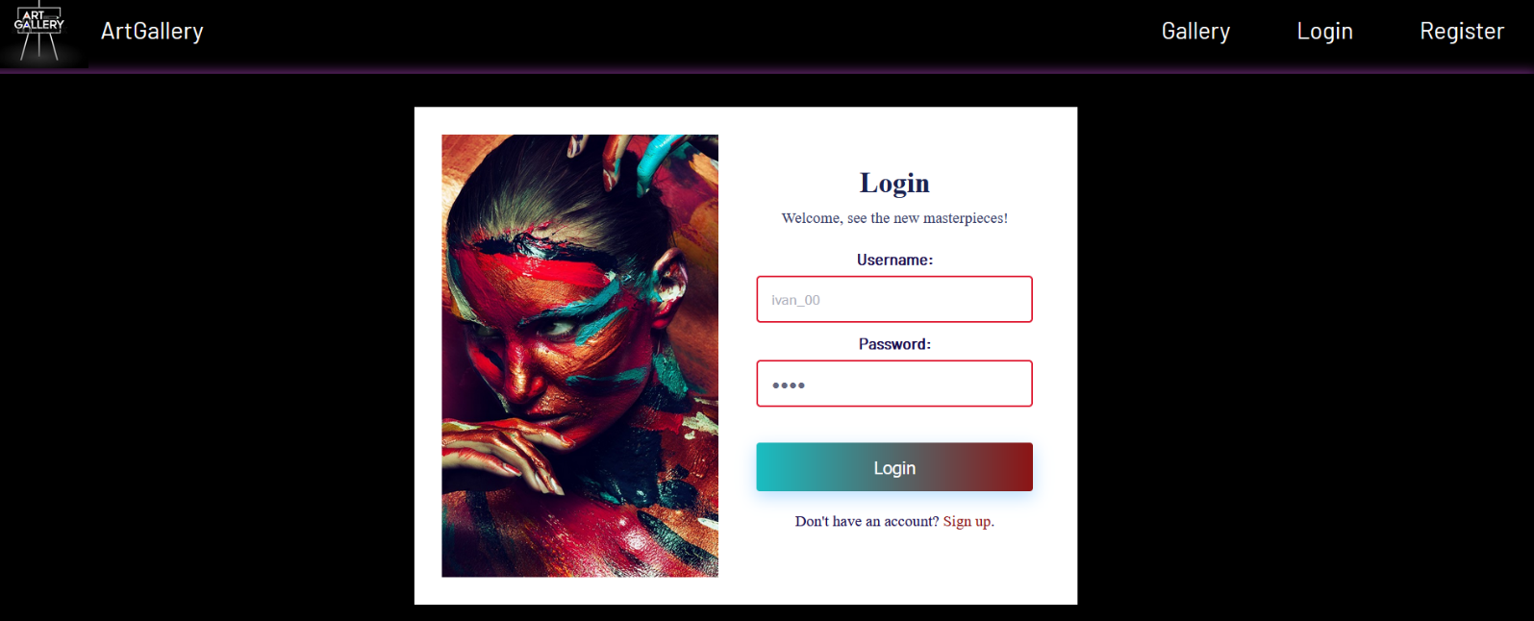
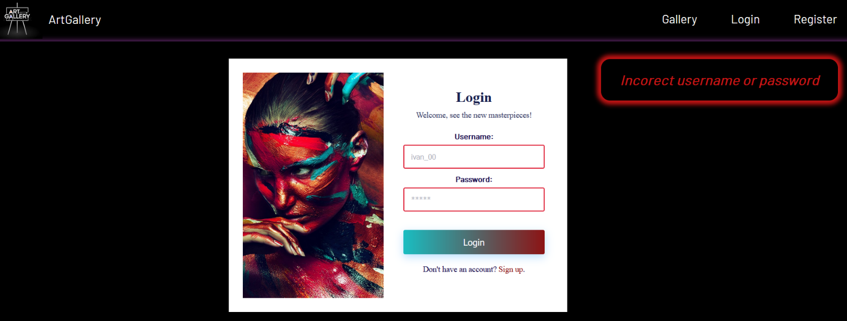

Publication
You should make the following validations while creating and editing a publication:
- The Title should be a minimum of 6 characters long.
- The Painting technique should be a maximum of 15 characters long.
- The Certificate of authenticity there must be value "Yes" or "No".
- The Art picture should start with http:// or https://.

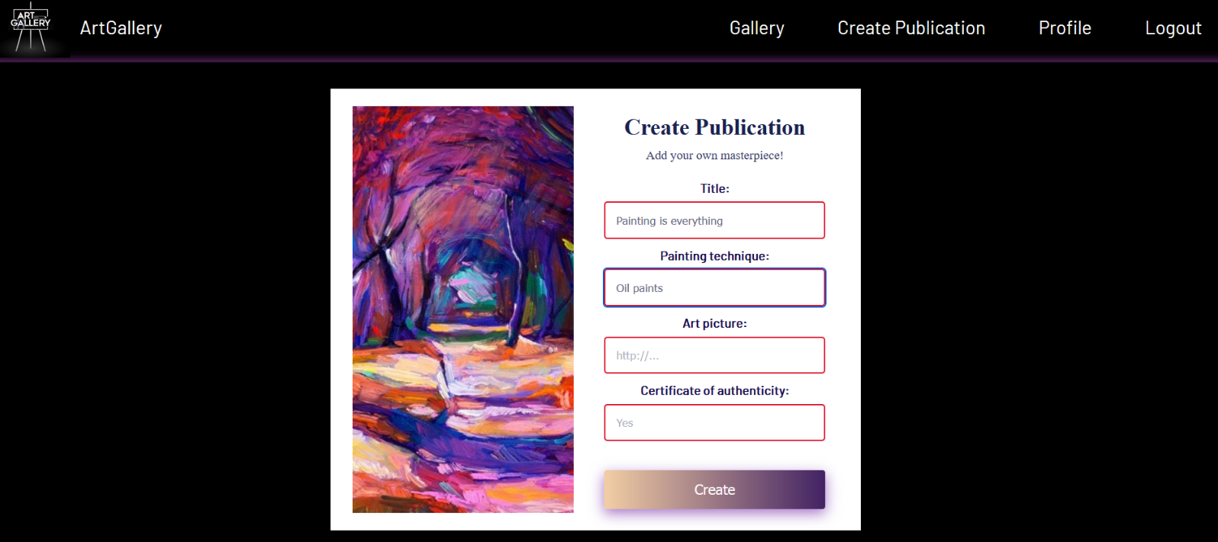

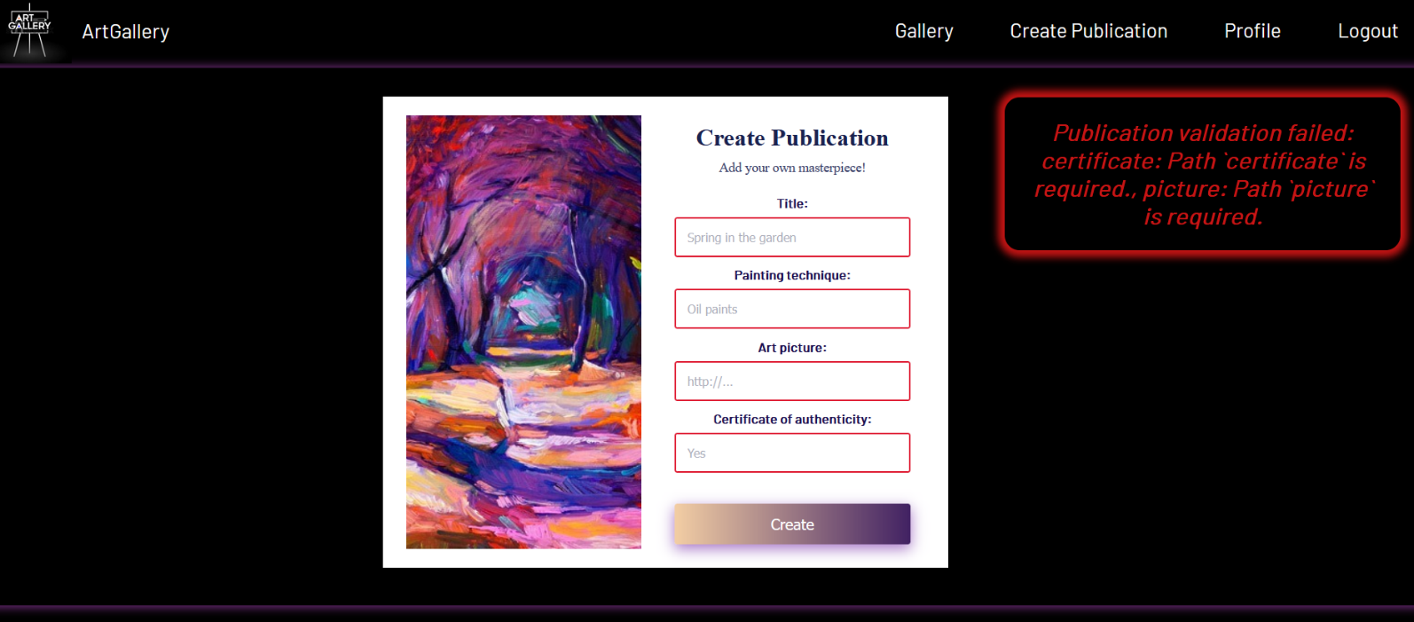

Bonus - Profile (10 pts)
Each logged-in user should be able to view their full profile information by clicking [Profile]. Username, address, titles of shared posts by the user (which the current user has shared), and the titles of which the user is the author with current user data must be completed.
If there are shared or own publications from the current user, separate their titles with a comma and a space (, ).
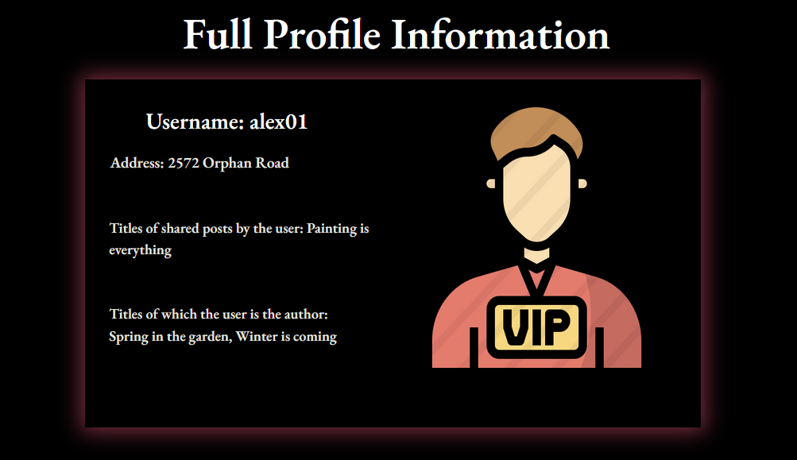
Otherwise, if there are no shared or own publications yet, the message "Not yet." should be visualized.
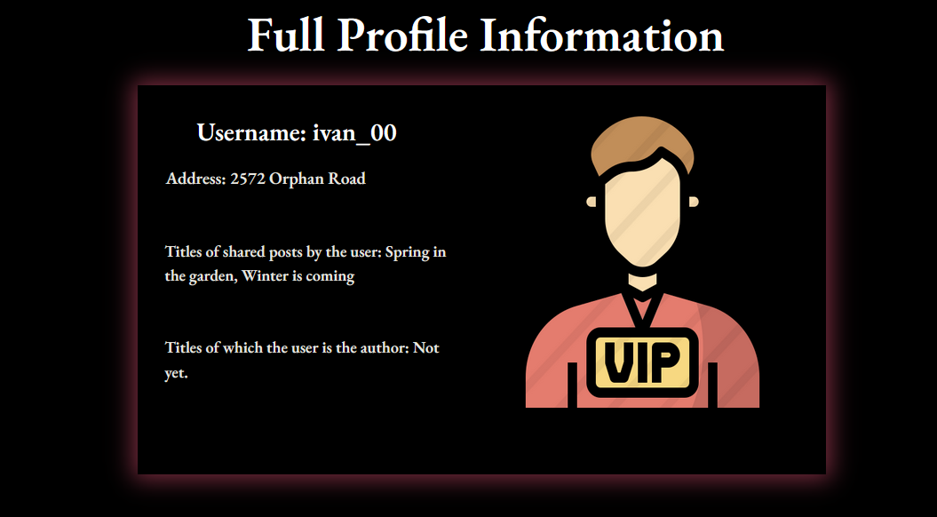

Submitting Your Solution
Place in a ZIP file your project folder. Exclude the node_modules folder. Upload the archive to Judge.
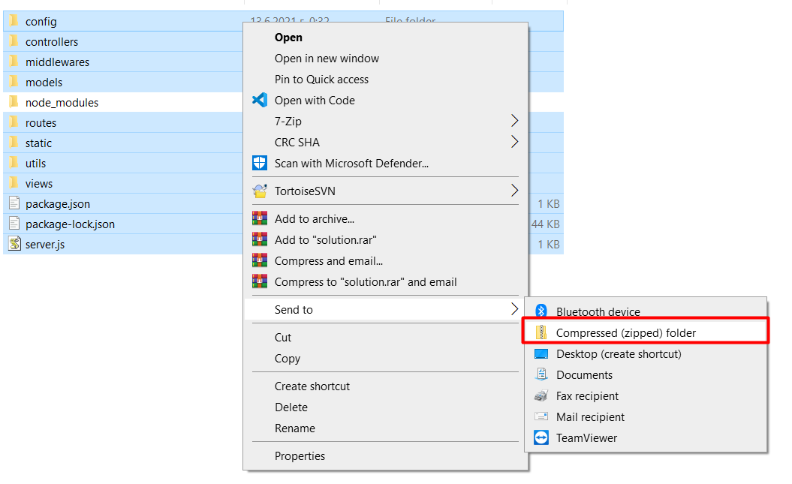
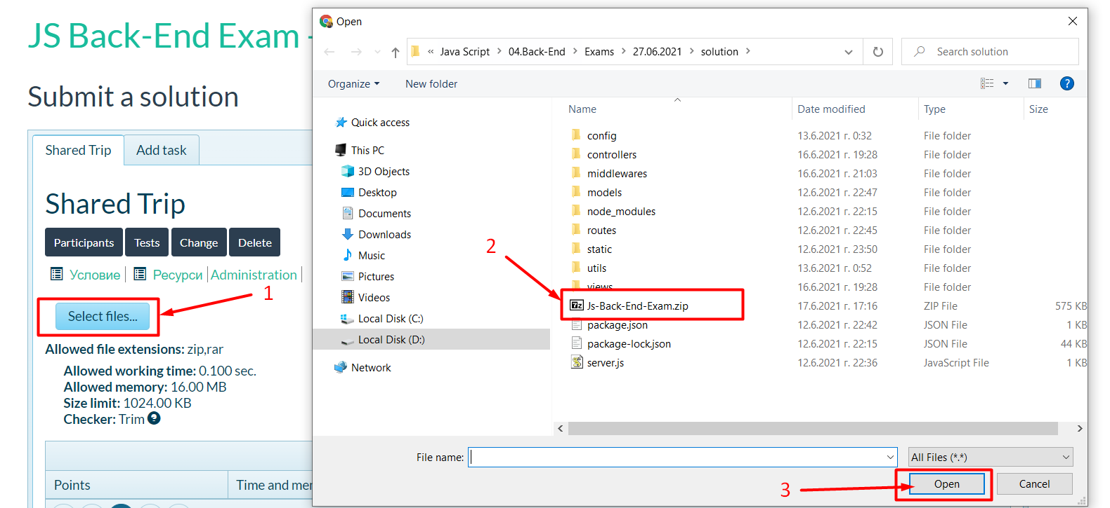
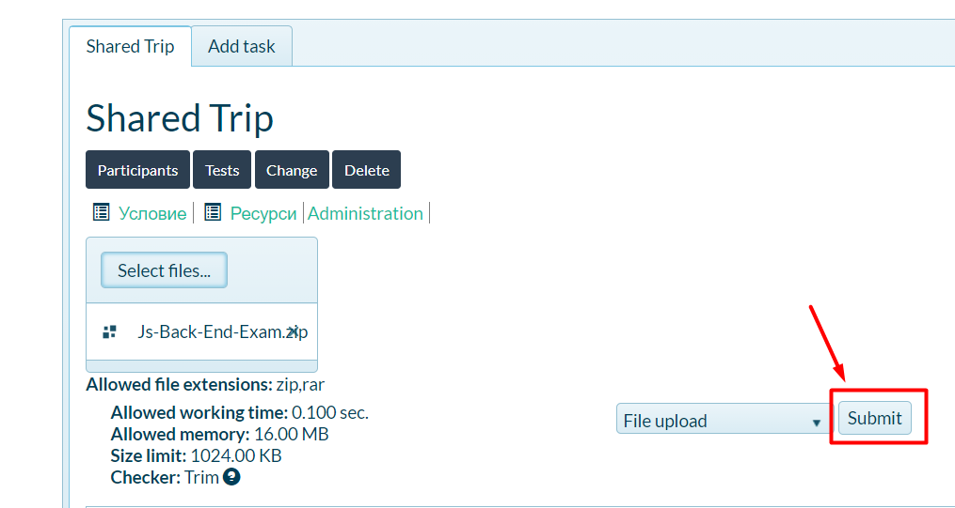
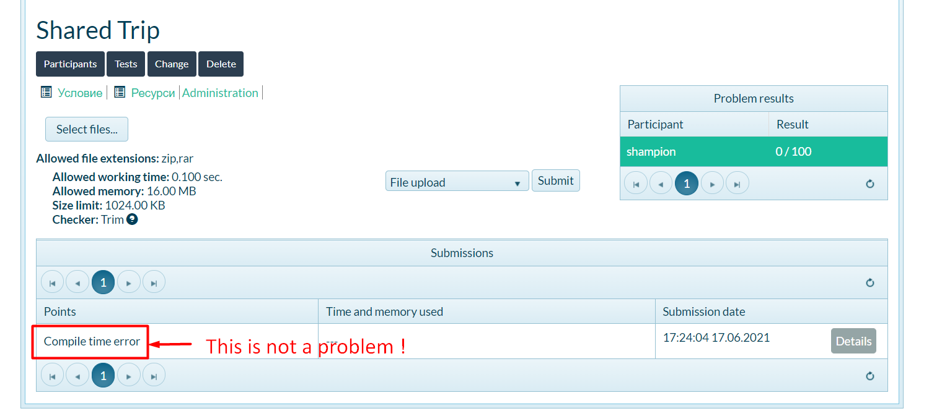

GOOD LUCK! 😊

