Lab: Databases and SQL Language
Problems for exercises and homework for the "Databases and SQL" course from the official "Applied Programmer" curriculum.
You can check your solutions here: https://judge.softuni.bg/Contests/3100/Databases-and-SQL-Language-Lab

Preface Databases and SQL Language
Note: if you don't have installed MS SQL Server LocalDB and SQL Server Management Studio, follow the installation guide 01. Databases-and-SQL-Server-Installation-Guide.docx to install:
- SQL Server LocalDB – this is the database engine
- SQL Server Management Studio (SSMS) – this is the tool to browse the database

Import the Database
Unzip the 01.Databases-and-SQL-Language-Lab.zip file, containing the databases. Start your SQL Server Manager Studio.
Import the SoftUni database. Follow the steps from 01.Import-the-DB-Guide.docx, if you already have this database, delete it and import it again.

Create E/R Diagram
In order to create an E/R diagram of the SoftUni database, go to Object Explorer -> Databases -> SoftUni and right-click on Database Diagrams. Choose [New Database Diagram].
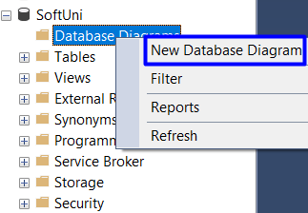
Then, select all tables and press [Add].
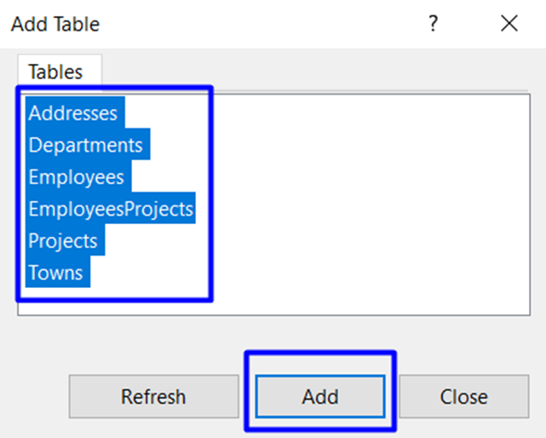
When tables are loaded, press [Close] and your diagram is already created. You can always re-arrange table blocks. The diagram should be something like this:
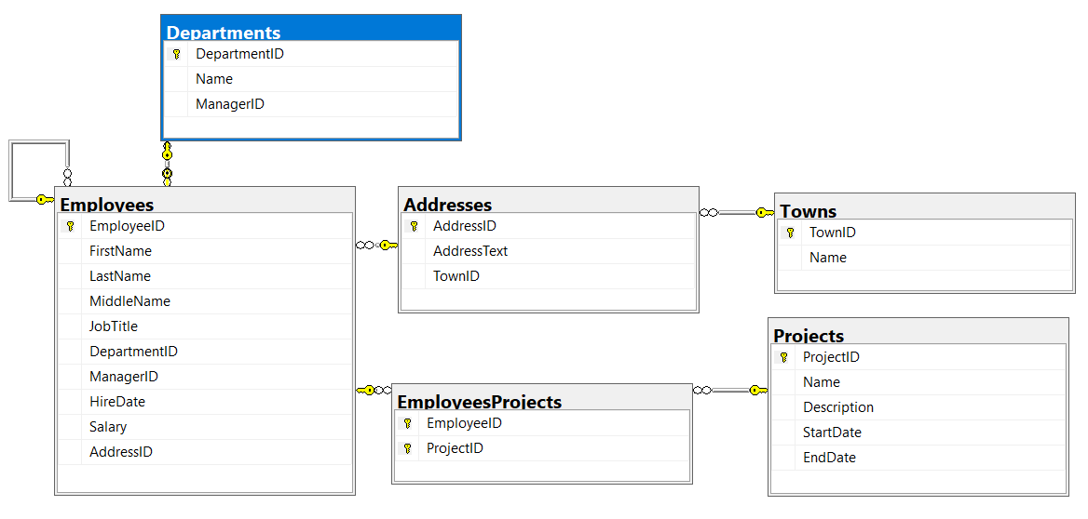

Display All Information about the Departments
Write a SQL query to find all available information about the Departments.

Example
DepartmentID | Name | ManagerID
1 | Engineering | 12
2 | Tool Design | 4
3 | Sales | 273
… | … | …

Hints
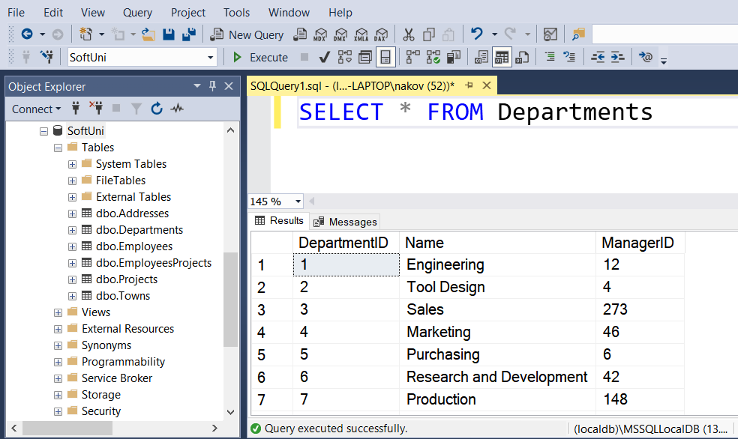

Submit Your Solution in Judge
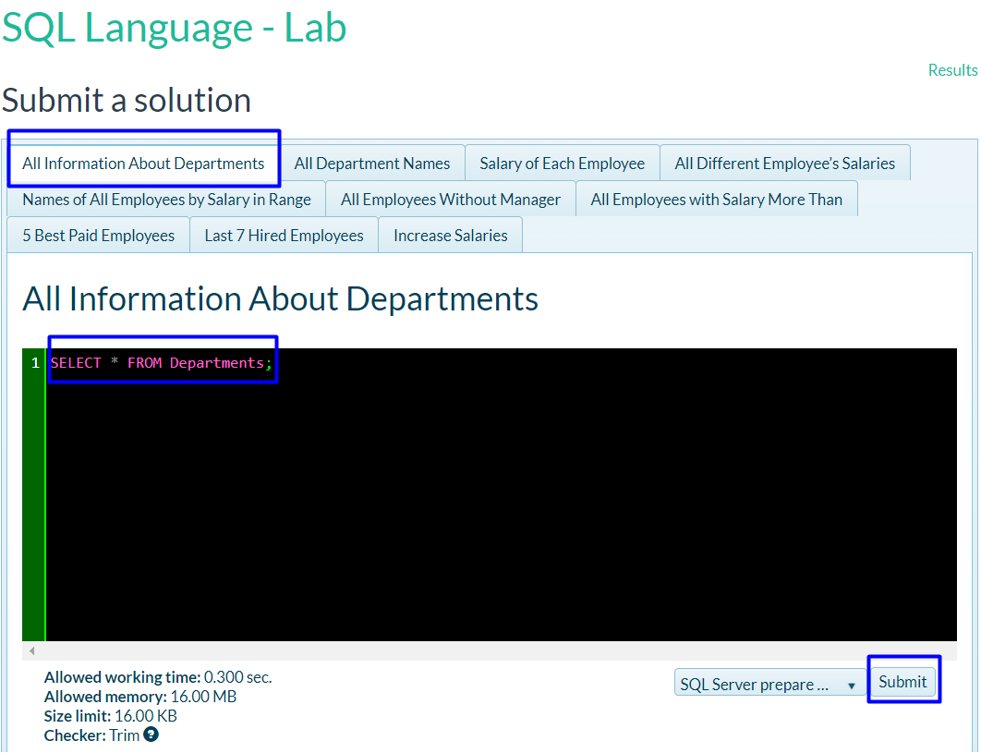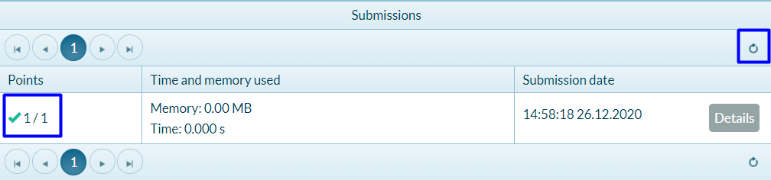

Display All Department Names
Write SQL query to find all Department names.

Example
Name
Engineering
Tool Design
Sales
…

Hints
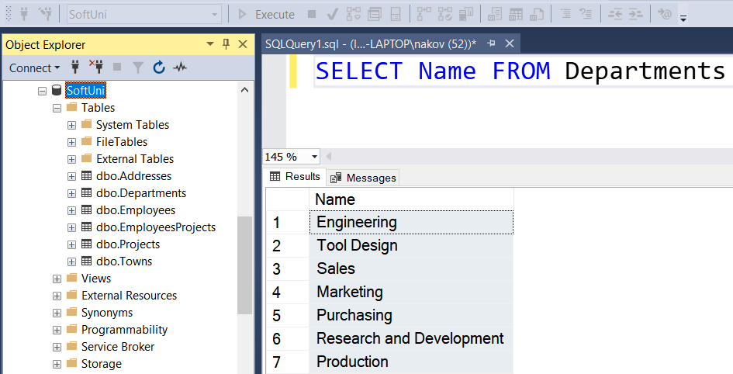

Salary of Each Employee
Write SQL query to find the first name, last name and salary of each employee.

Example
FirstName | LastName | Salary
Guy | Gilbert | 12500.00
Kevin | Brown | 13500.00
Roberto | Tamburello | 43300.00
… | … | …

All Different Employee’s Salaries
Write a SQL query to find all different employee’s salaries. Show only the salaries.

Example
Salary
9000.00
9300.00
9500.00
…

Names of All Employees by Salary in Range
Write a SQL query to find the first name, last name and job title of all employees whose salary is in the range [20000, 30000].

Example
FirstName | LastName | JobTitle
Rob | Walters | Senior Tool Designer
Thierry | D'Hers | Tool Designer
JoLynn | Dobney | Production Supervisor
… | … | …

All Employees Without Manager
Write a SQL query to find first and last names about those employees that does not have a manager.

Example
FirstName | LastName
Ken | Sanchez
Svetlin | Nakov
… | …

All Employees with Salary More Than 50000
Write a SQL query to find first name, last name and salary of those employees who has salary more than 50000. Order them in decreasing order by salary.

Example
FirstName | LastName | Salary
Ken | Sanchez | 125500.00
James | Hamilton | 84100.00
… | … | …

5 Best Paid Employees.
Write SQL query to find first and last names about 5 best paid Employees ordered descending by their salary.

Example
FirstName | LastName
Ken | Sanchez
James | Hamilton
… | …

Last 7 Hired Employees
Write a SQL query to find last 7 hired employees. Select their first, last name and their hire date.

Example
FirstName | LastName | HireDate
Rachel | Valdez | 2005-07-01 00:00:00
Lynn | Tsoflias | 2005-07-01 00:00:00
Syed | Abbas | 2005-04-15 00:00:00
… | … | …

Increase Salaries
Write a SQL query to increase salaries of all employees that are in the Engineering, Tool Design, Marketing or Information Services department by 12%. Then select Salaries column from the Employees table.

Example
Salary
12500.00
15120.00
48496.00
33376.00
…

Employee Address
Write a query that selects:
- EmployeeId
- JobTitle
- AddressId
- AddressText
Return the first 5 rows sorted by AddressId in ascending order.

Example
EmployeeId | JobTitle | AddressId | AddressText
142 | Production Technician | 1 | 108 Lakeside Court
30 | Human Resources Manager | 2 | 1341 Prospect St
… | … | … | …

Addresses with Towns
Write a query that selects:
- FirstName
- LastName
- Town
- AddressText
Sorted by FirstName in ascending order then by LastName. Select first 50 employees.

Example
FirstName | LastName | Town | AddressText
A.Scott | Wright | Newport Hills | 1400 Gate Drive
Alan | Brewer | Kenmore | 8192 Seagull Court
… | … | … | …

Sales Employee
Write a query that selects:
- EmployeeID
- FirstName
- LastName
- DepartmentName
Sorted by EmployeeID in ascending order. Select only employees from “Sales” department.

Example
EmployeeID | FirstName | LastName | DepartmentName
268 | Stephen | Jiang | Sales
273 | Brian | Welcker | Sales
… | … | … | …

Employee Departments
Write a query that selects:
- EmployeeID
- FirstName
- Salary
- DepartmentName
Filter only employees with salary higher than 15000. Return the first 5 rows sorted by DepartmentID in ascending order.

Example
EmployeeID | FirstName | Salary | DepartmentName
3 | Roberto | 43300.00 | Engineering
9 | Gail | 32700.00 | Engineering
… | … | … | …

Employees Without Project
Write a query that selects:
- EmployeeID
- FirstName
Filter only employees without a project. Return the first 3 rows sorted by EmployeeID in ascending order.

Example
EmployeeID | FirstName
2 | Kevin
6 | David
… | …

Employees Hired After
Write a query that selects:
- FirstName
- LastName
- HireDate
- DeptName
Filter only employees hired after 1.1.1999 and are from either "Sales" or "Finance" departments, sorted by HireDate (ascending).

Example
FirstName | LastName | HireDate | DeptName
Debora | Poe | 2001-01-19 00:00:00 | Finance
Wendy | Kahn | 2001-01-26 00:00:00 | Finance
… | … | … | …

Upgrade Databases and SQL Language

Create View Highest Peak
Write a SQL query to create view v_HighestPeak that selects all the information about the highest peak in the table Peaks. Use the Geography database.

Example
Id | PeakName | Elevation | MountainId
68 | Everest | 8848 | 9

Students and Classes
Create database called School.
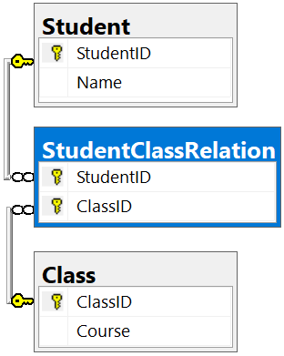
The school has classes and students and each class has many students and each student has many classes. There should be no student enrolled twice in a course. To create appropriate database you will need:
Table Student columns:
- StudentID – int, identity and primary key
- Name – string with size up to 100
Table Class columns:
- ClassID – int, identity and primary key
- Course – string with size up to 100
Table StudentClassRelation columns:
- StudentID – int and not null
- ClassID – int and not null
- Two FOREIGN KEY with references to tables Student and Class
- Primary key pair of (StudentID, ClassID)
Insert the following data:
- Add two students with names: Olaf Alfonso and Clark Davis
- Add the following classes: Biology, Chemistry, Physics, English, Computer Science, History
- The student Olaf Alfonso studies in these classes: Chemistry, English, History
- The student Clark Davis studies in these classes: Biology, Physics, History
The table StudentClassRelation should look like this:

Example
StudentID | ClassID
1 | 2
1 | 4
1 | 6
2 | 1
2 | 3
2 | 6

