Exercises: Databases and SQL Language
Problems for exercises and homework for the "Databases and SQL" course from the official "Applied Programmer" curriculum.
You can check your solutions here: https://judge.softuni.bg/Contests/3102/Databases-and-SQL-Language-Exercises

Preface Databases and SQL Language
Note: if you don't have installed MS SQL Server LocalDB and SQL Server Management Studio, follow the installation guide 01. Databases-and-SQL-Server-Installation-Guide.docx to install:
- SQL Server LocalDB – this is the database engine
- SQL Server Management Studio (SSMS) – this is the tool to browse the database

Import the Database
Unzip the 01.Databases-and-SQL-Language-Exercises.zip file, containing the databases. Import the Diablo database. If you already have this database, delete it and import it again.

Display All Information about the GameTypes
Write a SQL query to find all available information about the GameTypes. Use table GameTypes.

Example
Id | Name | BonusStatsId
1 | Expert | 116
2 | Beginner | 117
3 | Kinky | 118
4 | Intermediate | 119
5 | Funny | 120

Names of All Items by Price in Range
Write a SQL query to find the Name, Price, MinLevel of all items whose price is in the range [790, 800]. Use table Items.
Name | Price | MinLevel
Adventurers Journal | 792.00 | 24
Amulets | 792.00 | 49
Madstone | 795.00 | 52
Maras Kaleidoscope (Diablo III) | 791.00 | 68
… | … | …

All Games Without Duration
Write a SQL query to find Name and IsFinished about those games that does not have a duration. Use table Games.

Example
Name | IsFinished
Allium drumstick | 0
California pepperberry | 1
Eric John | 0

5 Best Items by Price
Write SQL query to find Name and Price about 5 best most expensive items ordered in descending by their price. Use table Items.

Example
Name | Price
Oculus Ring | 799.00
Thing of the Deep | 799.00
… | …

Increase Price
Write a SQL query to increase price by 10% of all items that are with minimum level 24, 41, 8 or 18. Then select Price column from the Items table.

Example
Price
792.00
473.00
714.00
313.00
…

Game and Type
Write a query that selects:
- Name from table Games
- Start from table Games
- Name as GameTypeName from table GameTypes
Sorted by Duration. Select first 50 games.

Example:
Name | Start | GameTypeName
Allium drumstick | 2014-05-07 08:39:00.000 | Beginner
California pepperberry | 2010-01-06 20:29:00.000 | Kinky
Eric John | 2015-06-07 09:17:00.000 | Intermediate
... | … | …

Items with Price, Type, Speed and Luck
Write a query that selects:
- Name of the items as Item Name
- Price of the items
- Name of the item type as Item Type
- Speed
- Luck
Select only items with MinLevel equal to 76. Sorted by Luck in descending order.

Example:
Item Name | Price | Item Type | Speed | Luck
Aquila Cuirass | 405.00 | Amulet | 10 | 19
Deathseers Cowl | 348.00 | Pauldron | 13 | 16
The Final Witness | 16.00 | Wand | 7 | 15
… | … | … | …
Users Joined On Game After
Write a query that selects:
- Username
- Name of games as Game Name
- Level of user on game (UsersGames)
- Cash of of user on game (UsersGames)
Filter only users joined on game after 1.1.2015 and the game duration is either 5 or 7.

Example:
Username | Game Name | Level | Cash
potterssnarky | Bucharest | 69 | 7573.00
printerstencils | Eucalyptus seeded | 35 | 7719.00
inguinalself | Bucharest | 9 | 5176.00
Siyka | Lake Mead | 45 | 6337.00
… | … | … | …

Upgrade Databases and SQL Language

One-To-One Relationship
Create two tables as follows. Use appropriate data types.
Persons |  |  |  |  | Passports
PersonID | FirstName | Salary | PassportID |  | PassportID | PassportNumber
1 | Roberto | 43300.00 | 102 |  | 101 | N34FG21B
2 | Tom | 56100.00 | 103 |  | 102 | K65LO4R7
3 | Yana | 60200.00 | 101 |  | 103 | ZE657QP2
Insert the data from the example above.
Alter the customers table and make PersonID a primary key. Create a foreign key between Persons and Passports by using PassportID column.

One-To-Many Relationship
Create two tables as follows. Use appropriate data types.
Models |  |  |  | Manufacturers
ModelID | Name | ManufacturerID |  | ManufacturerID | Name | EstablishedOn
101 | X1 | 1 |  | 1 | BMW | 07/03/1916
102 | i6 | 1 |  | 2 | Tesla | 01/01/2003
103 | Model S | 2 |  | 3 | Lada | 01/05/1966
104 | Model X | 2
105 | Model 3 | 2
106 | Nova | 3
Insert the data from the example above. Add primary keys and foreign keys.

Many-To-Many Relationship
Create three tables as follows. Use appropriate data types.
Students |  |  | Exams |  |  | StudentsExams
StudentID | Name |  | ExamID | Name |  | StudentID | ExamID
1 | Mila |  | 101 | SpringMVC |  | 1 | 101
2 | Toni |  | 102 | Neo4j |  | 1 | 102
3 | Ron |  | 103 | Oracle 11g |  | 2 | 101
 |  |  |  |  |  | 3 | 103
 |  |  |  |  |  | 2 | 102
 |  |  |  |  |  | 2 | 103
Insert the data from the example above.
Add primary keys and foreign keys. Have in mind that table StudentsExams should have a composite primary key.

Self-Referencing
Create a single table as follows. Use appropriate data types.
Teachers
TeacherID | Name | ManagerID
101 | John | NULL
102 | Maya | 106
103 | Silvia | 106
104 | Ted | 105
105 | Mark | 101
106 | Greta | 101
Insert the data from the example above. Add primary keys and foreign keys. The foreign key should be between ManagerId and TeacherId.

Online Store Database
Create a new database and design the following structure:
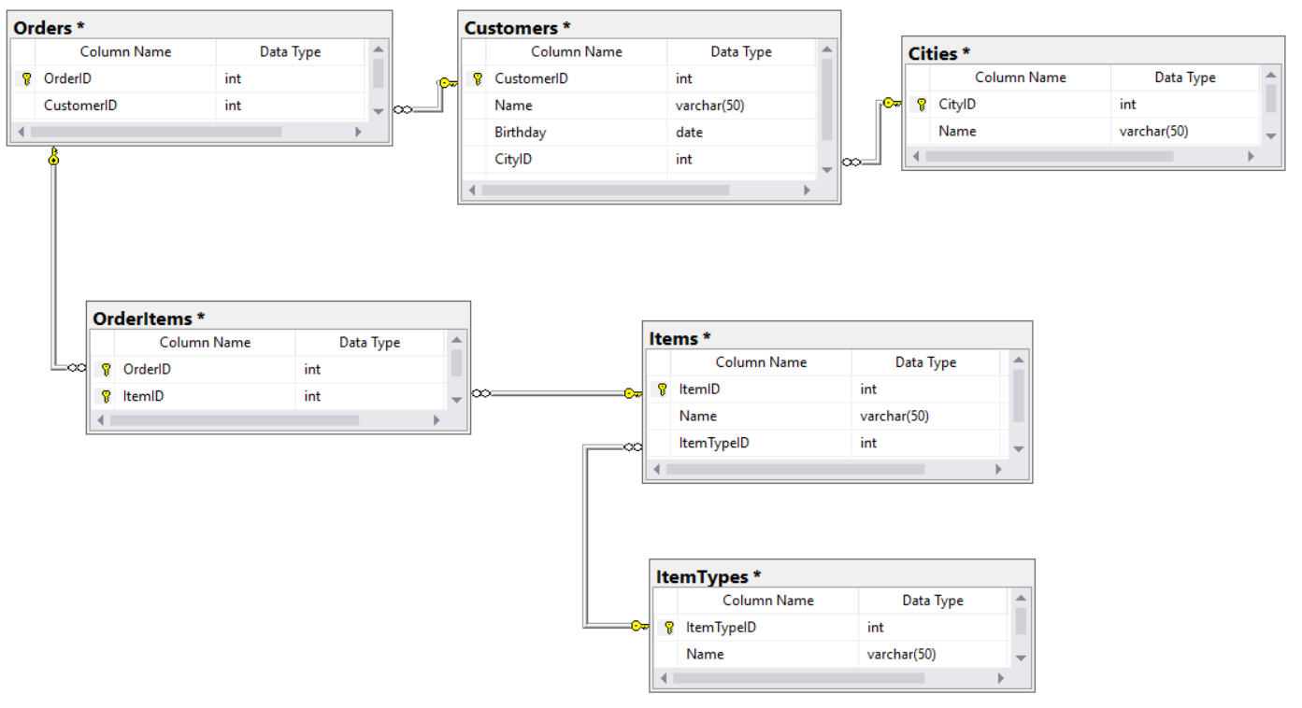

University Database
Create a new database and design the following structure:
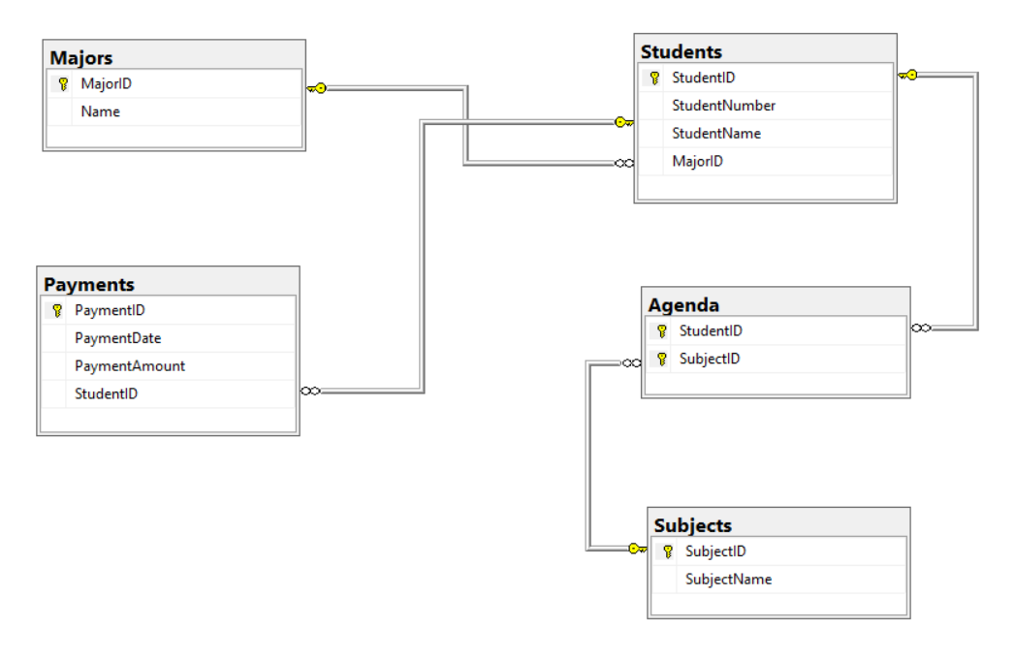

SoftUni Design
Create an E/R Diagram of the SoftUni Database. There are some special relations you should check out: Employees are self-referenced (ManagerID) and Departments have One-to-One with the Employees (ManagerID) while the Employees have One-to-Many (DepartmentID). You might find it interesting how it looks on the diagram.

Geography Design
Create an E/R Diagram of the Geography Database.

*Peaks in Rila
Display all peaks for "Rila" mountain. Include:
- MountainRange
- PeakName
- Elevation
Peaks should be sorted by elevation descending.

Example
MountainRange | PeakName | Elevation
Rila | Musala | 2925
… | … | …

