Universes
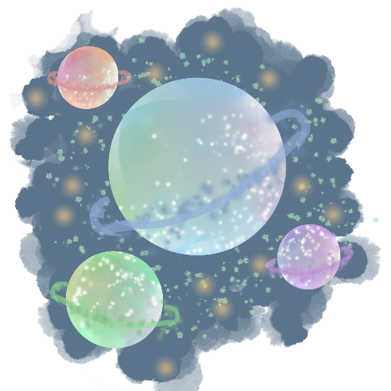
There are n planets. Some of them are connected, while some are not. If planet a is connected directly with planet b, and planet b is connected directly with planet c, then planet a is connected indirectly with planet c.
A universe is a group of directly or indirectly connected planets and no other planets outside of the group.
Write a program that prints the total number of universes.

Input
- On the first line you will receive an integer – l – number of lines.
- On the next l lines, you will receive a list in the following format: "{planet1} - {planet2}".
  - This means that planet1 and planet2 are connected.

Output
- Print the total number of universes.

Constraints
- Number of planets will be in the range [1… 20].
- Number of lines will be in the range [1… 100].

Examples
Input | Output
5  Mercury - Mars  Mars - Saturn  Saturn - Venus  Dibiasky - Arion  Dimidium - Galileo | 3

