Exercises: ORM and Entity Framework Overview
Problems for exercises and homework for the "Databases Programming and ORM" course from the official "Applied Programmer" curriculum.
You can check your solutions here: https://judge.softuni.org/Contests/3150
(delete all "bin"/"obj" folders)
Use the provided skeleton from resources! Do not change its methods, classes and namespaces!
NOTE: If the installed versions of the NuGet packages are newer than version 3, your solution may be marked as incorrect when tested in judge.
Install-Package Microsoft.EntityFrameworkCore.Tools –Version 3.1.3
Install-Package Microsoft.EntityFrameworkCore.SqlServer –Version 3.1.3
Install-Package Microsoft.EntityFrameworkCore.SqlServer.Design

Games Information
NOTE: You will need method public static string GetGamesInformation(DiabloContext context) and public StartUp class.
Now we can use the DiabloContext to extract data from Diablo database. Your first task is to extract all games and return their Name, Start, Duration and IsFinished, all of those separated with a space. Order them by Start. If the game is finished write Finished else Unfinished.

Example
Output
California pepperberry 06-Jan-10 8:29:00 PM Finished
Papyrus lions head 07-Jan-10 5:14:00 PM 7 Unfinished
…

Hints
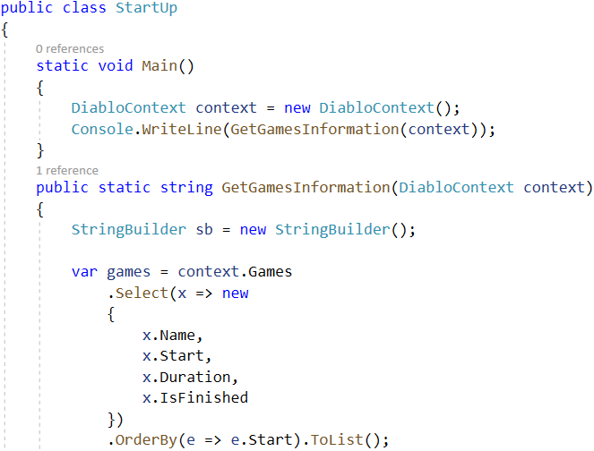
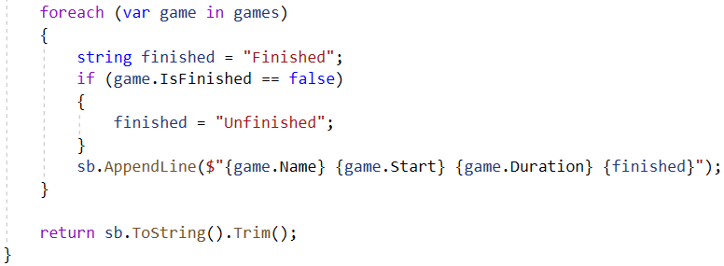

Submit in Judge
Delete "bin"/"obj" folders. These are the files in the Diablo folder:
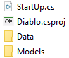
Add the Diablo folder and the .sln file to a new .zip archive.
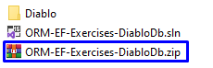
Submit the .zip file to the Judge system.

Items with Price Over 790
NOTE: You will need method public static string GetItemsWithPriceOver790(DiabloContext context) and public StartUp class.
Your task is to extract all Items with Price over 790. Return their names and price in format “{Name} - {Price}”. Price must be rounded to 2 symbols, after the decimal separator. Sort them alphabetically by name.

Example
Output
Amulets - 792.00
Madstone - 795.00
…

Items with Type Axe
NOTE: You will need method public static string GetItemWithTypeAxe(DiabloContext context) and public StartUp class.
Extract all Items with type Axe from ItemTypes. Order them by price (in ascending order), then by name (in descending order). Return only their Name, ItemTypes and Price rounded to 2 symbols, after the decimal separator in the format: "{ Name} with type {Item Type} - ${Price}".

Example
Output
Wands with type Axe - $16.00
Rimeheart with type Axe - $33.00
…

Adding a New Game
NOTE: You will need method public static string AddNewGame(DiabloContext context) and public StartUp class.
Create a new game with:
- Name – Demo
- Start – 2016-02-13 00:00:00.000
- Duration – 7
- GameType – the game type that has Id 5
- IsFinished – false
Then order by descending all the games by their Id, take 10 rows and from them, take the Name. Return the results each on a new line:

Example
Output
Demo
Victoria Peak
…
After this restore your database for the tasks ahead!

Hints
Use Convert.ToDateTime.

Users And Games Information
NOTE: You will need method public static string GetUsersAndGamesInformation(DiabloContext context) and public StartUp class.
Find the first 10 users who joined on the period 2013 - 2014 (inclusive). Print each employee's username, first name, last name and registration date. Then return all of their games in the format
"-- Game: {Game Name}, Level: {Level} - {Joined On Date}, Duration: {Duration}",
each on a new row. If a game has no end date, print Not finished instead.

Constraints
Use date format: "M/d/yyyy h:mm:ss tt".

Example
Output
Username:VGeorgiev Names: Vladimir Georgiev - Registration Date: 16-Dec-13 12:00:00 AM
-- Game: Misty blue Limonium, Level: 67 - 11/24/2013 12:00:00 AM, Duration: 2
-- Game: Amsterdam, Level: 20 - 5/25/2010 12:00:00 AM, Duration: 7
-- Game: Pompeii, Level: 22 - 3/8/2010 12:00:00 AM, Duration: 2
Username:VGeorgiev Names: Vladimir Georgiev - Registration Date: 16-Dec-13 12:00:00 AM
…

Users Games
NOTE: You will need method public static string GetUsersGames(DiabloContext context) and public StartUp class.
Find all users, ordered by the number of games played (descending), then by username (ascending), and finally by first name (ascending). Take only the first 10 users. For each user return it in the format:
"{Username}, {Email} - {Games Count} games"

Example
Output
Pesho, pesho@abv.bg - 10 games
rotoriginally, gosyen2000@hotmail.com - 10 games
…

Users with Games More Than 5
NOTE: You will need method public static string GetUsersWithMoreThan5Games(DiabloContext context) and public StartUp class.
Find all users with more than 5 games. Order them by games count (ascending), then by username (alphabetically).
For each user, print the username and the count of his games.
Print each user in the format:
"Username: {Username} - Count Games:{Users Games Count}"

Example
Output
Username: baroquegainful - Count Games:6
…

Increase Price
NOTE: You will need method public static string IncreasePrice(DiabloContext context) and public StartUp class.
Write a program that increases the price by 12% of all items whose statistical luck is equal to 18. Then return name, speed and price (2 symbols after the decimal separator) for those items whose price was increased. Order them by name (ascending), then by price (ascending). Format of the output.

Example
Output
Ancestors Grace 7 ($632.80)
Band of Untold Secrets 6 ($702.24)
Cosmic Strand 6 ($272.16)
…

