Lab: Entity Framework Code First
Problems for exercises and homework for the "Databases Programming and ORM" course from the official "Applied Programmer" curriculum.
You can check your solutions here: https://judge.softuni.org/Contests/3372/Entity-Framework-Code-First-Lab
(delete all "bin"/"obj" folders)

Forum Database
Use the provided skeleton.
Note: When testing in judge do not include the Migrations folder into the zip archive.
Use the Code First model to create a Forum database with three tables:
- Posts
- Users
- PostAnswers
Use Migrations to create that database in Microsoft SQL Server.
The structure of the tables and the relationship between them should be as follows:
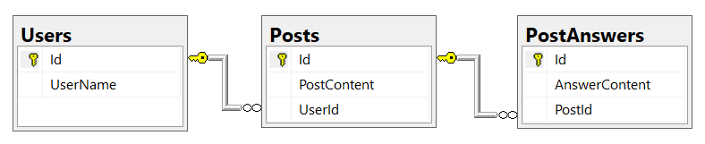

Hints
Create ForumDbContext class in the Data folder and make sure it uses the namespace Forum.Data.
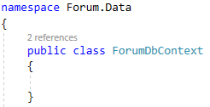
Install the following Packages:
Install-Package Microsoft.EntityFrameworkCore.Tools -v 3.1.3
Install-Package Microsoft.EntityFrameworkCore.SqlServer -v 3.1.3
Install-Package Microsoft.EntityFrameworkCore -v 3.1.3
Install-Package Microsoft.EntityFrameworkCore.Design
Create Post, User and PostAnswer classes in the Models folder and make sure they use the namespace Forum.Models.
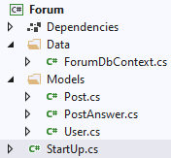
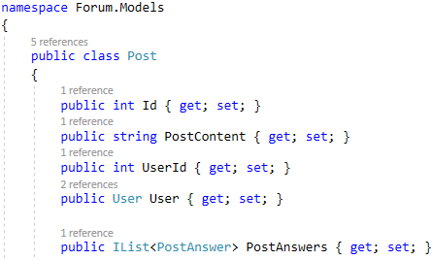
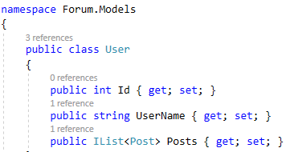
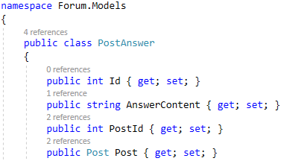
Add constructors, DbSet of the entities and override OnConfiguring method in the ForumDbContext.
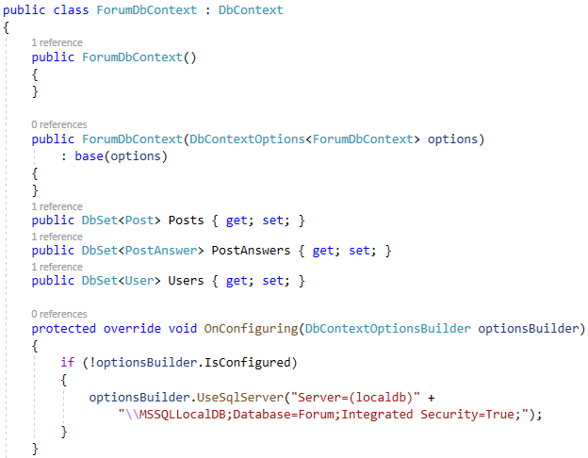
You will need a constructor, accepting DbContextOptions to test your solution in Judge!
Use Migrations to create that database in Microsoft SQL Server.
- run the following commands in Package Manager Console:
Add-Migration Initial
Update-Database
The Forum database should look like this in Microsoft SQL Server:
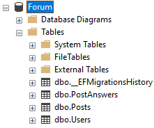
You can access the database like this:


