C# Web Basics Exam – 19 April 2022

Bus Station
Exam problems for the C# Web Basics course @ SoftUni. Submit your solutions in the SoftUni judge system (delete all "bin"/"obj" folders).
Bus Station is an online platform that is used to create destinations, tickets, and book trips.

Technological Requirements
- Use the MyWebServer – 5.0
- Use the BasicWebServer.Server – 6.0
The Technological Requirements are ABSOLUTE. If you do not follow them, you will NOT be scored for other Requirements. All the NuGet packages which are necessary to solve the exam are installed.
When the final work is submitted, make sure that the project could be run (build) successfully. When starting the submitted project a compile-time error occurs, the project will receive zero points, without further evaluation.
Now that you know the Technological Requirements, let us see what the Functional Requirements are.

Database Requirements
The Database of Buss Station:

User
- Has an Id – an string, Primary Key
- Has a Username – a string with min length 5 and max length 20 (unique, required)
- Has an Email – a string with min length 10 and max length 60 (unique, required)
- Has a Password – a string with min length 5 and max length 20 (before hashed) - no max length required for a hashed password in the database (required)
- Has Tickets collection

Destination
- Has Id – an int, Primary Key
- Has DestinationName – a string with min length 2 and max length 50 (required)
- Has Origin – a string with min length 2 and max length 50 (required)
- Has Date – a string with max length 30 (required). We recommend using "d" as a date format. The date cannot be smaller than the date of the creation of the destination.
- Has Time – a string with max length 30 (required). We recommend using "t" as a time format.
- Has ImageUrl – a string (required)
- Has Tickets collection
Note: The recommended date and time format are optional, you can use any other format.

Ticket
- Has Id – an int, Primary Key
- Has Price – a decimal, between 10 and 90
- Has UserId – an int
- Has DestinationId – an int
Implement the entities with the correct data types and their relations.

Page Requirements

Index Page (logged-out user)
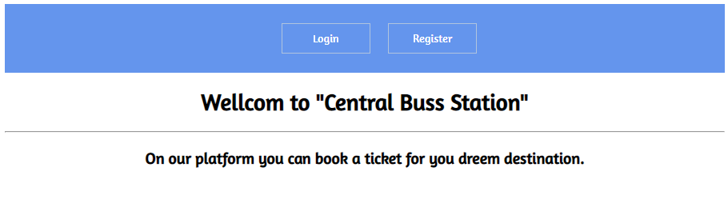

Register Page (logged-out user)
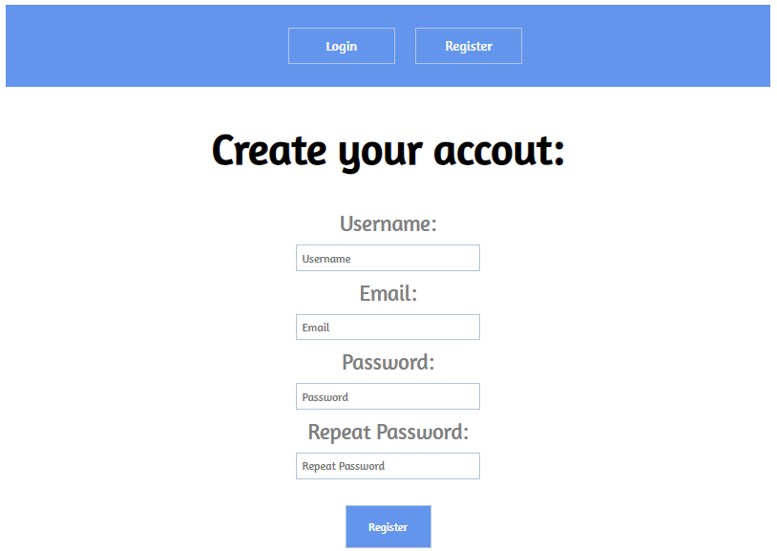

Login Page (logged-out user)
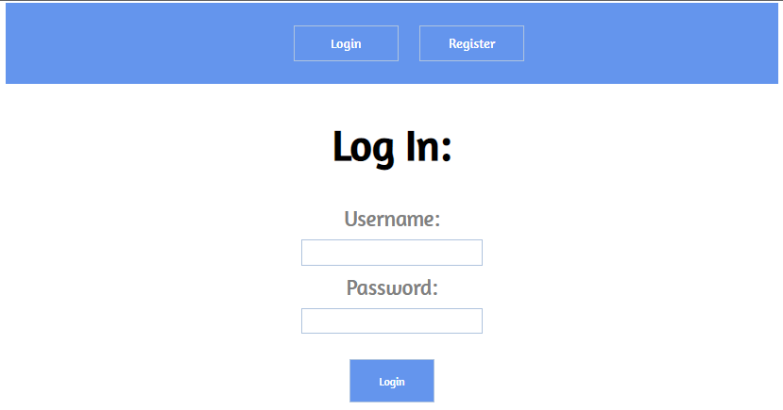

/Destinations/All (logged-in user)
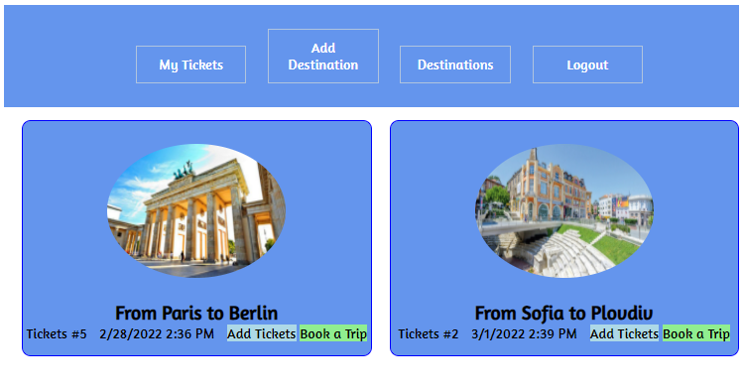
NOTE: If the user is logged in and tries to go to the home page, the application must redirect him to the /Destinations/All

/Destinations/Add (logged-in user)
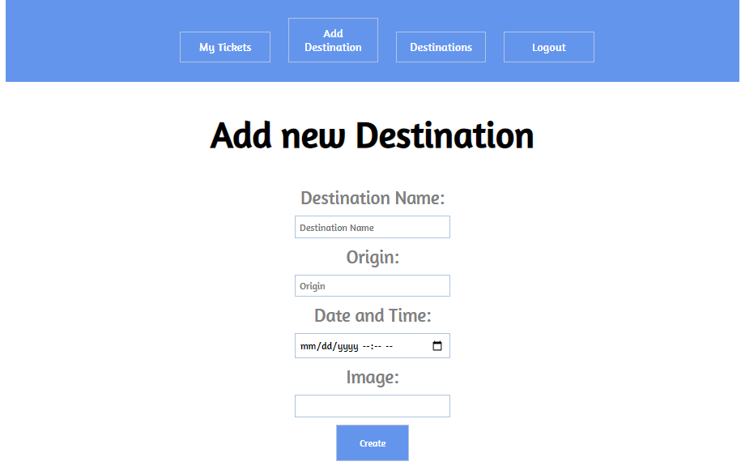

/Tickets/Create?destinationId={destinationId} (logged-in user)
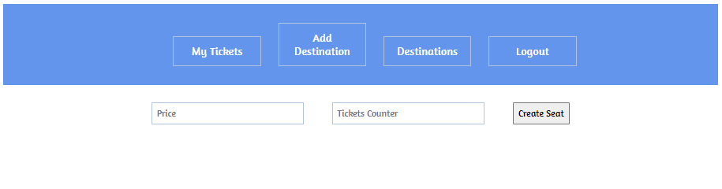
Adds tickets to a current destination. The price of tickets should be between 10 and 90 euros. A user can add up to 10 tickets at a time. If everything is successful, the user must be redirected to the home ("/Destinations/All") page.

/Tickets/MyTickets (logged-in user)
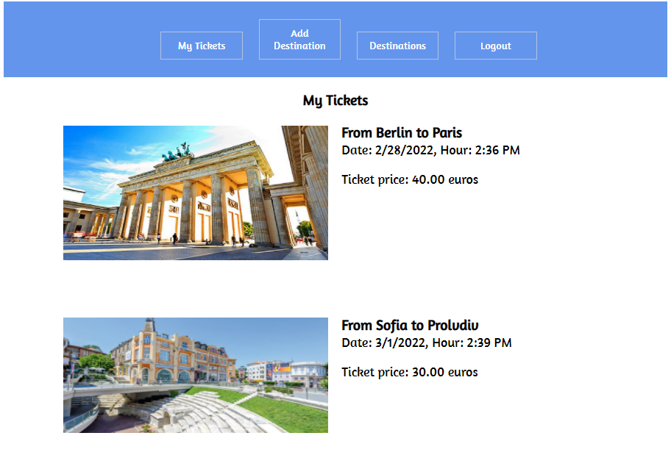
Here is where all the user's booked trips are displayed.
Note: A user can add more than one ticket for a destination.
Note: The date and hour should be passed to the view as an interpolated string.

Functionality
The functionality of the Bus Station platform is very simple.

Users
Guests can Register, Login, and view the Index Page.
Users can Add Destinations, Add Tickets, see all added Destinations on the Home Page, and see all user's tickets. From the Home Page, they can also view My Tickets and Destinations.

Destinations
Destinations can be Added by Users. All created Destinations are visualized on the Home Page, each one in its separate rectangular element.
Destinations are visualized on the Home Page with all their information, including the number of available tickets they have. When a destination is added, it starts with zero tickets.
Destinations are visualized on the Home Page with two buttons [Add Tickets] and [Book a Trip]:
- The [Add Tickets] button adds tickets to the given destination. А user can add a ticket to any destination. The ticket has a Price and Tickets count. Up to 10 tickets can be added at a time and the price of tickets should be between 10 and 90 euros.
- The [Book a Trip] button reserve a ticket for the given destination and adds it to the user's booked trips. When a ticket is added, it is no longer available for other users. A user cannot book a trip to a destination without available tickets. If the user tries to book a trip for a destination without available tickets, redirect the user to "Destinations/All".

Redirections
- Upon successful Registration of a User, you should be redirected to the Login Page.
- Upon successful Login of a User, you should be redirected to the /Destinations/All.
- Upon successful Adding of a Destinations, you should be redirected to the /Destinations/All.
- Upon successful Create Tickets to the Destinations, the user should be redirected to the /Destinations/All.
- Upon successful Book Trip, the user should be redirected to the /Destinations/All.
- If a User tries to add a Ticket to Destination, which does not have any available tickets, they should be redirected to /Destinations/All (or just a page refresh).
- Upon successful Logout of a User, you should be redirected to the Index Page.
- If any of the validations in the POST forms don’t pass, redirect to the same page (reload/refresh it).

Security
The Security section mainly describes access requirements. Configurations about which users can access specific functionalities and pages:
- Guest (not logged in) users can access the Index page.
- Guest (not logged in) users can access the Login page.
- Guest (not logged in) users can access the Register page.
- Guests (not logged in) cannot access Users-only pages.
- Users (logged in) cannot access Guest pages.
- Users (logged in) can access the Destinations All page and its functionality.
- Users (logged in) can access the Destinations Add the page and its functionality.
- Users (logged in) can access the Tickets Create page and its functionality.
- Users (logged in) can access the Tickets MyTickets page.
- Users (logged in) can access Logout functionality.

Code Quality
Make sure you provide the best architecture possible. Structure your code into different classes, follow the principles of high-quality code (SOLID). You will be scored for the Code Quality and Architecture of your project.

Scoring

Database Requirements – 10 points.

Template Requirements – 10 points.

Functionality – 50 points.

Security – 10 points.

Code Quality – 10 points.

Data Validation – 10 points.

