JS Advanced Final Exam

Problem 1. Travel Agency
Environment Specifics
Please, be aware that every JS environment may behave differently when executing code. Certain things that work in the browser are not supported in Node.js, which is the environment used by Judge.
The following actions are NOT supported:
- .forEach() with NodeList (returned by querySelector() and querySelectorAll())
- .forEach() with HTMLCollection (returned by getElementsByClassName() and element.children)
- Using the spread-operator (...) to convert a NodeList into an array
- append() in Judge (use only appendChild())
- prepend()
- replaceWith()
- replaceAll()
- closest()
- replaceChildren()
- Always turn the collection into a JS array (forEach, forOf, et.)
If you want to perform these operations, you may use Array.from() to first convert the collection into an array.
Use the provided skeleton to solve this problem.
Write the missing functionality of this user interface. The functionality is divided in the following steps:
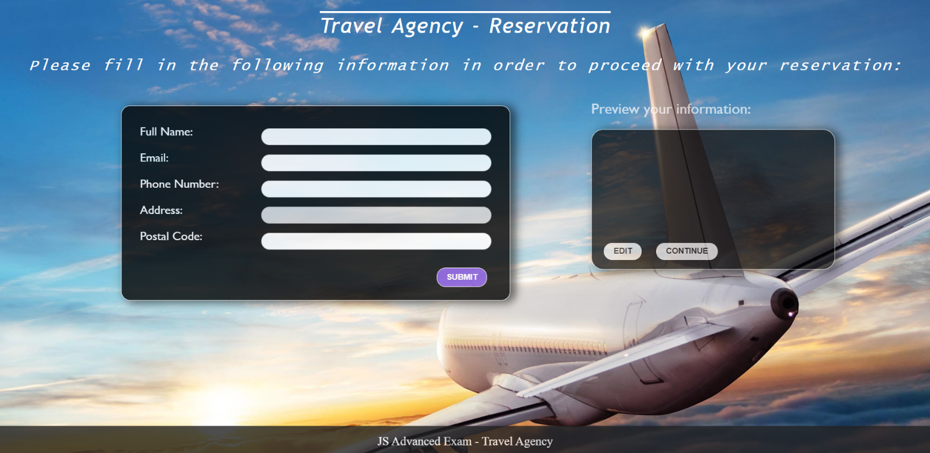

Getting the user’s personal information
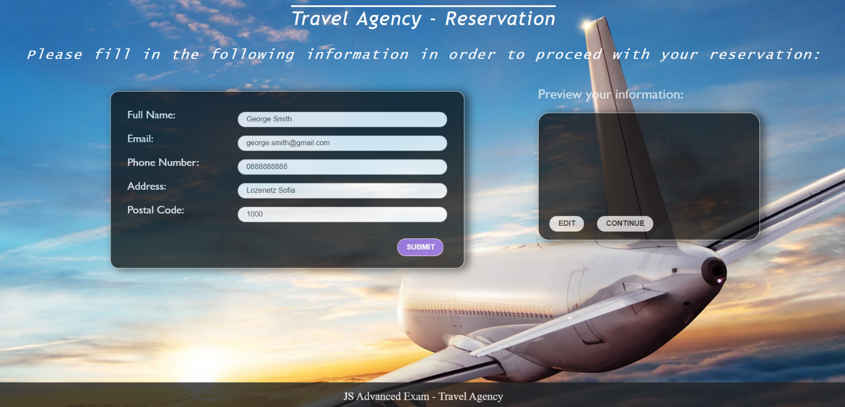
- On clicking the “Submit” button the information from the input fields is listed in the “preview” section. For each input field, a list item is added to the “infoPreview” unordered list.
- The text format and order for each list item should be the same as in the second picture below.
- When the button is clicked, the input fields must be cleared and the “Submit” button must be disabled. At the same time, the “Edit” button and the “Continue” button must be enabled.
- One can only submit information if the “Full Name” and “Email” input fields are not empty.
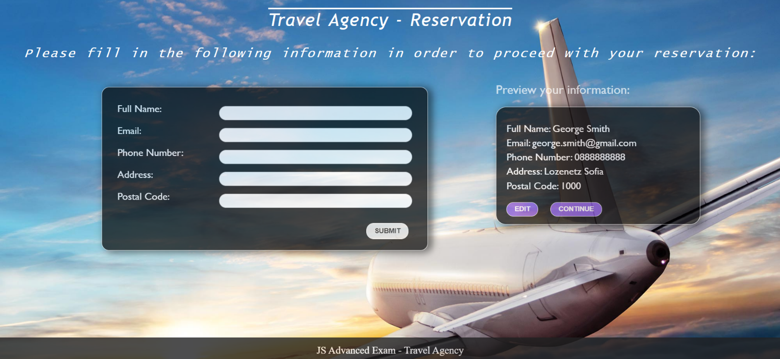

Previewing the user’s personal information
This is an example for the preview section:
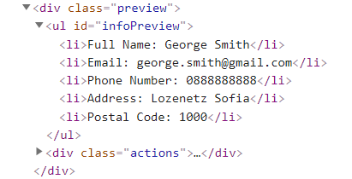
The functionality here is the following:
- When the “Edit” button is clicked, all of the personal information of the user is loaded in the input fields from step I and both the “Edit” and “Continue” buttons are disabled while the “Submit” button is enabled again.
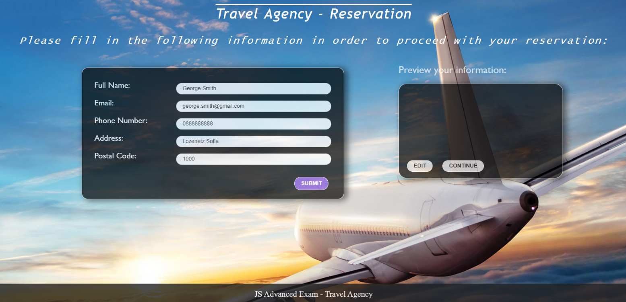
- The list items must be removed from the “infoPreview”.
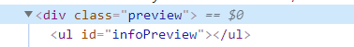
- When the “Continue” button is clicked, the reservation is completed. For you, this means removing everything inside of the “block” <div> and adding there only a <h3> tag: "Thank you for your reservation!" message:

This is everything your webpage must contain at this step:
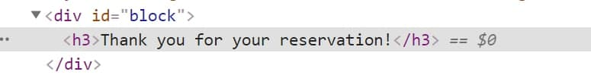

Submission
Submit only yours solution() function.

