Data Structures Fundamentals with Java - Exam - 20 March 2022
Do not modify the interface or the package, or anything from the given recourses.
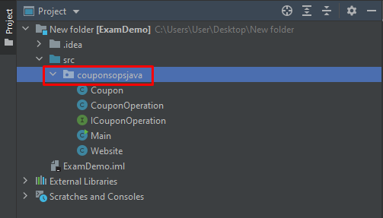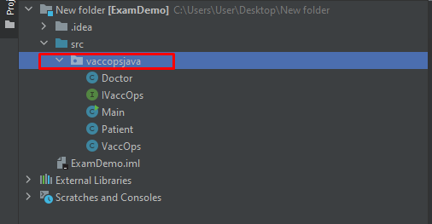

Vacc Ops
Everybody is talking about vaccines and green certificates. Also, as you can guess, the systems managing the personal doctors and their patients are morally obsolete. Now it’s your job to implement a new and fresh one.
You are given a skeleton with a class VaccOps that implements the IVaccOps interface.
The VaccOps works with Doctor & Patient entities, all doctors and patients are identified by their unique names. Implements all the operations from the interface:
- void AddDoctor(Doctor d) – adds a doctor. If there is a doctor with the same name added before throw IllegalArgumentException();
- void AddPatient(Doctor d, Patient p) – adds a patient for the provided doctor. If the doctor does not exist, throw IllegalArgumentException();
- Collection <Doctor> GetDoctors() – returns all added doctors. If there aren’t any - return empty collection
- Collection <Patient> GetPatients() – returns all added patients. If there aren’t any - return empty collection
- bool Exist(Doctor d) – returns whether the Doctor has been added or not
- bool Exist(Patient p) – returns whether the Patient has been added or not
- Doctor RemoveDoctor(String name) – removes Doctor by provided name and all his patients. If the doctors does not exist - throw IllegalArgumentException();
- void ChangeDoctor(Doctor from, Doctor to, Patient p) – Move the patients from the first doctor to another. If any of the provided entities does not exist - throw IllegalArgumentException();
- Collection<Doctor> GetDoctorsByPopularity(int popularity) – return only doctors with popularity equal to specified. If there are not any return empty collection
- Collection<Patient> GetPatientsByTown(String town) – return only patients from the specified town. If there are not any return empty collection.
- Collection<Patient> GetPatientsInAgeRange(int lo, int hi) – returns all patients with the specified age range - inclusive upper and lower bound . If there aren’t return empty collection
- Collection<Doctor> GetDoctorsSortedByPatientsCountDescAndNameAsc() – returns all doctors sorted by their patients count descending and the doctor's name ascending. If there are not any return empty collection
- Collection<Patient>GetPatientsSortedByDoctorsPopularityAscThenByHeightDescThenByAge() – returns all patients sorted by their doctor's popularity ascending then by the patient's height descending and then by patient’s age ascending. If there are not any return empty collection

Vacc Ops – Performance
For this task you will only be required to submit the code from the previous problem. If you are having a problem with this task, you should perform detailed algorithmic complexity analysis, and try to figure out weak spots inside your implementation.
For this problem it is important that other operations are implemented correctly according to the specific problems: add, size, remove, get etc…
You can submit code to this problem without full coverage from the previous problem, not all test cases will be considered, only the general behavior will be important, edge cases will mostly be ignored such as throwing exceptions etc…

Coupon Ops
You are given a skeleton with a class CouponOperations that implements the ICouponOperations interface.
The CouponOperations works with Coupon & Website entities, all websites and coupons are identified by their unique domains & codes. Implements all the operations from the interface:
- void RegisterSite(Website w) – adds a website. If there is a website with the same domain added before, throw IllegalArgumentException()
- void AddCoupon(Website w, Coupon c) – adds a coupon for the provided website. If the website does not exist, throw IllegalArgumentException()
- Website RemoveWebsite(String domain) – removes the website. If there is no website with the provided domain - throw IllegalArgumentException() Removing the website should delete all it’s coupons.
- Coupon RemoveCoupon(String code) – removes the coupons. If there is no coupons with the provided code - throw IllegalArgumentException()
- bool Exist(Website w) – returns whether the Website has been added or not
- bool Exist(Coupon c) – returns whether the Coupon has been added or not
- Collection<Website> GetSites() – return collection of all added websites. If there aren’t any, return an empty collection.
- Collection<Coupon> GetCouponsForWebsite(Website w) – return all coupons for the provided website. If there are not any - return an empty collection. If the website does not exist throw IllegalArgumentException()
- void UseCoupon(Website w, Coupon c) – remove the provided coupon for the provided website. If the coupon is not for the provided website, throw IllegalArgumentException() Both website and coupon should be existent, otherwise throw IllegalArgumentException()
- Collection<Coupon> GetCouponsOrderedByValidityDescAndDiscountPercentageDesc() – return all coupons ordered by their validity descending and then by their discount percentage descending
- Collection<Website> GetWebsitesOrderedByUserCountAndCouponsCountDesc() – return all websites ordered by their user count ascending and available coupons descending

Coupon Ops – Performance
For this task you will only be required to submit the code from the previous problem. If you are having a problem with this task, you should perform detailed algorithmic complexity analysis, and try to figure out weak spots inside your implementation.
For this problem it is important that other operations are implemented correctly according to the specific problems: add, size, remove, get etc…
You can submit code to this problem without full coverage from the previous problem, not all test cases will be considered, only the general behavior will be important, edge cases will mostly be ignored such as throwing exceptions etc…

