Lab: First Steps in Coding
Problems for exercise and homework for the "Programming Basics" course @ SoftUni Global.
Submit your solutions in the SoftUni Judge system at: https://judge.softuni.org/Contests/Compete/Index/3447

Console Program "Hello SoftUni"
Write a Java console program that prints the text "Hello SoftUni".

Hints and Guidelines
- Start IntelliJ IDEA
- Create a new project: New Project
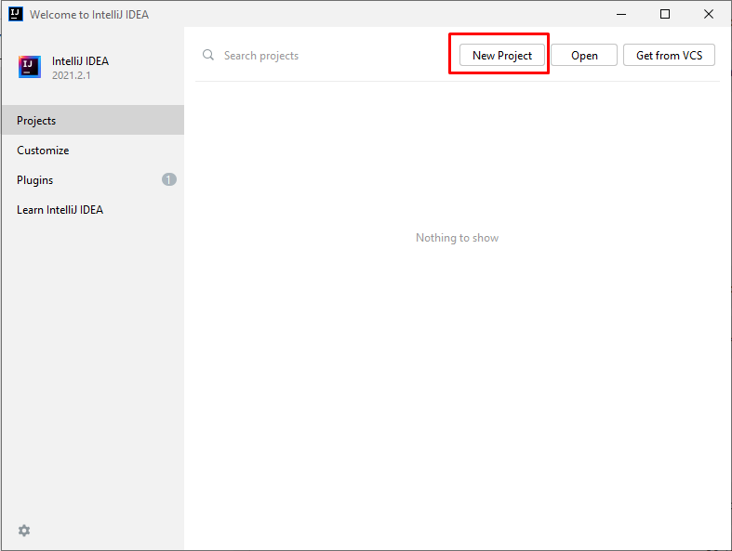
- Select Java project and proceed:

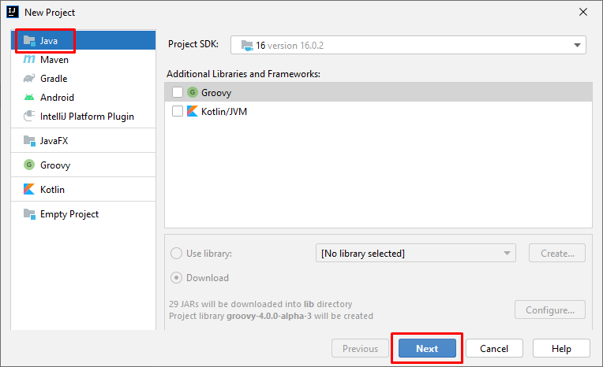
- Select "Create project from template":

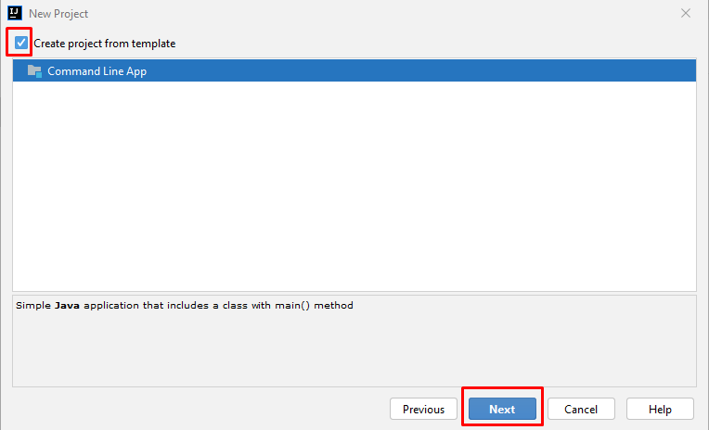
- Enter an appropriate project name and select a directory in which to be created:
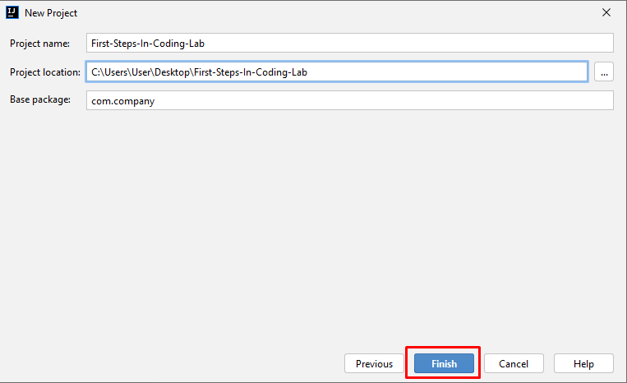
- Find the main(String[] args) section. Inside it, we write program code(commands) in Java language.
- Write the following program code (command to print the text "Hello SoftUni"):

System.out.println("Hello SoftUni");

The program code is written offset in one tab relative to the opening parenthesis {.

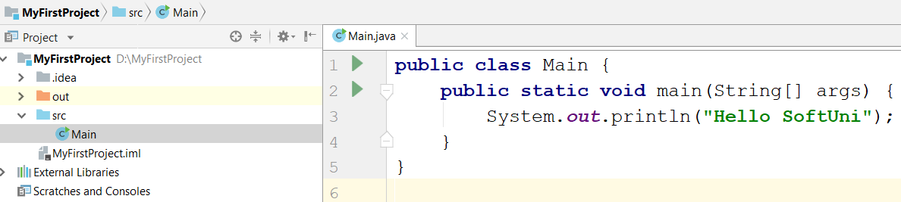

- Start the program by pressing [Ctrl+Shift+F10]. You should get the following result:

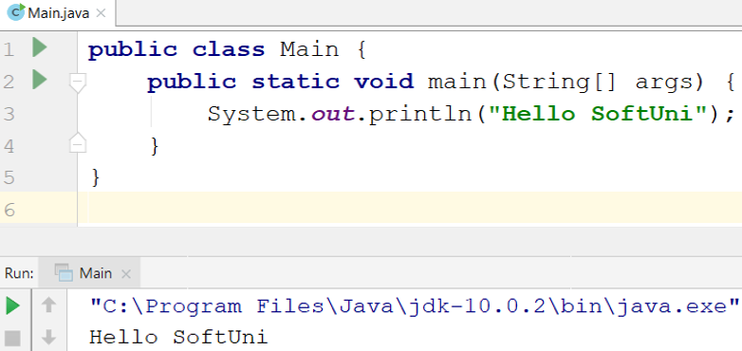

- Test the solution to this problem in the online Judge system of SoftUni. To do this, open: https://judge.softuni.org/Contests/Compete/Index/3447#0. Test the solution to this problem in the online judge system of SoftUni. To do this, open it first. Log in with your SoftUni username. A window for submitting solutions for the "Hello SoftUni" task will appear. Copy the entire source code from IntelliJ and paste it into the solution submission box:
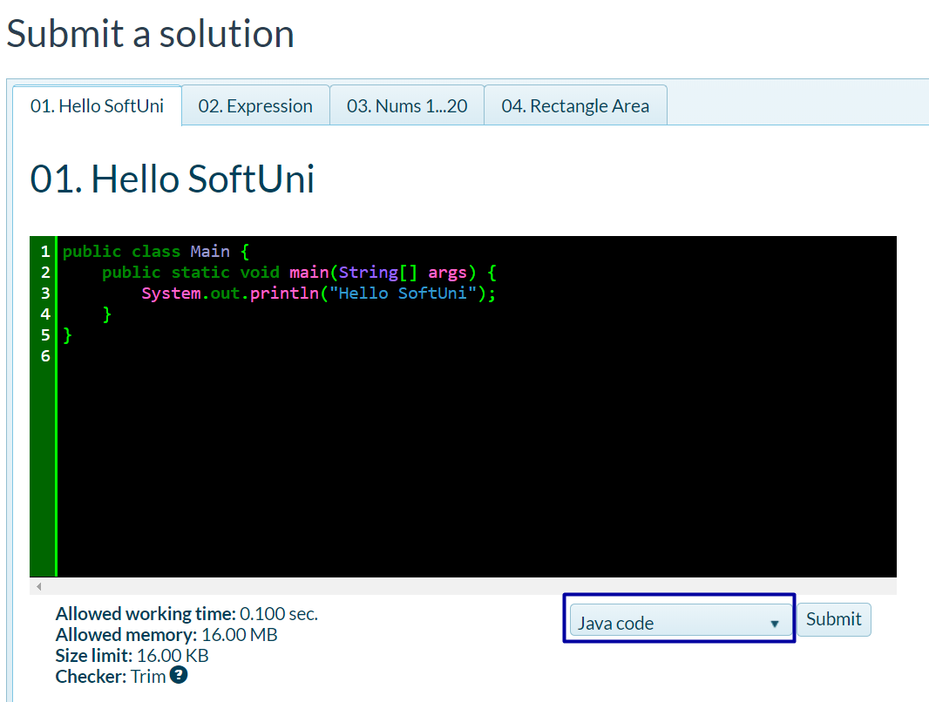

- Press the "Submit" button.
- The result will appear in the window below. To see it, press the "Refresh" button:
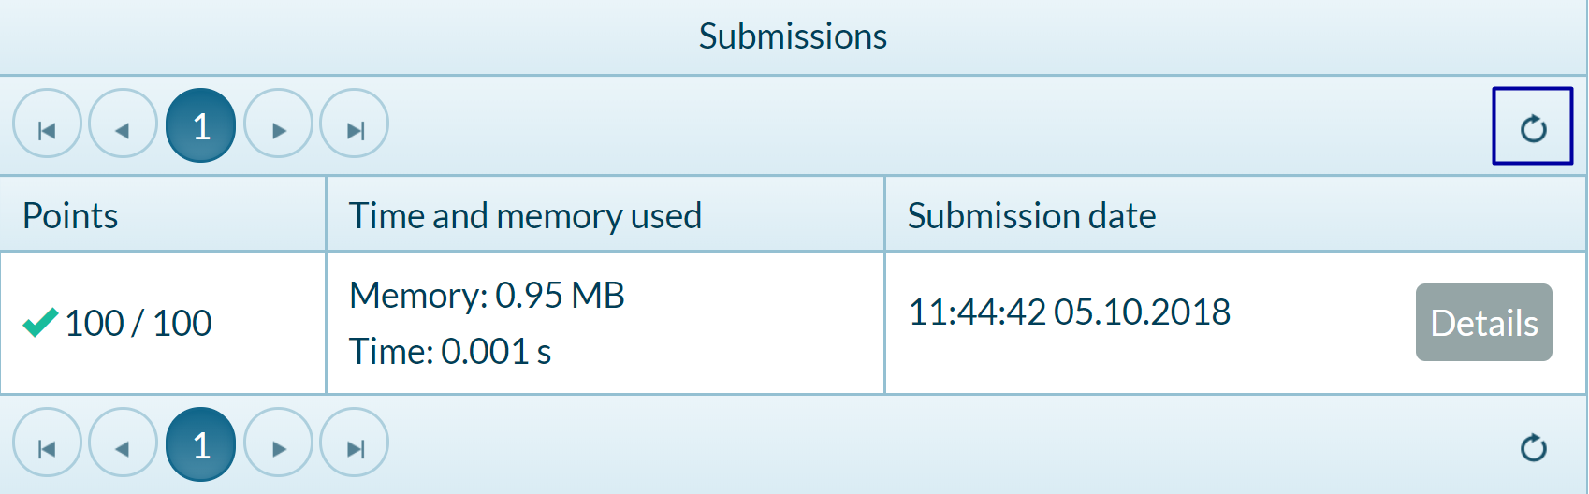

Nums 1...10
Write a Java console program that prints the numbers 1 through 10 on separate lines on the console.

Hints and Guidelines
- Create a new Java class named "Nums1To10" (right-click on the "src" folder New Java Class):
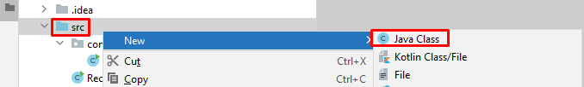
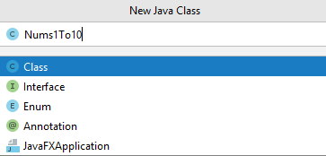

- Write your main method.
- Type 10 commands System.out.println(); one after another to print the numbers from 1 to 10:
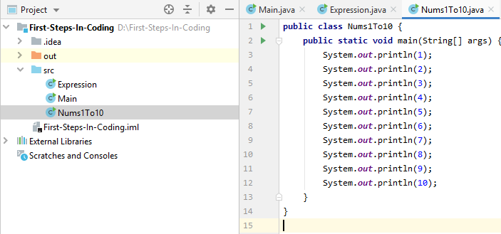

Testing in the Judge System
Test the solution to this problem here: https://judge.softuni.org/Contests/Compete/Index/3448#1

Rectangle Area

Write a Java program that calculates and prints the area of a rectangle with predefined sides a and b.

Sample Input and Output
Input | Output
5  7 | 35
Input | Output
6  8 | 48

Hints and Guidelines
- Initialize two variables (a and b) and save the values entered by the console:
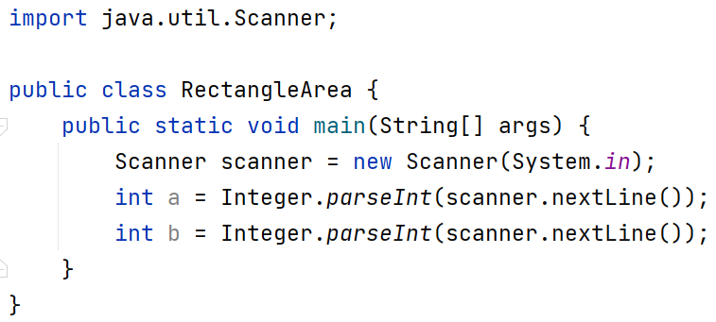

- Initialize a second variable area in which to write the value for the face of the rectangle obtained by the formula a * b. Print the result:
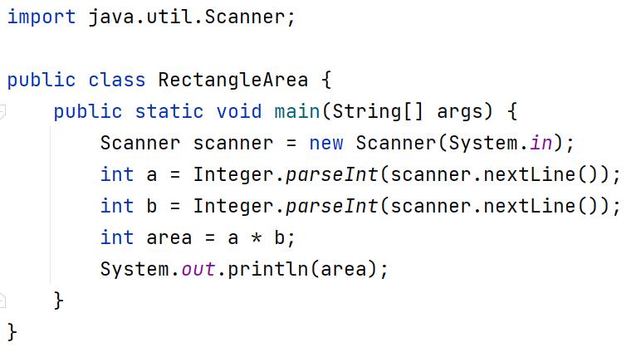

Testing in the Judge System
Test the solution to this problem here: https://judge.softuni.org/Contests/Compete/Index/3448#2

Inches to Centimeters

Write a program that reads a floating-point number from the console and converts it from inches to centimeters. To do this, multiply the inches by 2.54 (1 inch = 2.54 centimeters).

Sample Input and Output
Input | Output
5 | 12.7
Input | Output
7 | 17.78

Testing in the Judge System
Test the solution to this problem here: https://judge.softuni.org/Contests/Compete/Index/3448#3

Warning: It is recommended that you change the settings on your computer to use a decimal point:
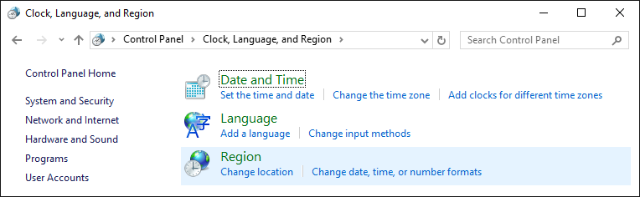
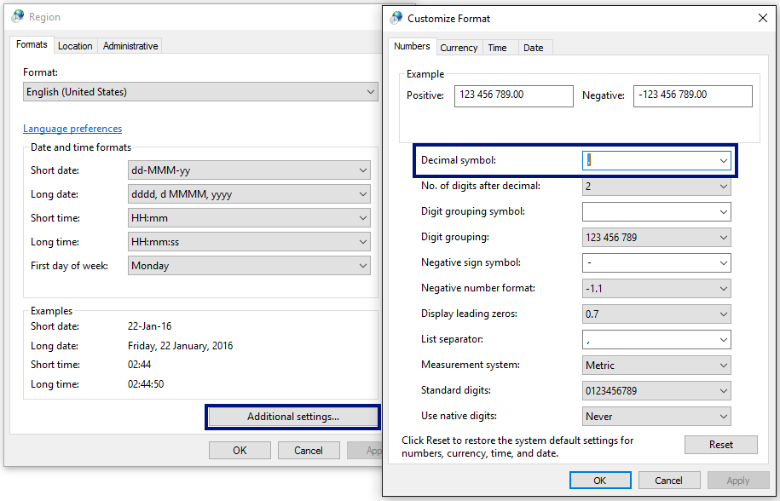

Greeting by Name
Write a program that reads text (person's name) from the console and prints "Hello, <name>!", where <name> is the name entered from the console.

Hints and Guidelines
- First, create a new Java class named "GreetingByName" in the existing project. Right-click on the "src" folder in the project and select New -> Java Class.
Enter an appropriate name:
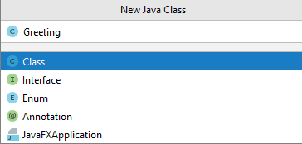

Create a main method in the body of the GreetingByName class. You can do this by writing the abbreviation psvm and pressing the Tab button twice:
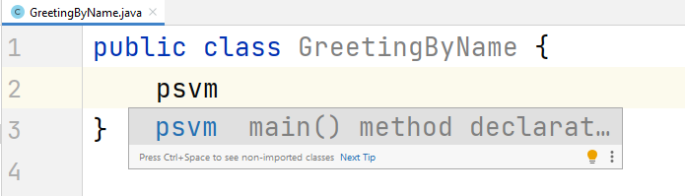
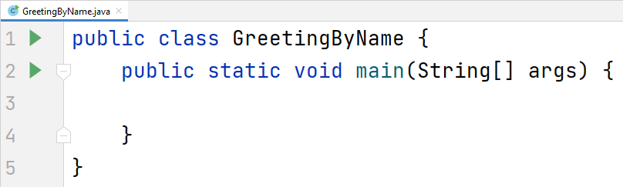

- To read input from the console, create a Scanner object.
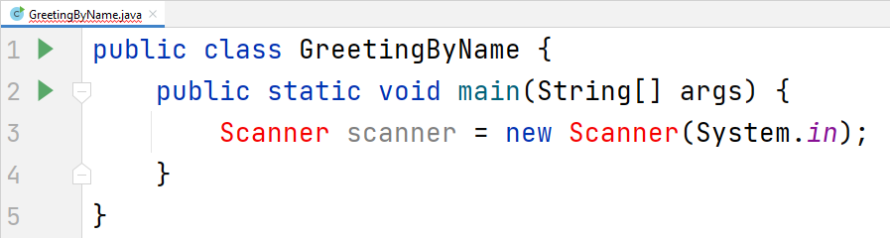
You will notice that the development environment warns us that this object cannot be used yet. To do this, we need to add it from the Java development package we have installed (JDK). We can do this by typing "import java.util.Scanner;" on the first line of the program, or place the cursor on the red text in the field and press Alt + Enter and choose Import Class -> Scanner (java.util):
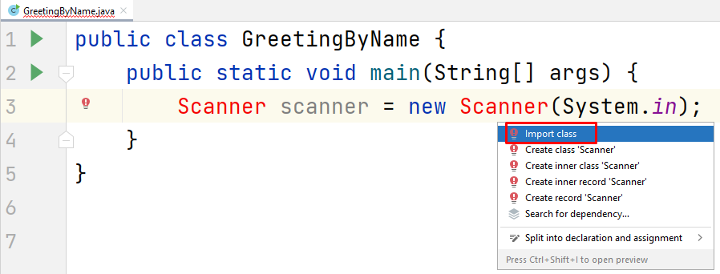
You should get the following result:
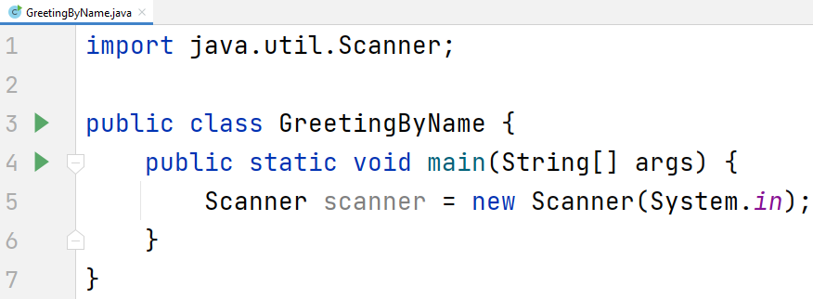

- Create a String variable and save the name you get from the console using the nextLine() method from the Scanner object you created in the previous step:
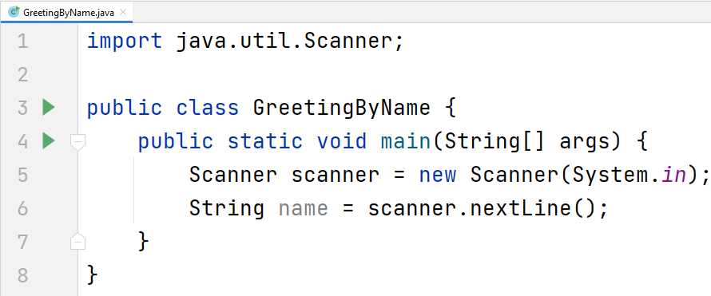

- Output the console output using the following template:
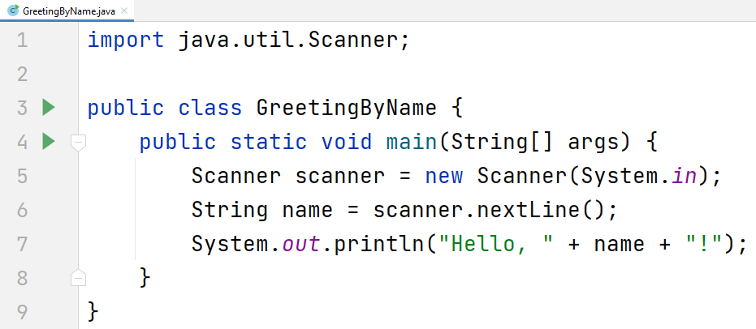
- Start the program with Ctrl + Shift + F10 and test with different input examples:

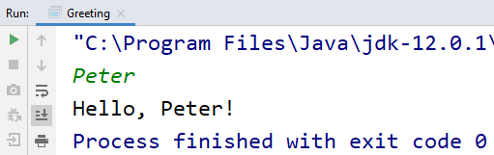

Testing in the Judge System
Test the solution to this problem here: https://judge.softuni.org/Contests/Compete/Index/3448#4

Concatenate Data
Write a program that reads the name, surname, age, and city from the console and prints the following message: "You are <firstName> <lastName>, a <age>-years old person from <town>."

Hints and Guidelines
- Create a new Java class named ConcatenateData and the main method inside it.
- Enter the input data and save it in variables with the appropriate data type
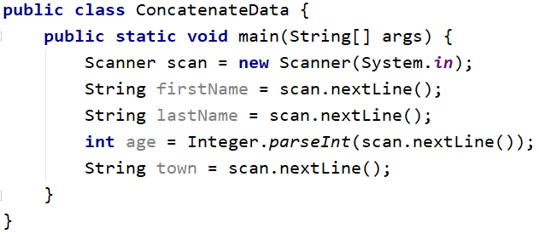

- Display the formatted output on the console:
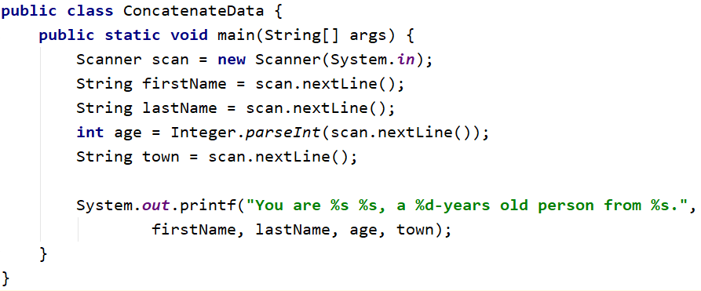
You can achieve the same result with the concatenation method:
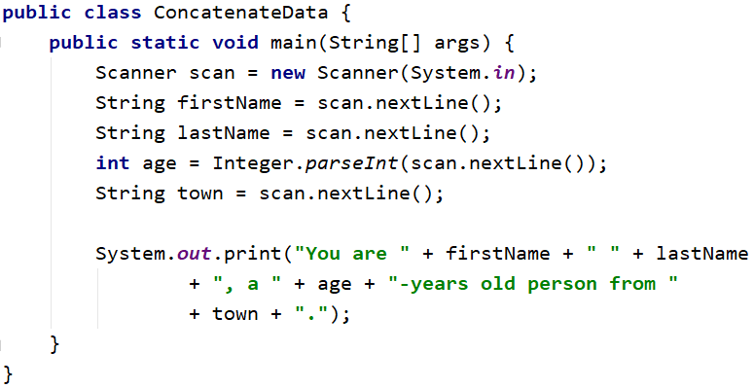
You will notice that the concatenation method has a longer record and creates preconditions for more errors compared to the template method.
- Start the program and test with different input examples.
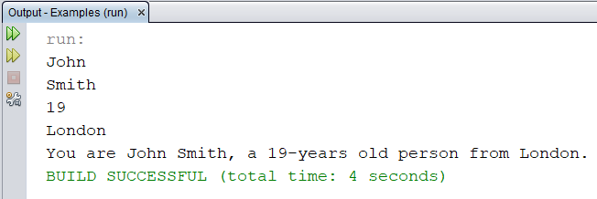

Testing in the Judge System
Test the solution to this problem here: https://judge.softuni.org/Contests/Compete/Index/3448#5

Projects Creation
Write a program that calculates how many hours it will take for an architect to design several construction projects. The preparation of a project takes three hours.

Input Data
2 lines are read from the console:
- Name of the architect – string
- Number of projects to be prepared – an integer in the interval [0 … 100]

Output Data
On the console print:
- "The architect {name of architect} will need {needed time} hours to complete {number of projects} project/s."

Sample Input and Output
Input | Output |  | Input | Output
George  4 | The architect George will need 12 hours to complete 4 project/s. |  | John  9 | The architect John will need 27 hours to complete 9 project/s.

Testing in the Judge System
Test the solution to this problem here: https://judge.softuni.org/Contests/Compete/Index/3448#6

Pet Shop
Write a program that calculates the cost of buying dog and cat food. The food is bought from a pet store, as one package of dog food costs 2.50 USD, and a package of cat food costs 4 USD.

Input Data
2 lines are read from the console:
- Number of packages of dog food - an integer in the range [0… 100]
- Number of packages of cat food - an integer in the range [0… 100]

Output Data
On the console print:
"{Total sum} USD"

Sample Input and Output
Input | Output |  | Input | Output
5  4 | 28.5 USD. |  | 13  9 | - USD.

Testing in the Judge System
Test the solution to this problem here: https://judge.softuni.org/Contests/Compete/Index/3448#7

Yard Greening
Sophia has several houses on the Black Sea coast and wants to green the yards of some of them, thus creating a cozy atmosphere and comfort for its guests. She has hired a company for this purpose.
Write a program that calculates the amount needed for Sophie to pay to the project contractor. The price per square meter is 7.61 USD including VAT. Because her yard is quite large, the contractor company offers an 18% discount on the final price.

Input Data
One line is read from the console:
- Square meters of the landscaped – a floating-point number in the range [0.00 … 10000.00]

Output Data
Two lines are printed on the console:
- "The final price is: {final price of the service} USD."
- "The discount is: {discount} USD."

Sample Input and Output
Input | Output | Comments
550 | The final price is: 3432.11 USD.  The discount is: 753.39 USD. | We calculate the price for landscaping the whole yard:  550 * 7.61 = 4185.50 USD.  We deduct the discount (18% = 0.18) of the total:  0.18 * 4185.5 = 753.39 USD.  We calculate the final price of the service:  4185.50 – 753.39 3432.11 USD.
Input | Output
150 | The final price is: 936.03 USD.  The discount is: 205.47 USD. | We calculate the price for landscaping the whole yard:  150 * 7.61 = 1141.50 USD.  We deduct the discount (18% = 0.18) of the total:  0.18 * 1141.50 = 205.47 USD.  We calculate the final price of the service:  1141.50 – 205.47 936.03 USD.

Testing in the Judge System
Test the solution to this problem here: https://judge.softuni.org/Contests/Compete/Index/3448#8

