Lab: For Loop
Problems for exercise and homework for the "Programming Basics" course @ SoftUni Global.
Submit your solutions in the SoftUni Judge system at: https://judge.softuni.org/Contests/Compete/Index/3453

Numbers from 1 to 100
Write a program that prints the numbers from 1 to 100, each on a new line.

Sample Input and Output
Input | Output
(no input) | 1  2  3  …  98  99  100

Hints and Guidelines
- Create a for loop with an initial value of the control variable i = 1. Make the end value less than or equal to 100. In the block of the cycle code, print i:
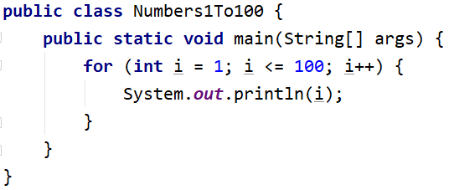
- Start the program with [Ctrl+Shift+F10] and test it:
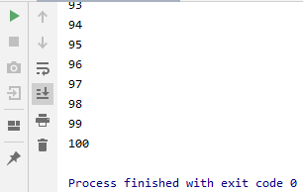

Testing in the Judge System
Test the solution to this problem here: https://judge.softuni.org/Contests/Compete/Index/3453#0

Numbers N...1
Write a program that reads a positive integer n entered by the user and prints the numbers from n to 1 in reverse order. The number n entered will always be greater than 1.

Sample Input and Output
Input | Output |  | Input | Output |  | Input | Output
2 | 2  1 |  | 3 | 3  2  1 |  | 5 | 5  4  3  2  1

Hints and Guidelines
- Read an integer from the console:
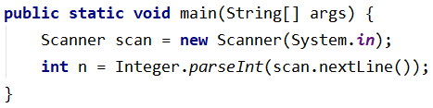
- Create one for loop from n to 0, but instead of increasing the variable i by 1, decrease it by 1 for each iteration of the loop:
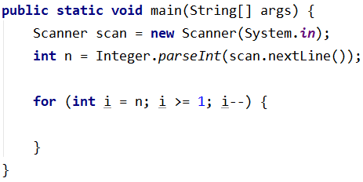
- Print the variable i in the body of the loop:
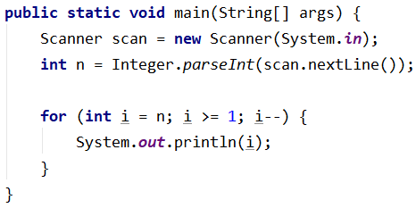

Testing in the Judge System
Test the solution to this problem here: https://judge.softuni.org/Contests/Compete/Index/3453#1

Numbers 1...N with Step 3
Write a program that reads the number n entered by the user and prints the numbers from 1 to n through 3.

Sample Input and Output
Input | Output |  | Input | Output |  | Input | Output
10 | 1  4  7  10 |  | 7 | 1  4  7 |  | 15 | 1  4  7  10  13

Hints and Guidelines
- Read an integer n from the console:
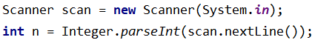
- Write a for loop from 1 to n (inclusive) and set the step to 3. This means that with each iteration of the loop, the variable i will increase its value by 3 instead of 1:
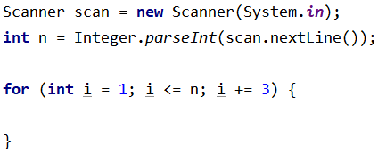
- Print the variable i in the body of the loop:
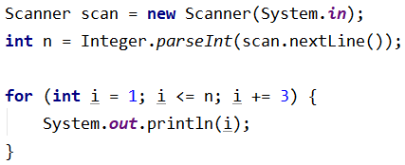

Testing in the Judge System
Test the solution to this problem here: https://judge.softuni.org/Contests/Compete/Index/3453#2

Even Powers of 2
Write a program that reads the number n entered by the user and prints the even power of 2 ≤ 2^{n}: 2⁰, 2², 2⁴, 2⁶, …, 2^{n}.

Sample Input and Output
Input | Output |  | Input | Output |  | Input | Output |  | Input | Output |  | Input | Output
3 | 1  4 |  | 4 | 1  4  16 |  | 5 | 1  4  16 |  | 6 | 1  4  16  64 |  | 7 | 1  4  16  64

Testing in the Judge System
Test the solution to this problem here: https://judge.softuni.org/Contests/Compete/Index/3453#3

Character Sequence
Write a program that reads text (string) entered by the user and prints each character of the text on a separate line.

Sample Input and Output
Input | Output | Input | Output
softuni | s  o  f  t  u  n  i | ice cream | i  c  e  c  r  e  a  m

Hints and Guidelines
- Read the input text:
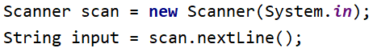
- Write a for loop with an initial value of the control variable from 0 to input.length(). On each iteration, take the letter at the position in the entered word equal to the value of the control variable i, using the method charAt()
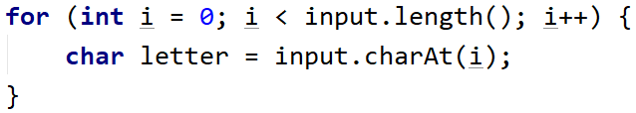
- At each iteration, print the value of the variable letter:
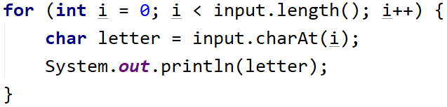
Testing in the Judge System
Test the solution to this problem here: https://judge.softuni.org/Contests/Compete/Index/3453#4

Vowels Sum
Write a program that reads text (string) entered by the user, calculates, and prints the sum of the values of the vowels according to the table below:
letter | a | e | i | o | u
value | 1 | 2 | 3 | 4 | 5

Sample Input and Output
Input | Output | Comments
hello | 6 | e + o = 2 + 4 = 6
hi | 3 | i = 3
bamboo | 9 | a + o + o = 1 + 4 + 4 = 9
beer | 4 | e + e = 2 + 2 = 4

Testing in the Judge System
Test the solution to this problem here: https://judge.softuni.org/Contests/Compete/Index/3453#5

Sum Numbers
Write a program that reads n-number integers entered by the user and sums them.
- On the first line, print the number n that you will enter.
- On the next lines, enter the n numbers that you will sum.
The program must read the numbers, sum them, and print their sum.

Sample Input and Output
Input | Output |  | Input | Output |  | Input | Output |  | Input | Output |  | Input | Output
2  10  20 | 30 |  | 3  -10  -20  -30 | -60 |  | 4  45  -20  7  11 | 43 |  | 1  999 | 999 |  | 0 | 0

Testing in the Judge System
Test the solution to this problem here: https://judge.softuni.org/Contests/Compete/Index/3453#6

Number sequence
Write a program that reads n integers. Print the largest and smallest numbers from the entered numbers.

Sample Input and Output
Input | Output |  | Input | Output
5  10  20  304  0  50 | Max number: 304  Min number: 0 |  | 6  250  5  2  0  100  1000 | Max number: 1000  Min number: 0

Testing in the Judge System
Test the solution to this problem here: https://judge.softuni.org/Contests/Compete/Index/3453#7

Left and Right Sum
Write a program that reads 2 * n numbers of integers submitted by the user and checks if the sum of the first n numbers (left sum) is equal to the sum of the second n numbers (right sum). In the case of equality, print "Yes, sum = " + the amount; otherwise print "No, diff = " + the difference. The difference is calculated as a positive number (use absolute value).

Sample Input and Output
Input | Output | Comments |  | Input | Output | Comments
2  10  90  60  40 | Yes, sum = 100 | 10+90 = 60+40 = 100 |  | 2  90  9  50  50 | No, diff = 1 | 90+9 ≠ 50+50  Difference = |99-100| = 1

Testing in the Judge System
Test the solution to this problem here: https://judge.softuni.org/Contests/Compete/Index/3453#8

Odd Even Sum
Write a program that reads n-number integers submitted by the user and checks if the sum of the numbers of even positions is equal to the sum of the numbers of odd positions.
- If the amounts are equal, print two lines: "Yes" and a new line "Sum = " + the amount
- If the amounts are not equal, print two lines: "No" and a new line "Diff = " + the difference
The difference is calculated as absolute value.

Sample Input and Output
Input | Output | Comments |  | Input | Output | Comments |  | Input | Output | Comments
4  10  50  60  20 | Yes  Sum = 70 | 10+60 = 50+20 = 70 |  | 4  3  5  1  -2 | No  Diff = 1 | 3+1 ≠ 5-2  Diff =  |4-3| = 1 |  | 3  5  8  1 | No  Diff = 2 | 5+1 ≠ 8  Diff =  |6-8| = 2

Testing in the Judge System
Test the solution to this problem here: https://judge.softuni.org/Contests/Compete/Index/3453#9

