Exercise: For Loop
Problems for exercise and homework for the "Programming Basics" course @ SoftUni Global.
Submit your solutions in the SoftUni Judge system at: https://judge.softuni.org/Contests/Compete/Index/3454

Numbers Ending in 7
Write a program that prints numbers in the range 1 to 1000 that end in 7.
Input | Output
(no input) | 7  17  27  …  997

Hints and Guidelines
- Make a for loop to print a number if it ends in 7. The initial step from which you can start is 7 and the final one is 997. The first number in your series is 7 and the last is 997.
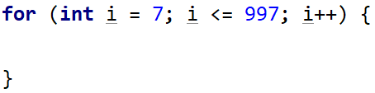
- To print numbers ending in 7, you must check that the current number ends in 7. To do this, use a modular division of 10 and print the number if the result of this division is 7.
* Note: With a modular division of 10 you can find the last digit of any integer, regardless of its length.

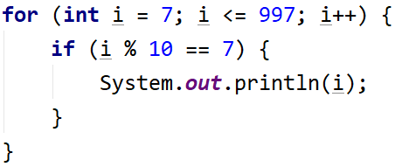
Testing in the Judge System
Test the solution to this problem here: https://judge.softuni.org/Contests/Compete/Index/3454#0

Half Sum Element
Write a program that reads n-number integers entered by the user and checks if there is a number among them which is equal to the sum of all the others.
- If there is such an element, print "Yes" and on a new line "Sum = " + its value
- If there is no such element, print "No" and on a new line "Diff = " + the difference between the largest number and the sum of the other (in absolute value)

Sample Input and Output
Input | Output | Comments
7  3  4  1  1  2  12  1 | Yes  Sum = 12 | 3 + 4 + 1 + 2 + 1 + 1 = 12
4  6  1  2  3 | Yes  Sum = 6 | 1 + 2 + 3 = 6
3  1  1  10 | No  Diff = 8 | |10 - (1 + 1)| = 8
3  5  5  1 | No  Diff = 1 | |5 - (5 + 1)| = 1
3  1  1  1 | No  Diff = 1

Hints and Guidelines
- Read the input n (the number of the input numbers):
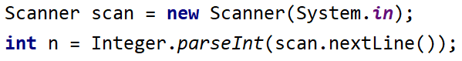
- Create two new variables. In one calculate the maximum number, in the other the sum of all numbers. Set initial values for both variables. Set the maximum variable to Integer.MIN_VALUE, and the sum variable to 0.
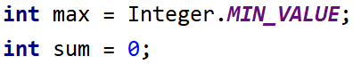
- Make a for loop to read n numbers. Each time you read a number, add it to the amount. Check if the number entered is greater than the current maximum. If it is greater, the maximum becomes equal to this number.
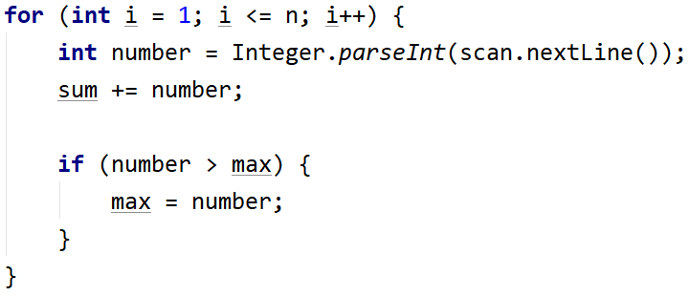
- Once you have the sum of all the numbers and the maximum number among them, find the sum of the numbers without the maximum number. Create a new variable in which to calculate the amount without the maximum number.
- 5. Check if the sum without the maximum number is equal to the maximum number, print two lines of output - (Yes…) and the maximum number, or - (No…) and the absolute value of the difference between the maximum number and the sum of all numbers without the maximum (use Math.abs to find the absolute value).

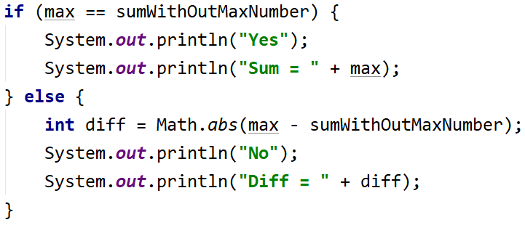
Testing in the Judge System
Test the solution to this problem here: https://judge.softuni.org/Contests/Compete/Index/3454#1

Histogram
N integers are given in the interval [1… 1000]. Some of these, percentage p1, are below 200, another percentages p2 are from 200 to 399, another percentages p3 are from 400 to 599, other percentages p4 are from 600 to 799 and the remaining p5 percent are above 800. Write a program that calculates and prints the percentages p1, p2, p3, p4, and p5.
Example: we have n = 20 numbers: 53, 7, 56, 180, 450, 920, 12, 7, 150, 250, 680, 2, 600, 200, 800, 799, 199, 46, 128, 65. We get the following distribution and visualization:
Range | Numbers in the range | Numbers | Percentage
< 200 | 53, 7, 56, 180, 12, 7, 150, 2, 199, 46, 128, 65 | 12 | p1 = 12 / 20 * 100 = 60.00%
200 … 399 | 250, 200 | 2 | p2 = 2 / 20 * 100 = 10.00%
400 … 599 | 450 | 1 | p3 = 1 / 20 * 100 = 5.00%
600 … 799 | 680, 600, 799 | 3 | p4 = 3 / 20 * 100 = 15.00%
≥ 800 | 920, 800 | 2 | p5 = 2 / 20 * 100 = 10.00%

Input Data
The first line of the input is the integer n (1 ≤ n ≤ 1000) - count of numbers. The next n lines contain an integer in the interval [1… 1000] - the numbers with which to calculate the histogram.

Output Data
Print the histogram on the console - 5 lines, each of which contain a number between 0% and 100%, formatted two digits after the decimal point, for example 25.00%, 66.67%, 57.14%.

Sample Input and Output
Input | Output |  | Input | Output |  | Input | Output |  | Input | Output |  | Input | Output
3  1  2  999 | 66.67%  0.00%  0.00%  0.00%  33.33% |  | 4  53  7  56  999 | 75.00%  0.00%  0.00%  0.00%  25.00% |  | 7  800  801  250  199  399  599  799 | 14.29%  28.57%  14.29%  14.29%  28.57% |  | 9  367  99  200  799  999  333  555  111  9 | 33.33%  33.33%  11.11%  11.11%  11.11% |  | 14  53  7  56  180  450  920  12  7  150  250  680  2  600  200 | 57.14%  14.29%  7.14%  14.29%  7.14%

Testing in the Judge System
Test the solution to this problem here: https://judge.softuni.org/Contests/Compete/Index/3454#2

Clever Lily
Lily is already N years old. She receives a gift for each of her birthdays.
- For the odd birthdays (1, 3, 5...n), she receives toys.
- For the even birthdays (2, 4, 6...n), she receives money.
For the second birthday she receives 10.00 USD, as the amount increases by 10.00 USD, for each subsequent even birthday (2 -> 10, 4 -> 20, 6 -> 30 ... etc.). Over the years, Lily has secretly saved money. Lily's brother, in the years she receives money, takes 1.00 USD from them. Lily sold the toys received over the years, each for p USD, and added the amount to the saved money. With the money, she wanted to buy a washing machine for x USD. Write a program to calculate how much money she has raised and whether she has enough to buy a washing machine.

Input Data
3 lines are read from the console:
- Lily’s age – an integer in the range [1...77]
- Price of washing machine – a floating-point number in the range [1.00...10 000.00]
- Single price of a toy – an integer in the range [0...40]

Output Data
On the console print:
- If Lily has enough money:
  - "Yes! {N}" - where N is the remaining money after the purchase
- If the money is not enough:
  - "No! {М}" - where M is the amount that is not enough
The numbers N and M must be formatted to the second decimal place.

Sample Input and Output
Input | Output | Comments
10  170.00  6 | Yes! 5.00 | On her first birthday, she receives a toy  On her second birthday, she receives money (10 USD)  She receives a toy on her third birthday  On her fourth birthday, she receives money (20 USD)  She gets a toy on her fifth birthday  On her sixth birthday receives money (30 USD)  She receives a toy on her seventh birthday  On her eighth birthday, she receives money (40 USD)  On her ninth birthday, she receives a toy  On her tenth birthday, she receives money (50 USD)  She saved: 10 + 20 + 30 + 40 + 50 = 150 USD  She sold 5 toys and got * 6 USD = 30 USD  Her brother took 5 times * 1 USD = 5 USD  Total money saved: (150 + 30) – 5 = 175 USD  175 >= 170 (the price of the washing machine)  => she managed to buy it  Remaining: 175 - 170 = 5 USD
21  1570.98  3 | No! 997.98 | She saved 550 USD.  She sold 11 toys * 3 USD = 33 USD  Her brother took 10 years * 1 USD = 10 USD  Total money saved: (550 + 33) – 10 = 573 USD  573 < 1570.98 – failed to buy a washing machine  Needed money: 1570.98 – 573 = 997.98 USD

Testing in the Judge System
Test the solution to this problem here: https://judge.softuni.org/Contests/Compete/Index/3454#3

Salary
A company boss notices that more and more employees are spending time on sites that distract them.
To prevent this, he introduces surprise checks on the open tabs of his employees' browsers.
According to the open site, the following fines are imposed in the tab:
• "Facebook" -> 150 USD
• "Instagram" -> 100 USD
• "Reddit" -> 50 USD
Two lines are read from the console:
• Number of open tabs in the browser n - integer in the range [1 ... 10]
• Salary - a number in the interval [500 ... 1500]
Then n-times - the name of the website - text (string)

Output Data
- If during the inspection, the salary becomes less than or equal to USD0, it is printed on the console
"You have lost your salary." and the program stops.
- Otherwise, after checking the console, the rest of the salary is displayed (to be written as an integer).

Sample Input and Output
Input | Output | Comments
10  750  Facebook  Dev.bg  Instagram  Facebook  Reddit  Facebook  Facebook | You have lost your salary. | There are 10 open tabs in the browser.  The initial salary is: 750  For the first tab -> Facebook -> fine 150 USD (salary: 750 – 150 = 600)  For the second tab -> Dev.bg -> no fine  For the third tab -> Instagram -> fine 100 USD (salary: 600 – 100 = 500)  For the fourth tab -> Facebook -> fine 150 USD (salary: 500 – 150 = 350)  For the fifth tab -> Reddit -> fine 50 USD (salary: 350 – 50 = 300)  For the sixth tab -> Facebook -> fine 150 USD (salary: 300 – 150 = 150)  For the seventh tab -> Facebook -> fine 150 USD (salary: 150 – 150 = 0)  The salary is equal to 0 => the corresponding output is printed and the program ends
Input | Output | Input | Output
3  500  Github.com  Stackoverflow.com  softuni.bg | 500 | 3  500  Facebook  Stackoverflow.com  softuni.bg | 350

Testing in the Judge System
Test the solution to this problem here: https://judge.softuni.org/Contests/Compete/Index/3454#4

Oscars
You are invited by the academy to write software to calculate the points for an actor / actress. The academy will give you initial points for the actor. Then each evaluator will give his evaluation. The points that the actor receives are formed with the length of the evaluator's name multiplied by the points he gives divided by two.
If the result at some point exceeds 1250.5 the program must be interrupted, and it must be printed that the actor has received a nomination.

Input Data
- Actor's name- string
- Points from the academy – a floating-point number in the range [2.0... 450.5]
- Number of evaluators n – integer in the range [1… 20]
On the next n number of rows:
- Name of evaluator - string
- Evaluator points – a floating-point number in the range [1.0... 50.0]

Output Data
On the console print:
- If the points are above 1250.5:
"Congratulations, {actor’s name} got a nominee for leading role with {points}!"
- If the points are not enough:
"Sorry, {actor’s name} you need {needed points} more!"
The result should be formatted to the first digit after the decimal point!

Sample Input and Output
Input | Output | Comments
Mark Zuckerberg  205  4  Johnny Depp  45  Will Smith  29  Jet Lee  10  Matthew Mcconaughey  39 | Sorry, Mark Zuckerberg you need 247.5 more! | Mark Zuckerberg starts with 205 points, and 4 people will rate him.  First is Johnny Depp  => 205 + ((11 * 45) / 2) = 452.5  Second is Will Smith  => 452.5 + ((10 * 29) / 2) = 597.5  Third is Jet Lee  => 597.5 + ((7 *10) / 2) = 632.5  Fourth is Matthew Mcconaughey  => 632.5 + ((19 * 39) / 2) = 1003.0  1003.0 < 1250.5  => The points are not enough.  Neded points: 1250.5 - 1003.0 = 247.5
Sandra Bullock  340  5  Robert De Niro  50  Julia Roberts  40.5  Daniel Day-Lewis  39.4  Nicolas Cage  29.9  Will Smith  33 | Congratulations, Sandra Bullock got a nominee for leading role with 1268.5!

Testing in the Judge System
Test the solution to this problem here: https://judge.softuni.org/Contests/Compete/Index/3454#5

7. Trekking Mania
Climbers from all over the world gather in groups and mark the next peaks to climb. Depending on the size of the group, the climbers will climb different peaks.
- Group of up to 5 people – climb Mount Funi
- Group of 6 to 12 people – climb Mont Blanc
- Group of 13 to 25 people – climb Kilimanjaro
- Group of 26 to 40 people – climb K2
- Group of 41 or more people – climb Everest
Write a program that calculates the percentage of climbers climbing each peak.

Input Data
From the console read:
- On the first row – number of groups of climbers – an integer in the range [1...1000]
- For each group print the number of the climbers – an integer in the range [1...1000]

Output Data
5 rows are printed on the console, each containing a percentage between 0.00% and 100.00%, formatted to the second digit after the decimal point.
- First row – the percentage of people climbing Mount Funi
- Second row – the percentage of people climbing Mont Blanc
- Third row – the percentage of people climbing Kilimanjaro
- Fourth row – the percentage of people climbing K2
- Fifth row – the percentage of people climbing Everest

Sample Input and Output
Input | Output | Comments
10  10  5  1  100  12  26  17  37  40  78 | 1.84%  6.75%  5.21%  31.60%  54.60% | All climbers: 10 + 5 + 1 + 100 + 12 + 26 + 17 + 37 + 40 + 78 = 326  Climbing Mount Fuji: 6 / 326 * 100 = 1.84%  Climbing Mont Blanc: 22/326*100 = 6.75%  Climbing Kilimanjaro: 17/326*100 = 5.21%  Climbing K2: 103/326*100 = 31.60%  Climbing Everest: 178/326*100 = 54.60%
Input | Output | Comments
5  25  41  31  250  6 | 0.00%  1.70%  7.08%  8.78%  82.44% | All climbers: 25 + 41 + 31 + 250 + 6 = 353  Climbing Mount Fuji: 0 / 353 * 100 = 0.00%  Climbing Mont Blanc: 6 / 353 * 100 = 1.78%  Climbing Kilimanjaro: 25 / 353 * 100 = 7.08%  Climbing K2: 31 / 353 * 100 = 8.78%  Climbing Everest: 291 / 353 * 100 = 82.44%

Testing in the Judge System
Test the solution to this problem here: https://judge.softuni.org/Contests/Compete/Index/3454#6

8. Tennis Ranklist
Peter Parker is a tennis player whose next goal is to rise in the world rankings in men's tennis.
During the year Peter participates in several tournaments, receiving points for each tournament, which depend on the position in which he finished in the tournament. There are three options for completing a tournament:
- W - if he is a winner, he receives 2000 points
- F - if he is a finalist, he receives 1200 points
- SF - if he is a semifinalist, he gets 720 points
Write a program that calculates how many points will Peter have after playing all the tournaments, knowing how many points the season starts with. Also, calculate how many points he won on average in all tournaments played and what percentage of tournaments he has won.

Input Data
2 lines are read from the console:
- Number of tournaments in which he participated - an integer in the range [1…20]
- The initial number of points in the rankings - an integer in the range [1...4000]
For each tournament a row is read from the console:
- Reached tournament stage – string – "W", "F", or "SF"

Output Data
3 lines are printed on the console:
- "Final points: {number of points after playing the tournament}"
- "Average points: {average points earned per tournament}"
- "{percentage of won tournaments}%"
The average points should be rounded down to the nearest whole number, and the percentage should be formatted to the second digit after the decimal point.

Sample Input and Output
Input | Output | Comments
5  1400  F  SF  W  W  SF | Final points: 8040  Average points: 1328 40.00% | 5 tournaments and starting number of points: 1400  1st tournament -> final (F) -> points = 1400 + 1200 = 2600  2nd tournament -> semifinal (SF) -> points = 2600 + 720 = 3320  3rd tournament -> winner (W) -> points = 3320 + 2000 = 5320  4th tournament -> winner (W) -> points = 5320 + 2000 = 7320  5th tournament -> semifinal (SF) -> points = 7320 + 720 = 8040  Points after playing tournaments: 8040  Average tournament points earned:  (1200 + 720 + 2000 + 2000 + 720) / 5 = 6640 / 5 = 1328  Number of won tournaments: 2  Percentage of tournaments won: (2 / 5) * 100 = 40 %
Input | Output | Input | Output
4  750  SF  W  SF  W | Final points: 6190  Average points: 1360  50.00% | 7  1200  SF  F  W  F  W  SF  W | Final points: 11040  Average points: 1405  42.86%

Testing in the Judge System
Test the solution to this problem here: https://judge.softuni.org/Contests/Compete/Index/3454#7

