Lab: Conditional Statements
Problems for lab exercise for the "Programming Basics" course @ SoftUni Global.
Submit your code in the Judge system: https://judge.softuni.org/Contests/Compete/Index/3542

Excellent Result
Write a console program that reads a rating (integer) entered by the user and prints "Excellent!" if the score is 5 or higher.
Input | Output |  | Input | Output |  | Input | Output |  | Input | Output
6 | Excellent! |  | 4 | (no output) |  | 5 | Excellent! |  | 3 | (no output)

Hints and Guidelines:
- Create a new class in the existing IntelliJ project. Right-click on the "src" folder. Select [New] [Java Class]:
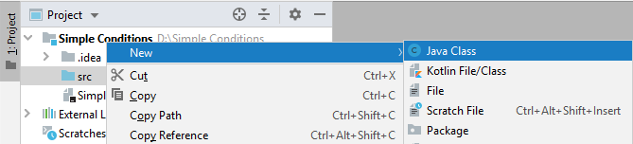
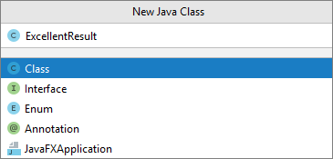
You already have a project with one class in it. It remains to write the code to solve the task.
- Create a main method by going to the "ExcellentResult" class (between curly brackets) and type:

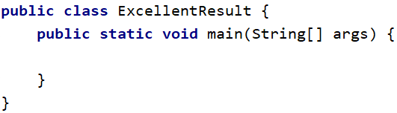

- Go to the body of the main (String [] args) method (between the curly braces). Create a Scanner object to read from the console and read a floating-point number - the grade:

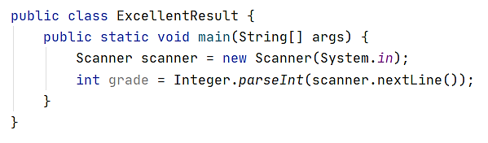

- Check the value of the assessment. If it is greater than or equal to 5, print the conditional output:

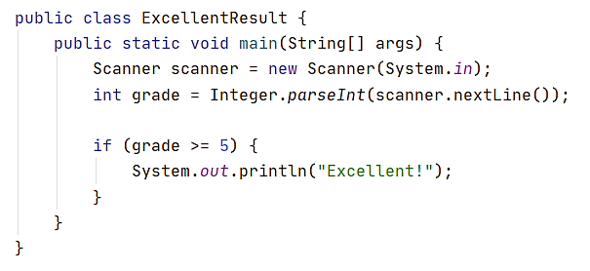

- Start the program with [Ctrl + Shift + F10] and test it with different input values:
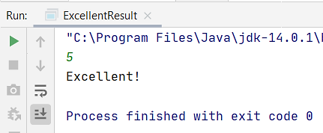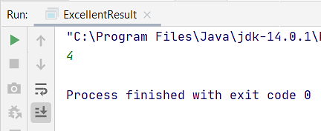

Testing in the Judge System
Test the solution to this problem here: https://judge.softuni.org/Contests/Compete/Index/3542#0

Greater Number

Write a program that reads two integers entered by the user and prints the larger of the two.

Sample Input and Output
Input | Output |  | Input | Output |  | Input | Output |  | Input | Output
5  3 | 5 |  | 3  5 | 5 |  | 10  10 | 10 |  | -5  5 | 5

Hints and Guidelines
- Read two integers from the console:

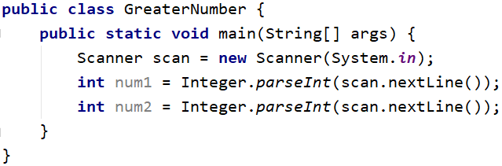

- Compare whether the first number num1 is greater than the second num2. Print the larger number.

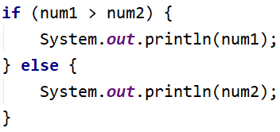

Testing in the Judge System
Test the solution to this problem here: https://judge.softuni.org/Contests/Compete/Index/3542#1

Even or Odd

Write a program that reads an integer entered by the user and prints whether it is even or odd.

Sample Input and Output
Input | Output |  | Input | Output |  | Input | Output |  | Input | Output
2 | even |  | 3 | odd |  | 25 | odd |  | 1024 | even

Hints and Guidelines
- First, add a new Java class to the existing project.
- Create a Scanner object and read an integer from the console:
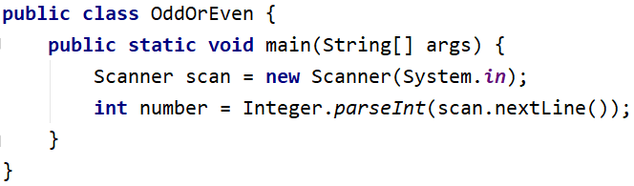
- Check that the number is even by dividing it by 2, and check what is the remainder of the division. Print the output depending on the condition:

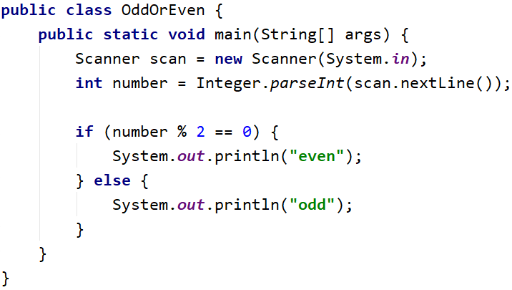

Testing in the Judge System
Test the solution to this problem here: https://judge.softuni.org/Contests/Compete/Index/3542#2

Password Guess
Write a program that reads a password (string) entered by the user and checks if the entered password matches the phrase "s3cr3t!P@ssw0rd". In case of coincidence, display "Welcome". In case of discrepancy, display "Wrong password!".

Sample Input and Output
Input | Output |  | Input | Output |  | Input | Output
qwerty | Wrong password! |  | s3cr3t!P@ssw0rd | Welcome |  | s3cr3t!p@ss | Wrong password!

Testing in the Judge System
Test the solution to this problem here: https://judge.softuni.org/Contests/Compete/Index/3542#3

Number 100...200
Write a program that reads an integer entered by the user and checks if it is below 100, between 100 and 200 or above 200. If the number is:
- below 100 print: "Less than 100"
- between 100 and 200 print: "Between 100 and 200"
- above 200 print: "Greater than 200"

Sample Input and Output
Input | Output |  | Input | Output |  | Input | Output
95 | Less than 100 |  | 120 | Between 100 and 200 |  | 210 | Greater than 200

Testing in the Judge System
Test the solution to this problem here: https://judge.softuni.org/Contests/Compete/Index/3542#4

Speed Info
Write a program that reads the speed (floating-point number) entered by the user and prints speed information.
- At speed up to 10 (inclusive) print "slow"
- At speed between 10 and 50 (inclusive) print "average"
- At speed between 50 and 150 (inclusive) print "fast"
- At speed between 150 and 1000 (inclusive) print "ultra fast"
- At a higher speed print "extremely fast"

Sample Input and Output
Input | Output |  | Input | Output |  | Input | Output |  | Input | Output |  | Input | Output
8 | slow |  | 49.5 | average |  | 126 | fast |  | 160 | ultra fast |  | 3500 | extremely fast

Testing in the Judge System
Test the solution to this problem here: https://judge.softuni.org/Contests/Compete/Index/3542#5

Area of Figures
Write a program in which the user enters the type and dimensions of a geometric figure and calculates its area. The figures are of four types: square, square, rectangle, circle, and triangle. The first line of the input reads the type of figure (string with the following options: square, rectangle, circle, or triangle).
- If the figure is a square: on the next line read a floating-point number - the length of its side
- If the figure is a rectangle: on the next two lines read two floating-point numbers - the lengths of its sides
- If the figure is a circle: on the next line read a floating-point number - the radius of the circle
- If the figure is a triangle: on the next two lines read two floating-point numbers - the length of its side and the length of the height to it
Round the result up to 3 digits after the decimal point.

Sample Input and Output
Input | Output |  | Input | Output |  | Input | Output |  | Input | Output
square  5 | 25.000 |  | rectangle  7  2.5 | 17.500 |  | circle  6 | 113.097 |  | triangle  4.5  20 | 45.000

Testing in the Judge System
Test the solution to this problem here: https://judge.softuni.org/Contests/Compete/Index/3542#6

