Database Basics MS SQL Exam – 19 June 2022
Submit your solutions in the SoftUni Judge system here

Zoo
Your childhood dream came true and you are invited to work in the local Zoo. Noticing your potential, you are asked to design a management system, so that they can keep track of the animals and the people, who are involved in the zoo.

Section 1. DDL (30 pts)
You have been given the E/R Diagram of the Zoo
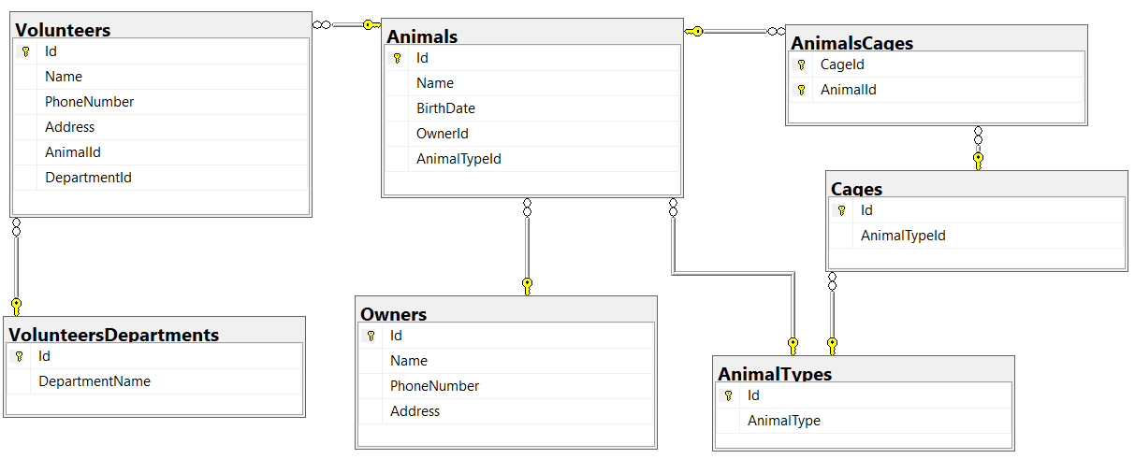
Create a database called Zoo. You need to create 7 tables:
- Owners – contains information about the owners of the animals;
- AnimalTypes – contains information about the different animal types in the zoo;
- Cages – contains information about the animal cages;
- Animals – contains information about the animals;
- AnimalsCages – a many-to-many mapping table between the animals and the cages;
- VolunteersDepartments – contains information about the departments of the volunteers;
- Volunteers – contains information about the volunteers.

NOTE: Please keep in mind that in case you have to work with a date, you have to use the exact same data type, described in the models tables. For example, data type Date means that you have to use Date, DateTime means that you have to use DateTime. If you don't use the correct type, the Judge system won't accept your submission as correct.
NOTE: Keep in mind that Judge doesn't accept "ALTER" statement and square brackets naming (when the names are not keywords).
NOTE: Use VARCHAR for strings, not NVARCHAR.
You have been tasked to create the tables in the database by the following models:

Owners
Column Name | Data Type | Constraints
Id | Integer from 0 to 2,147,483,647 | PK, Unique table identification, Identity
Name | String up to 50 symbols | Null is not allowed
PhoneNumber | String up to 15 symbols | Null is not allowed
Address | String up to 50 symbols | Null is allowed

AnimalTypes
Column Name | Data Type | Constraints
Id | Integer from 0 to 2,147,483,647 | PK, Unique table identification, Identity
AnimalType | String up to 30 symbols | Null is not allowed

Cages
Column Name | Data Type | Constraints
Id | Integer from 0 to 2,147,483,647 | PK, Unique table identification, Identity
AnimalTypeId | Integer from 0 to 2,147,483,647 | Relationship with table AnimalTypes, Null is not allowed

Animals
Column Name | Data Type | Constraints
Id | Integer from 0 to 2,147,483,647 | PK, Unique table identification, Identity
Name | String up to 30 symbols | Null is not allowed
BirthDate | Date | Null is not allowed
OwnerId | Integer from 0 to 2,147,483,647 | Relationship with table Owners, Null is allowed
AnimalTypeId | Integer from 0 to 2,147,483,647 | Relationship with table AnimalTypes, Null is not allowed

AnimalsCages
Column Name | Data Type | Constraints
CageId | Integer from 0 to 2,147,483,647 | PK, Unique table identification, Relationship with table Cages, Null is not allowed
AnimalId | Integer from 0 to 2,147,483,647 | PK, Unique table identification, Relationship with table Animals, Null is not allowed

VolunteersDepartments
Column Name | Data Type | Constraints
Id | Integer from 0 to 2,147,483,647 | PK, Unique table identification, Identity
DepartmentName | String up to 30 symbols | Null is not allowed

Volunteers
Column Name | Data Type | Constraints
Id | Integer from 0 to 2,147,483,647 | PK, Unique table identification, Identity
Name | String up to 50 symbols | Null is not allowed
PhoneNumber | String up to 15 symbols | Null is not allowed
Address | String up to 50 symbols | Null is allowed
AnimalId | Integer from 0 to 2,147,483,647 | Relationship with table Animals; Null is allowed
DepartmentId | Integer from 0 to 2,147,483,647 | Relationship with table VolunteersDepartments, Null is not allowed.

Database design
Submit all of your created statements to Judge (only creation of tables).

Section 2. DML (10 pts)
Before you start you have to import "01. DDL_Dataset.sql ". If you have created the structure correctly the data should be successfully inserted.
In this section, you have to do some data manipulations:

Insert
Let's insert some sample data into the database. Write a query to add the following records into the corresponding tables. All Ids should be auto-generated.
Volunteers
Name | PhoneNumber | Address | AnimalId | DepartmentId
Anita Kostova | 0896365412 | Sofia, 5 Rosa str. | 15 | 1
Dimitur Stoev | 0877564223 | null | 42 | 4
Kalina Evtimova | 0896321112 | Silistra, 21 Breza str. | 9 | 7
Stoyan Tomov | 0898564100 | Montana, 1 Bor str. | 18 | 8
Boryana Mileva | 0888112233 | null | 31 | 5

Animals
Name | BirthDate | OwnerId | AnimalTypeId
Giraffe | 2018-09-21 | 21 | 1
Harpy Eagle | 2015-04-17 | 15 | 3
Hamadryas Baboon | 2017-11-02 | null | 1
Tuatara | 2021-06-30 | 2 | 4

Update
Kaloqn Stoqnov (a current owner, present in the database) came to the zoo to adopt all the animals, who don't have an owner. Update the records by putting to those animals the correct OwnerId.

Delete
The Zoo decided to close one of the Volunteers Departments - Education program assistant. Your job is to delete this department from the database.
NOTE: Keep in mind that there could be foreign key constraint conflicts!

Section 3. Querying (40 pts)
You need to start with a fresh dataset, so recreate your DB and import the sample data again (01. DDL_Dataset.sql). DO NOT CHANGE OR INCLUDE DATA FROM DELETE, INSERT AND UDATE TASKS!!!

Volunteers
Extract information about all the Volunteers – name, phone number, address, id of the animal, they are responsible to and id of the department they are involved into. Order the result by name of the volunteer (ascending), then by the id of the animal (ascending) and then by the id of the department (ascending).

Example
Name | PhoneNumber | Address | AnimalId | DepartmentId
Anton Antonov | 0877456123 | Varna, 2 Dobrotitsa str. | 11 | 3
Boyan Boyanov | 0896321546 | Plovdiv, 15 Arda str. | 14 | 1
Darina Petrova | 0889654236 | Sofia, 39 Bratya Buxton str. | 31 | 3
Dilyana Stoeva | 0889412025 | Sofia, 15 Lyulyak str. | NULL | 2
Dimitrichka Stateva | 0888632123 | Sofia, 26 Vasil Levski str. | 7 | 8
Gabriel Radkov | 0889745102 | Sliven, 6 Krim str. | 18 | 5
… | … | … | … | …

Animals data
Select all animals and their type. Extract name, animal type and birth date (in format 'dd.MM.yyyy'). Order the result by animal's name (ascending).

Example
Name | AnimalType | BirthDate
African Penguin | Birds | 17.07.2017
African Spurred Tortoise | Reptiles | 26.09.2009
American Kestrel | Birds | 27.04.2019
Anaconda | Reptiles | 13.07.2016
Axolotl | Amphibians | 21.01.2019
Bald Eagle | Birds | 29.06.2014
… | … | …

Owners and Their Animals
Extract the animals for each owner. Find the top 5 owners, who have the biggest count of animals. Select the owner's name and the count of the animals he owns. Order the result by the count of animals owned (descending) and then by the owner's name.

Example
Owner | CountOfAnimals
Kaloqn Stoqnov | 4
Kiril Peshev | 4
Kamelia Yancheva | 3
Martin Genchev | 3
Metodi Dimitrov | 3

Owners, Animals and Cages
Extract information about the owners of mammals, the name of their animal and in which cage these animals are. Select owner's name and animal's name (in format 'owner-animal'), owner's phone number and the id of the cage. Order the result by the name of the owner (ascending) and then by the name of the animal (descending).

Example
OwnersAnimals | PhoneNumber | CageId
Anelia Mihova-Koala | 0897856147 | 16
Borislava Kamenova-Fennec Fox | 0877477112 | 21
Gergana Mancheva-Brown bear | 0897412123 | 26
Kaloqn Stoqnov-Leopard | 0878325642 | 32
Kaloqn Stoqnov-Elephant | 0878325642 | 37
Kamelia Yancheva-Lion | 0876213799 | 7
… | … | …

Volunteers in Sofia
Extract information about the volunteers, involved in 'Education program assistant' department, who live in Sofia. Select their name, phone number and their address in Sofia (skip city's name). Order the result by the name of the volunteers (ascending).

Example
Name | PhoneNumber | Address
Dilyana Stoeva | 0889412025 | 15 Lyulyak str.
Kiril Kostadinov | 0896541233 | 213 Tsarigradsko shose str.
Yanko Totev | 0896369258 | 54 Hristo Botev str.
Zdravko Asenov | 0889652365 | 6 Neven str.

Animals for Adoption
Extract all animals, who does not have an owner and are younger than 5 years (5 years from '01/01/2022'), except for the Birds. Select their name, year of birth and animal type. Order the result by animal's name.

Example
Name | BirthYear | AnimalType
Banded Archer Fish | 2022 | Fish
Chameleon | 2018 | Reptiles
Desert Hairy Scorpion | 2020 | Invertebrates
Goliath Frog | 2020 | Amphibians
Koi | 2021 | Fish
Poison Frog | 2020 | Amphibians

Section 4. Programmability (20 pts)

All Volunteers in a Department
Create a user-defined function named udf_GetVolunteersCountFromADepartment (@VolunteersDepartment) that receives a department and returns the count of volunteers, who are involved in this department.

Examples
Query
SELECT dbo.udf_GetVolunteersCountFromADepartment ('Education program assistant')
Output
6

Query
SELECT dbo.udf_GetVolunteersCountFromADepartment ('Guest engagement')
Output
4

Query
SELECT dbo.udf_GetVolunteersCountFromADepartment ('Zoo events')
Output
5

Animals with Owner or Not
Create a stored procedure, named usp_AnimalsWithOwnersOrNot(@AnimalName).
Extract the name of the owner of the given animal. If there is no owner, put 'For adoption'.

Example
Query
EXEC usp_AnimalsWithOwnersOrNot 'Pumpkinseed Sunfish'

Result
Name | OwnersName
Pumpkinseed Sunfish | Kamelia Yancheva

Example
Query
EXEC usp_AnimalsWithOwnersOrNot 'Hippo'

Result
Name | OwnersName
Hippo | For adoption

Example
Query
EXEC usp_AnimalsWithOwnersOrNot 'Brown bear'

Result
Name | OwnersName
Brown bear | Gergana Mancheva

