Lab: First Steps in Coding
Problems for lab exercise for the "Programming Basics" @ SoftUni Global.
Submit your solutions to the SoftUni Judge system at: https://judge.softuni.org/Contests/3564

Console Program "Hello SoftUni"
Write a console Python program, which prints the text "Hello SoftUni".
- Start PyCharm
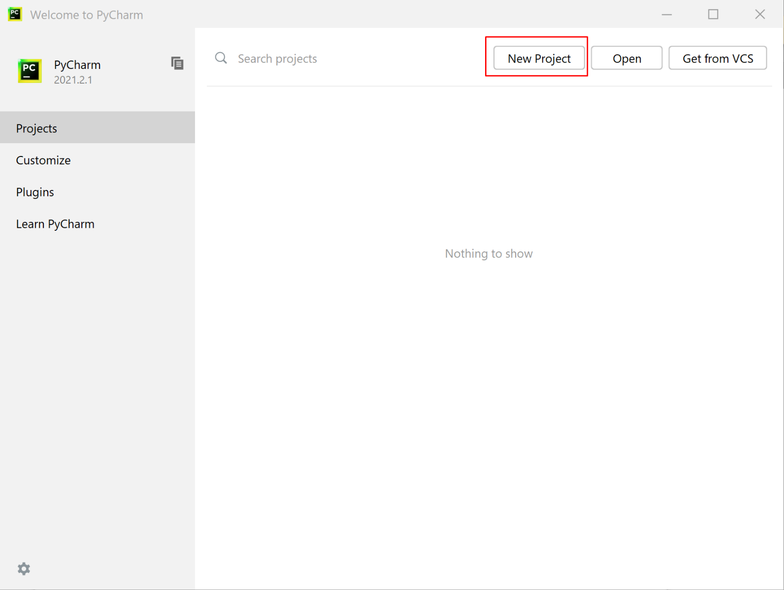
- Create a new project: New Project
- Choose an appropriate name and directory, in which to create your project
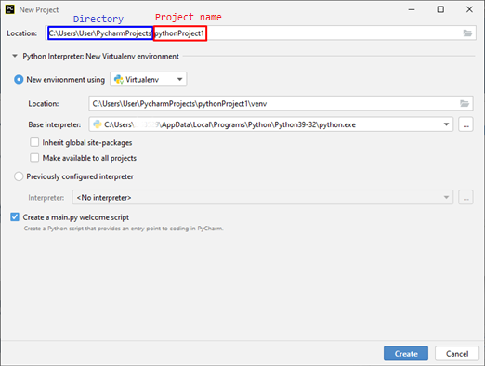
- Create a new file: Right click on the name of the project New Python File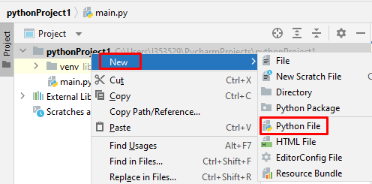
- Enter the name of the file:
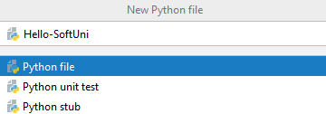
- Write the programming code(commands) for Python
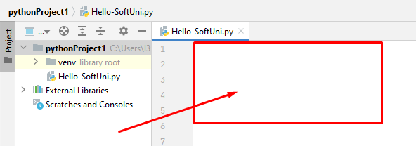
- Write the following code (command for printing the text"Hello SoftUni"):
print('Hello SoftUni')
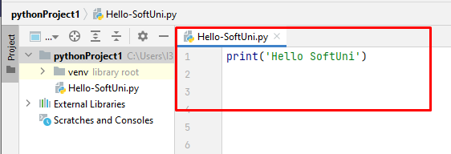
8. Start the program by pressing: Alt + Shift + F10 or right click in the code field -> Run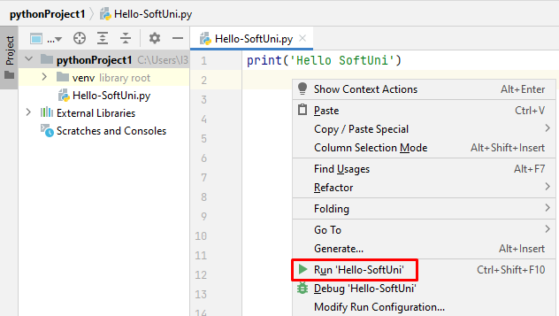

- At the bottom of the development environment you will get the following result:
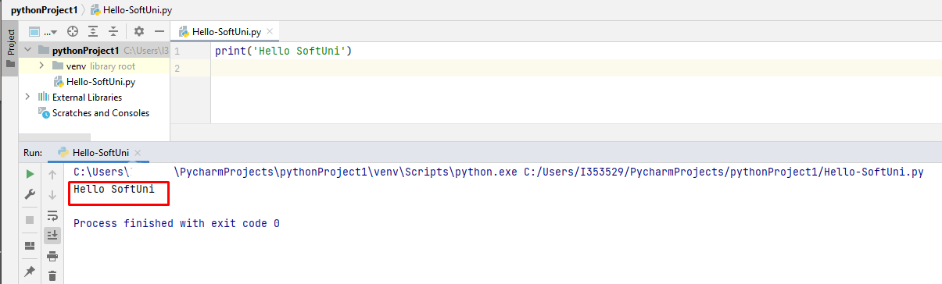
- Test your solutions in the online Judge system https://judge.softuni.org/Contests/Compete/Index/3564#0.
10. Log in with your SoftUni account. A window for submitting solutions for the "Hello SoftUni" task will appear. Copy the source code from the development environment and paste it into the solution submission box.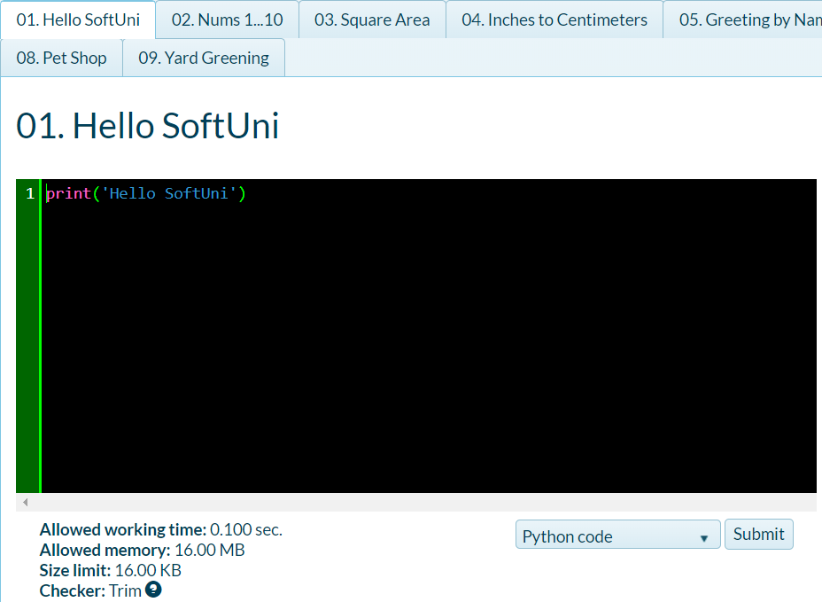
- Send your solution using the button Submit.
- You will receive the result within a few seconds in the table with sent decisions in the judge system:
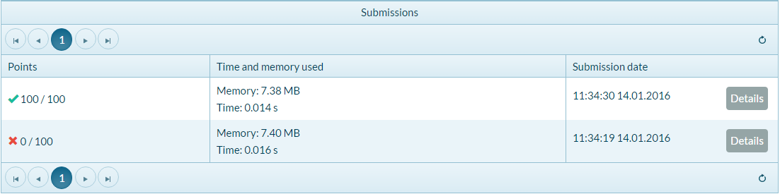

Numbers from 1 to 10
Write a Python console program, which prints the numbers from 1 to 10 each on a new line.
- Write 10 print() commands, for each of the numbers from 1 to 10.
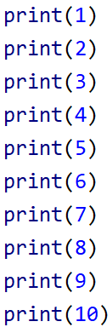
- Test your solution in the Judge system: https://judge.softuni.org/Contests/Compete/Index/3564#1

Area of a rectangle
Write a console program that receives two integers (the sides of rectangle a and b) and calculates the area of a rectangle with these sides.

Sample Input and Output
Input | Output
5  7 | 35
Input | Output
6  8 | 48

Hints and Guidelines
- Initialize two variables (a and b) and save the values entered in the console
- Initialize a second variable area in which to save the value for the face of the rectangle obtained by the formula a * b.
- Print the resulting result.
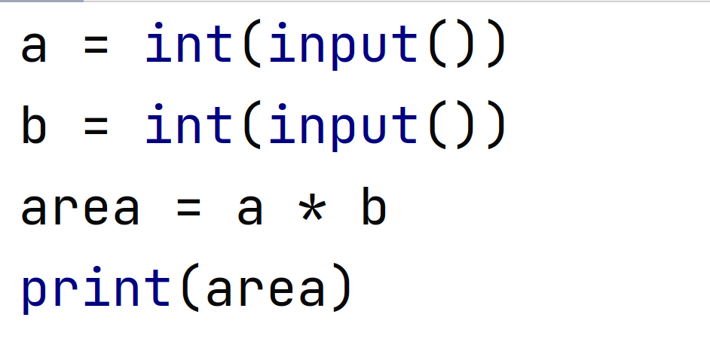
- Test your solution in the Judge system: https://judge.softuni.org/Contests/Compete/Index/3564#2

Converter: inches to centimeters
Write a program that reads a floating-point number from the console and converts it from inches to centimeters. To do this, multiply the inches by 2.54 (1 inch = 2.54 centimeters).

Sample Input and Output
Input | Output
5 | 12.7
Input | Output
7 | 17.78

Caution: depending on the regional settings of the operating system, a decimal point (US settings) may be used instead of a decimal point (BG settings). If the program expects a decimal point and a decimal place or reverse number is entered (a decimal point is entered when a decimal point is expected), an error may be made.
We recommend that you change your computer's settings to use a decimal point:
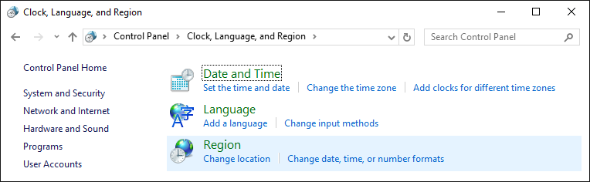
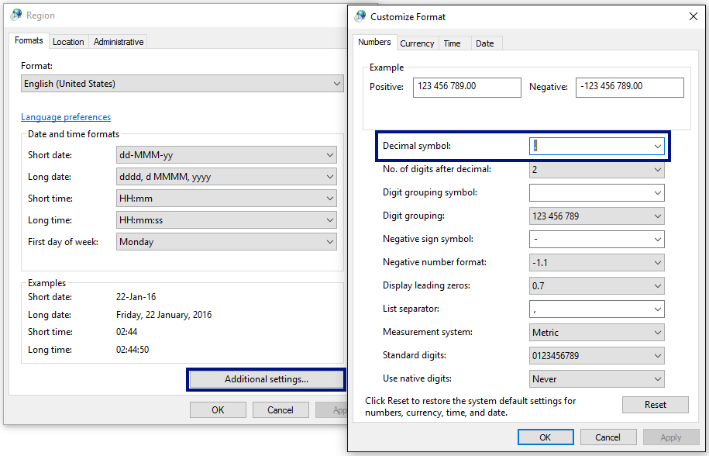
Test your solution in the Judge system: https://judge.softuni.org/Contests/Compete/Index/3564#3

Greetings by Name
Write a program that reads text from the console (person's name) and prints "Hello, <name>! " where <name> name is entered from the console.

Guidelines
- First create a new PyCharm file named greeting
- Create the variable name and keep in it the name you will read from the console using input():
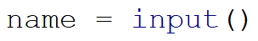
- Output the console by concatenation (gluing texts):
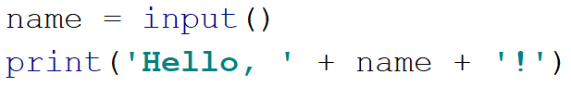

- Start the program with Ctrl + Shift + F10 or right mouse button -> Run and test with different input examples.
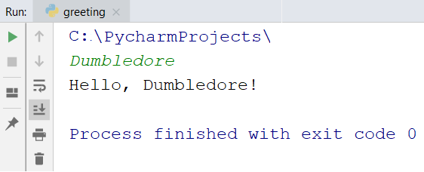

5. Test your solution in the Judge system: https://judge.softuni.org/Contests/Compete/Index/3564#4

Concatenate Data
Write a program that read from the console name, family, age and town and prints the following message: "You are <firstName> <lastName>, a <age>-years old person from < town>."

Guidelines
- Add another file to the current PyCharm project.
- Enter the input data and save it into variables with the appropriate data type:
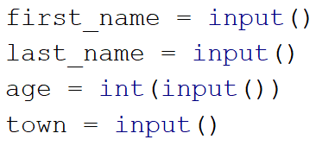
- Print the formatted output:
- Start the program with Ctrl + Shift + F10 and test with different input examples:
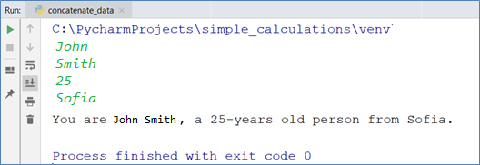

- Test your solution in the Judge system: https://judge.softuni.org/Contests/Compete/Index/3564#5

Projects Creation
Write a program that calculates how many hours it will take an architect to prepare the projects on several construction sites. The preparation of a project takes three hours.

Input
2 lines are read from the console
- Name of the architect - text
- Number of projects to be prepared- integer in the interval [0 … 100]

Output
Print on the console:
- "The architect {architect name} will need {needed hours} hours to complete {projects count} project/s."

Sample Input and Output
Input | Output |  | Input | Output
George  4 | The architect George will need 12 hours to complete 4 project/s. |  | John  9 | The architect John will need 27 hours to complete 9 project/s.
Test your solution in the Judge system: https://judge.softuni.org/Contests/Compete/Index/3564#6

Pet shop
Write a program that calculates the necessary costs for the purchase of food for dogs and cats. Food is shopped at a pet store, with a pack of dog food priced at 2.50 USD and a pack of cat food costing 4 USD.

Input
2 lines are read from the console:
- The number of packages of food for dogs – integer in the interval [0… 100]
- The number of packages of food for cats – integer in the interval [0… 100]

Output
Print on the console:
"{end sum} USD."

Sample Input and Output
Input | Output |  | Input | Output
5  4 | 28.5 USD. |  | 13  9 | - USD.
Test your solution in the judge system: https://judge.softuni.org/Contests/Compete/Index/3564#7

Yard Greening
Sophia has several houses on the Black Sea coast and wants to green the yards of some of them, thus creating a cozy atmosphere and comfort for its guests. She has hired a company for this purpose.
Write a program that calculates the amount needed for Sophie to pay to the project contractor. The price per square meter is 7.61 USD including VAT. Because her yard is quite large, the contractor company offers an 18% discount on the final price.

Input Data
One line is read from the console:
- Square meters of the landscaped – a floating-point number in the range [0.00 … 10000.00]

Output Data
Two lines are printed on the console:
- "The final price is: {final price of the service} USD."
- "The discount is: {discount} USD."

Sample Input and Output
Input | Output | Comments
550 | The final price is: 3432.11 USD.  The discount is: 753.39 USD. | We calculate the price for landscaping the whole yard:  550 * 7.61 = 4185.50 USD.  We deduct the discount (18% = 0.18) from the total:  0.18 * 4185.5 = 753.39 USD.  We calculate the final price of the service:  4185.50 – 753.39 3432.11 USD.
Input | Output | Comments
150 | The final price is: 936.03 USD.  The discount is: 205.47 USD. | We calculate the price for landscaping the whole yard:  150 * 7.61 = 1141.50 USD.  We deduct the discount (18% = 0.18) from the total:  0.18 * 1141.50 = 205.47 USD.  We calculate the final price of the service:  1141.50 – 205.47 936.03 USD.
Test your solution in the Judge system: https://judge.softuni.org/Contests/Compete/Index/3564#8

