Lab: Arrays
Problems for exercises and homework for the “Programming Fundamentals” course @ SoftUni.
You can check your solutions here: https://judge.softuni.bg/Contests/172/Arrays-Lab.

Day of Week
Enter a day number [1…7] and print the day name (in English) or “Invalid Day!”. Use an array of strings.

Examples
Input | Output
1 | Monday
2 | Tuesday
7 | Sunday
0 | Invalid Day!

Hints
- Use an array of strings holding the day names: {"Monday", "Tuesday", "Wednesday", "Thursday", "Friday", "Saturday", "Sunday"}.
- Print the element at index (day-1) when it is in the range [1…7] or “Invalid Day!” otherwise.

Reverse an Array of Integers
Write a program to read an array of integers, reverse it and print its elements. The input consists of a number n (the number of elements) + n integers, each as a separate line. Print the output on a single line (space separated).

Examples
Input | Output
3  10  20  30 | 30 20 10
4  -1  20  99  5 | 5 99 20 -1

Hints
- First, read the number n.
- Allocate an array of n integers.
- Read the integers in a for-loop.
- Instead of reversing the array, you can just pass through the elements from the last (n-1) to the first (0) with a reverse for-loop.

Last K Numbers Sums Sequence
Enter two integers n and k. Generate and print the following sequence of n elements:
- The first element is: 1
- All other elements = sum of the previous k elements (if less than k are available, sum all of them)
- Example: n = 9, k = 5 120 = 4 + 8 + 16 + 31 + 61

Examples
Input | Output
6  3 | 1 1 2 4 7 13
8  2 | 1 1 2 3 5 8 13 21
9  5 | 1 1 2 4 8 16 31 61 120

Hints
- Use an array of integers to hold the sequence.
- Initially seq[0] = 1
- Use two nested loops:
  - Loop through all elements i = 1 … n
  - Sum the elements i-k … i-1: seq[i] = sum(seq[i-k … i-1])

Triple Sum
Write a program to read an array of integers and find all triples of elements a, b and c, such that a + b == c (where a stays to the left from b). Print “No” if no such triples exist.

Examples
Input | Output
1 1 1 1 | No
4 2 8 6 | 4 + 2 == 6  2 + 6 == 8
2 7 5 0 | 2 + 5 == 7  2 + 0 == 2  7 + 0 == 7  5 + 0 == 5
3 1 5 6 1 2 | 3 + 2 == 5  1 + 5 == 6  1 + 1 == 2  1 + 2 == 3  5 + 1 == 6  1 + 2 == 3

Hints:
- Read the input numbers in array arr[].
- Use nested loops to generate all pairs {a, b}, such that 0 ≤ a < b < n.
- Check whether arr[] contains the sum arr[a] + arr[b].

Rounding Numbers Away from Zero
Write a program to read an array of real numbers (space separated values), round them to the nearest integer in “away from 0” style and print the output as in the examples below.
Rounding in “away from zero” style means:
- To round to the nearest integer, e.g. 2.9 3; -1.75 -2
- In case the number is exactly in the middle of two integers (midpoint value), round it to the next integer which is away from the 0:
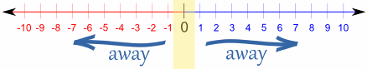

Examples
Input | Output
0.9 1.5 2.4 2.5 3.14 | 0.9 => 1  1.5 => 2  2.4 => 2  2.5 => 3  3.14 => 3
-5.01 -1.599 -2.5 -1.50 0 | -5.01 => -5  -1.599 => -2  -2.5 => -3  -1.50 => -2  0 => 0

Hints:
- Approach I: Take the absolute value of each input number, add 0.5 and truncate the integral part. If the original number is negative, make the result also negative.
- Approach II: Search in Internet for “rounding away from zero” + C#. You should find a built-in C# method for rounding in many styles. Choose the “away from zero” rounding.

Reverse an Array of Strings
Write a program to read an array of strings, reverse it and print its elements. The input consists of a sequence of space separated strings. Print the output on a single line (space separated).

Examples
Input | Output
a b c d e | e d c b a
-1 hi ho w | w ho hi -1

Hints
- Read the array of strings.
- Exchange the first element (at index 0) with the last element (at index n-1).
- Exchange the second element (at index 1) with the element before the last (at index n-2).
- Continue the same way until the middle of the array is reached.
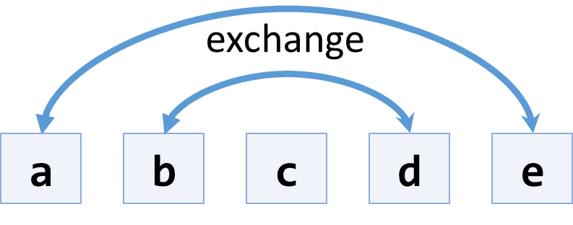
- Another, shorter approach, is to use the .Reverse() extension method from “System.Linq”.

Sum Arrays
Write a program that reads two arrays of integers and sums them. When the arrays are not of the same size, duplicate the smaller array a few times.

Examples
Input | Output | Comments
1 2 3 4  2 3 4 5 | 3 5 7 9 | 1 2 3 4 +  2 3 4 5 =  3 5 7 9
1 2 3 4 5  2 3 | 3 5 5 7 7 | 1 2 3 4 5 +  2 3 2 3 2 =  3 5 5 7 7
5 4 3  2 3 1 4 | 7 7 4 9 | 5 4 3 5 +  2 3 1 4 +  7 7 4 9

Hints
- Assume the first array arr1 has len1 elements and the second arr2 has len2 elements.
- The result array will have max(len1, len2) elements.
- We sum array elements one by one (from the first to the last). To enable rotating (take the first element as next after the last), we use the position % length indexing: arr1[i % len1] and arr2[i % len2].

Condense Array to Number
Write a program to read an array of integers and condense them by summing adjacent couples of elements until a single integer is obtained. For example, if we have 3 elements {2, 10, 3}, we sum the first two and the second two elements and obtain {2+10, 10+3} = {12, 13}, then we sum again all adjacent elements and obtain {12+13} = {25}.

Examples
Input | Output | Comments
2 10 3 | 25 | 2 10 3 2+10 10+3 12 13 12 + 13 25
5 0 4 1 2 | 35 | 5 0 4 1 2 5+0 0+4 4+1 1+2 5 4 5 3 5+4 4+5 5+3 9 9 8 9+9 9+8 18 17 18+17 35
1 | 1 | 1 is already condensed to number

Hints
While we have more than one element in the array nums[], repeat the following:
- Allocate a new array condensed[] of size nums.Length-1.
- Sum the numbers from nums[] to condensed[]:
  - condensed[i] = nums[i] + nums[i+1]
- nums[] = condensed[]
The process is illustrated below:
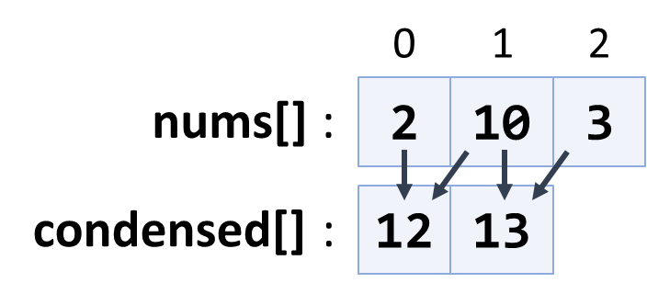
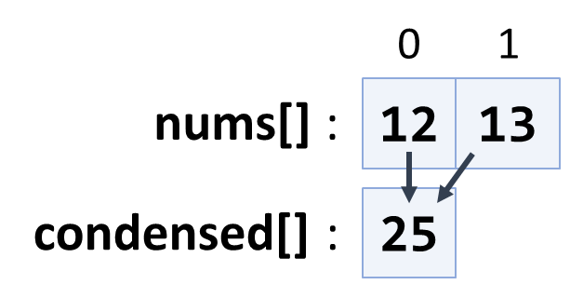

Extract Middle 1, 2 or 3 Elements
Write a method to extract the middle 1, 2 or 3 elements from array of n integers and print them.
- n = 1 -> 1 element
- even n -> 2 elements
- odd n -> 3 elements
Create a program that reads an array of integers (space separated values) and prints the middle elements in the format shown in the examples.

Examples
Input | Output
5 | { 5 }
2 3 8 1 7 4 | { 8, 1 }
1 2 3 4 5 6 7 | { 3, 4, 5 }
10 20 30 40 50 60 70 80 | { 40, 50 }

Hints
- Write different logic for each case (n = 1, even n, odd n)
- n = 1 take the first element
- odd n take elements n/2-1, n/2, n/2+1
- even n take elements n/2-1 and n/2

