Lab: B-2-3 and AVL Trees
This document defines the lab for "Data Structures – Advanced (Java)" course @ Software University. Please submit your solutions (source code) of all below described problems in Judge.
Write Java code for solving the tasks on the following pages. Code should compile under the Java 8 and above standards you can write and locally test your solution with the Java 13 standard, however Judge will run the submission with Java 10 JRE. Avoid submissions with features included after Java 10 release doing otherwise will result in compile time error.
Any code files that are part of the task are provided as Skeleton. In the beginning import the project skeleton, do not change any of the interfaces or classes provided. You are free to add additional logic in form of methods in both interfaces and implementations you are not allowed to delete or remove any of the code provided. Do not change the names of the files as they are part of the tests logic. Do not change the packages or move any of the files provided inside the skeleton if you have to add new file add it in the same package of usage.
Some tests may be provided within the skeleton – use those for local testing and debugging, however there is no guarantee that there are no hidden tests added inside Judge.
Please follow the exact instructions on uploading the solutions for each task. Submit as .zip archive the files contained inside "...\src\main\java" folder this should work for all tasks regardless of current DS implementation.
In order for the solution to compile the tests successfully the project must have single Main.java file containing single public static void main(String[] args) method even empty one within the Main class.
Some of the problem will have simple Benchmark tests inside the skeleton. You can try to run those with different values and different implementations in order to observe behaviour. However keep in mind that the result comes only as numbers and this data may be misleading in some situations. Also the tests are not started from the command prompt which may influence the accuracy of the results. Those tests are only added as an example of different data structures performance on their common operations.
The Benchmark tool we are using is JMH (Java Microbenchmark Harness) and that is Java harness for building, running, and analyzing, nano/micro/milli/macro benchmarks written in Java and other languages targeting, the JVM.
Additional information can be found here: JMH and also there are other examples over the internet.
Important: when importing the skeleton select import project and then select from maven module, this way any following dependencies will be automatically resolved. The project has NO default version of JDK so after the import you may (depends on some configurations) need to specify the SDK, you can download JDK 13 from HERE.

AVL Tree Insertion
For this task submit only AVL.java, Main.java and Node.java files as .zip
You are given a skeleton that supports the following operations:
- Node<T> root returns the root of the AVL tree
- bool contains(T item) checks if an element exists
- void eachInOrder(Consumer<T> consumer) performs an action in order on each element
- void insert(T item) inserts an item into the tree
public class AVL<T extends Comparable<T>> {
private Node<T> root;
public Node<T> getRoot() {
return this.root;
}
public boolean contains(T item) {
Node<T> node = this.search(this.root, item);
return node != null;
}
public void insert(T item) {
this.root = this.insert(this.root, item);
}
public void eachInOrder(Consumer<T> consumer) {
this.eachInOrder(this.root, consumer);
}
private void eachInOrder(Node<T> node, Consumer<T> action) {
if (node == null) {
return;
}
this.eachInOrder(node.left, action);
action.accept(node.value);
this.eachInOrder(node.right, action);
}
private Node<T> insert(Node<T> node, T item) {
if (node == null) {
return new Node<>(item);
}
int cmp = item.compareTo(node.value);
if (cmp < 0) {
node.left = this.insert(node.left, item);
} else if (cmp > 0) {
node.right = this.insert(node.right, item);
}
return node;
}
private Node<T> search(Node<T> node, T item) {
if (node == null) {
return null;
}
int cmp = item.compareTo(node.value);
if (cmp < 0) {
return search(node.left, item);
} else if (cmp > 0) {
return search(node.right, item);
}
return node;
}
}

And a node class:
public class Node<T extends Comparable<T>> {
public T value;
public Node<T> left;
public Node<T> right;
public int height;
public Node(T value) {
this.value = value;
this.height = 1;
}
}

Your task is to balance the tree after each insertion.

Height
First, you should update the height of all nodes along an insertion path
You will need a method to find a node's height
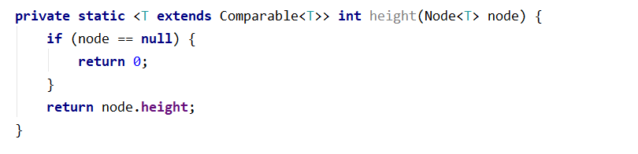
And a method to update a node's height
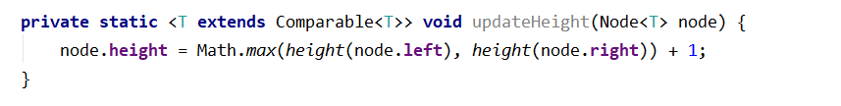
Consider when it is appropriate to update the height of a node
Check if Height tests pass
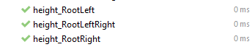

Rotations
If you find it difficult to imagine the links that need to be updated in a rotation, refer to the presentation
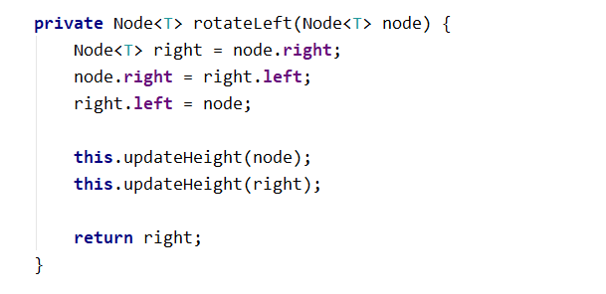
The rotation are analogous.
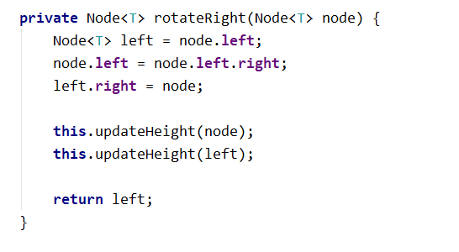

Balancing
Start by creating the method
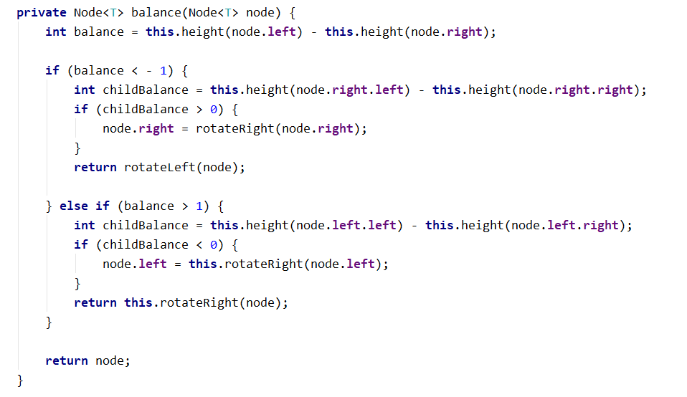
Make sure that all tests pass:
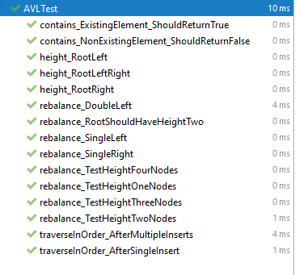
Congratulations, you have completed the lab for AVL Trees.

