Lab: Hash Tables Sets and Maps
This document defines the lab for "Data Structures – Advanced (Java)" course @ Software University. Please submit your solutions (source code) of all below described problems in Judge.
Write Java code for solving the tasks on the following pages. Code should compile under the Java 8 and above standards you can write and locally test your solution with the Java 13 standard, however Judge will run the submission with Java 10 JRE. Avoid submissions with features included after Java 10 release doing otherwise will result in compile time error.
Any code files that are part of the task are provided as Skeleton. In the beginning import the project skeleton, do not change any of the interfaces or classes provided. You are free to add additional logic in form of methods in both interfaces and implementations you are not allowed to delete or remove any of the code provided. Do not change the names of the files as they are part of the tests logic. Do not change the packages or move any of the files provided inside the skeleton if you have to add new file add it in the same package of usage.
Some tests may be provided within the skeleton – use those for local testing and debugging, however there is no guarantee that there are no hidden tests added inside Judge.
Please follow the exact instructions on uploading the solutions for each task. Submit as .zip archive the files contained inside "...\src\main\java" folder this should work for all tasks regardless of current DS implementation.
In order for the solution to compile the tests successfully the project must have single Main.java file containing single public static void main(String[] args) method even empty one within the Main class.
Some of the problem will have simple Benchmark tests inside the skeleton. You can try to run those with different values and different implementations in order to observe behavior. However keep in mind that the result comes only as numbers and this data may be misleading in some situations. Also, the tests are not started from the command prompt which may influence the accuracy of the results. Those tests are only added as an example of different data structures performance on their common operations.

You must implement a hash table that uses chaining in a linked list as a collision resolution strategy:
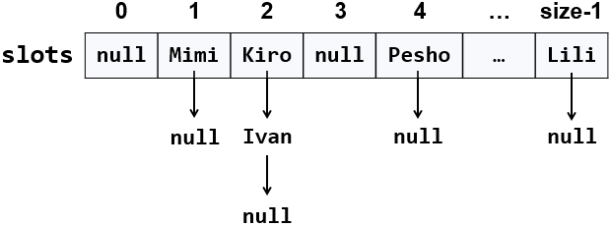
The hash table will hold its elements (key-value pairs) in a class KeyValue<Key, Value>. The hash table will consist of slots, each holding a linked list of key-value pairs: LinkedList<KeyValue<Key, Value>>.

Learn about Hash Tables in Wikipedia
Before starting, get familiar with the concept of hash table: https://en.wikipedia.org/wiki/Hash_table. Note that there are many collision resolution strategies like chaining and open addressing. We will use one of the simplest strategies: chaining elements with collisions in a linked list.
The typical operations over a hash table are add or replace, find and remove. Additional operations are enumerate all elements, enumerate all keys, enumerate all values and get count. Let's start coding!

HashTable<K, V> – Project Skeleton
You are given an unfinished project holding the class KeyValue<Key, Value>, the unfinished class HashTable<K, V> and unit tests for its entire functionality.
Your goal is to implement the missing functionality to finish the project.
First, let's look at the KeyValue<Key, Value> class. It holds a key-value pair of parameterized types Key and Value. To enable comparing key-value pairs, the class implements equals(…) and hashCode(). It also has toString() method to enable printing it on the console and view it inside the debugger. The KeyValue<Key, Value> class comes out-of-the-box with the project skeleton, so you will not need to change it:

The project comes also with unit tests covering the entire functionality of the hash table see the class HashTableTests

Run the Unit Tests to Ensure All of Them Initially Fail
Run the unit tests from the HashTableTests class. All of them should fail:
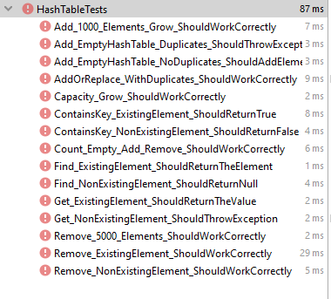
This is quite normal. We have unit tests, but the code covered by these tests is missing. Let's write it.

Define the Hash Table Internal Data
The first step is to define the inner data that holds the hash table elements:
- LinkedList<KeyValue<Key, Value>>[] slots – an array that holds the slots in the hash table
  - Each slot is either empty (null) or holds a linked list of elements with the same hash code
- int count – holds the number of elements in the hash table
- int capacity – holds the number of slots in the hash table
- Thus, the hash table fill factor can be calculated by Count / Capacity
The code might look like this:
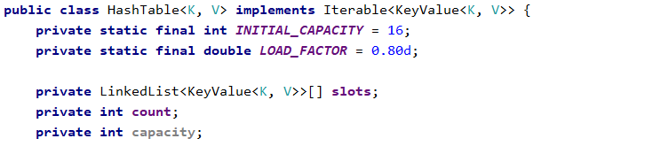

Implement the Hash Table Constructor
Now, let's implement the hash table constructor. Its purpose is to allocate the slots that will hold the hash table elements. The hash table constructor has two forms:
- Parameterless constructor – should allocate 16 slots (16 is the default initial hash table capacity)
- Constructor with parameter capacity – allocates the specified capacity in the underlying array (slots)

Implement the Add(key, value) Method
Now, we are ready to implement the most important method add(key, value) that inserts a new element in the hash table. It should take into account several things:
- Detect collisions and resolve them through chaining the elements in a linked list.
- Detect duplicated keys and throw an exception.
- grow the hash table if needed (resize to double capacity when the fill factor is too high).
The add(key, value) method might look like this:
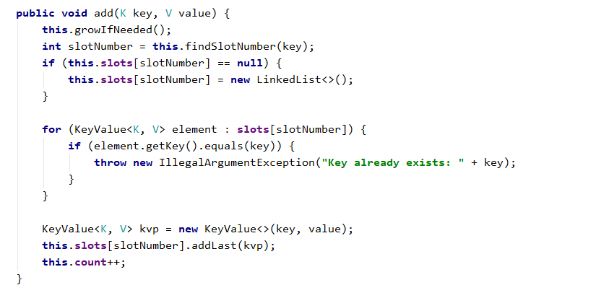
How it works? First, if the hash table is full, grow it (resize its capacity to 2 times bigger capacity). This will be discussed later. We can leave the growIfNeeded() method empty.
Next, find the slot that should hold the element to be added. The slot number is calculated by the hash value of the key. Typically, the hashCode() method. We need a number in the range [0 … size-1] so we take the modulus of the hash code:
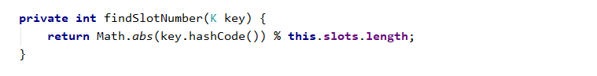
We take the absolute value because hashCode() sometimes return negative numbers.
Once we have the slot number, it is either empty (null) or holds a linked list of elements with the same hash code like the new element. In both cases, we should have in the target slot a linked list holding the elements with the same hash value like the key.
We check for duplicated key and throw an exception if the same key already exists. Then we append the new element at the end of the linked list in the target slot of the hash table and increase this.count.

Implement the Enumerator (Iterable<T>)
Now let's implement the enumerator: a method that passed through all elements in the hash table exactly once. The hash table holds key-value pairs (KeyValue<Key, Value>) elements, so we need to implement the interface Iterable<KeyValue<Key, Value>>.

Implement Find(key)
Let's implement the second most important operation after adding a key-value pair – finding an element by key. The find(key) method should either return the element by its key or return null if the key does not exist:
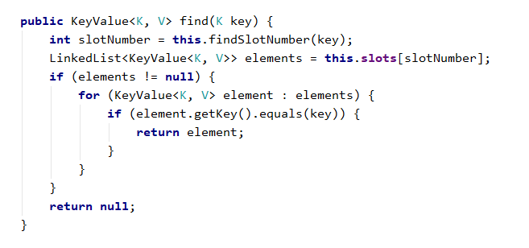
The above code works as follows:
- Finds the slot holding the specified key (by calculating the hash code modulus the hash table size).
- Passes through all elements in the target slot (in its linked list) and compare their key with the target key.

Implement Get(key) and ContainsKey(key) Methods
Once we have the find(key) method, it is easy to implement the methods that directly depend on it:
- get(key) – returns the element by given key or throws and exception when the key does not exist
- containsKey(key) – returns whether the key exists in the hash table
Let's start with the get(key) method:
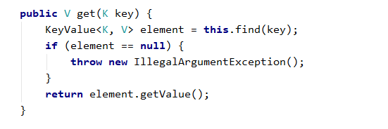
The containsKey(key) method is trivial. Implement it yourself:

Implement the GrowIfNeeded() and Grow() Methods
The growIfNeeded() method check whether the hash table should grow. The hash table should grow when it has filled its capacity to more than 75% (load factor > 75%) and we are trying to add a new element. In this case, it first calls grow(), otherwise does nothing:
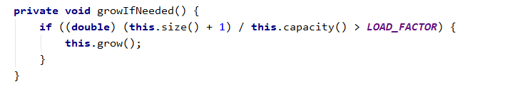
The grow() method allocates a new hash table with double capacity and adds the old elements in the new hash table, then replaces the old hash table with the new one:
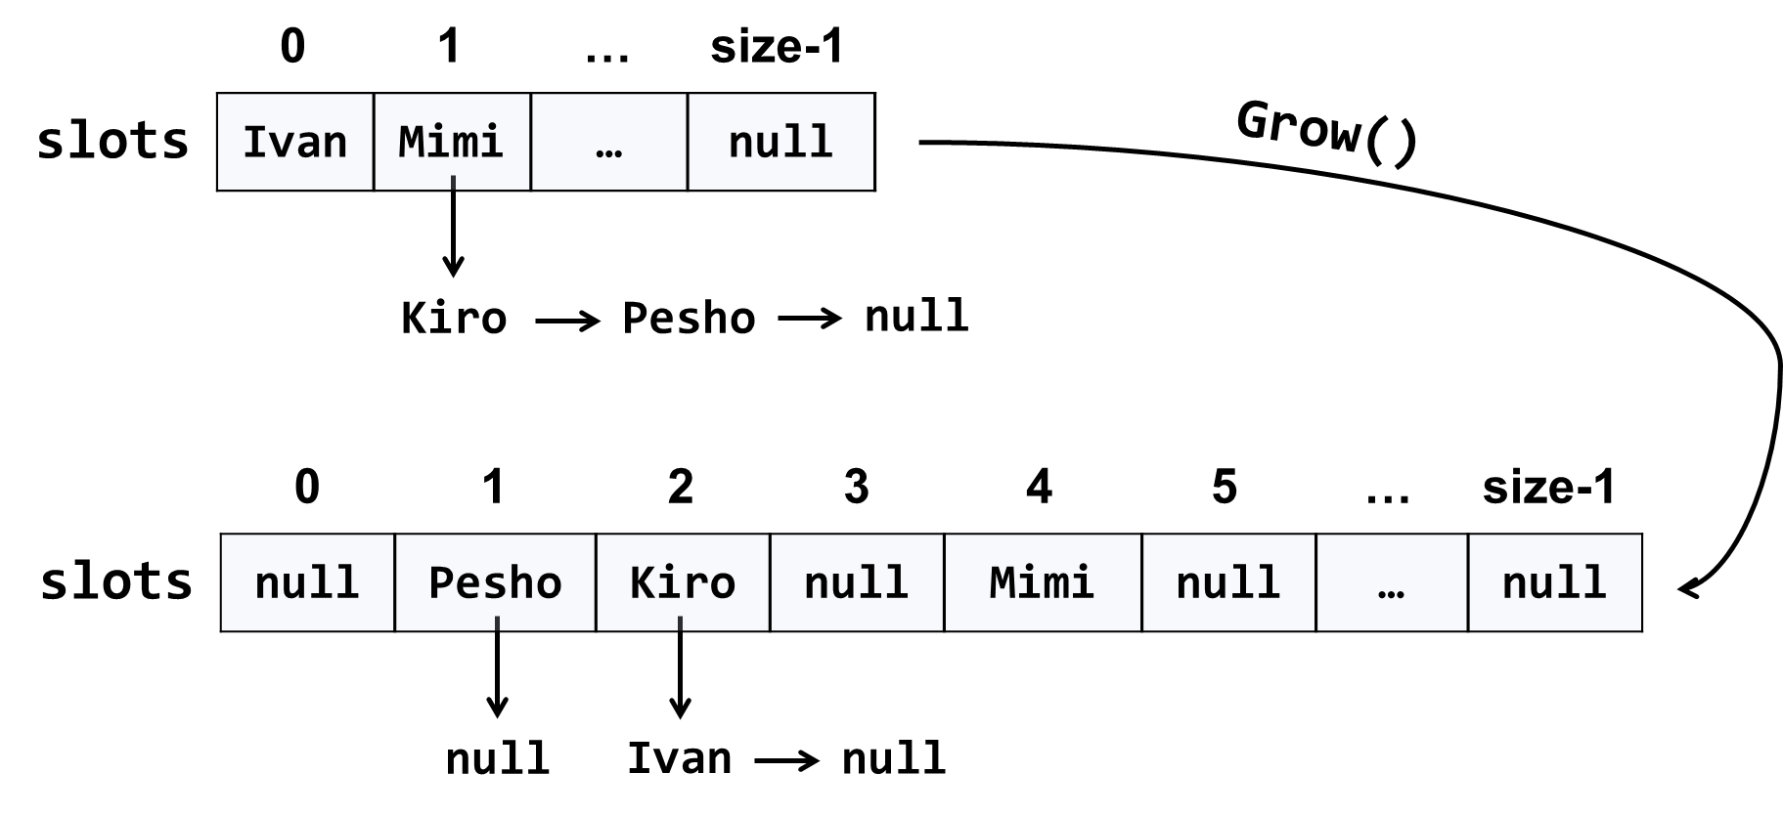
The code might look like this:
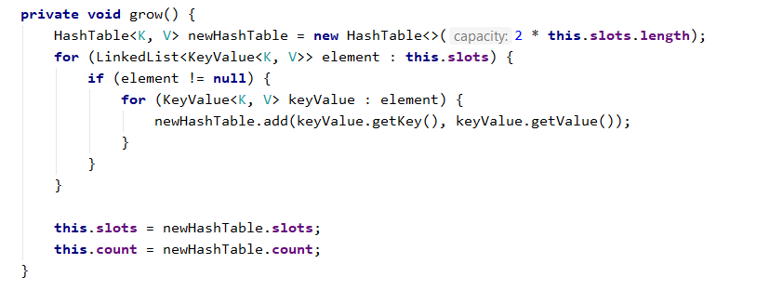

Implement AddOrReplace(key, value)
The method addOrReplace(key, value) is very similar to the add(key, value) method. The only difference is the add(key, value) throws and exception when the key is found to already exist in the hash table, while in the same situation addOrReplace(key, value) replaces the value in the element holding the key, with the new value passed as argument.
Hint: copy / paste the code from add(key, value) and slightly modify its logic.
Implement addOrReplace(key, value) yourself.

Implement Remove(key)
The next important functionality waiting to be implemented is removing an element by its key. The method remove(key) should either:
- Successfully remove the element (when the key exists) from the hash table and return true.
- Return false when the key does not exist in the hash table.
The remove(key) method is not trivial. It should first find the slot that is expected to hold the key, then traverse the linked list from its first to its last element and remove the element is case the key is found and return truе. Otherwise, it should return false:

Implement Clear()
The clear() method is trivial. It should reinitialize this.slots and this.count, like it was initially done in the hash table constructor. Implement it yourself.

Implement Keys and Values
Now implement the last piece of missing functionality: enumerating all keys and values. We already have enumerator that returns all elements from the hash table. We just need to filter (select) the keys / values:

"Mort was already aware that love made you feel hot and cold and cruel and weak, but he hadn’t realised that it could make you stupid." ― Terry Pratchett, Mort

