Practical Exam – Train System
You have been tasked to create a simple application for a train ticket administration. The application should hold train trips, which are the main app entities. The app is called TrainSystem.
The functionality of the application should support creating, listing, editing, deleting train trips.
The application should persist the data into a database.

Overview
Your application should be built on each one of the following technologies:

PHP
- Symfony framework
- Twig view engine
- Doctrine ORM
- MySQL database

JavaScript
- NodeJS + ExpressJS frameworks
- Handlebars.js view engine
- Mongoose data access library
- MongoDB database

Java
- Spring framework (Spring MVC + Spring Boot + Spring Data)
- Thymeleaf view engine
- JPA / Hibernate ORM + Spring Data data access
- MySQL database

C#
- ASP.NET framework (ASP.NET MVC + Entity Framework)
- Razor view engine
- Entity Framework ORM
- MS SQL Server database

Data Model
The Trip entity holds 5 properties:
- id – technology-dependent identifier (ObjectID for JavaScript, int for all other technologies)
- origin – non-empty text
- destination – non-empty text
- business – price for a Business Class ticket, a 32-bit integer
- economy – price for an Economy Class ticket, a 32-bit integer

Project Skeletons
You will be given the applications’ skeletons, which holds about 90% of the logic. You’ll be given some files (controllers, models etc.). The files will have partially implemented logic, so you’ll need to write some code for the application to function properly.
The application’s views will be given to you fully implemented. You only need to include them in your business logic.
Each technology will have its own skeleton, and the different skeletons may differ in terms of what is given to you and what is to be implemented.
Everything that has been given to you inside the skeleton is correctly implemented and if you write your code correctly, the application should work just fine. You are free to change anything in the Skeleton on your account.

User Interface
This is the user interface or how the application’s pages should look in their final form (fully implemented). You have several pages, described below:

Index Page

Route: “/”
Displays all the train trips from the database with options to edit or delete them.
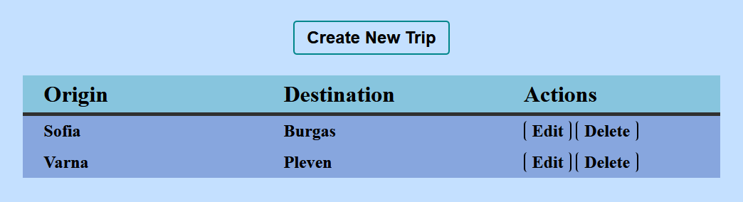

Create Page

Route: “/create”
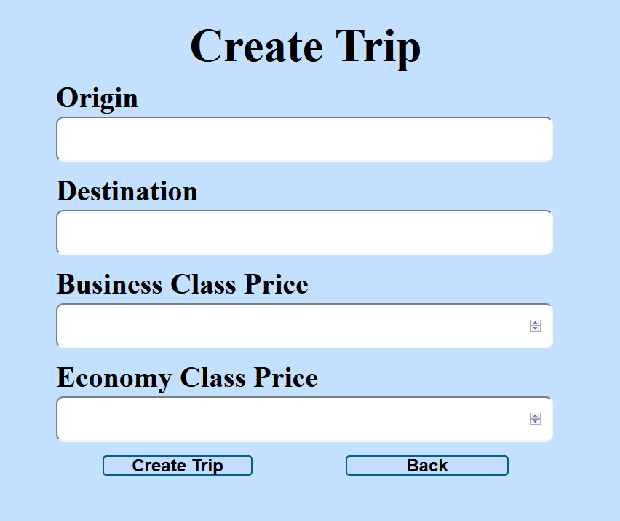

Edit Page

Route: “/edit/{id}”
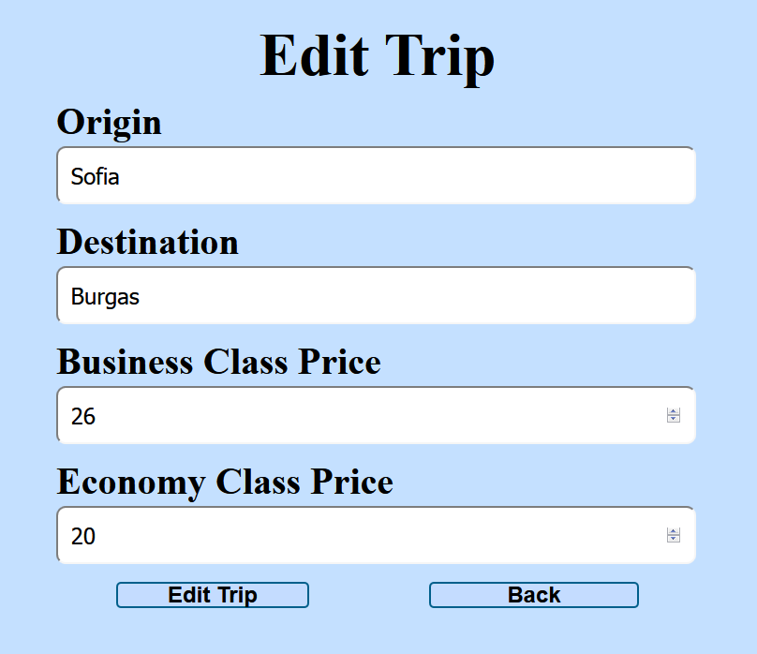

Delete Page

Route: “/delete/{id}”
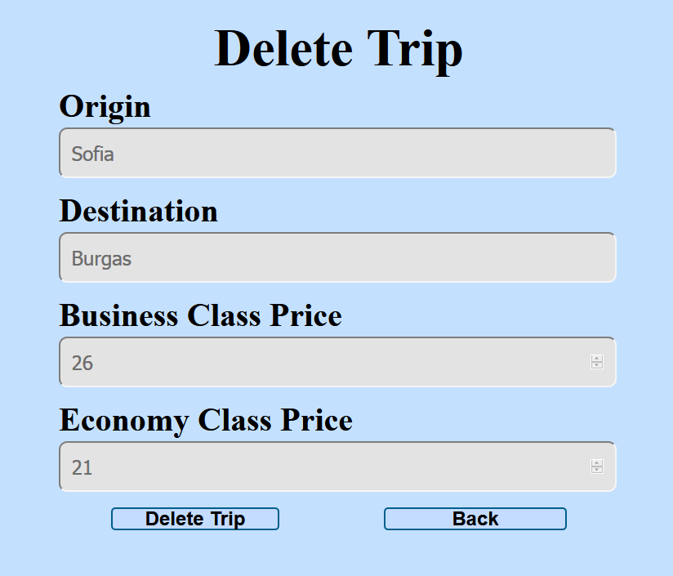

Problem
As you can see the different pages are on different routes. Most of the routing logic will be given to you in the Skeleton, but you should make sure that the application works properly.
Implement the “TrainSystem” app using all the above described 4 technologies.

Setup
Before you start working, make sure you download all the dependencies (packages) required for each technology and set up the databases! Below are instructions on how to do this:

PHP and Symfony
- Go into the root directory of the project (where the bin folder resides)
- Make sure you’ve started your MySQL server (either from XAMPP or standalone)
- Open a shell / command prompt / PowerShell window in the root directory: [Shift] + [Right click] [Open command window here]
- Enter the “php composer.phar install” command to restore its Composer dependencies (described in composer.json)
- Enter the “php bin/console doctrine:database:create --if-not-exists” command
- Done!

JavaScript and Node.js
- Go into the root directory of the project (where the bin folder resides)
- Make sure you’ve started your MongoDB server (mongod.exe --dbpath path/to/db/directory)
- Open a shell / command prompt / PowerShell window in the root directory: [Shift] + [Right click] [Open command window here]
- Enter the “npm install” command to restore its Node.js dependencies (described in package.json)
- Done!

C# and ASP.NET
The C# project will automatically resolve its NuGet dependencies (described in packages.config) using the NuGet package restore when the project is built.

Java and Spring MVC
The Java project will automatically resolve its Maven dependencies (described in pom.xml) when the project is built.

