Exercises: HTTP and Databases Basics
Problems for Exercise for the “Software Technologies” course @ SoftUni. Submit your solutions in the SoftUni judge system at https://judge.softuni.bg/Contests/969. Install “Postman” REST Client to ease your task.

II. HTTP

GitHub Repos for User "Tech-Module-Jan-2018"
Use POSTMAN to send a "GET" request to receive all the repositories, after that all you have to do is copy the request and paste it as a solution in judge.
Don’t forget that you should use the API provided from GitHub: https://api.github.com

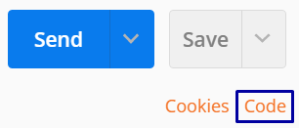
GitHub Issue by id
Use POSTMAN to send a "GET" request to receive an Issue by id. Try getting issue with id 1 in repo "test-repo" in "Tech-Module-Jan-2018". Don’t forget that you should use the API provided from GitHub: https://api.github.com.
Post the HTTP code as a solution in judge.

GitHub Issue
Use POSTMAN to send a "POST" request to the server with the following JSON as body (send it as application/JSON):
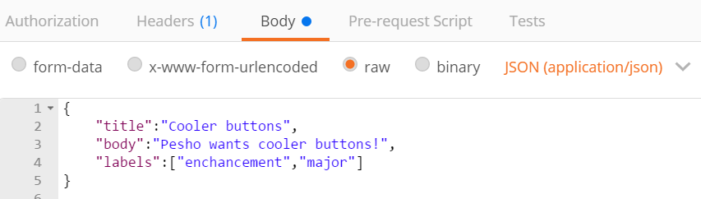
You need to use your GitHub account credentials to submit issues. Under the Authorization tab, select Basic and enter your username and password. Send the request to the URI https://api.github.com/repos/Tech-Module-Jan-2018/test-repo/issues
Post the RESPONSE BODY as a solution in judge.

Patch Issue
After creating an Issue, mark down the id of your created Issue and send "PATCH" request, changing the title to "Ugly buttons".
Paste the RESPONSE BODY as a solution in judge.

II. Databases

Create Database
We are going to use HeidiSQL to create a database with MySQL server. HeidiSQL is a useful and reliable tool designed for web developers. With HeidiSQL we can connect to the MySQL server and execute SQL queries to create, read, edit and delete databases, tables and records.
Open HeidiSQL and CREATE DATABASE "softuni".
In judge copy the SQL query that was executed to create the database.

Create Table
Using HeidiSQL in database "softuni" create table "students". You should specify three columns:
Name: id, Datatype: INT, Autoincrement, Primary Key
Name: Name, Datatype: VARCHAR
Name: Age, Datatype: INT, Allow NULL: true
Also set the id column as a primary key for the table.
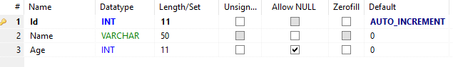
Post the executed SQL query as your solution.

Drop Table
Drop table 'students' using HeidiSQL. Use the executed query as a solution in judge.

Drop Database
Drop database 'softuni'. Use the executed query as a solution in judge.

III. Optional

Firebase: All Books
Firebase is a cloud-based DB, storage and app platform (BaaS).
Register at: https://console.firebase.google.com.
Create a “TestApp” and in the create the following structure:
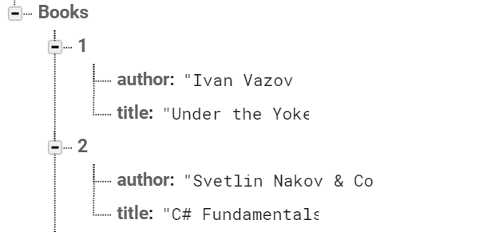
First task is to “GET” all books. To consume the request with POSTMAN your url should be the following: https://{databaseId}.firebaseio.com/.json.
DatabaseId is unique for every application. You can find yours from here:
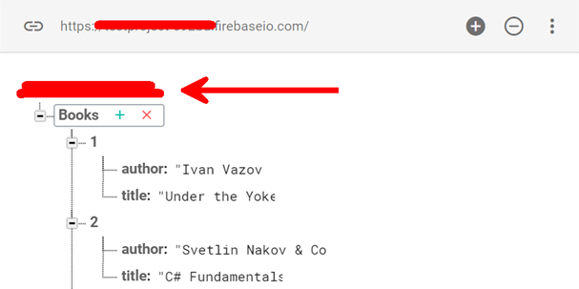
We should also do one more configuration. Go to Database/Rules and set .read & .write actions to “true”. This will allow us to send request with POSTMAN. Beware that now everyone can manipulate our database and even delete it. (this is for testing purposes only).
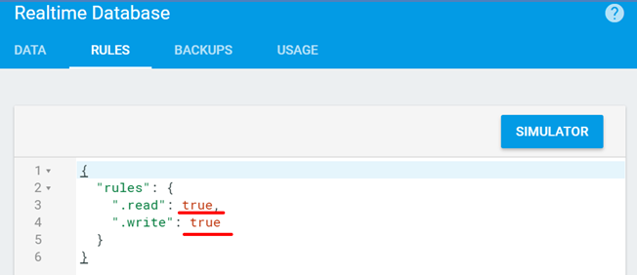

*Firebase: Get Book #1
“GET” the Book with id: 1. Don’t forget the .json extension at the end (otherwise you will receive the whole html).

*Firebase: Create Book
To create a book, we will have to send a “POST” request and the JSON body should be in the following format:
{
"title":"New Title",
"author":"New Author"
}

*Firebase: Patch Book #7
The HTTP command “PATCH” modifies an existing HTTP resource (it can also create the resource if it does not exist). The JSON body should be in the following format:
{
"year": 1981,
"author": "Author Changed"
}

*Firebase: Change Book #7 Author
This time we have to execute a “PUT” command (the difference is that with “PUT” we can update a resource partially). In our case we have to change the author’s name to "New author was assigned".
REQUEST: https://{databaseId}.firebaseio.com/Books/7/author/.json
The JSON body should be in the following format:
"New author was assigned".

