Problem 2 – Parking Feud
Sam finally got through the crossroads safely and made it to the airport. Now, he needs to park his car at the premium airport parking lot, so it’s safe and sound when he returns from his vacation. He has already pre-paid for his parking spot, so we needn’t worry about that. He even got a 20% discount for the early payment.
Anyway, the parking lot, as you might’ve deduced, is a rectangular matrix. The first and the last column of it will always be empty and the first column will also serve as an entrance to the parking lot. Starting from the first row (included), every other row will consist of parking spots. Parking spot rows will always be an odd number, so the top and bottom rows will always be parking rows.
Although Sam was stuck in traffic, the parking lot has just opened, so all the spots will be free when he arrives. He must go to an entrance, receive a parking spot location (represented by a capital Latin letter and a number), navigate to it and park his car. Simple enough. The problem is that the parking company is having an internet issue and thus, no communication is possible between the different entrances. To make Sam’s day even better, they might give somebody else the very same parking spot.
Your job is to help Sam solve these conflicts and calculate how much distance (number of squares) he has traveled before parking successfully.
- You will receive the number of parking columns and rows and will have to calculate the size of and create a parking lot (matrix).
- Then, upon approaching the parking, Sam will choose an entrance (numbered from 1 to n, where n is always 1 less than the number of parking rows). Sam will use this entrance row to enter the parking lot and will always return to it after an unsuccessful attempt to park.
- To park at a spot, Sam needs to move to a road square right next to the desired spot.
  - If Sam needs to get to a different row, he needs to pass through the whole row he’s on, go 2 squares up or down the free column and move on the next row.
  - Sam can NOT skip rows, even if he needs to move 2 or more rows away from his current one. He can NOT drive through parking spots, even if they are empty.
  - Sam starts on the left on his entrance row and moves to the right. After navigating to a row below/above he will be on the right and move left and so on with every following row, in a zig-zag manner.
  - Other drivers move the same way as Sam does.
- If there is no conflict, Sam will drive to his targeted parking spot and park successfully.
- If a conflict occurs, you need to calculate which driver will pass less squares to get to that spot.
  - Sam will always drive to that spot, but if the other driver is closer, it will be taken when Sam reaches it. If the spot is taken, Sam returns to his entrance, doubling his passed distance on the current turn.
  - If Sam and another driver are at the same distance, Sam will speed up and take the spot, winning the conflict and parking successfully.
- Your program ends when Sam parks successfully.

Input
- On the first line of input, you will receive 2 numbers: the parking spot rows and parking spot columns. Those are NOT the actual matrix dimensions. For example a 4 parking spot rows and 4 parking spot columns matrix would look like this:
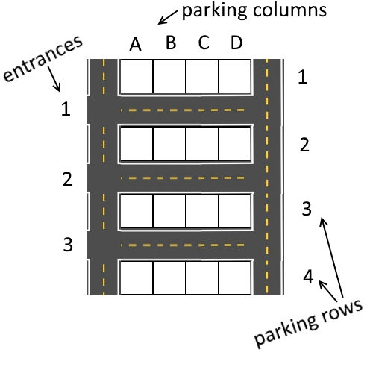
- On the next line, you will receive the number of the entrance at which Sam will enter the parking lot. Entrances will be numbered as shown on the picture above.
- On the following lines, until Sam parks successfully, you will receive a row of parking spots, one for each entrance.

Output
- When Sam parks successfully, end the program and print on the console on two rows:
  - The spot Sam has parked at in the format:
"Parked successfully at {parkingSpot}."
  - The distance Sam passed in the format:
"Total Distance Passed: {totalDistance}"

Constraints
- The parking will always be rectangular.
- Conflicts will only occur between Sam and another driver
- There will never be 3 cars in a conflict
- There will never be an invalid parking spot given as input
- There will never be a taken parking spot given as input
- The parking spots in the input will always be the same number as the entrances
- The parking lot will always have at least 3 parking rows and 1 column
- The parking lot will not have more than 10 parking rows and columns

Examples
First, let’s look at a simple parking without any conflicts.
Input
4 4
1
C1 D2 C4
A1 D2 C1
Sam enters the parking lot at entrance number 1 and has to navigate to spot C1:
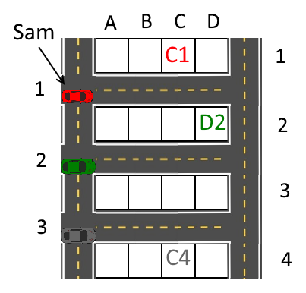
Then, he moves through the 3 squares marked in red and parks successfully at C1:
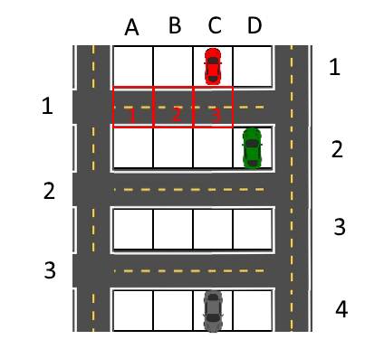
Output
Parked successfully at C1.
Total Distance Passed: 3
Keep in mind, that you should end your program and not read the last row of input!

Next, let’s look at an example with a conflict:
Input
4 4
1
D3 D3 C4
A1 D2 C1
We can see that both Sam and the driver at entrance 2 have the same parking spot:
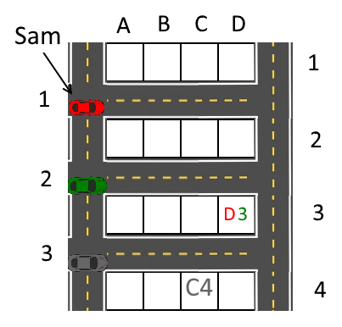
The green car is only 4 squares away from the spot, while Sam is 8 squares away, so the green car takes the spot and Sam will have to return to the start, passing a total of 16 squares.
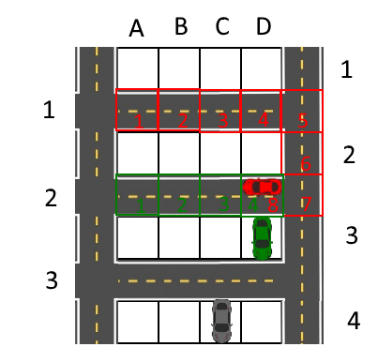
Then, Sam receives another spot with no conflict and parks successfully.
Output
Parked successfully at A1.
Total Distance Passed: 17

And finally, a more complicated example, to help you test your program:
Input | Output
5 4  4  C1 B2 D3 B2  B1 A1 D2 D2  D1 C3 D5 D5 | Parked successfully at D5.  Total Distance Passed: 72

