Exercises: Inheritance
This document defines the lab for the "Java Advanced" course @ SoftUni.
Please submit your solutions (source code) of all below described problems in Judge.

Person
NOTE: You need a public class Main. Create a package person.
You are asked to model an application for storing data about people. You should be able to have a Person and a Child. The child derives from the person. Every person has a name and an age. Your task is to model the application.
The Person class also has getters for the fields.
Create a Child class that inherits Person and has the same public constructor definition. However, do not copy the code from the Person class - reuse the Person class's constructor.

Sample Main()
public class Main {
public static void main(String[] args) {
Scanner sc = new Scanner(System.in);
String name = sc.nextLine();
int age = Integer.parseInt(sc.nextLine());
Child child = new Child(name, age);
System.out.println(child.getName());
System.out.println(child.getAge());
}
}

Input / Output
Input | Output
Peter  13 | Peter  13
George  10 | George  10

Zoo
NOTE: You need a public class Main.
Create a package zoo. It needs to contain the following classes:
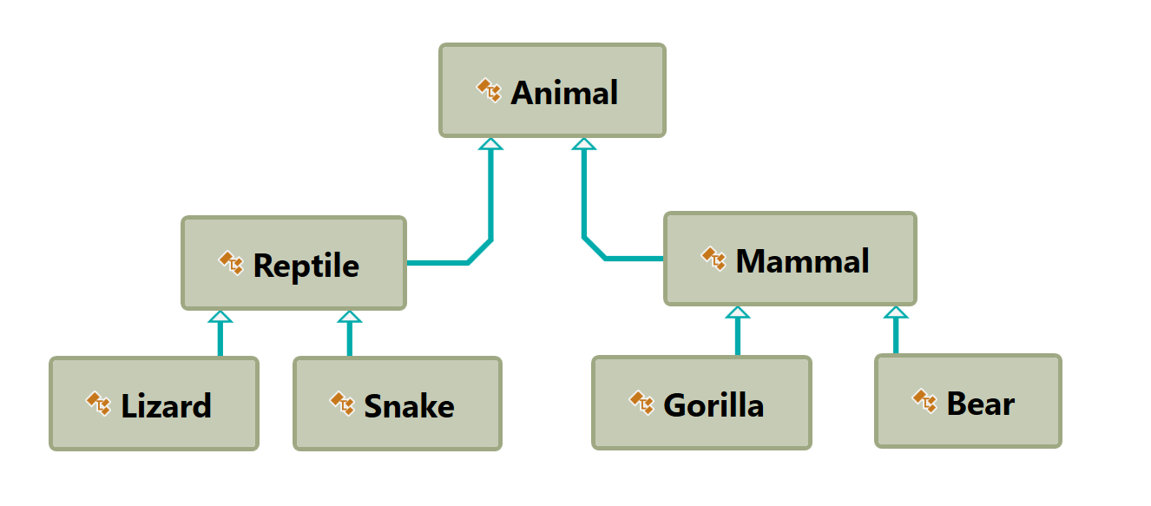
Follow the diagram and create all of the classes. Each of them, except the Animal class, should inherit from another class. The Animal class should have a field name – String and Getter for a name.
Every class should have:
- A public constructor, which accepts one parameter: name
Zip your package and upload it to Judge.

Players and Monsters
NOTE: You need a public class Main. Create a package hero.
Your task is to create the following game hierarchy:
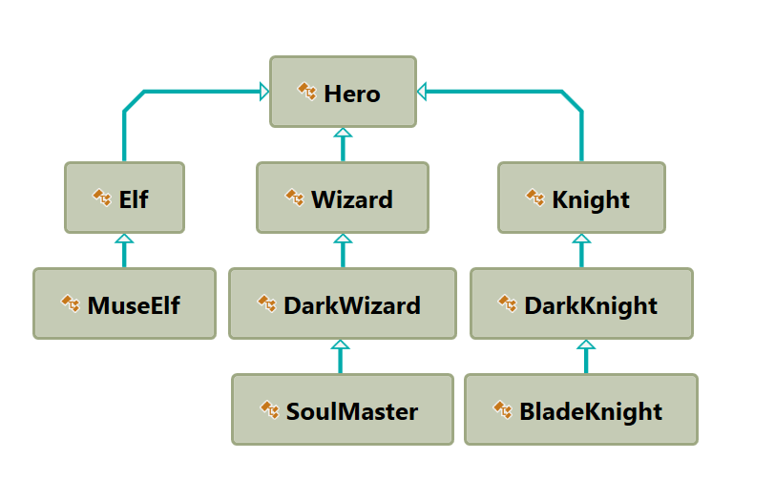
Create a class Hero. It should contain the following members:
- A public constructor, which accepts:
  - username – String
  - level – int
- The following fields:
  - username - String
  - level – int
- Getters for username and level
- toString() method
Hint: Override toString() of the base class in the following way:
Sample toString()
@Override
public String toString() {
return String.format("Type: %s Username: %s Level: %s",
this.getClass().getName(),
this.getUsername(),
this.getLevel());
}

Need for Speed
NOTE: You need a public class Main. Create the following hierarchy with the following classes: 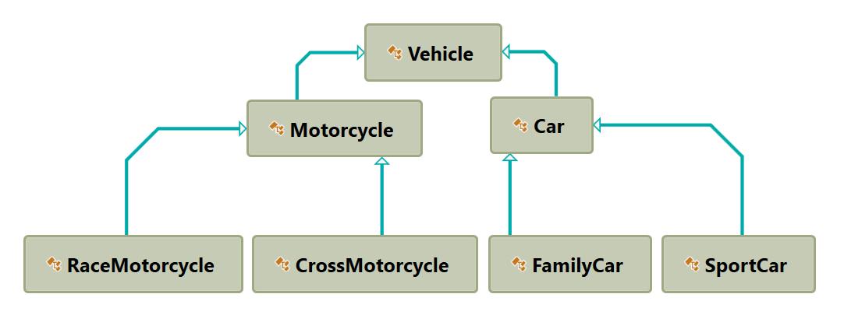

Create a base class Vehicle. It should contain the following members:
- DEFAULT_FUEL_CONSUMPTION – final static double (constant)
- fuelConsumption – double
- fuel – double
- horsePower – int
- Getters and Setters for the fields
- A public constructor which accepts (fuel, horsePower) and set the default fuel consumption on the field fuelConsumption
- void drive(double kilometers)
  - The drive method should have the functionality to reduce the fuel based on the traveled kilometers and fuel consumption. Keep in mind that you can drive the vehicle only if you have enough fuel to finish the driving.
The default fuel consumption for Vehicle is 1.25. Some of the classes have different default fuel consumption:
- SportCar – DEFAULT_FUEL_CONSUMPTION = 10
- RaceMotorcycle – DEFAULT_FUEL_CONSUMPTION = 8
- Car – DEFAULT_FUEL_CONSUMPTION = 3
Zip your package and upload it to Judge.

Hint
In the child classes' constructors use super.setFuelConsumption() to set fuelConsumption.

Restaurant
NOTE: You need a public class Main. Create a restaurant package with the following classes and hierarchy:
There are Food and Beverages in the restaurant and they are all products.
The Product class must have the following members:
- A public constructor with the following parameters: String name, BigDecimal price
- name – String
- price - BigDecimal
- Getters for the fields
Beverage and Food classes are products. The Beverage class must have the following members:
- A public constructor with the following parameters: String name, BigDecimal price, double milliliters
- name – String
- price – BigDecimal
- milliliters - double
- Getter for milliliters
The Food class must have the following members:
- A constructor with the following parameters: String name, BigDecimal price, double grams
- name – String
- price – double
- grams - double
- Getter for grams
HotBeverage and ColdBeverage are beverages and they accept the following parameters upon initialization: String name, BigDecimal price, double milliliters
Coffee and Tea are hot beverages. The Coffee class must have the following additional members:
- double COFFEE_MILLILITERS = 50
- BigDecimal COFFEE_PRICE = 3.50
- caffeine – double
- Getter for caffeine
MainDish, Dessert, and Starter are food. They all accept the following parameters upon initialization: String name, BigDecimal price, double grams. Dessert must accept one more parameter in its constructor: double calories.
- calories – double
- Getter for calories
Make Salmon, Soup and Cake inherit the proper classes.
A Cake must have the following members upon initialization:
- double CAKE_GRAMS = 250
- double CAKE_CALORIES = 1000
- BigDecimal CAKE_PRICE = 5
A Salmon must have the following members upon initialization:
- double SALMON_GRAMS = 22
Zip your package and upload it to Judge.

Animals
NOTE: You need a public class Main.
Create a hierarchy (package) of animals. Your program should have three different animals – Dog, Frog, and Cat. Deeper in the hierarchy you should have two additional classes – Kitten and Tomcat. Kittens are "Female" and Tomcats are "Male". All types of animals should be able to produce some kind of sound - String produceSound(). For example, the dog should be able to bark. Your task is to model the hierarchy and test its functionality. Create an animal of each kind and make them all produce sound and create getters for all fields.
You will be given some lines of input. Every two lines will represent an animal. On the first line will be the type of animal and on the second – the name, the age, and the gender. When the command "Beast!" is given, stop the input and print all the animals in the format shown below.

Output
- Print the information for each animal in three lines. On the first line, print: "{animalType}".
- On the second line, print: "{name} {age} {gender}".
- On the third line, print the sounds it produces: "{produceSound()}".

Constraints
- Each Animal should have a name, an age, and a gender.
- All input values should not be blank (e.g. name, age, and so on…).
- If you receive an input for the gender of a Tomcat or a Kitten, ignore it but create the animal.
- If the input is invalid for one of the properties, throw an exception with the message: "Invalid input!".
- Each animal should have the functionality to produceSound().
- Here is the type of sound each animal should produce:
  - Dog: "Woof!"
  - Cat: "Meow meow"
  - Frog: "Ribbit"
  - Kittens: "Meow"
  - Tomcat: "MEOW"

Examples
Input | Output
Cat  Tom 12 Male  Dog  Rex 132 Male  Beast! | Cat  Tom 12 Male  Meow meow  Dog  Rex 132 Male  Woof!
Frog  Kermit 12 Male  Beast! | Frog  Kermit 12 Male  Ribbit
Frog  Froakie -2 Male  Frog  Froakie 2 Male  Beast! | Invalid input!  Frog  Froakie 2 Male  Ribbit

Hint
To find the name of the class you can use this.getClass().getSimpleName() in toString() method inside Animal class.

