Lab: Inheritance
This document defines the lab for the "Java Advanced" course @ SoftUni.
Please submit your solutions (source code) of all below described problems in Judge.

Part I: Inheritance

Single Inheritance
Create two classes named Animal and Dog.
Animal with a single public method eat() that prints: "eating…"
Dog with a single public method bark() that prints: "barking…"
The Dog should inherit from the Animal.
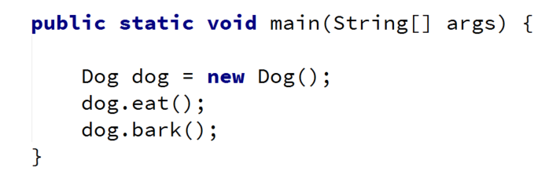
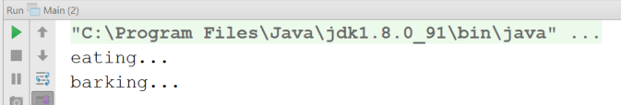

Hints
Use the extends keyword to build a hierarchy.

Multiple Inheritance
Create three classes named Animal, Dog, and Puppy.
Animal with a single public method eat() that prints: "eating…"
Dog with a single public method bark() that prints: "barking…"
Puppy with a single public method weep() that prints: "weeping…"
The Dog should inherit from the Animal. The Puppy should inherit from Dog.
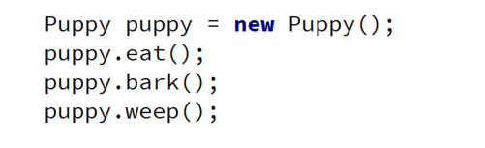
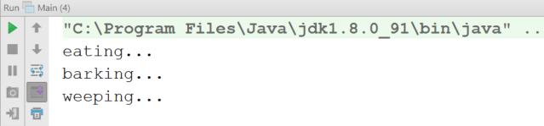

Hierarchical Inheritance
Create three classes named Animal, Dog, and Cat.
Animal with a single public method eat() that prints: "eating…"
Dog with a single public method bark() that prints: "barking…"
Cat with a single public method meow() that prints: "meowing…"
Dog and Cat should inherit from Animal.
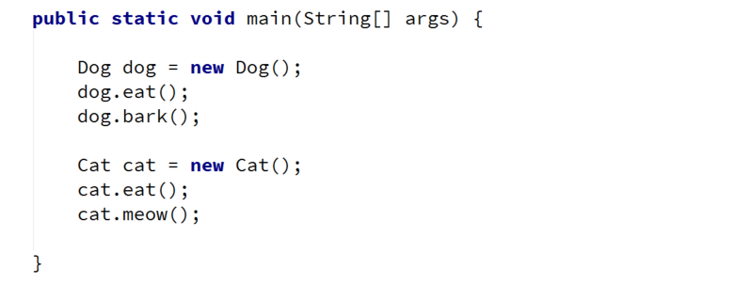
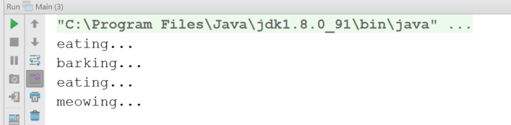

Part II: Reusing Classes

Random Array List
Create a RandomArrayList class that has all the functionality of an ArrayList.
Add an additional function that returns and removes a random element from the list.
- Public method: getRandomElement(): Object

Stack of Strings
Create a class Stack that can store only strings and has the following functionality:
- Private field: data: ArrayList<String>
- Public method: push(String item): void
- Public method: pop(): String
- Public method: peek(): String
- Public method: isEmpty(): boolean
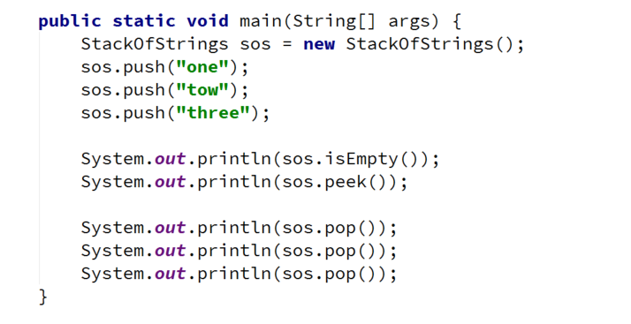

Hints
Use composition/delegation to have a field in which to store the stack's data.

