Lab: Polymorphism
This document defines the lab for the "Java Advanced" course @ SoftUni.
Please submit your solutions (source code) of all below described problems in Judge.

Math Operation
Create a class MathOperation, which should have method add(). Method add() has to be invoked with two, three, or four Integers.
You should be able to use the class like this:
Main.java
public static void main(String[] args) throws IOException {
MathOperation math = new MathOperation();
System.out.println(math.add(2, 2));
System.out.println(math.add(3, 3, 3));
System.out.println(math.add(4, 4, 4, 4));
}

Examples
Input | Output
4
9
16

Solution
Class MathOperation should look like this:
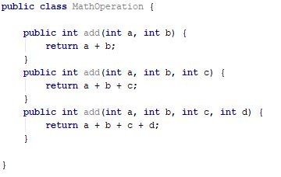

Shapes
Create class hierarchy, starting with abstract class Shape:
- Fields:
  - perimeter: Double
  - area: Double
- Encapsulation for these fields
- Abstract methods:
  - calculatePerimeter()
  - calculateArea()
Extend Shape class with two children:
- Rectangle
- Circle
Each of them needs to have:
- Fields:
For Rectangle
  - height: Double
  - width: Double
For Circle
  - radius: Double
- Encapsulation for these fields
- Public constructor
- Concrete methods for calculations (perimeter and area)

Animals
Create a class Animal, which holds two fields:
- name: String
- favouriteFood: String
The Animal has one abstract method explainSelf(): String.
You should add two new classes - Cat and Dog. Override the explainSelf() method by adding concrete animal sound on a new line. (Look at examples below)
You should be able to use the class like this:
Main
public static void main(String[] args) {
Animal cat = new Cat("Oscar", "Whiskas");
Animal dog = new Dog("Rocky", "Meat");
System.out.println(cat.explainSelf());
System.out.println(dog.explainSelf());
}

Examples
Input | Output
I am Oscar and my favourite food is Whiskas
MEEOW
I am Rocky and my favourite food is Meat
DJAAF

Solution


