Exercises: Reflection
This document defines the lab for the "Java Advanced" course @ SoftUni.
Please submit your solutions (source code) of all below described problems in Judge.

Harvesting Fields
You are given a RichSoilLand class with lots of fields (look at the provided skeleton). Like the good farmer you are, you must harvest them. Harvesting means that you must print each field in a certain format (see output).

Input
You will receive a maximum of 100 lines with one of the following commands:
- private - print all private fields
- protected - print all protected fields
- public - print all public fields
- all - print ALL declared fields
- HARVEST - end the input

Output
For each command, you must print the fields that have the given access modifier as described in the input section. The format in which the fields should be printed is:
"{access modifier} {field type} {field name}"

Examples
Input | Output
protected  HARVEST | protected String testString  protected double aDouble  protected byte testByte  protected StringBuilder aBuffer  protected BigInteger testBigNumber  protected float testFloat  protected Object testPredicate  protected Object fatherMotherObject  protected String moarString  protected Exception inheritableException  protected Stream moarStreamz
private  public  private  HARVEST | private int testInt  private long testLong  private Calendar aCalendar  private char testChar  private BigInteger testBigInt  private Thread aThread  private Object aPredicate  private Object hiddenObject  private String anotherString  private Exception internalException  private Stream secretStream  public double testDouble  public String aString  public StringBuilder aBuilder  public short testShort  public byte aByte  public float aFloat  public Thread testThread  public Object anObject  public int anotherIntBitesTheDust  public Exception justException  public Stream aStream  private int testInt  private long testLong  private Calendar aCalendar  private char testChar  private BigInteger testBigInt  private Thread aThread  private Object aPredicate  private Object hiddenObject  private String anotherString  private Exception internalException  private Stream secretStream
all  HARVEST | private int testInt  public double testDouble  protected String testString  private long testLong  protected double aDouble  public String aString  private Calendar aCalendar  public StringBuilder aBuilder  private char testChar  public short testShort  protected byte testByte  public byte aByte  protected StringBuilder aBuffer  private BigInteger testBigInt  protected BigInteger testBigNumber  protected float testFloat  public float aFloat  private Thread aThread  public Thread testThread  private Object aPredicate  protected Object testPredicate  public Object anObject  private Object hiddenObject  protected Object fatherMotherObject  private String anotherString  protected String moarString  public int anotherIntBitesTheDust  private Exception internalException  protected Exception inheritableException  public Exception justException  public Stream aStream  protected Stream moarStreamz  private Stream secretStream

Black Box Integer
You are helping a buddy of yours who is still in the OOP Basics course - his name is John. He is rather slow and made a class with all private members. Your tasks are to instantiate an object from his class (always with start value 0) and then invoke the different methods it has. Your restriction is to not change anything in the class itself (consider it a black box). You can look at his class but don't touch anything! The class itself is called BlackBoxInt. It is a wrapper for the int primitive. The methods it has are:
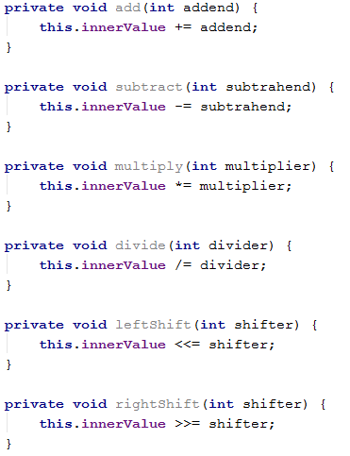

Input
The input will consist of lines in the form:
"{command name}_{value}"
Input will always be valid and in the format described, so there is no need to check it explicitly. You stop receiving input when you encounter the command "END".

Output
Each command (except the "END" one) should print the current value of innerValue of the BlackBoxInt object you instantiated. Don't cheat by overriding toString in the class - you must get the value from the private field.

Examples
Input | Output
add_999999  subtract_19  divide_4  multiply_2  rightShift_1  leftShift_3  END | 999999  999980  249995  499990  249995  1999960
subtract_3000  add_556677  add_889915  rightShift_3  leftShift_3  END | -3000  553677  1443592  180449  1443592

BarracksWars – A New Factory
You are given a small console-based project called Barracks (the code for it is included in the provided skeleton).
The general functionality of the project is adding new units to its repository and printing a report with statistics about the units currently in the repository. First, let's go over the original task before the project was created:

Input
The input consists of commands each on a separate line. Commands that execute the functionality are:
- add {Archer/Swordsman/Pikeman/{…}} - adds a unit to the repository
- report - prints a lexicological ordered statistic about the units in the repository
- fight - ends the input

Output
Each command except fight should print output on the console.
- add should print: "{Archer/Swordsman/Pikeman/{…}} added!"
- report should print all the info in the repository in the format: "{UnitType} -> {UnitQuantity}", sorted by UnitType

Constraints
- Input will consist of no more than 1000 lines.
- report command will never be given before any valid add command was provided.
Your Task
1) You have to study the code of the project and figure out how it works. However, there are parts of it that are not implemented (left with TODOs (TODO window will be useful)). You must implement the functionality of the createUnit method in the UnitFactoryImpl class so that it creates a unit based on the unit type received as a parameter. Implement it in such a way that whenever you add a new unit it will be creatable without the need to change anything in the UnitFactoryImpl class (psst - use reflection). You can use the approach called Simple Factory.
2) Add two new unit classes (there will be tests that require them) - Horseman with 50 health and 10 attacks and Gunner with 20 health and 20 attacks.
If you do everything correctly for this problem, you should write code only in the factories and units packages.

Examples
Input | Output
add Swordsman  add Archer  add Pikeman  report  add Pikeman  add Pikeman  report  fight | Swordsman added!  Archer added!  Pikeman added!  Archer -> 1  Pikeman -> 1  Swordsman -> 1  Pikeman added!  Pikeman added!  Archer -> 1  Pikeman -> 3  Swordsman -> 1
add Pikeman  add Pikeman  add Gunner  add Horseman  add Archer  add Gunner  add Gunner  add Horseman  report  fight | Pikeman added!  Pikeman added!  Gunner added!  Horseman added!  Archer added!  Gunner added!  Gunner added!  Horseman added!  Archer -> 1  Gunner -> 3  Horseman -> 2  Pikeman -> 2

BarracksWars – the Commands Strike Back
As you might have noticed commands in the project from Problem 3 are implemented via a switch case with method calls in the Engine class. Although this approach works it is flawed when you add a new command because you have to add a new case for it. In some projects, you might not have access to the engine and this would not work. Imagine this project will be outsourced and the outsourcing firm will not have access to the engine. Make it so whenever they want to add a new command they won't have to change anything in the Engine.
To do so employ the design pattern called Command Pattern. Here is how the base (abstract) command should look like:
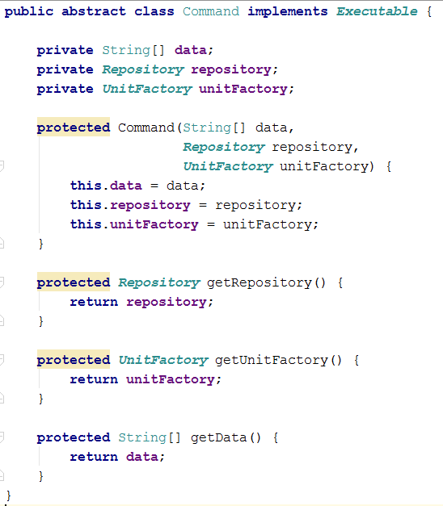
Notice how all commands that extend this one will have both a Repository and a UnitFactory although not all of them need these. Leave it like this for this problem, because for the reflection to work we need all constructors to accept the same parameters. We will see how to go around this issue in Problem 5.
Once you've implemented the pattern add a new command. It will have the following syntax:
- retire {UnitType} - All it has to do is remove a unit of the provided type from the repository.
  - If there are no such units currently in the repository print: "No such units in repository."
  - If there is such a unit currently in the repository, print: "{UnitType} retired!"
To implement this command, you will also have to implement a corresponding method in the UnitRepository.
If you do everything correctly for this problem, you should write/refactor code only in the core and data packages.

Examples
Input | Output
retire Archer  add Pikeman  add Pikeman  add Gunner  add Horseman  add Archer  add Gunner  add Gunner  add Horseman  report  retire Gunner  retire Archer  report  retire Swordsman  retire Archer  fight | No such units in repository.  Pikeman added!  Pikeman added!  Gunner added!  Horseman added!  Archer added!  Gunner added!  Gunner added!  Horseman added!  Archer -> 1  Gunner -> 3  Horseman -> 2  Pikeman -> 2  Gunner retired!  Archer retired!  Archer -> 0  Gunner -> 2  Horseman -> 2  Pikeman -> 2  No such units in repository.  No such units in repository.
add Pikeman  add Gunner  add Horseman  report  add Gunner  add Pikeman  retire Pikeman  retire Gunner  report  fight | Pikeman added!  Gunner added!  Horseman added!  Gunner -> 1  Horseman -> 1  Pikeman -> 1  Gunner added!  Pikeman added!  Pikeman retired!  Gunner retired!  Gunner -> 1  Horseman -> 1  Pikeman -> 1

* BarracksWars – Return of the Dependencies
In the final part of this epic problem trilogy, we will resolve the issue where all Commands received all utility classes as parameters in their constructors. We can accomplish this by using an approach called dependency injection container. This approach is used in many frameworks like Spring for instance.
We will do a little twist on that approach. Remove all fields from the abstract command except the data. Instead, put whatever fields each command needs in the concrete class. Create an annotation called Inject and make it so it can be used only on fields. Put the annotation over the fields we need to set through reflection. Once you've prepared all of this, write the necessary reflection code in the Command Interpreter (which you should have refactored out from the engine in Problem 4).
Use the tests from Problem 4 to test your solution.

