Lab: Files and Streams
Problems for exercises and homework for the “Java Advanced” course @ SoftUni.
You can check your solutions here: https://judge.softuni.bg/Contests/1032/Files-And-Directories-Lab.
For this lab exercises you are given a zipped folder with resources, that you will need to use. For each exercise submit the output of the program, not the code.

Stream Basics

Read File
You are given a file named "input.txt". Read and print all of its contents as a sequence of bytes (the binary representation of the ASCII code for each character) separated by a single comma.
Submit in Judge only the output of the program.

Examples
Input | Output
On January 1 , 1533 , Michael Angelo, then fifty-seven years old, writes… | 11101111 10111011 10111111 1001111 1101110 100000 1001010 1100001 1101110 1110101…
Two households, both alike in dignity,  In fair Verona, where we lay our scene… | 1010100 1110111 1101111 100000 1101000 1101111 1110101 1110011 1100101 1101000…

Hints
- Create a string variable holding the path to the file. If, for example, the file is located in "D:\"
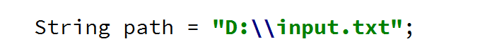
- Use try-with-resources to open the file and to be sure that it will be closed after you are done with it
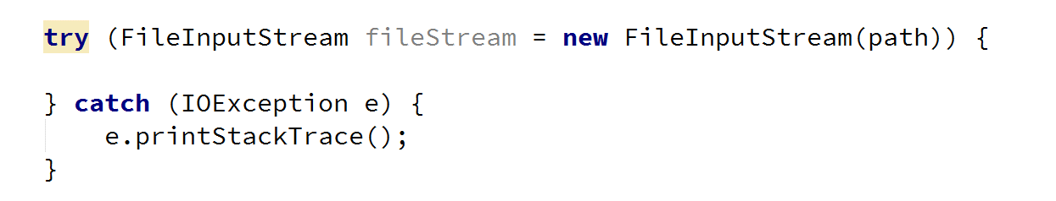
- Use the read() method to read each byte of the file until it returns -1
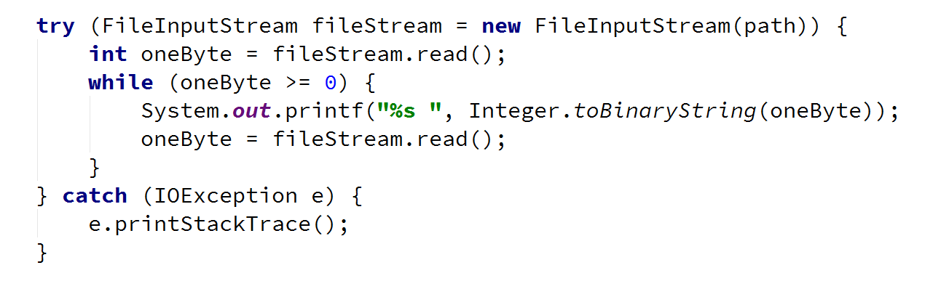
- Select the output of the program and copy it [Ctrl + C]
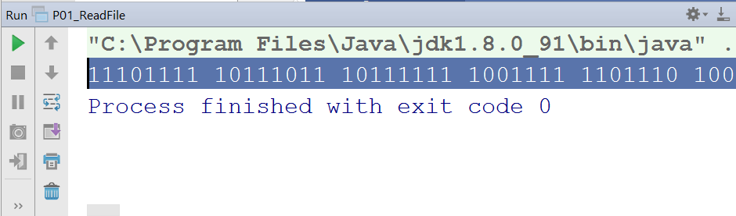
- Paste the output in Judge
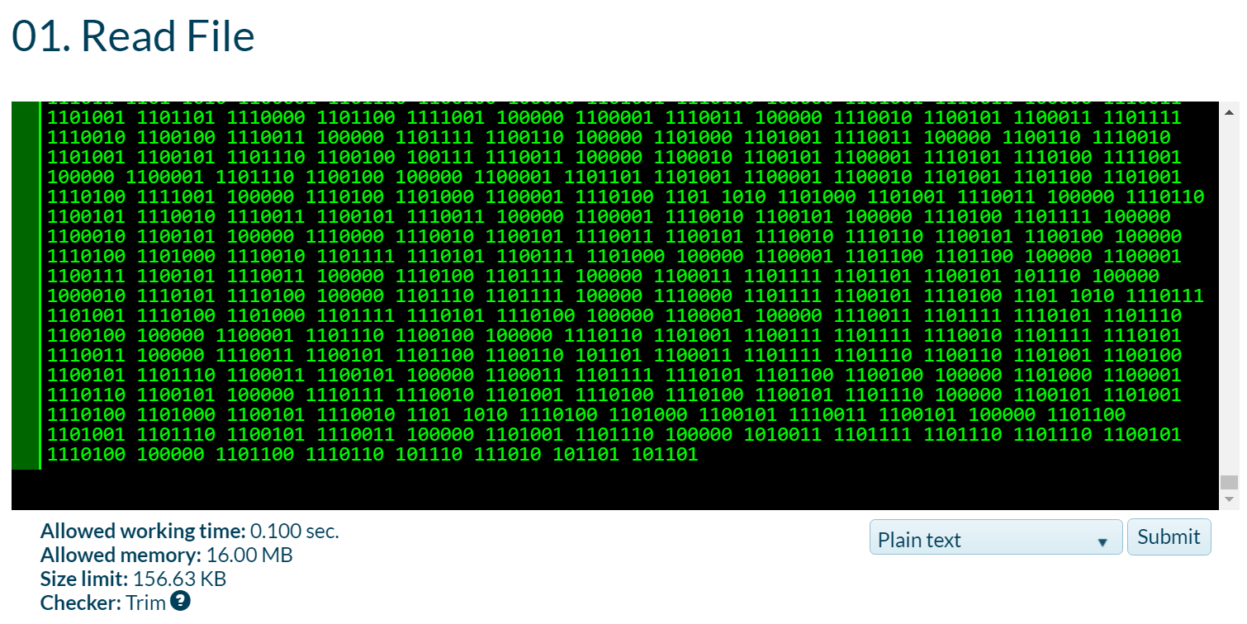

Writ to File
Read the file named "input.txt" that is provided for this exercise and write all its content to a file while skipping any punctuation. Skip the following symbols: ',', '.', '!', '?'.
Submit in Judge only the output of the program.

Examples
Input | Output
On January 1 , 1533 , Michael Angelo, then fifty-seven years old, writes | On January 1 1533 Michael Angelo then fifty-seven years old writes
Two households, both alike in dignity.  In fair Verona, where we lay our scene. | Two households both alike in dignity  In fair Verona where we lay our scene

Hints
- Create a FileInputStream to read the file
- Create a FileOutputStream to write to a file
- Create a list, containing all characters that you need to skip and check if the current char is contained in it
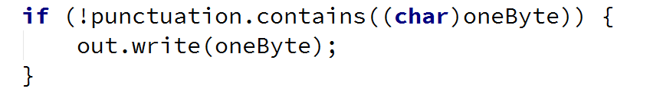

Copy Bytes
Read the file named "input.txt" and write to another file every character's ASCII representation.
Write every space or new line as it is, e.g. as a space or a new line.

Examples
Input | Output
Two households, both alike in dignity.  In fair Verona, where we lay our scene. | 84119111 10411111711510110411…  73110 10297105114 861011141111109744 1…

Hints
- Get the value of every byte as string and then write its every digit one by one
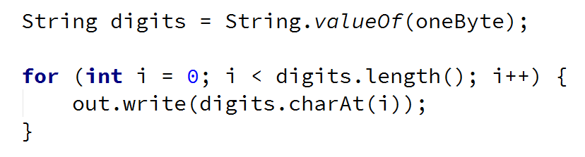

Extract Integers
Read the file provided, named "input.txt" and extracts all integers that are not a part of a word in a separate file. A valid integer is surrounded with white spaces.
Submit in Judge only the output of the program.

Examples
Input | Output
Households 2 , 2 alike in 3nity,  In fair Verona 4, where we lay our… | 2  2
On January 1 , 1533 , Michael Angelo, then fifty-seven years old, writes | 1  1533

Hints
- Wrap a FileInputStream in a Scanner and use the methods, hasNext(), hasNextInt() and nextInt()
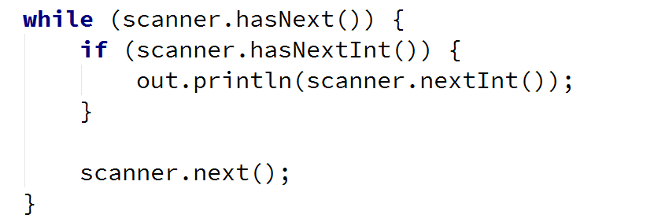

Write Every Third Line
Read the file provided, named "input.txt" and write to another file all lines which number is divisible by 3. Line numbers start from one.
Submit in Judge only the output of the program.

Examples
Input | Output
On January 1 , 1533 ,  Michael Angelo,  then fifty-seven years old,  writes  from Florence to  Tommaso de' Cavalieri,  a youth of noble Roman family, | then fifty-seven years old,  Tommaso de' Cavalieri,
Two households,  both alike in dignity,  In fair Verona,  where we lay our scene,  From ancient grudge  break to new mutiny | In fair Verona,  break to new mutiny

Hints
- To get the functionality to read and write lines use BufferedReader and PrintWriter
- Wrap streams appropriately

Sort Lines
Read the file provided, named "input.txt" and sort all lines. Write text to another text file. Use Path and Files Classes.
Submit in Judge only the output of the program.

Examples
Input | Output
C  A  B  D | A  B  C  D

Hints
- To read all lines together use Files.readAllLines()
- To sort the list of strings use Collections.sort()

List Files
You are provided a folder named "Files-and-Streams". Create a program that lists the names and file sizes (in bytes) of all files that are placed directly in it (do not include files in nested folders).
Submit in Judge only the output of the program.

Examples
Input | Output
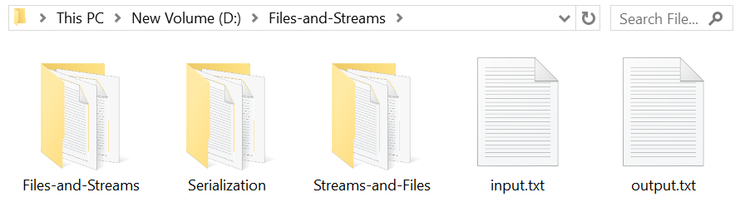 | input.txt: [size in bytes]  output.txt: [size in bytes]

Hints
- Use the File class and its method listFiles()

Nested Folders
You are provided a folder named "Files-and-Streams". Create a program that lists the names of all directories in it (including all nested directories).
On the last line, print the count of all folders, including the root folder.
Submit in Judge only the output of the program.

Examples
Input | Output
…
Streams-and-Files
Files-and-Streams
Streams-and-Files
Serialization
Streams-and-Files
[folder count] folders

Hints
- Use the File class and its method listFiles()

Serialize Custom Object
Create a class called "Cube". It should have properties for color, width, height and depth.
Create an instance of the class with the following values:
- Color: "green"
- Width: 15.3
- Height: 12.4
- Depth: 3.0
Serialize and deserilalize the instance created. When saved to a file the object should look like something like the example below.

Examples
Input | Output
(no input) | 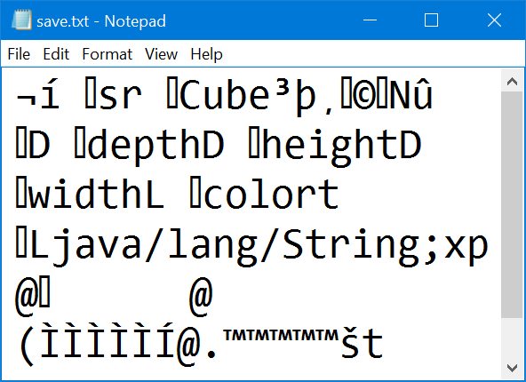

Hints
- Create a class called Cube, which should implement the Serializable interface:
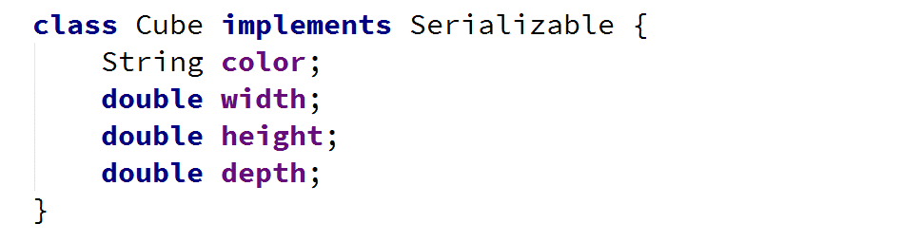
- Create a new instance of the Cube class and set its properties:
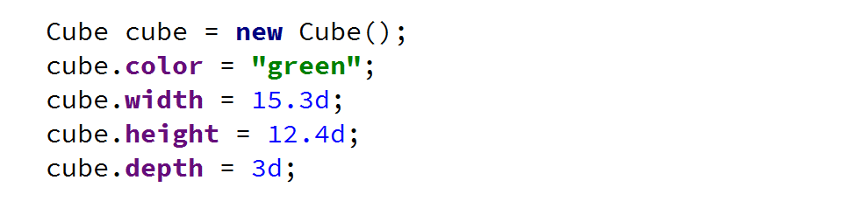
- Use ObjectOutputStream to serialize the object:


