Lab: String Processing
This document defines the exercises for "Java Advanced" course @ Software University. Please submit your solutions (source code) of all below described problems in Judge.

Student’s Results
Write a program that reads one line, containing a student’s name and his results in format {name} - {firstResult}, {secondResult}, {thirdResult}
Print a table on the console. Each row must contain:
- JAdv - first result, aligned right, rounded to a precision of 2
- OOP - second result, aligned right, rounded to a precision of 2
- AdvOOP - third result, aligned right, rounded to a precision of 2
- Average – average result, rounded to a precision of 4
- Columns have a width of 7 characters and must be separated with "|"
- Don't forget the heading row

Examples
Input | Output
Gosho - 3.33333, 4.4444, 5.555 | Name | JAdv|JavaOOP| AdvOOP|Average|  Gosho | 3,33| 4,44| 5,56| 4,4442|
Mara - 5, 4, 3 | Name | JAdv|JavaOOP| AdvOOP|Average|  Mara | 5,00| 4,00| 3,00| 4,0000|

Hints
It is up to you what type of data structures you will use to solve this problem
- The first row is easy, but long.
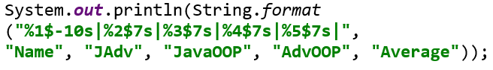
- Data rows are just a little bit more complicated:
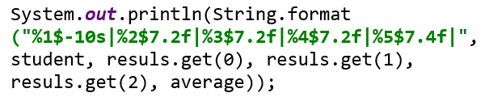

Parse URL
Write a program that parses an URL address given in the format: [protocol]://[server]/[resource] and extracts from it the [protocol], [server] and [resource] elements.
If the URL is not in a correct format, print “Invalid URL” on the console.

Examples
Input | Output
https://softuni.bg/courses/java-advanced | Protocol = https  Server = softuni.bg  Resources = courses/java-advance
https://www.google.bg/search?q=google&oq=goo&aqs=chrome.0.0j69i60l2://j0j69i57j69i65.2112j0j7&sourceid=chrome&ie=UTF-8 | Invalid URL

Hints
- "://" is used to show where a protocol name ends. If you have it more than once, the URL will be invalid.
- Server name ends with "/", but it is not part of resourses.
- Resources use the same symbol "/" to show that we go deeper in the folders tree, so be careful.
Think about the proper operations over the input:
- .split()
- .substring()
- .indexOf()

Parse Tags
You are given a text. Write a program that changes the text in all regions surrounded by the tags <upcase> and </upcase> to upper-case. The tags won’t be nested.

Examples
Input | Output
We are living in a <upcase>yellow submarine</upcase>. We don't have <upcase>anything</upcase> else. | We are living in a YELLOW SUBMARINE. We don't have ANYTHING else.
<upcase>StringBuilder</upcase> is <upcase>awesome</upcase> | STRINGBUILDER is AWESOME

Hints
- Be careful when replacing tags with empty strings.
- Consider that, after replacing a tag, the indexes in the string are not the same.

Series of Letters
Read a string from the console and replace all series of consecutive identical letters with a single one.

Examples
Input | Output
aabb | ab
abc | abc
aaaaabbbbbcdddeeeedssaa | abcdedsa

Hints
- Use a quantifier for one or more repetitions +, grouping () and a backreference construct

Vowel Count
Find the count of all vowels in a given text using a regex.
The vowels that you should be looking for are upper and lower case: a, e, i, o, u and y.

Examples
Input | Output
Abraham Lincoln | Vowels: 5
In 1519 Leonardo da Vinci died at the age of 67. | Vowels: 15
n vwls. | Vowels: 0

Hints
- Read the input using
- Compile the pattern and create a Matcher object:
- Count the occurrences:
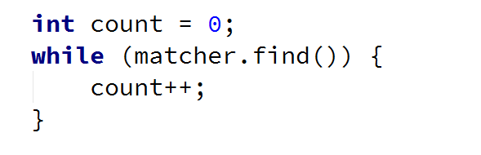
- Finally, print the result:

Extract Tags
Read lines until you get the "END" command. Extract all tags from the given HTML using RegEx. If there are no tags, don’t print anything.

Examples
Input | Output
<!DOCTYPE html>  <html lang="en">  <head>  <meta charset="UTF-8">  <title>Title</title>  </head>  </html>  END | <!DOCTYPE html>  <html lang="en">  <head>  <meta charset="UTF-8">  <title>  </title>  </head>  </html>
No tags.  END | (no output)

Hints
- Use the special character dot "." and one of the regex quantifiers made lazy:
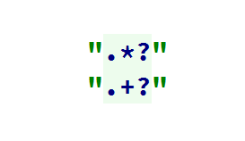
- Design your own regex to get a complete solution

Valid Usernames
Scan through the lines for valid usernames.
A valid username:
- Has length between 3 and 16 characters
- Contains only letters, numbers, hyphens and underscores
- Has no redundant symbols before, after or in between
Read the lines until you get the "END" command. If there are no valid usernames, don’t print anything.

Examples
Input | Output
sh  too_long_username  !lleg@l ch@rs  jeff_butt  END | invalid  invalid  invalid  valid
END | (no output)

Hints
- Use character classes [], quantifiers {} and anchors ^ and $

