Lab: Stream API
Problems for exercises and homework for the "Java Advanced" course @ SoftUni.
You can check your solutions here: https://judge.softuni.bg/Contests/1040/Stream-API-Lab.

Part I: Stream<T> and Types of Streams

Take Two
Read a sequence of integers, given on a single line separated by a space.
Finds all unique elements, such that 10 ≤ n ≤ 20 and print only the first 2 elements.
If there are fewer than 2 elements, print as much as there are. If there are no elements, print nothing.

Examples
Input | Output
15 2 15 14 12 | 15 14
17 -2 3 | 17
-2 3 | (no output)

Hints
- Read the input using a Scanner or a BufferedReader and parse the strings to a list of numbers:
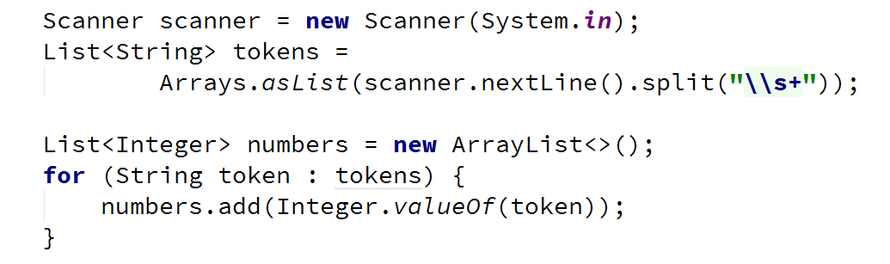
- Filter the numbers with filter(), take the unique ones with distinct(), take only two from the stream with limit() and iterate over them while printing with forEach():
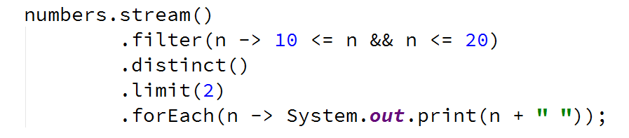

Upper Strings
Read a sequence of strings, given on a single line separated with a space.
Map each to upper case and print them, using the Stream API.

Examples
Input | Output
Pesho Gosho Stefan | PESHO GOSHO STEFAN
Soft Uni Rocks | SOFT UNI ROCKS
(empty line) | (no output)

Hints
- Read the input using a Scanner or a BufferedReader into a list of strings List<String>:
- Call a stream over the list and map every element to upper case. Iterate over the stream and print the result:
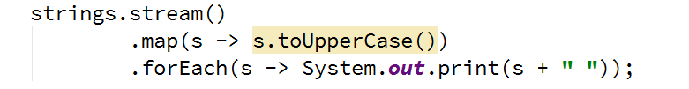

First Name
Read a sequence of names, given on a single line, separated by a space.
Read a sequence of letters, given on the next line, separated by a space.
Find the names that start with one of the given letters and print the first of them (ordered lexicographically).
If there is no name that conforms to the requirement, print "No match".

Examples
Input | Output
Rado Plamen Gosho  p r | Plamen
Plamen Gosho Rado  s c | No match

Hints
- You can use a hash set to store letter, for efficient searching
- Make sure you are comparing letter with the same casing (lower or upper)
- Use filter(), sorted() and findFirst()
- Use Optional<T>

Average of Doubles
Read a sequence of double numbers, given on a single line, separated by a space.
Find the average of all elements, using the Stream API.
Round the output to the second digit after the decimal separator.
If there are no numbers in the sequence, print "No match".

Examples
Input | Output
3 4 5 6 | 4.50
3.14 5.2 6.18 | 4.84
(empty list) | No match

Hints
- Use a primitive stream DoubleStream
- Use OptionalDouble
- Make sure to filter empty strings before transforming the stream

Part II: Types of Operations

Min Even Number
Read a sequence of numbers, given on a single line, separated by a space.
Find the smallest number of all even numbers, using the Stream API.
If there are no numbers in the sequence, print "No match".

Examples
Input | Output
1 2 3 4 5 6 | 2.00
3.14 -2.00 1.33 | -2.00
(empty list) | No match

Hints
- Use map function to map the objects to Double
- Make sure to filter empty strings
- Filter the even numbers
- Get the smallest number using Double.compare(x1, x2)

Find and Sum Integers
Read a sequence of elements, given on a single line, separated by a space.
Filter all elements that are integers and calculate their sum, using the Stream API.
If there are no numbers in the sequence, print "No match".

Examples
Input | Output
Sum 3 and 4 | 7
Sum -3 and -4 | -7
Sum three and four | No match

Hints
- Use filter map reduce pattern
- Check if element's char at index 0 is a sign (+ or -)
- Check if all else element's chars are digits

*Map Districts
On the first line, you are given the population count of districts in different cities, separated by a single space in the format "city:district population".
On the second line, you are given the minimum population for filtering of the towns. The population of a town is the sum of populations of all of its districts.
Print all cities with population greater than a given. Sort cities and districts by descending population and print top 5 districts for a given city.
For a better understanding, see the examples below.

Examples
Input | Output
Pld:9 Pld:13 Has:7 Sof:20 Sof:10 Sof:15  10 | Sof: 20 15 10  Pld: 13 9
Sof:10 Sof:12 Sof:15  10 | Sof: 15 12 10
Sof:5  15 | (no output)

Hints
- Read the input into a proper collection:
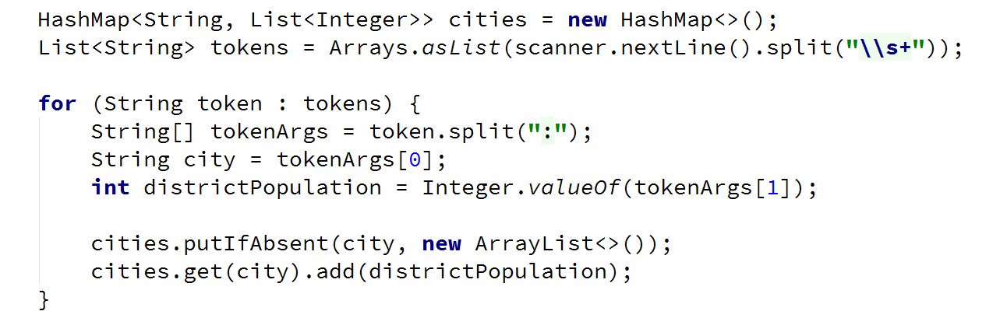
- Read the population bound
- Filter, sort and print the cities:
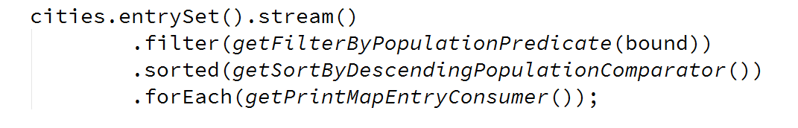
- Crete methods for generating labda expressions, stored in functional interfaces
- Crete a method that returns a predicate for filtering:
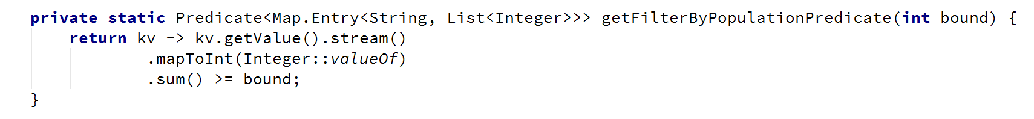
- Create a method that returns a comparator for sorting:
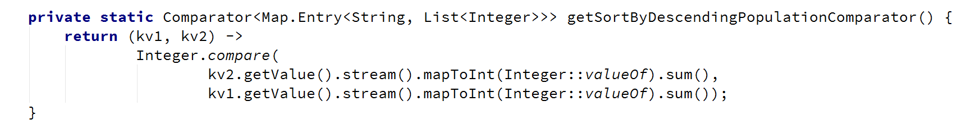
- Create a method that returns a consumer for printing a map entry:
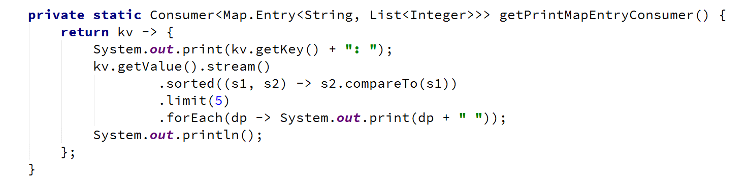

Bounded Numbers
On the first line, read two numbers, a lower and an upper bound, separated by a space.
On the second line, read a sequence of numbers, separated by a space.
Print all numbers, such that [lower bound] ≤ n ≤ [upper bound].

Examples
Input | Output
5 7  1 2 3 4 5 6 7 8 9 | 5 6 7
7 5  9 5 7 2 6 8 | 5 7 6
3 4  5 6 7 8 | (no output)

Hints
- Use collect(Collectors.toList())

