Problem 3 – Earthquake
You are given N – an integer. On the next N lines you will receive sequences of integers, which will represent seismic activities, and the seismic waves in them. The waves will hit the surface one by one, but they will also neutralize the weaker waves after them. The integers represent the waves’ power.
You must take the first integer from the first activity – that’s the seismicity. Then, you must start comparing it with the other integers from the current activity, by order of input. If the seismicity is greater than or equal to an integer (the wave), that integer must be removed from the activity. If the seismicity has smaller value than the integer, the seismicity should be removed.
When the current seismicity is removed, the process should repeat with the next sequence of integers in order. The previous sequence should go at the back of all sequences and should await its next turn.
When all integers from a given activity are removed, you should remove the activity itself.
Your task is to find how many seismic waves will hit the surface and their power are they. That means you must calculate how many seismicities you will find, before all integers and activities are removed.

Input
- On the first line of input you will receive N.
- On the next N lines you will receive sequences of integers, separated by a space.

Output
- As output you must print a single integer on the first line, indicating the amount of seismicities you’ve found.
- On the second line of output you must print the seismicities you found, by order of entrance.

Constrains
- Each of the integers in the input will be in the range [0, 1000].
- The sequences of integers will consist of [0, 300] integers.
- All data must be processed by order of input.
- Allowed time/memory: 100ms/16MB.

Examples
Input | Output | Comments
2  4 1 5 6  2 3 | 5  4 2 5 3 6 | 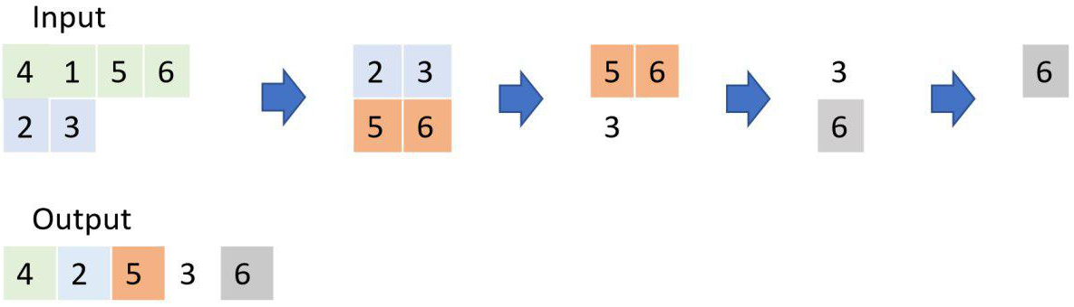
3  3 2 2 5  2 2 6  1 4 | 6  3 2 1 5 6 4

